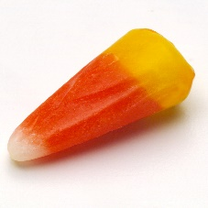**Candy Corn Halloween Fruit Cup**

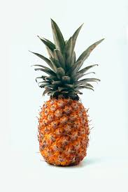**Course** Seasonal

**Prep Time** 5 minutes

**Total Time** 5 minutes

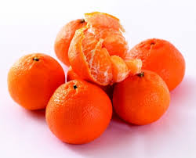**Servings** 6

**Author** Stephanie Ertel

**Ingredients**

* 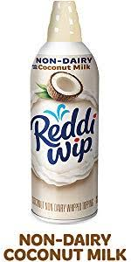1 can mandarin oranges
* 1 can pineapple chunks
* whipped cream
* candy corn

**Instructions**

1. Fill cup with pineapple chunks; about 1/3 of the cup.
2. Next fill another layer with mandarin oranges.
3. Top with whipped cream and place candy corn on top.
4. Serve and enjoy!

**Recipe Notes**

You can make these ahead of time and keep in the fridge until ready to serve. Just don't put on the whipped cream and candy corn until you are ready to serve.

*Candy Corn Halloween Fruit Cup https://www.stockpilingmoms.com/candy-corn-halloween-fruit-cup/*

