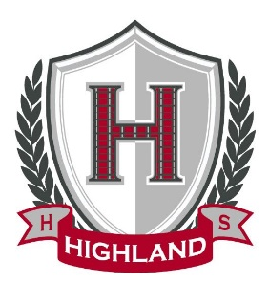

December 17, 2024

Congratulations!
“November”
Student of the Month
“Senior”
Julian Ramos

WooHoo….Food drive collected a total of 958.6# of Food. Thank you
To EVERYONE that contributed….

Make sure you are giving yourself enough time to get to where you need to be…..

BAND STUDENTS….IF YOU RENT YOUR INSTRUMENT FROM THE SCHOOL, PLEASE SEE MRS. KRAMER.

Spirit Week:
Tuesday – Christmas/Winter Hat
Wednesday – PJ’s
Thursday – Flannel
Friday – Ugly Sweater or Cozy Outfit

Lunch Today:

Pizza
Cookie
Salad
Fruit
Milk

Thought of the week:
“Instruction does much, but encouragement does everything.”
-Johann Wolfgang von Goethe-

