**STAP-COMM**

**Retiree Book Recommendations**

**2008**

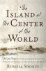 **Sandy Behrend** – *The Island at the Center of the World*

Shorto, Russell

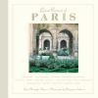 **Vicki Bruning** – *Quiet Corners of Paris*

Napias, Jean-Christophe

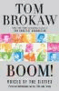 **Bob Farwell** – *Boom!*

Brokaw, Tom

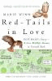 **Doug Happ** – *Red- Tails in Love*

Winn, Marie

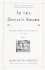 **Karen Liebel** – *In the Devil’s Snare*

Norton, Mary Beth

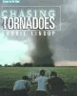 **Jim Soyka** – *Chasing Tornados*

Lindop, Laurie

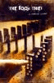 **Brigette Wagner-Ott** – *The Book Thief*

Zusak, Markus

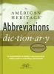 **Paula Wheeler** *– The American Heritage Abbreviations*

*Dictionary*

Cover image **Jean Wilson** – *Persuasion*

Austin, Jane

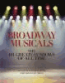 **Darcy Young** *- Broadway Musicals*

Bloom, Ken

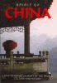 **Christina Zawierucha** – *Spirit of China*

Davies, Gill

**2009**

Cover image **Margaret Curran** – *The Aeneid*

Virgil



**Ann Hopcus** – *A friend Like Henry*

Gardner, Nuala

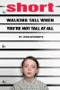 **Julie Kindelan** – *Short- Walking Tall When you’re Not*

*Tall at All*

Schwartz, John

**2010**

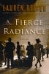 **Amy Henry** – *A Fierce Radiance*

Belfer, Lauren

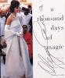 **Maria Leone** – *A Thousand Days of Magic*

Cassini, Oleg



**John Nicklas** – *By Order of the King*

Hugo, Victor

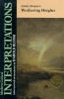 **Helen Rosati** – *Wuthering Heights*

Bronte, Emily

**2011**

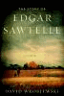 **Art Aungst** – *The Story of Edgar Sawtelle*

Wroblewski, David

 **Teri Drum** – *The Heart and Science of Yoga*

Perlmutter, Leonard

Cover image **Andrea Kadish** – *Cutting For Stone*

Verghese, Abraham

|  |
| --- |
|  |
| Cover image **Tony Agnello** – *Afghanistan 101 : understanding Afghan Culture*  Entezar, Ehsan |  |

**2012**

**Mike Behm** - *The Alienist*

Carr, Caleb



**Colleen Butera** - *The art of racing in the rain : a novel*

Stein, Garth

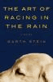

**Angelo Daluisio** - *Teacher man : a memoir*

Frank McCourt



**Bob Ferrentino** - *Summer of '49*

**H**alberstam, David



**Carol Fitscher** - *Jane Eyre*

Bronte, Charlotte



**Sue Ketzer** - *Fall of giants*

Follett, Ken

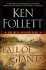

**Don Lorentz** - *Rich dad poor dad for teens : the secrets*

*about money that you don’t learn in school*

Kiyosaki, Robert T



**Kevin Schott** - *Ansel Adams : 400 photographs*



**Walt Stefani** - *The essential Wooden : a lifetime of lessons*

*on leaders and Leadership*

Wooden, John

Cover image

**2014-**

**Nancy Burns**- *Les Miserables*

Hugo, Victor

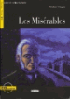

**Frani Evedon –** *SHOGUN: A novel of Japan*

Clavell, James



**Sue Hassenfratz** - *My Life in France*

Child, Julia



**Chris Revett** – *Treasures of Britain : The Architectural, Cultural,*

*Historical and Natural History of Britain*



**Anna Robinson***- All the Light We Can Not See*

*Anthony Doerr*



**Ruth Kartais –** *NIKE*

*- Tracy Carbasho*

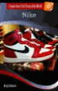

**2016-**

**MaryEllen Bargmann –** *Born To Run*

*- Bruce Springsteen*

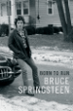

**George DeShaies –** *I Always Sit With My Back to the Wall*

*-* Dr. Harry A. Croft, M.D.



**Brian Godfrey -** *Orphan Train*

*- Christina Baker Kline*



**Peg Sullivan –** *A Dog’s Purpose*

*- W. Bruce Cameron*



**Cindy Siener –** *The Girl on the Train*

*- Paula Hawkins*



**2017-**

**John Hitchings –** *The Future of Life*

*-* *Edward Osborne Wilson*

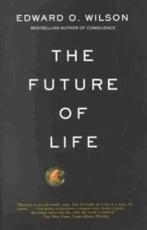

**Barb Battistella –** *The Adventures of Huckleberry Finn*

*- Mark Twain*

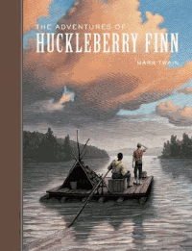

**Nancie Wagner –** *Cutting for Stone*

*- Abraham Verghese*

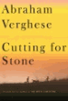

**Bob Finn-** *The Franchise Affair*

*-* *Josephine Tey*



**2018-**