**Parent and Family Engagement Policy for Shared Student Success**

**2024-2025**

## **School Plan for Shared Student Achievement**

## **What is it?**

## This is a plan that describes how Westside Elementary will provide opportunities to improve family engagement to increase student achievement and success in the 2024-2025 school year.

## **What is Title I?**

Westside Elementary is identified as a Title I school as part of that every Student Succeeds Act (ESSA). Title I is designed to support State and local school reform efforts tied to the challenging State academic standards to improve teaching and learning for students. Title I programs must be based on effective means of improving student achievement and include strategies to support family engagement. All Title I schools must jointly develop with parents and family members a written parent and family engagement policy. This ensures that all individuals support student learning. Westside Elementary values the contributions and involvement of families to establish an equal partnership for the common goal of improving student achievement. This plan describes the different ways that Westside Elementary will support family engagement and how families can help plan and participate in activities and events to promote student learning at school and at home.

## **How is it revised?**

Westside Elementary School invited all families to attend our annual School Title One Night to review and revise this parent and family engagement policy, our school-parent compact, and the family engagement budget. The plan is posted on our school website for families to view and submit feedback throughout the year. All feedback received during the year will be used to revise the plan for the next school year. Families can also give feedback during several meetings and activities during the school year.

**Who is it for?**

All students participating in the Title 1, Part A program, and their families are encouraged and invited to fully participate in the opportunities described in this plan. Westside Elementary will provide full opportunity for the participation of parents and family members with limited English, with disabilities, and of migratory children.

**School-Parent Compacts**

-As part of this plan, Westside Elementary and our families will develop a school-parent compact. A compact is a written agreement that families, teachers, and students jointly develop to explain how everyone will work together to ensure all students reach grade-level standards. The compacts will be reviewed and updated annually based on feedback from families, students, and teachers during various event and the annual Title One night. The school-parent compacts are posted on our school website (<http://wes.rcstn.net>).

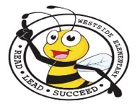

|  |  |
| --- | --- |
| **2024-2025 District & School Goals** | |
| **In the 2024-2025 school year, Robertson County Schools will commit to the following:** | **In the 2024-2025 school year, Westside Elementary School will commit to the following:** |
| * increase the percentage of students scoring “On-Track” or “Mastered” in ELA and Math for all students and in each of the accountability subgroups. * create a culture and climate where stakeholder feedback and diversity are valued and where school personnel are highly trained on culturally-responsive and trauma-informed practices. * Employees will be recognized for different things such as attendance, years of service and academic achievement. | * Student Growth: The goal for 2024-2025 is at least 74% opf students will score above the 25% percentile in reading and reduce the number scoring below to 26%. The Math goal will align with the district goal of reducing the number scoring below the 25th percentile to 14%. We aim for 86% of our students to score above the 25th percentile in Math. * By supporting students physically, emotionally, behaviorally, and culturally, WES will increase the amount of time that students are receiving high-quality, classroom instruction by decreasing absenteeism and reducing student incidents, including assignments of in-school and out-of-school suspension. We desire increased communication and relationships withh families to support students. * In the 2024-2025 school year, WES will support certified and classified staff to encourage and increase effectiveness. Our goal is to retain 90% of the number of effective certified and classified staff choosing to reamin at the school for the 2025-2026 school year. |

|  |
| --- |
| **Westside Family Engagement Plan** |
| Westside Elementary School developed the following standards of family engagement to help accomplish our mission to ensure all students learn how to read and comprehend text, while fostering a love for reading.   * The school plan is developed with input from school staff, teachers, families, and community members. * Individual assessment results, progress reports, and report cards are provided to families in English and * Handbooks, newsletters, report cards and other communications are easy to understand and translated in the appropriate language.   westside elementary school from wes.rcstn.net  **Look for our school sign.**  Best Email Clipart Royalty-Free Images, Stock Photos ...Brechbiel, Sadie -- Grade 1 / Class DojoFree Facebook Cliparts, Download Free Facebook Cliparts png ...    Ways to connect with the school and the classroom teacher.    Get connected with us! |

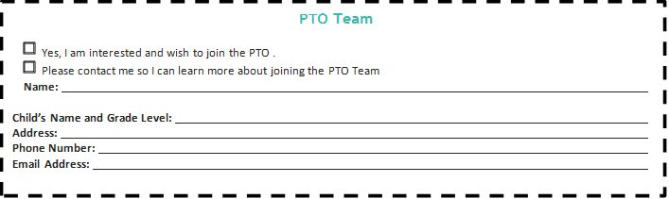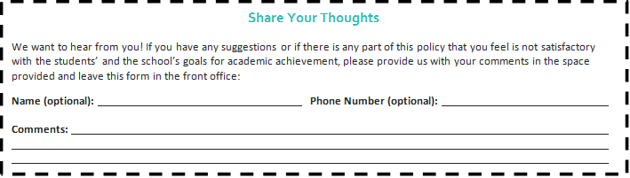

# **Share Your Thoughts**

We want to hear from you! If you have any suggestions or if there is any part of this policy that you feel is not satisfactory with the students’ and the school’s goals for academic achievement, please provide us with your comments in the space provided and leave this form in the front office:

**Name (optional): Phone Number (optional):**

**Comments:**