**MyOpenMath**

**Online Homework System**

MyOpenMath is a free online homework system that will be used to give students the opportunity to practice the concepts learned in class. Homework assignments and quizzes will be given on MyOpenMath website.

**Registration**

1. Go to [www.myopenmath.com](http://www.myopenmath.com) and click on “Register as a new student”.

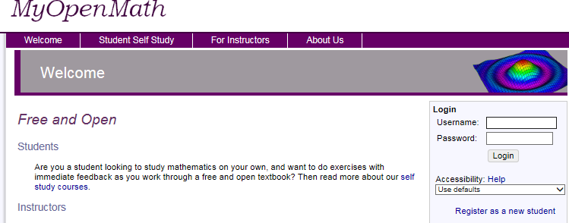

2. Fill out the information requested and enter the course ID and Enrollment key listed below.

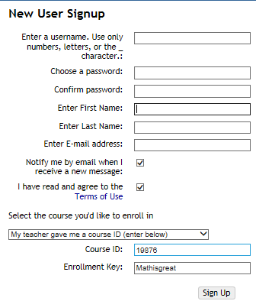

**Enter the following information provided by your instructor.**

Course ID:

Enrollment Key:

3. Click on “return to the login page”.

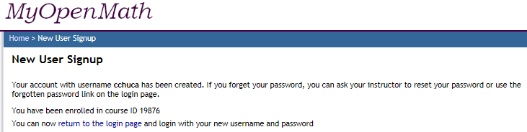

4. Click on the course you enrolled for.

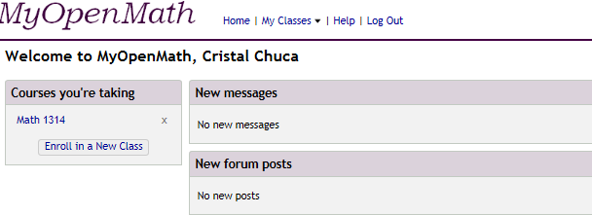

5. The course is setup by Units. Each unit is broken down into Learning Objectives and each of those folders has the lecture and homework folders. First you should view the lecture folder. **Print** out the student handout and take notes while you **READ** or **VIEW** the videos.

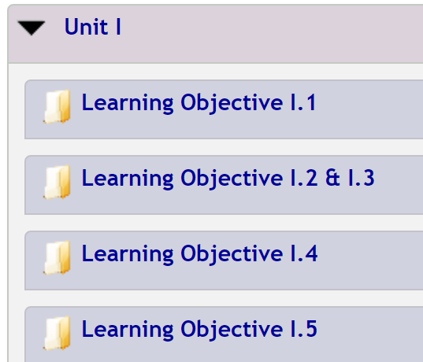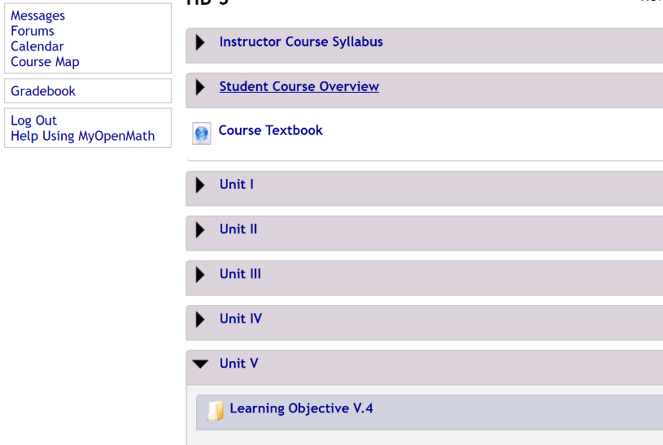

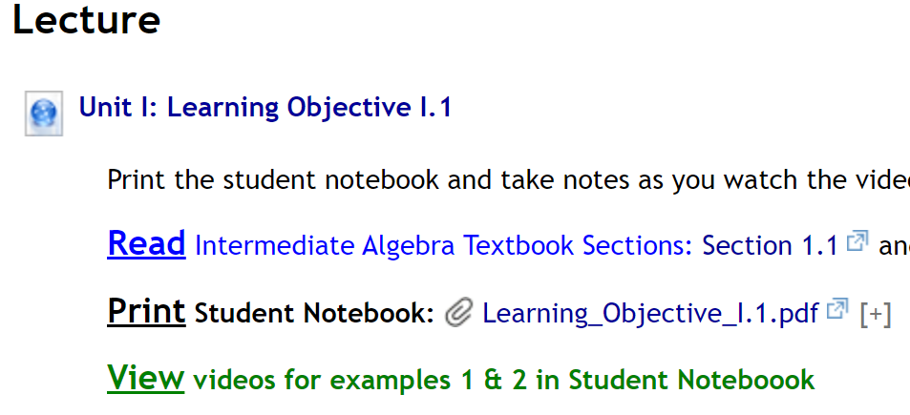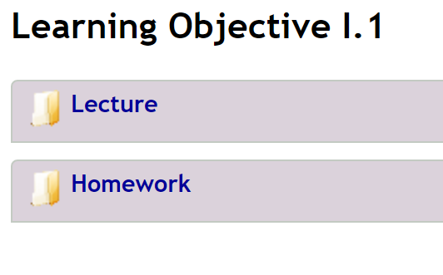

6. After viewing the videos and taking notes then you can complete the homework for that Learning Objective.

