**Tier 1 PBIS Team Training Content Guide:**

**4 - Data Entry & Analysis Plan Established**

*“We are all continually faced with a series of great opportunities, brilliantly disguised as insolvable problems.”* John Gardner

|  |  |
| --- | --- |
|  | The 4 core features of PBIS are represented here visually. Measurable outcomes are seen when we address data, systems, and practices in our districts and campuses.  Data is gathered and disaggregated to help campuses and districts make effective and efficient decisions.    The data will tell us if the outcomes we desired are being reached with our systems or practices and whether we need to continue, tweak, or drop those the data tells us are not working. Using this process will help us make effective and efficient decisions. |

**Data Defined**

* Information that is used to select, monitor, and evaluate outcomes, practices, and systems
  + Examples: office referrals, attendance records, grades, surveys, verbal feedback, and observations
  + To be effective in action planning, data must be documented and shared

Team Discussion

|  |
| --- |
| What are different sources of data you use in school-wide decision making? |
|  |
| How comfortable are you accessing and interpreting these data? |
|  |

**Benchmarks of Quality**

|  |  |
| --- | --- |
| **13** | **Data system is used to collect & analyze ODR data** |
| *The database can quickly output data in graph format and allows the team access to ALL of the following information: average referrals per day per month, by location, by problem behavior, by time of day, by student, and compare between years.* |
| **14** | **Additional data are collected (attendance, grades, faculty attendance, surveys) and used by SWPBS**  **team** |
| *The team collects and considers data other than discipline data to help determine progress and successes*  *(i.e. attendance, grades, faculty attendance, school surveys, etc.)* |
| **15** | **Data analyzed by team at least monthly** |
| *Data are printed, analyzed, and put into graph format or other easy to understand format by a member of the team monthly (minimum)* |
| **16** | **Data shared with team and faculty monthly (minimum)** |
| *Data are shared with the PBS team and faculty at least once a month.* |

**Data Systems**

**Core Reports**

Core reports provide information at the school-wide level. The value of these reports is to provide a data dashboard schools can use to quickly and visually identify potential problems that may need further inquiry.

* Average Referrals Per Day Per Month
* Referrals By Location
* Referrals By Problem Behavior
* Referrals By Time
* Referrals By Student
* Referrals By Grade

**Additional Reports**

Other reports that are beneficial for looking at long-term decision making are multi-year and reports about staff referral behavior. Not everyone needs access to the names of staff by referral, depending on the transparency of your organization, but administrators can use this information to find where supports are needed. As a PBIS team, it is useful to know if referrals are being generated equitably or by a certain group of staff.

* Multi-year reports
* Referrals By Staff
* Referrals By Ethnicity
* Relative Risk Ratio By Sub-population
* Attendance
* Grades

**Continued**

* “Triangle Report” – Based on the 3 Tiers of PBIS
  + What percentage of students have 6 + office referrals?
  + What percentage of students have 2-5 office referrals?
  + What percentage of students have 0-1 office referrals?

Team Discussion

|  |
| --- |
| Do I have access to core reports for data, directly or through someone else? |
|  |
| What other reports do I need on a regular basis? |
|  |

**Data Based Decision Making**

**Problem Solving Process**

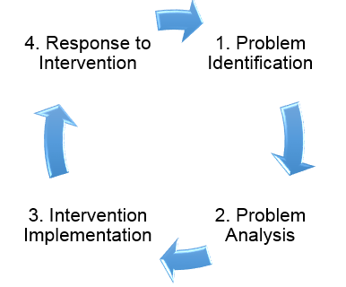

**Problem Identification**

In order to identify potential problems, the PBIS team will first need to answer the question “What is our current status?”

What are:

* the levels, trends, peaks, and/or valleys in our data;
* current year data compared to previous year data;
* our data compared with national and/or regional norms;
* our data compared with our preferred or expected status?

**Big 5 Data**

|  |  |
| --- | --- |
| Problem Behavior | What problem behaviors are most common? |
| Location | Why classroom management is important? |
| Student | Are there many students receiving referrals or only a small number of students with many referrals? |
| Time of Day | Are there specific times when problems occur? |
| Why | What is maintain the behavior, or why are students doing this? |

**Sample Data**

|  |  |
| --- | --- |
| **What?** |  |
| **Where?** |  |
| **When?** |  |
| **Who?** |  |
| **Why?** |  |

**Precise Problem Statement**

There is __________________________________________________

[What?]

in _______________________________________________________.

[Where?]

These are occurring _________________________________________

[When?]

by________________________________________________________.

[Who/Whom?]

The likely motivation for this behavior is___________________________.

**Data Decision Rules**

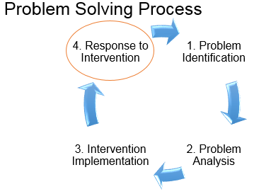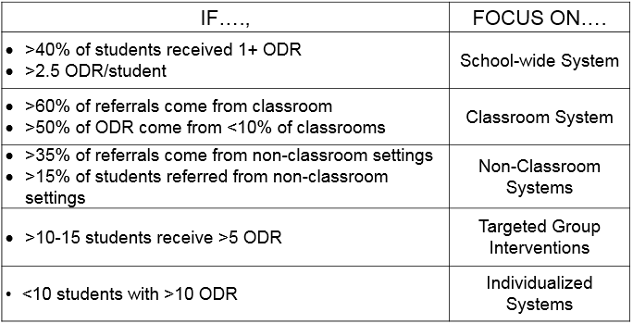

Response to intervention is figuring out how we will check to see if what we did is working. We are assuming that any intervention we implemented was in fact evidence-based and implemented with fidelity.

If the team creates a simple intervention, such as “we will post blank number of staff members in this given location for 2 weeks to prompt students about something”, then create the plan to check in and evaluate the process. If you decided to use a certain program or contract for support in a certain area, then use the protocol for what you have chosen. In other words, don’t just do parts of something or just train the staff without any internal responsibility for seeing if it works. Every intervention, program, or training will be different, and your results may vary, but your team can have some influence.