**Tier 1 Team Training Content Guide:**

**6 – Reward/Recognition Program**

**Why Develop a School-Wide Reinforcement System?**

* An acknowledgement system fosters a welcoming and positive climate.
  + In April 2013, the National School Climate Center and Fordham University concluded that "sustained positive school climate is associated with positive child and youth development, effective risk-prevention and health-promotion efforts, student learning and academic achievement, increased student graduation rates, and teacher retention."
* An acknowledgement system allows staff and students to focus their attention on desired behaviors and increases likelihood of the demonstration of desired behaviors.
  + We want to give attention to behaviors that are appropriate so that they are reinforced and continue to occur. Remember, giving attention to negative or inappropriate behavior is often reinforcing for many students.
  + Behavior that is not reinforced is less likely to be repeated.
  + Acknowledgement systems also reinforce the teaching of new behaviors and reduce the time spent correcting student misbehavior.

**Terms used synonymously in this training:**

* Reinforcement, Acknowledgement, Recognition

**Team Discussion**

|  |
| --- |
| What is positive acknowledgement and why is it important for us to use? |
|  |

**Activity 6-A: How Do You Acknowledge?**

**Directions:**

With your team, brainstorm a list of acknowledgements that your school provides (academic & behavior) to students and staff. When your list is completed, record the following in the Reinforcement Matrix:

* In the WHAT column provide a description of the acknowledgements your campus currently provides.
* In the WHEN column, identify when the acknowledgements are delivered (immediately, every few weeks, few times a year, etc.)
* In the WHO column, identify if it is student or staff reinforcement.

|  |  |  |
| --- | --- | --- |
| **WHAT** | **WHEN** | **WHO** |
|  |  |  |
|  |  |  |
|  |  |  |
|  |  |  |

**Benchmarks of Quality (BoQ)**

|  |  |
| --- | --- |
| **22** | **A system of acknowledgement has elements that are implemented consistently across campus** |
| *The acknowledgement system guidelines and procedures are implemented consistently across campus. Almost all members of the school are participating appropriately. (90-100% staff participation)* |
| **23** | **A variety of methods are used to acknowledge students** |
| *The school uses a variety of methods to acknowledge students (e.g. praise, cashing in tokens/points). There should be opportunities that include tangible items, praise/recognition and social activities/events* |
| **24** | **Acknowledgements are linked to expectations** |
| *Acknowledgement is provided for behaviors that are identified in the rules/expectations and staff members verbalize the appropriate behavior when giving acknowledgement* |
| **25** | **Acknowledgements are varied to maintain student interest** |
| *The acknowledgement is varied throughout year and reflects students’ interests (e.g. consider the student age, culture, gender, and ability level to maintain student interest.)* |
| **26** | **Ratios of acknowledgement/reinforcement to corrections are high** |
| *Ratios of teacher acknowledgement of appropriate behavior to correction of inappropriate behavior are high (e.g., 4:1)* |
| **27** | **Students are involved in identifying/ developing incentives** |
| *Students are often involved in identifying/developing incentives* |
| **28** | **The system includes acknowledgement/incentives for staff/faculty** |
| *The system includes incentives for staff/faculty delivered consistently* |

**Positive Acknowledgement:**

Positive acknowledgement (reinforcement) is:

* The presentation of something pleasant or rewarding immediately following a behavior that makes that behavior more likely to occur in the future.
* One of the most powerful tools for shaping or changing behavior.

**Shaping Behavior with Positive Acknowledgement**

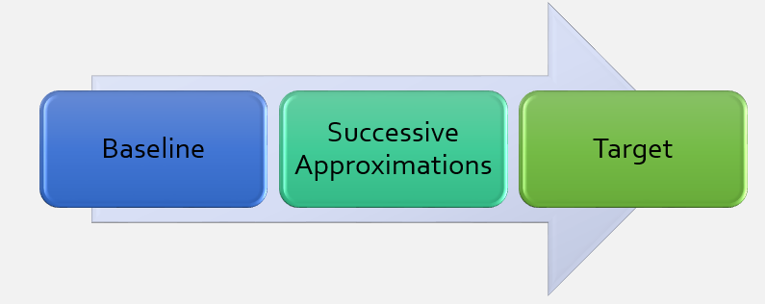

**Acknowledgement Guidelines**

* Provide reinforcement for demonstration of school-wide expectations
  + Remember that the purpose of acknowledging appropriate behavior is to increase the likelihood that students will continue to demonstrate the desired behavior.
* Students are ALWAYS eligible to receive acknowledgements
  + Students who are frequently sent to the office do not have the opportunity to earn rewards/recognition for appropriate behavior. Staff often feel these students do not exhibit appropriate behavior for long enough periods of time to be recognized for it.
* Reinforcements are for EVERY student
* Refrain from threatening the loss of rewards and/or taking earned items away as a strategy for motivating desired behaviors
  + At times, educators take away previously earned rewards following inappropriate behavior. If a student loses rewards that were previously earned for following expectations, why would he/she be motivated to follow the expectations in the future?

**Non-Contingent & Contingent Reinforcement:**

There are two types of adult attention and both have a positive impact on interactions in schools.

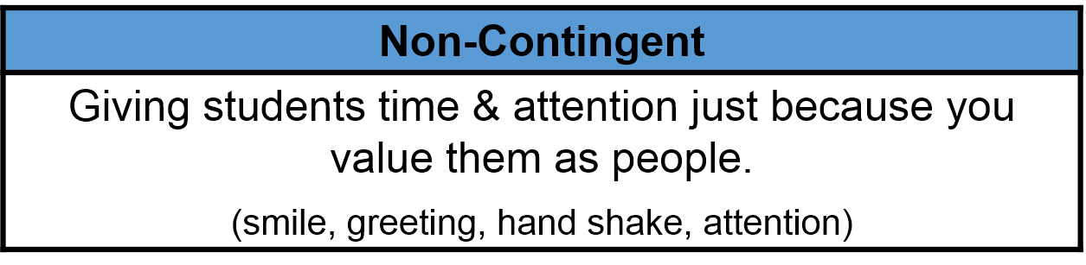

**Non-contingent reinforcement** is attention provided regardless of performance. Non-contingent attention is not sufficient to change and sustain behavior. Given that many instances of inappropriate behavior are based in a desire for attention, if we provide sufficient non-contingent attention, the frequency of behavior problems may decrease. As teachers report that positive student–teacher interactions increase, the numbers of disciplinary referrals students receive decreases. Also, students report an increase of positive quality in the student–teacher relationship, a decrease in the number of behavior referrals they receive and an increase in the amount of time they spent on-task (Decker, Dona & Christenson 2007).

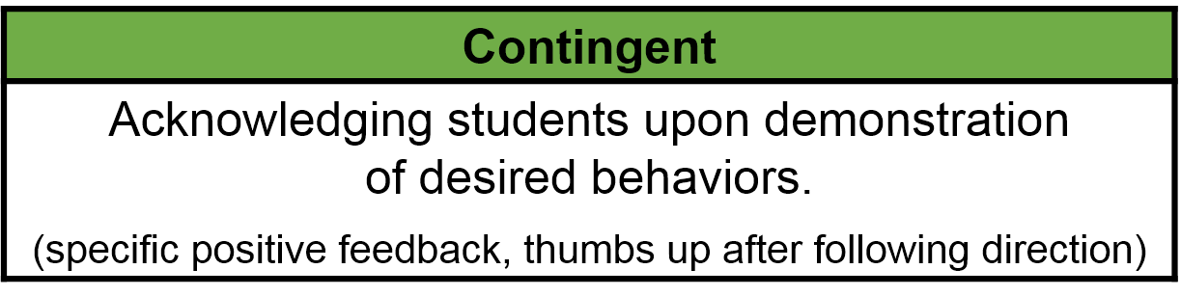

**Contingent reinforcement** is provided based upon student performance of an identified expectation or behavior. The attention is contingent upon the student performing a specific desirable behavior. Research shows that contingent attention increases academic performance (Good, Eller, Spangler, & Stone, 1981) and on-task behavior (Sutherland, Wehby, & Copeland, 2000). Contingent attention or specific positive feedback is essential. With specific positive feedback you are recognizing attainment of specified performance criteria, effort, or successes at tasks that are difficult for the child. To ensure continued use, specific positive feedback is essential. General praise are inadequate for building and sustaining desired behavior. Students need clear, specific feedback on their use of the schoolwide expectations.

**How to Give Specific, Contingent Acknowledgement**

* **Specifically describe the behavior.**

Students need to know explicitly what behavior they did that was correct and earned the acknowledgement of the teacher. Teachers readily do this when giving feedback about academic work. Teachers often use a rubric when reviewing academic work that helps specifically describe the desirable behavior displayed. Davis (2007) describes this as acting “like a video camera, helping students see their own positive behavior.” In effective praise we simply describe the behavior observed to make the feedback clear and specific. For example, “When I said it was time to begin your assignment, you cleared off your desk, got your materials out immediately, and began working quickly.” It is a videotape replay of exactly what the student did, couched in the words of your expectations. Do not add any references to past mistakes the student has made or wishes for future behavior. Simply describe exactly what you saw that you want the student to continue doing in the future. Additionally, be cautious in adding “I’m proud of you.” We want students doing the appropriate behavior because of the benefits to them rather than simply to please the teacher.

* **Provide a rationale.**

Explain the reason why the behavior is important. Rationales or reasons teach the students the benefits of their behavior and the impact it has on them and others. This often includes stating the overarching schoolwide expectation (e.g., respect, caring, cooperation, etc.) and pointing out what the student might expect could happen if they use the appropriate behavior. “Getting started right away like that shows cooperation and will help you avoid having homework.”

* **Can include a tangible item or preferred activity.**

For many students, the specific positive feedback alone is sufficiently reinforcing to strengthen the behavior. However for some students, and when a behavior requires a great deal of effort, pairing the verbal feedback with tangible or activity reinforcement may be helpful. When using a tangible item or preferred activity it is imperative that you also use the complete verbal praise so that students are aware of exactly what they did that has resulted in earning the consequence. It is not the consequence that changes the behavior so much as the awareness of what is being reinforced; the consequence merely provides additional incentive.

**Acknowledgement: Positive to Negative Ratio**

Another important point in building positive schoolwide and classroom environments is to ensure:

* That appropriate behavior receives much more attention (at a higher ratio) than inappropriate behavior. We want students to experience predominantly positive interactions across all school settings.

Reavis, Jenson, Kukic & Morgan (1993) recommend a ratio of 4:1; four comments in response to desired student behavior to one response to student misbehavior. Interactions with students are considered positive or negative based on the behavior of the student at the time the attention is given, not the demeanor of the teacher.

Below is the link/address for the Randy Sprick video shown https://youtu.be/Dbi_gsDGk8w

*“High implementing PBIS schools were found to use a variety of individual and group rewards to inform parents of appropriate student behavior while low implementing schools were found to use schoolwide reinforcement either inconsistently or not at all”. (Sparks, 2007)*

**School-Wide Positive Reinforcement**

A system that provides immediate, intermittent, & long-term reinforcements, given by adults in the building, to ANY student displaying desired school-wide expectations, or associated rules.

**School-Wide Acknowledgement Systems:**

There are three types of acknowledgements that are the “nuts and bolts” of a school-wide reinforcement systems:

* **Immediate/high frequency** predictable acknowledgements
* **Intermittent/unexpected** unpredictable acknowledgements
* **Long-term** celebrations**.**

***Immediate, High Frequency & Predictable Acknowledgements***

Many schools use a ticket system to provide this type of acknowledgment. What it boils down to is that the tickets serve as a visual reminder to the staff to work on providing that 4:1 ratio of interactions.

* Ticket/Token System
  + Tied into school-wide expectations
  + Prompts for specific behavior feedback on the student’s behavior
  + Provides a visible acknowledgement of appropriate behavior for student
  + Helps to remind staff to provide acknowledgements & achieve the 4:1 ratio
* Considerations for Ticket Systems
* Use tokens that students can “cash in” for back-up reinforcers
* Solicit input from students regarding the type of back up reinforcers to provide, using multiple methods (i.e. on-line surveys, voting, suggestion box, etc…)
* Change the color and/or design of tokens frequently to discourage counterfeiting.
* Ensure an ample supply of tokens
* Ensure all students have fair chance of earning rewards.
* Provide visual prompts in all settings
* Include information and encouraging messages on daily basis
* Select criteria for earning rewards based on data already being collected (e.g., attendance, grades)
* Continue school-wide efforts and align your classroom rewards system with the school-wide system.

***Unexpected/Intermittent Acknowledgement***

Once behaviors have been learned, we want them to be maintained. Intermittent, unexpected, and unpredictable acknowledgement can support this.

* Things like raffles, “out of the blue” special privileges, and random positive calls from the principal to parents are ways to use intermittent reinforcement to support the ongoing demonstration of expected behaviors.
* The Principal’s 200 Club works on the premise of a token economy but also a sense of chance. Students are provided a token when they are observed following the school-wide expectations. The token is taken to the office and they draw a number. That student owns that square. When the column or row is filled, students with those numbers receive the reward.
* Another example is to collect the tickets and enter them into a drawing for a chance at some type of additional reinforcement. Because it is a raffle drawing, students do not know who will win but they do know that each ticket they have earned is another chance to receive additional reinforcement.

***Long Term Celebrations***

There are two types of long-term celebrations.

* One is specifically for students who have demonstrated appropriate behaviors
* The other is for ALL students and adults to celebrate a school-wide success related to behavior.

Student of the month or good attendance clubs are great, but are not enough, as they don’t reach enough students.

**Sample Acknowledgement Plans**

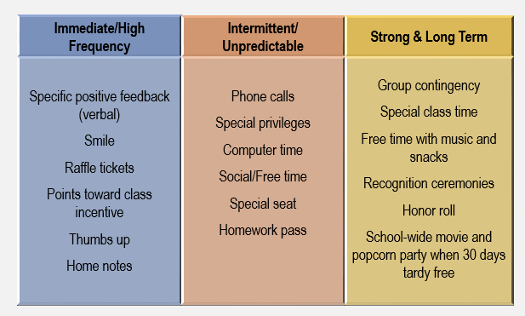

**Activity 6-B: Acknowledgement Plan Review**

**Directions:**

* Individually review one of the acknowledgement plans in the Resources documents for this section.
* With a partner discuss whether the “Critical Features” of Acknowledgement Systems are evident in the examples. Use the Critical Features Checklist provided in your Action Plan template to assist with this task. Document your findings below:

|  |
| --- |
| Document your findings below: |
|  |

**System for Faculty/Staff Reinforcement**

Staff members need and respond to rewards/reinforcement too. Adults will better understand the need for reinforcement if they actually experience it.

* **Examples:**
  + Reserved parking space
  + Gift cards
  + Positive peer comment cards
  + Jeans coupon
  + “Fly the coop early” card

**Web-Based Recognition Systems**

PBIS Rewards

https://www.pbisrewards.com/about/

Class DoJo

https://www.classdojo.com/pbis/

Hero

http://herok12.com/tour

Live School

http://whyliveschool.com/

6- Reward/Recognition Program

Resource Documents

Acknowledgement Plan

Example 1

|  |  |  |  |
| --- | --- | --- | --- |
| Type | What | When | Who |
| Daily/Monthly | Teachers will all have | Slips given daily. | Make blue slips: |
| Use “Caught Being | custom blue slips to | Drawing monthly. | Amanda |
| Blue” slips. Kids will write their own names on the slips and turn them in for the raffle; teachers will have their own slips, but will need to initial | give, they will initial for proof and circle the expectation used.  Students will turn in their slips for a monthly drawing. |  | Make passes for various things (Amanda and others)  Put blanks by copy machine |
| when they give them out. We can have a weekly focus areas (example: bathroom behavior). Have a specific number for staff to give per week or day.  *Morning administrator email | Raffle Ideas:  -yearbook discounts  -entrance to games and dances  -lunch w/ a teacher  -front of line at lunch  -parking passes  -graduation supplies  -free or discounted bobcat wear  -20 minute free pass? |  | Turn in bins--one by the cafetorium, one by Amanda’s room, one by Chelsea’s room  Postcards--order for the school; we will need to talk to the new principal |
| postcards/notes home | -free popcorn from |  |  |
| each teacher does one | concessions |  |  |
| a week | -gift cards |  |  |
|  | -special parking pass |  |  |
| Long Term, School | Students with 10% or | Near the end of each | Teachers will need to |
| Wide | fewer days absent per | quarter on a randomly | plan for what they |
|  | marking period. | assigned day. | want to host and how |
|  | Special fun day for kids who qualify: movies, arts and |  | to get the kids into groups they want to be in. |
|  | crafts, tech room, |  |  |
|  | game room, sports, |  |  |
|  | etc |  |  |
| Staff Incentives | We will draw a blue | Incentive ideas: | The principal or |
|  | slip from the box, and | -lunch from Tracks | MTSS team member |
|  | the staff member who | not to exceed $10. | will draw the name at |
|  | is drawn will win an | ($100 per year) | the monthly |
|  | incentive for that month. | -Special parking | assembly. |

|  |  |  |  |
| --- | --- | --- | --- |
|  |  | place for the staff member  -One class period of prep time  -Free jeans Friday for a month |  |

NORTHWEST SECONDARY SCHOOL

PBIS SCHOOL-WIDE ACKNOWLEDGEMENT MATRIX STUDENTS

|  |  |  |  |
| --- | --- | --- | --- |
| **Type** | **What** | **When** | **Who** |
| **Immediate/** | **Raffle Tickets** | High frequency for a short | **Secretary:** Order Raffle |
| **High Frequency** | Student is praised by receiving a raffle | time when first teaching desired behavior or re- | tickets and distribute weekly |
|  | ticket. Student writes first & last name | teaching identified problem |  |
|  | Each staff person receives photocopied tickets. These will be replaced by generic raffle tickets when photocopied tickets are gone. | behavior from data, and to reinforce desired behaviors  Weekly | **All Staff:** All staff are expected to support the PBIS approach. Teaching is 95% encouragement and this is one way to |
|  | *Optional: Teachers could do a random drawing in class with comparable reward to encourage appropriate behavior. This |  | encourage behavior that is conducive to learning. Staff should give out a minimal |
|  | was the benefit of collecting these in class. |  | of 20 tickets a week. Staff |
|  | Ms. Figueroa, used the in class drawing often so we may want to think about it as a way for teachers to reinforce and integrate PBIS within their system |  | should give one ticket per praise. There is no gesture or accomplishment that should be inflated by |
|  |  |  | awarding more than one |
|  |  |  | ticket at a time. |
|  |  |  | **Students:** |
|  |  |  | Student writes first, last |
|  |  |  | name, homebase room |
|  |  |  | number. |

|  |  |  |  |
| --- | --- | --- | --- |
| **Type** | **What** | **When** | **Who** |
| **Redemption of** | A drawing will be held and gifts awarded; | Weekly | **Official PBIS Ticket** |
| **High Frequency** | 10 from each group; 6-8, 9-12. |  | **Handler:** Gather tickets on |
|  | Homeroom teachers will receive raffle |  | Fridays |
|  | winners coupons via teacher mailbox to |  |  |
|  | distribute to respective winners to redeem |  | **PBIS Implementation** |
|  | in Ms. Krejcha’s Room 20, after school |  | **Team:** Select and order |
|  | only. |  | incentive items |
|  | All tickets collected throughout the month | Monthly |  |
|  | will be entered in a drawing and the |  |  |
|  | identified student and teachers will receive |  |  |
|  | a coupon with a menu of choices to be |  |  |
|  | redeemed within the month. |  |  |
|  | Teacher Gifts: TBA @ August 31st |  |  |
| **Intermittent/** | Random drawings will be done throughout | To be determined | **Implementation Team:** |
| **Unpredictable** | the year. |  | Hold random drawings |
|  | These will be put in the yearly plan maybe |  | **Educational** |
|  | four-six of these with big prizes just to mix it up. |  | **Assistant/Support Staff: Implementation Team:** Determine when the |
|  |  |  | random drawings will be an |
|  |  |  | what the incentives will be |
| **Long-term,** | Four times a year the all school goal will | Quarterly | **Implementation Team:** |
| **School-wide Celebrations** | be to reduce by 5% the number of suspensions compared with the number of suspensions for last year at that time. The **all school** celebration is a middle school |  | Will host the dance and recruit additional staff to provide supervision during the dance |

|  |  |  |  |
| --- | --- | --- | --- |
| **Type** | **What** | **When** | **Who** |
|  | and high school dance to be done fourth hour and 4:30-6:30 pm respectively. The whole school participates. The cafeteria bulletin board will have an eagle with feathers that represent the number of suspensions compared in the mark period compared to the suspensions of last year’s mark period. If the eagle has feathers the week before the scheduled dance then there will be an all school dance celebration. An announcement will be made one week prior to the scheduled dances notifying staff and students if the goal was made. See calendar for tentative dance dates. |  |  |

LANCASTER PBIS SCHOOL-WIDE ACKNOWLEDGEMENT MATRIX STUDENTS

|  |  |  |  |
| --- | --- | --- | --- |
| **Type** | **What** | **When** | **Who** |
| **Immediate/High Frequency** | **Lancaster Gold Card** will be given out to **individual students**. Once a student | High frequency for a short time when first teaching desired behavior or re- | **Secretary:** Order Gold & Blue Cards, and Lancaster Shields (Red, Yellow, |
|  | receives 10 gold cards they | teaching identified problem | Green, Blue) |
|  | can cash them in for | behavior from data, and to |  |
|  | incentive items | reinforce desired behaviors | **PBIS Implementation** |
|  |  |  | **Team:** Select and order |
|  | **Lancaster Blue Cards** will |  | incentive items |
|  | be given out to |  |  |
|  | **classrooms** for exhibiting | Weekly | **All Staff:** Distribute Gold |
|  | Safe, Responsible, and |  | and Blue Cards |
|  | Respectful behaviors. |  |  |
|  | Once the classroom |  |  |
|  | receives 10 blue cards, the |  |  |
|  | class will receive a |  |  |
|  | Lancaster Shield to display |  |  |
|  | outside classrooms and |  |  |
|  | classroom will be |  |  |
|  | recognized in the |  |  |
|  | announcements |  |  |
| **Redemption of High Frequency** | Students will be able to trade their Lancaster Gold Cards for incentive items at | Weekly | **Educational Assistant/Support Staff:** Staff school store |
|  | school store |  | **Office Staff:** Generating |
|  |  |  | quarterly class list for |
|  |  |  | student store |

|  |  |  |  |
| --- | --- | --- | --- |
| **Type** | **What** | **When** | **Who** |
| **Intermittent/Unpredictable** | Each day, Ten teachers will randomly distribute | Redeemed Immediately | **Implementation Team:**  Create Lancaster Knights |
|  | Lancaster Knights to | Maintaining a taught | cards and distribute cards |
|  | students caught making | behavior (fading) | to staff |
|  | Safe, Respective, and |  |  |
|  | Responsible choices | Quarterly celebrations for | **Educational** |
|  |  | Kindergarten, Primary, | **Assistant/Support Staff:** |
|  | Classrooms with the most | Intermediate, and Middle | Collect Lancaster Knights |
|  | Shields per quarter will | School for classrooms that | card, make phone calls, |
|  | Spin The Wheel | earn the most Lancaster | and take pictures |
|  |  | Shields |  |
|  |  |  | **Implementation Team:** |
|  |  |  | Design and creation of |
|  |  |  | PBIS Rewards Wheel, |
|  |  |  | Create a prize list, and |
|  |  |  | executing implementation |
|  |  |  | the prize |
| **Long-term, School-wide Celebrations** | When the school reaches school-wide goal, school- wide dances, ice cream | May range from monthly to quarterly depending on PBIS Goal | **Implementation Team:** Determine school-wide goal and school-wide |
|  | socials, movie days, |  | celebration |
|  | popcorn parties, field |  |  |
|  | day/recess party will be |  |  |
|  | held to celebrate |  |  |

