**Tier 1 PBIS Team Training**

**3-Effective Procedures for Addressing Discipline**

**School Practices that Promote Serious Discipline Problems**

*(Jenson, Evans, Morgan, & Rhode, 2006)*

When common language, vision and purpose are missing from a school, practices that promote serious discipline problems are evident. Specifically:

|  |  |
| --- | --- |
| Unclear rules and expectations regarding behavior | Inconsistent and punitive schoolwide, classroom, and individual behavior management practices |
| Failure to correct rule violations as well as to recognize and reward adherence to rules | Ineffective and overuse of verbal reprimands, restrictions, suspensions, expulsions and other aversive consequences to “control” student behavior |

When schools focus on developing a system for addressing discipline, common language, vision and purpose are created. The following are elements of an effective system for dealing with discipline.

**Benchmarks of Quality**

|  |  |
| --- | --- |
| 7 | Discipline process described in narrative format or depicted in graphic format |
| *Team has established clear, written procedures that lay out the process for handling both major and minor discipline incidents* |
| 8 | **Discipline process includes documentation procedures** |
| *There is a documentation procedure to track both major and minor behavior incidents* |
| 9 | **Referral form includes information useful in decision making** |
| *Information on the referral form includes all of the required fields: student’s name, date, time of incident, grade level, referring staff, location of incident, race, problem behavior, possible motivation, others involved, and administrative decision* |
| 10 | **Problem behaviors are defined** |
| *Written documentation exists that include clear definitions of al behaviors listed* |
| 11 | **Major/minor behaviors are clearly differentiated** |
| *Most staff members are clear about which behaviors are staff managed and which are sent to the office. (e.g., appropriate use of office referrals). Those behaviors are clearly defined, differentiated and documented)* |
| 12 | **Suggested array of appropriate responses to major (office-managed problem behaviors** |
| *There is evidence that all administrative staff members are aware of and use an array of predetermined appropriate responses to major behavior problems* |

**Re-Thinking Discipline**

**Team Discussion**

|  |
| --- |
| How is student or staff behavior positively or negatively impacting school climate? |
|  |

**Impact of Problem Behaviors:**

First, let’s talk about the impact of problem behaviors. The truth is that problem behaviors happen and have an impact on all stakeholders.

**Lower student achievement.** Teachers report that “uncivil” behavior is increasing and is a threat to learning. Up to 50% of the school day is lost due to misbehavior during transitions, discipline, and other non-instructional activities (Cotton, 1990; Sugai & Horner, 1994).

**School failure and life-long difficulties**. Students with discipline problems are clearly at risk for school failure and developing more severe antisocial behaviors as well as other life-long difficulties. These students tend to experience juvenile delinquency, social isolation, diminished employment rates and income, and more frequent legal and mental health issues (Gresham, 1984).

**Increased use of exclusionary practices.** As behavior problems have increased, so have exclusionary practices such as detentions, in-school suspension, homebound instruction, shortened school day, referral to alternative schools, administrative transfers, or ignored truancies that restrict student access to learning. (U.S. Department of Education, 2014).

**Teacher effectiveness and morale.** Studies show up to 60% of new teachers leave the profession within the first five years, often citing student discipline as the primary reasons for leaving (Martinez, 2001).

**School improvement initiatives impeded.** When discipline issues impact the school climate teachers, principals, parents and students are affected (Bryk & Schneider, 2003; Gordon, 2002).

Let’s further illustrate the impact that problem behaviors have on administrator time, the instructional leaders of a school.

The formula for calculating this loss of time is take the total number of office discipline referrals, or ODR’s and multiply by the minutes spent processing referrals. Take the resulting number and divide by 420 minutes, the number of minutes in a 7 hour school day. That equals the total number of administrator days lost due to processing referrals.

**total # of ODR’s x minutes spent processing referrals =_____/ 420 min(7hrs.) =_____**

Consider one school had 2,498 total referrals in one school year. When calculating 15 minutes of administrator time to process a referral, that is 89.2 days lost to processing referrals. When calculating 20 minutes of administrator time to process referrals, that is 119 days lost to processing referrals.

**2498 ODRs x 15 min = 37,470 min / 420 min (7hrs) = 89.2 Days**

Let’s further illustrate the impact that problem behaviors have on student time.

Using the same formula, let’s consider the amount of time a student is out of the classroom to process an office discipline referral. Between waiting for and conferencing with the administrator, let’s say a student misses a total of 30 minutes instructional time. When you consider 30 minutes of lost instructional time for each of the 2,498 office referrals. That is a total of 178.4 days of lost instructional time.

**2498 ODRs x 30 min = 74,940 min / 420 min (7hrs) = 178.4 Days**

Now let’s consider if the consequence for those referrals resulted in In-School suspension, out-school suspension, or placement in DAEP. In the case of this school, of the 2,498 total referrals, ISS was assigned for a total of 1003 days (each student assigned multiple days, one student may have more than one consequence for ISS). OSS was assigned for a total of 124 days (each student assigned multiple days, one student may have more than one consequence for OSS), and 13 DAEP placements which at the minimum require a 45 day placement, totaling 585 days. The resulting number of days lost to instruction is 1,712 days!

**1003 ISS days + 124 OSS days + 585 DAEP days= 719,040 min**

**719,040 min /420 min (7hrs) = 1,712 Days**

These days represent about 20% of the 499, so about 100 students. This means these students miss almost 19 days of school just on discipline. Also not captured here is any time spent out of the classroom but didn’t get reported (e.g. sent to the hall, another teacher’s room or the office).

*“These exclusionary approaches are in direct conflict with school missions to help all students achieve their fullest potential. Our punitive policies fail the very students they target”.*

*(U.S. Department of Education, 2014)*

**The Traditional View of Discipline**

Traditional Discipline: Our Approach to school discipline is still largely based on the punitive and exclusionary practices developed when public education began in early 20th century.

In the past, school was oriented to academically inclined & socially acceptable students, and followed a punitive approach.

Currently, many students do not respond to traditional discipline methods that are reactive and punitive in nature.

When reactionary & punitive approaches are used with students, they do not change behavior for the betterment of students, rather they:

* Devalue child-adult relationship
* Weaken academic & social behavior development
* Trigger & reinforce anti-social behavior
* Shift accountability away from school
* Create environment of control

**Discipline = Teaching**

**Positive Behavioral Interventions & Supports (PBIS)**

The message of Positive Behavioral Interventions & Supports (PBIS) is:

*“Emphasis is placed on the prevention of problem behavior through creating predictable environments and acknowledging appropriate behavior.”*

Reacting to problem behavior is no longer the norm. By placing emphasis on “teaching” the desired behavior, we are practicing prevention and reducing the amount of time reacting.

**Discipline Process: Three Big Ideas**

* Disciplinary policies and practices are part of a cohesive behavior support system within a school.
* Discipline is a complementary system to expectations and acknowledgements.
* Effective discipline includes opportunities for students to LEARN and PRACTICE appropriate behaviors through an instructional approach.

**Coherent Discipline Process**

|  |  |  |
| --- | --- | --- |
| Documentation procedures to track both major & minor behavior incidents | Process described in narrative format or depicted in graphic format | Continuum of Consequences |

In order to have a coherent and consistently implemented discipline process there are several things that will need to be established and documented.

First, consider the many behaviors that occur on your campus that have to be addressed with your students. Some will be small, easily managed, requiring quick redirection so that instruction can continue and are not considered offenses that would go straight to the administrator to handle. These types of behaviors are referred to as minor or teacher managed behavior. Behaviors which are disruptive to the learning environment to the point that instruction cannot continue, and are severe enough to require administrator intervention are referred to as major or office managed behaviors. In order for a discipline system to work everyone needs to understand which behaviors are expected to be handled in the classroom and those that will require administrator intervention.

While differentiating behaviors as minors or majors is important, they will also need to be defined so that it is clear across staff members and administrators how a behavior is classified. This creates consistency when referrals are written, discipline is assigned, and improves the accuracy of data.

Once we have this done we describe the discipline process in a narrative or graphic format. This process documents in an easy to follow format the procedures to track both major and minor behavior incidents, including any processes staff must follow from beginning to end with addressing the behavior, completing documentation, and what possible consequences may be used.

 Documenting a continuum of consequences gives staff an idea of options for handling minor misbehavior in the classroom. It also spells out the expectations of the process for handling more chronic minor behaviors that can lead to a possible office referral.

**Impact of Problem Behavior**

**Minor Problem Behaviors**

Behaviors that are managed on the spot, student can be quickly redirected with little to no loss of instructional time. These behaviors are always teacher/staff managed.

**Major Problem Behaviors**

Office managed behaviors are considered harmful to self and others, are illegal, and part of the prescribed continuum of predetermined consequences

**Activity 3-A: Is it Minor or Major?**

**Directions:** Using your school handbook/ discipline guide/ behavior codes or other tools which may identify how behaviors are labeled on your campus, begin differentiating which column they belong in. Some behaviors may belong in both columns depending on severity.

**Teacher Managed Behavior (Minor) Office Managed Behavior (Major)**

**Activity 3-B: Defining Disrespect, Defiance, Disruption**

**Directions:**

* As a team define Disrespect, Defiance, and Disruption as majors and minors.
* Agree on a team definition for each & record on the chart paper.
* Be prepared to share one of your definitions.

|  |  |  |
| --- | --- | --- |
|  | **Minor Definition** | **Major Definition** |
| **Disrespect** |  |  |
| **Defiance** |  |  |
| **Disruption** |  |  |

Problem behaviors are defined by the school leadership team and staff to minimize judgment calls. All the problem behaviors must be:

|  |  |  |
| --- | --- | --- |
| Operationally defined | Clear & concise | Simple |
| Predictable | Consistent | Approved by ALL staff |

In any given school we know with a large level of confidence that without having these behaviors defined, what one teacher may consider disrespectful may not be disrespectful to another teacher. Therefore it is essential that all staff are involved in providing feedback on problem behavior definitions.

**Defining Behaviors**

An operational definition of behavior describes what the behavior of interest looks like in a way that is observable & measurable. Observable and measurable means you can see it, hear it, count it.

**Activity 3-C: Operationally Defined?**

Directions: Review the definitions below as a team & determine if they are operationally defined. Based on the definition could a stranger easily identify or determine if the behavior is occurring?

|  |  |  |
| --- | --- | --- |
| **Behavior Incident Definitions** | **YES** | **NO** |
| **Skip Class/Truancy:** Student stays out of class 5 or more minutes or is out of class without permission, student leaves class or school without permission. |  |  |
| **Dress Code Violation:** Students who do not meet dress standards. |  |  |
| **Cheating:** Student misleads with a message or action found to be false/against the rules, with the intent of personal gain. |  |  |

**Defining Behaviors – SWIS Definitions**

Turn to the resources section of this module. Find the SWIS Referral Definitions document. This is an example of problem behaviors defined. Problem behaviors are each defined, but are also categorized as a “minor” problem behavior or a “major” problem behavior.

Just like School-Wide Information Systems (SWIS) provides us with a list of problem behaviors to use, they also provide a set of definitions for these same behaviors. This provides a great starting point for your team and staff. However, we can not lose sight of the importance of contextualization - working to make this fit within your school system. The bottom line is that everyone within a school staff must be on the same page with the definitions.

It may vary form school to school but within the school it needs to be consistent. Please know that this is not necessarily an easy task. It takes some concentrated efforts and deliberate review and revisiting over time. It is within our nature to drift so once we have agreement we need to deliberately re-calibrate ourselves with regards to our understanding and application of the definitions through booster sessions with staff members.

**Activity 3-D Follow Up: Defining Disrespect, Defiance, & Disruption**

* Review the minor & major behavior definitions your team recorded earlier.
* Determine if they are operationally defined, make any necessary changes.
* Record these corrected definitions in the content guide.

**Developing a Continuum of Consequences**

**Continuum to Respond to Minor Inappropriate Behavior**

**More Intensive Response**

**Less Intensive Response**

|  |  |  |
| --- | --- | --- |
| Planned Ignoring  Physical Proximity  Signal/Non-Verbal Cue  Direct Eye Contact  Praise Appropriate Behavior  Redirect | Support for Procedure/Routine  Re-teach  Differential Reinforcement  Specific Error Correction  Provide Choice  Conference with Student | Problem Solving with:  Tier II Support  Family  Grade level team  Department Team  Students Assistance Team |

Once a campus has differentiated and defined behaviors staff will be much more clear on whether behaviors should be handled in their classroom or sent to the office for administer consequences. While differentiating and defining behaviors are important, it is equally important that a continuum of strategies to respond to minor inappropriate behavior in the classroom be developed. If educators are writing referrals for behaviors which should be handled within the classroom it may be likely the teacher does not know how else to handle the behavior and has used what tools they had at their disposal or they may simply be unaware of what they can use for lower level behaviors.

**Activity 3-E: What’s Your Continuum?**

Identify the strategies utilized with minor behavior on your campus and place them on the continuum in your content guide.

**More Intensive Response**

|  |  |  |
| --- | --- | --- |
| **Less Intensive Response** |  |  |

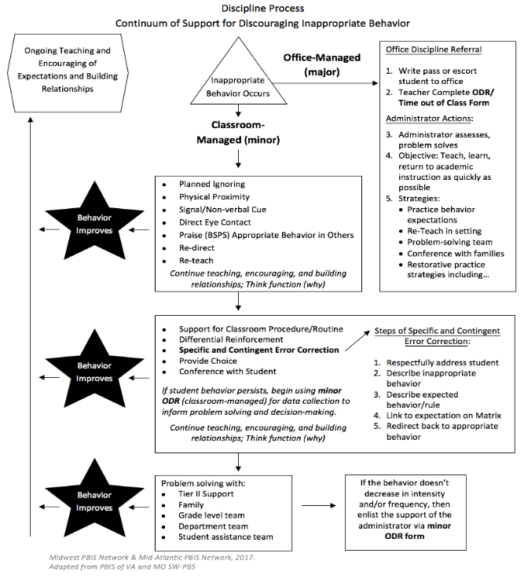

**Discipline Process - Graphic Format**

Once the team has differentiated and defined major and minor behaviors for their campus, as well as the continuum of supports teachers can use to address minor behavior infractions in the classroom, the process needs to be documented in an easy to follow format. This way staff can refer to the discipline system and use it appropriately.

Without a format that describes the process, even with differentiated and defined behaviors and a continuum of support, staff are likely to miss steps or disregard the processes put in place to create consistency across the campus with how discipline is addressed. It does no good to have a great system if it is not followed.

Here is a model of a discipline process in flow chart format. It walks the staff through the steps for addressing both minors and majors.

**Activity 3-F: Good, Better, Best**

As a team look over the flow chart examples in the content guide.

* Identify aspects of the flow charts your team finds clear and concise.
* Identify flow charts with missing or confusing pieces.
* Note in your content guide aspects you would want to include in your discipline process graphic.

|  |  |
| --- | --- |
| **Flow Charts with Missing Pieces** | **Include in Discipline Graphic** |
|  |  |

**Discipline Process - Narrative Format**

Here’s an example of the discipline process in narrative format. Here you see that have differentiated their behaviors. Somewhere there should also be definitions of each of these as well. The first 2 are behaviors that will be addressed within the classroom setting. The last 2 will be handled by administration and are color coded to make it easier for teachers to see.

The back of their narrative format is the process to follow for each of the differentiated levels of discipline, how to address those behaviors, any paperwork that needs to be completed, and the plan for how the behavior is handled during lunch/recess time for this particular campus.

**Activity 3-G: Responding to Minors**

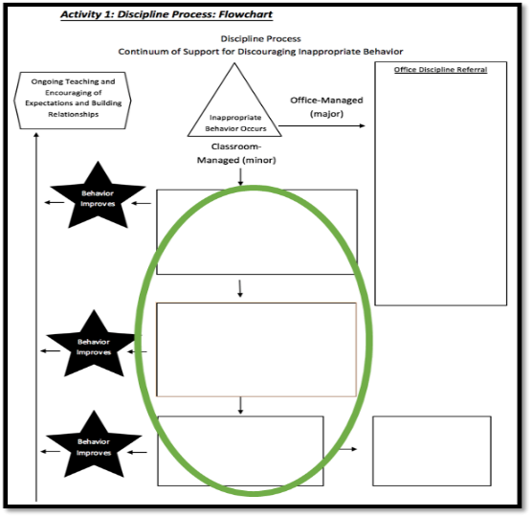

1. Identify your continuum of strategies. Include response strategies already being used.

* Include prevention strategies
* Include re-teaching and other classroom management practices

2. Add your continuum to the flowchart to document the process for responding to behavior.

3. When do staff complete a minor ODR form?

4. How do they complete the form (electronic, paper, etc.)

**Activity 3-H: Making a Major Referral**

**Office Procedures for Discipline Referral**

1. Write pass or escort student to office
2. Teacher Complete Time out of Class Form
3. Administrator assesses, problem solves
4. Objective: Teach, learn, return to academic instruction as quickly as possible
5. Strategies:

* Practice behavior expectations
* Re-Teach in setting
* Problem-solving team
* Conference with families
* Restorative practice strategies including…

**What happens if a student needs to be referred to the office?**

* Do you complete an office referral electronically?
* Do you complete an office referral on paper?

What is the procedure for getting a student to the office (call to office, student goes to the office)?

What’s the administrator’s disposition and is it communicated to referring teachers?

**Activity 3-I: Response to Majors**

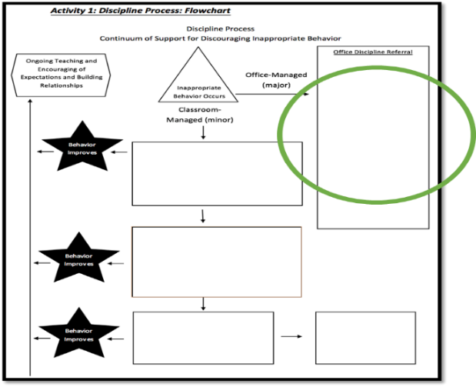

**What practices are in place for how school administration responds to a major discipline referral?**

1. Identify your office process and practices

* Include prevention strategies
* Include re-teaching and other educational approaches to discipline

2. Add your process for Major ODRs to the flowchart

**Developing Behavior Tracking Forms**

**Features of an Effective ODR Form**

|  |  |  |
| --- | --- | --- |
| Answer 5 questions:  Who, Why, What, When & Where | Clarity on the referral form takes the guesswork out of data entry | Data will be more reliable & accurate as judgment calls are minimized |

**Information to Make Data Informed Decisions**

Student name, date, grade level, referring staff, and problem behavior will be found on almost all standard referrals whether they are paper or digital referrals. Most of the other items listed here vary across schools and districts. The referral information detailed below is important for PBIS teams to have when making data-based decisions and planning for schoolwide interventions.

|  |  |
| --- | --- |
| **Time of Incident** | Staff will need to be taught to fill in this item consistently and with the correct information. Sometimes staff may put the time they wrote or entered the referral rather than when the actual incident took place. When time is omitted or staff record it incorrectly our data will become skewed and decreases the ability of the team to make accurate decisions. |
| **Location of Incident** | Having choices on a referral for where the incident occurred can be helpful to staff. This information will be another crucial piece to the PBIS team in identifying schoolwide problems and developing data based interventions. |
| **Others Involved** | Others involvedrefers to whether it was a peer, staff member, substitute, or other person on your campus. It does not mean that names of others have to be specifically added where confidentiality is necessary. This information is helpful to the PBIS team when drilling down campus problems through data to make more accurate decisions |
| **Possible Motivation** | Possible motivation is the function or reason why the person writing the referral believes the student engaged in the behavior. Functions of behavior are typically to get something or get out of something. Students typically misbehave to try to get attention from peers or adults, or attempt to get an item or activity. Students may also attempt to get away from peer or adult or attention, an object/item or activity. When this information is collected we are able to determine through our data, not only what is happening school-wide, but why it’s happening. This allows the team to then design an appropriately effective intervention. |
| **Antecedent** | Refers to what happened before the behavior occurred. It should be written in observable measureable terms. Reporting the antecedent can help determine the function or motivation of a student’s behavior over time. While it is a helpful piece of information it is not necessarily required, especially if the referral form is collecting possible motivation. |
| **Response Strategy Used** | Identifying the response strategy used can be helpful in determining what works or does not work with a student over a period of time. The main purpose of it however, is to ensure that there were intervention strategies used prior to the staff member generating the referral. |
| **Administrative Decision** | Including the administrative decision is helpful for several reasons. The student and parent are clear on how the misbehavior was handled when it was documented on the referral. PBIS team members also have the benefit of collecting that piece of data for review. It will help the team review data on administrative decisions when looking at issues of disproportionality of discipline to ensure that administrative decisions regarding misbehavior consequences are administered in an equitable fashion. It will also help the team when disaggregating or drilling down their data. |

**Activity 3-J: ODR Review**

**Directions:** Evaluate your campus referral form with the checklist below of necessary elements of an ODR form. Does your campus form have missing elements? Make a list of modifications and/or additions that need to be made & document on your action plan.

|  |  |  |  |
| --- | --- | --- | --- |
|  | Student’s Name |  | Problem Behavior |
|  | Date |  | Possible Motivation |
|  | Time of Incident |  | Antecedent |
|  | Location of Incident |  | Response Strategies Used |
|  | Student’s Grade Level |  | Administrative Decision |
|  | Others Involved |  | Other Comments |
|  | Referring Staff |

3-Effective Procedures for Addressing Discipline:

Resource Documents

**SWIS 5.6 Office Referral Form Definitions**

**Minor Problem Behaviors**

|  |  |
| --- | --- |
| **Minor Problem Behavior** | **Definition** |
| Defiance  (M-Defiance) | Student engages in brief or low-intensity failure to follow directions or talks back. |
| Disrespect  (M-Disrespct) | Student delivers low-intensity, socially rude or dismissive messages to adults or students. |
| Disruption  (M-Disruption) | Student engages in low-intensity, but inappropriate disruption. |
| Dress Code  Violation  (M-Dress) | Student wears clothing that is near, but not within, the dress code guidelines defined by the school/district. |
| Inappropriate Language  (M-Inapp Lan) | Student engages in low-intensity instance of inappropriate language. |
| Other  (M-Other) | Student engages in any other minor problem behaviors that do not fall within the above categories. |
| Physical Contact/ Physical Aggression  (M-Contact) | Student engages in non-serious, but inappropriate physical contact. |
| Property Misuse  (M-Prpty Misuse) | Student engages in low-intensity misuse of property. |
| Tardy  (M-Tardy) | Student arrives at class after the bell (or signal that class has started). |
| Technology Violation  (M-Tech) | Student engages in non-serious, but inappropriate (as defined by school) use of cell phone, pager, music/video players, camera, and/or computer. |

**Major Problem Behaviors**

| **Major Problem Behavior** | **Definition** |
| --- | --- |
| Abusive Language/ Inappropriate Language/ Profanity  (Inapp Lan) | Student delivers verbal messages that include swearing, name calling, or use of words in an inappropriate way. |
| Arson  (Arson) | Student plans and/or participates in malicious burning of property. |
| Bomb Threat/  False Alarm  (Bomb) | Student delivers a message of possible explosive materials being on-campus, near campus, and/or pending explosion. |
| Bullying  (Bullying) | The delivery of direct or technology-based messages that involve intimidation, teasing, taunting, threats, or name calling. |
| Defiance/ Insubordination/  Non-Compliance  (Defiance) | Student engages in refusal to follow directions or talks back. |
| Disrespect  (Disrespct) | Student delivers socially rude or dismissive messages to adults or students. |
| Disruption  (Disruption) | Student engages in behavior causing an interruption in a class or activity. Disruption includes sustained loud talk, yelling, or screaming; noise with materials; horseplay or roughhousing; and/or sustained out-of-seat behavior. |
| Dress Code Violation  (Dress) | Student wears clothing that does not fit within the dress code guidelines practiced by the school/district. |
| Fighting  (Fight) | Student is involved in mutual participation in an incident involving physical violence. |
| Forgery/ Theft/Plagiarism  (Theft) | Student is involved by being in possession of, having passed on, or being responsible for removing someone else's property; or the student has signed a person’s name without that person’s permission, or claims someone else’s work as their own. |
| Gang Affiliation Display  (Gang Display) | Student uses gesture, dress, and/or speech to display affiliation with a gang. |
| Harassment  (Harass) | The delivery of disrespectful messages in any format related to gender, ethnicity, sex, race, religion, disability, physical features, or other protected class. |
| Inappropriate Display of Affection  (Inapp affection) | Student engages in inappropriate, consensual (as defined by school) verbal and/or physical gestures/contact, of a sexual nature to another student/adult. |
| Inappropriate Location/ Out of Bounds Area  (Out Bounds) | Student is in an area that is outside of school boundaries (as defined by school). |
| Lying/Cheating  (Lying) | Student delivers message that is untrue and/or deliberately violates rules. |
| Other Behavior  (Other) | Student engages in problem behavior not listed. |
| Physical Aggression  (PAgg) | Student engages in actions involving serious physical contact where injury may occur (e.g., hitting, punching, hitting with an object, kicking, hair pulling, scratching, etc.). |
| Property Damage/Vandalism  (Prop dam) | Student participates in an activity that results in destruction or disfigurement of property. |
| Skip class  (Skip) | Student leaves or misses class without permission. |
| Tardy  (Tardy) | Student is late (as defined by the school) to class or the start ~~up~~ of the school day (and Tardy is not considered a minor problem behavior in the school). |
| Technology Violation  (Tech) | Student engages in inappropriate (as defined by school) use of cell phone, pager, music/video players, camera, and/or computer. |
| Truancy  (Truan) | Student receives an ‘unexcused absence’ for ½ day or more. |
| Use/Possession of Alcohol  (Alcohol) | Student is in possession of or is using alcohol. |
| Use/Possession of Combustibles  (Combust) | Student is/was in possession of substances/objects readily capable of causing bodily harm and/or property damage (matches, lighters, firecrackers, gasoline, lighter fluid). |
| Use/Possession of Drugs  (Drugs) | Student is in possession of or is using illegal drugs/substances or imitations. |
| Use/Possession of Tobacco  (Tobacco) | Student is in possession of or is using tobacco. |
| Use/Possession of Weapons  (Weapons) | Student is in possession of knives (> 6 in., < 6 in.) and guns (real or look alike), or other objects readily capable of causing bodily harm. |

**Custom Fields (used in Demonstration School account)**

|  |  |
| --- | --- |
| Custom Fields | SWIS allows schools to use custom fields to more clearly define categories within their data. **Examples are listed below.** |
| Custom Fields Explanation | Categories : The additional information to be collected  Labels: The drop-down items to be available |
| Custom Fields Demo | Category: Hallway  Labels: East Wing, West Wing, Breezeway |
| Custom Fields Demo | Category: Bullying  Labels: threats, name calling, teasing/taunting |

**Locations**

|  |  |
| --- | --- |
| **Locations** | **Definition** |
| Art Room  (Art) | The area used for art classes and activities. |
| Bathroom/Restroom  (Bathrm) | Areas used by students for taking care of personal needs. |
| Bus  (Bus) | The area inside the bus. |
| Bus Loading Zone  (Bus zn) | The area used for bus loading and unloading. |
| Cafeteria  (Café) | The area used for breakfast and lunch. |
| Classroom  (Class) | Areas used for instructional purposes. |
| Commons/Common area  (Common) | Areas shared by students and staff for specific activities. |
| Computer Lab  (Comp) | Area used for group computer classes and activities. |
| Gym  (Gym) | Areas used for physical education activities. |
| Hallway/Breezeway  (Hall) | Areas designated for passing from one activity/class to another. |
| Library  (Library) | The area designated for research and study. |
| Locker Room  (Locker rm) | The area used by students to prepare for and completing physical education classes and/or sporting events. |
| Music Room  (Music rm) | The area used by students for music activities (e.g., music class, choir, band) |
| Off-Campus | An area beyond the property boundary of the school and not affiliated with a school activity. |
| Office  (Office) | The area used by school staff for primary school business and management. |
| Other Location  (Other) | The location for problem behavior event occurs in a location that is not listed |
| Parking Lot  (Park lot) | Areas used for parking vehicles during school hours. |
| Playground  (Plygd) | The outside area used for recess breaks. |
| Special Event/ Assembly/Field Trip  (Special evt) | Areas used for infrequent activities that occur in and/or out of school. |
| Stadium | Area used for athletic/special events. |
| Unknown Location  (Unknown) | The location of problem behavior event is not known or undetermined. |
| Vocational Room  (Voc Rm) | The area of a school used for vocational classes and activities. |

**Perceived Motivation (Function of Behavior)**

|  |  |
| --- | --- |
| **Perceived Motivation** | **Definition** |
| Avoid Adult  (Avoid a) | Student engages in problem behavior(s) to get away from adult(s). |
| Avoid Peer(s)  (Avoid p) | Student engages in problem behavior(s) to get away from/escape peer(s). |
| Avoid Tasks/Activities  (Avoid task) | Student engages in problem behaviors(s) to get away/escape from tasks and/or activities. |
| Obtain Adult Attention  (Ob a attn) | Student engages in problem behavior(s) to gain attention of adult(s). |
| Obtain items/Activities  (Ob itm) | Student engages in problem behavior(s) to gain items and/or activities. |
| Obtain Peer Attention  (Ob p attn) | Student engages in problem behavior(s) to gain attention of peer(s). |
| Other  (Other) | Possible motivation for referral is not listed above. Staff using this area will specify the possible motivation for this student’s problem behavior. |
| Unknown Motivation  (Unknown) | Student engages in problem behavior(s) for unclear reasons. |

**Others Involved**

|  |  |
| --- | --- |
| **Others Involved** | **Definition** |
| None  (None) | Student engages in problem behavior incident alone. |
| Other  (Other) | Student engages in problem behavior with person not listed above. |
| Peers  (Peers) | Student engages in problem behavior incident with peer(s). |
| Staff  (Staff) | Student engages in problem behavior incident with staff. |
| Substitute  **(**Substitute**)** | Student engages in problem behavior incident with substitute. |
| Teacher  (Teacher) | Student engages in problem behavior incident with teacher. |
| Unknown  (Unknown) | It is unclear if any others were involved in incident. |

**Restraint/Seclusion**

|  |  |
| --- | --- |
| **Restraint/Seclusion** | **Definition** |
| None | (Default) No restraint or seclusion was used. |
| Restraint | Any measure or condition used to immobilize or reduce the ability of a student to move his or her torso, arms, legs, or head freely. |
| Restraint & Seclusion | The use of both restraint and seclusion. |
| Seclusion | The involuntary confinement of a student alone in a room or area from which the student is physically prevented from leaving. |
| *Definitions based on documentation from the U.S. Department of Education on Restraint and Seclusion.* | |

**Action Taken**

|  |  |
| --- | --- |
| **Action Taken** | **Definition** |
| Action Pending  (Act Pen) | Consequence for referral is pending. Referral will be modified when “action taken” is determined. |
| Additional Attendance/ Saturday School  (Sat Sch) | Consequence for referral results in student attending classes on a Saturday. |
| Alternative Placement  (Alt Placement) | Consequence for referral results in student being placed in a different educational setting |
| Bus Suspension  (Bus susp) | Consequence for referral results in 1-3 day period when student not allowed on the bus. |
| Community Service  (Comm svc) | Consequence for referral results in involvement in community service activities or projects. |
| Conference with Student  (Conf) | Consequence for referral results in student meeting with administrator, teacher, and/or parent (in any combination). |
| Expulsion  (Expul) | Consequence for referral results in student being dismissed from school for one or more days. |
| In-School Suspension  (In-sch susp) | Consequence for referral results in a period of time spent away from scheduled activities/classes during the school day. |
| Individualized Instruction  (Intruct) | Consequence for referral results in student receiving individualized instruction specifically related to the student’s problem behaviors. |
| Loss of Privilege  (Loss priv) | Consequence for referral results in student being unable to participate in some type of privilege. |
| Other Action Taken  (Other) | Consequence for referral results in administrative decision that is not listed. Staff using this area will specify the administrative action taken. |
| Out-of-School Suspension  (Out-sch susp) | Consequence for referral results in a 1-3 day period when student is not allowed on campus. |
| Parent Contact  (Parent) | Consequence for referral results in parent communication by phone, email, or person-to-person about the problem. |
| Restitution/Community Service  (Restitution) | Consequence for referral results in apologizing or compensating for loss, damage, or injury; community services. |
| Time in Office  (Office) | Consequence for referral results in student spending time in the office away from scheduled activities/classes. |
| Time Out/Detention  (Detent) | Consequence for referral results in student spending time in a specified area away from scheduled activities/classes. |

