**Tier 1 PBIS Content Guide:**

**7-Lesson Plans**

*“Teaching behavior as relentlessly as we teach reading or other academic content is the ultimate act of prevention, promise and power underlying PBIS and other preventive interventions in America’s schools.”* *-Algozzine, Wang & Violette; 2011*

**BOQ Critical Element: Lesson Plans**

|  |  |
| --- | --- |
| **29** | **A behavioral curriculum includes concept and skill level instruction- develop scripted lesson plans for teaching expectations in all settings** |
| *Lesson plans are developed and used to teach rules and expectations* |
| **30** | **Lessons include examples and non-examples** |
| *Lesson plans include both examples of appropriate behavior and examples of inappropriate behavior* |
| **31** | **Lessons use a variety of teaching strategies** |
| ***Lesson plans are taught using at least 3 different teaching strategies (e.g., modeling, role-playing, videotaping). Lesson plans are age and contextually appropriate.*** |
| **32** | **Lessons are embedded into subject area curriculum** |
| *Nearly all teachers embed behavior teaching into subject area curriculum on a daily basis* |
| **33** | **Faculty/staff and students are involved in development & delivery of lesson plans** |
| *Faculty, staff, and students are involved in the development and delivery of lesson plans to teach behavior expectations and rules for specific settings* |
| **34** | **Strategies to reinforce the lessons with families/community are developed and implemented** |
| *The PBIS Plan includes strategies to acknowledge lessons with families and the community (e.g., after-school programs teach expectations, newsletters with tips for meeting expectations at home)* |

**Why Do We Need to Teach Behavior?**

|  |  |
| --- | --- |
| **Behaviors are prerequisites for academics** | **Procedures & routines create structure** |
| Everything we do academically is a behavior. | Remember that the behaviors observed are the direct result of the procedures, routines, and structures. If you have productive classroom behaviors, it is likely due to these factors. The same is true for unproductive behaviors. |

**Repetition is key to learning new skills, productive or unproductive**

This is true for positive practice of pro-social skills. It is also true of repeated exposure to inconsistency. Students notice when an adult repeatedly responds differently than what the expectation is. This is especially true when certain groups of students receive different responses than others. These students will learn whatever we teach, intentionally or not.

**Phases of Learning:**

|  |  |
| --- | --- |
| **Need for:** | Acquisition of skills |
| Fluency of skill performance |
| Maintenance of skills independent of reminders and prompts |
| Generalization of skills in context and real world situations. |

**Implementing a Behavioral Curriculum**

|  |  |  |
| --- | --- | --- |
| **Use behavior matrix to develop lesson plans** | **Develop a schedule for teaching lesson plans** | **Teach initial & booster lessons** |
| The school-wide expectations developed in the behavior matrix will guide what lessons are needed. | Teachers will need a schedule, a scope and sequence, for lesson plans throughout the year. | Initial lessons and practices and booster sessions should be based on what is needed through data. |

**Teaching Considerations**

The template for writing a behavioral objective will ensure the objective is observable and measurable, and it will give an outcome that can be assessed for the efficacy of the lesson.

There is a space to write positive examples of the skill; these are examples of what the skills should look like. For instance, “raising your hand to participate looks like raising your hand after a teacher asks a question, raising the hand high enough to be seen, and remaining silent while holding the hand still and waiting to be called on”. There is also a space to write non- examples of the skill; for example, “raising your hand to participate does not look like waving your hand back and forth, saying, ‘Me, me,’ or standing up to get the teacher’s attention”.

Consider what materials are needed to teach this lesson. Will the teacher need reference material, chart paper, content guides, glue, scissors, certain room arrangement, etc.

Write how to model, lead, and test the skill or skills being taught. Be specific about how to show the skill to students (model), have students them practice the skill (lead), and how to assess if the students learned the skill (test). For example, when teaching how to “raise your hand to participate”, model that skill for students; ask several questions so students could practice raising their hands and being called on; and then ask questions throughout the day to see if students are using the skill fluently and maintaining it across time and settings.

There is also a space to write follow-up activities, including ways to prompt, reinforce, correct, monitor, and collect data on use of the skill.

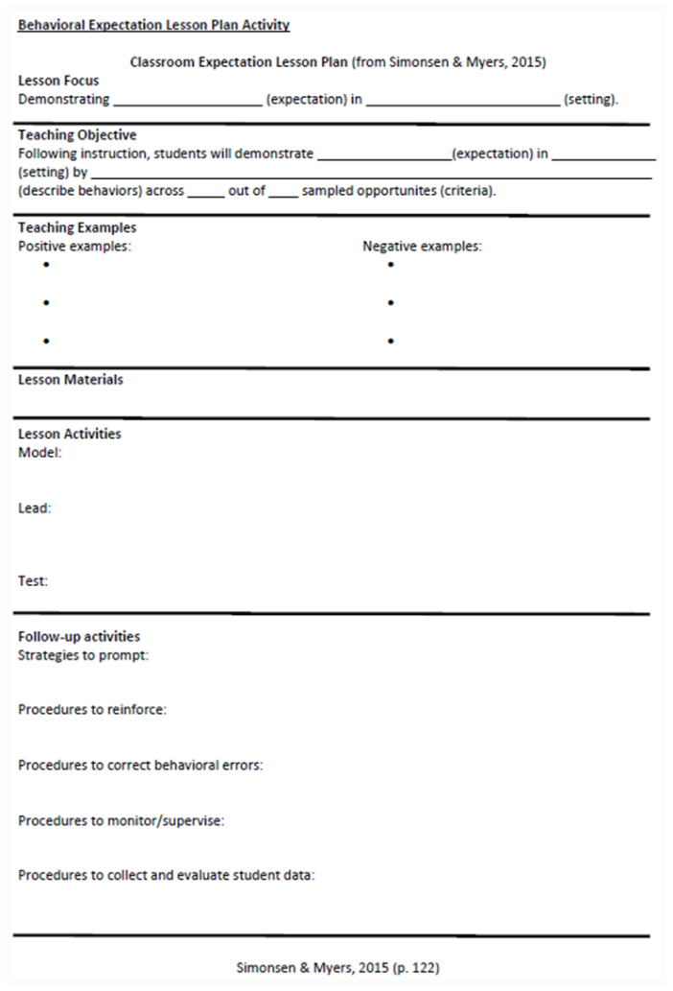

**Teaching Considerations: Lesson Modalities**

Lesson content is guided by the age of the students and their prior learning histories. Teaching of younger children is typically more direct and “hands on.” Teaching of older students typically involves embedding schoolwide expectations and behaviors into the academic curriculum as well as designated settings.

Teachers employ a variety of teaching strategies and modalities to help students become fluent with the skill. Examples of practice activities might include role playing, playing games that include use of the skill and watching videos of examples and non-examples.

**Video Examples:**

**Teaching Considerations: Lesson Content**

***Embedding into Academic Content: Social Studies***

* Have student’s research different cultures to find out how they define “respectful.”
* Talk about how different historical events occurred because of conflict & come up with solutions on how the conflict could have been resolved.

***Embedding into Academic Content: Language Arts***

* Use a novel that has an expectation (like respect) as a theme to illustrate the characteristic.
* Discuss characters in a novel and how they did not show respect. Then have the students write the story with the character showing respect.
* Have the students develop their own expectations and/or rules. Then have them write a persuasive essay or debate on why theirs should be used instead of the schools.

***Embedding into Academic Content: Fine Arts (music, art, computer graphics)***

* Choose a school play with a theme centered on one of the school expectations.
* Have the students compose a song/rap with the expectation.
* Have students come up with a campaign for promoting expectations to the entire student body.

**Team Discussion**

**Directions:**

|  |
| --- |
| Discuss who on your team or in your school can help with embedding academic curriculum. |
|  |

**Activity 7-A: Lesson Plans**

**Directions**: Looking back at the behavior matrix you have already begun developing, take one or two of your team’s expectations and begin placing the rules of the expectation(s) into the lesson plan format. You may use the example format we just discussed, unless you are able to access your own school or district template for writing lesson plans.

**Important Scheduling Consideration**

It is important to make sure the lesson plan schedule: 1) is acceptable to stakeholders, 2) is capable of being sustained throughout the year, 3) is adaptable to the instructional day, and 4) has adequate staff to teach in the identified locations.

**Activity 7-B: Scheduling Lessons**

**Directions:**

Discuss as a team when elements should be taught, initially and as boosters, during the school year. Decide what is essential for the beginning of the year versus what can be deferred to other times of the year. Remember that you and your staff will not have time to teach everything all at once.

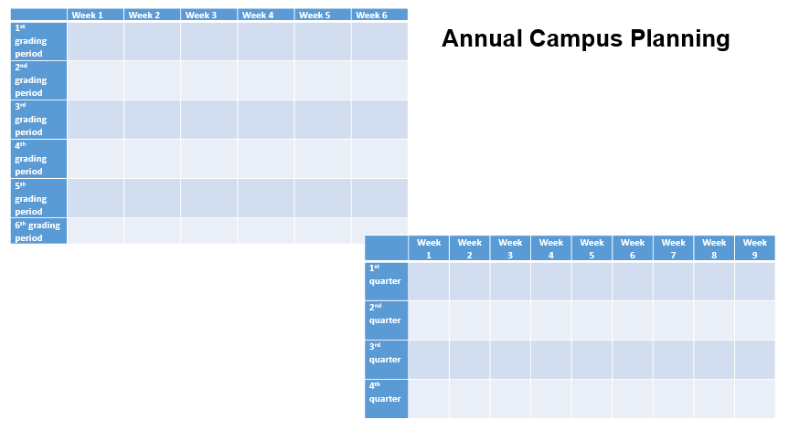

7-Lesson Plans

Resource Documents

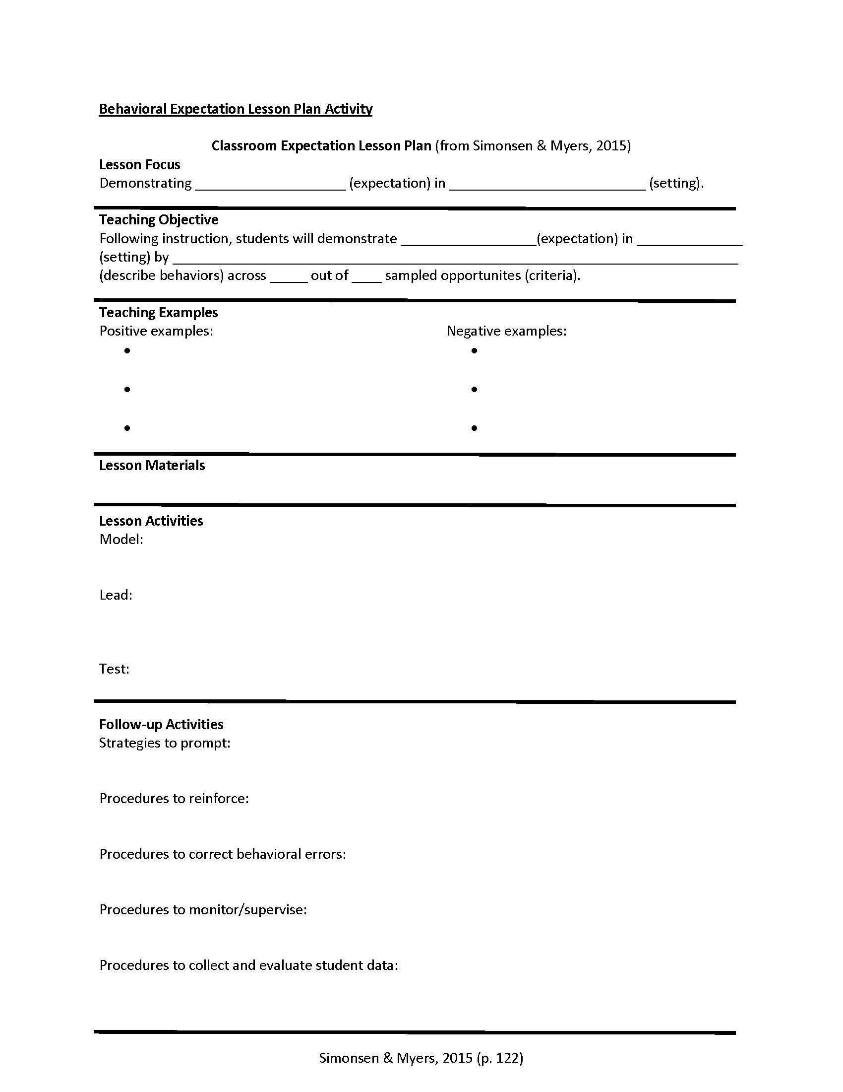

Annual Campus Planning

|  |  |  |  |  |  |  |
| --- | --- | --- | --- | --- | --- | --- |
|  | Week 1 | Week 2 | Week 3 | Week 4 | Week 5 | Week 6 |
| 1st grading period |  |  |  |  |  |  |
| 2nd grading period |  |  |  |  |  |  |
| 3rd grading period |  |  |  |  |  |  |
| 4th grading period |  |  |  |  |  |  |
| 5th grading period |  |  |  |  |  |  |
| 6th grading period |  |  |  |  |  |  |

Annual Campus Planning

|  |  |  |  |  |  |  |  |  |  |
| --- | --- | --- | --- | --- | --- | --- | --- | --- | --- |
|  | Week 1 | Week 2 | Week 3 | Week 4 | Week 5 | Week 6 | Week 7 | Week 8 | Week 9 |
| 1st Quarter |  |  |  |  |  |  |  |  |  |
| 2nd Quarter |  |  |  |  |  |  |  |  |  |
| 3rd Quarter |  |  |  |  |  |  |  |  |  |
| 4th Quarter |  |  |  |  |  |  |  |  |  |