Tier 1 Team Training Content Guide:
5 - Expectations & Rules
“Although expectations and rules used by effective educators may vary from teacher to teacher and school to school, we do not find effectively managed schools and classrooms operating without them." –(Evertson & Emmer,2008)

BoQ Critical Elements – Expectations & Rules
17 | 3-5 positively stated school-wide expectations posted around school
17 | Areas posted include the classroom and a minimum of 3 other school settings (e.g., cafeteria, hallway, front office)
18 | Expectations apply to both students and staff
18 | PBIS team has communicated that expectations apply to all students and all staff
19 | Rules developed and posted for specific settings (settings where data suggested rules are needed)
19 | Behavioral examples/rules are posted in all of the most problematic areas in the school
20 | Behavioral examples/rules are linked to expectations
20 | When taught or enforced, staff consistently links the rules with the school-wide expectations
21 | Staff feedback/involvement in expectations/rule development
21 | Most staff members were involved in providing feedback/input into the development of the school-wide expectations and rules (e.g., survey, feedback, initial brainstorming session, election process, etc.)

Identifying School-Wide Expectations
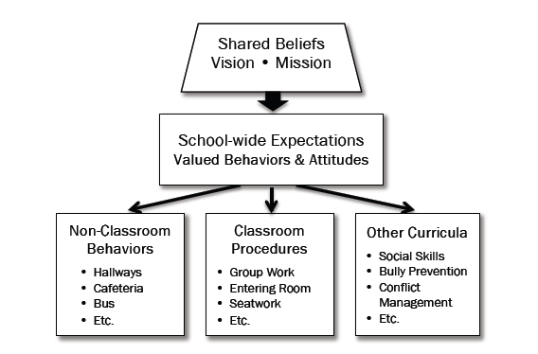

Without Clear Expectations
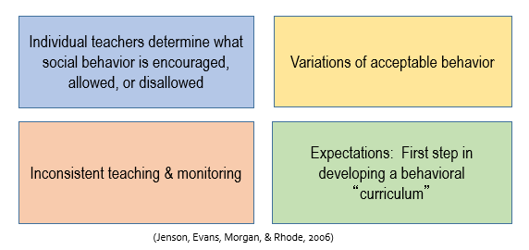

Guidelines for Developing Expectations
- 3 – 5 expectations
- stated positively and succinctly
- focus on all staff, students, and settings
- supports academic and behavioral outcomes
- contextually and culturally appropriate

Team Discussion

Why is it important to have all faculty/staff involved in identifying school expectations?

Sources to Assist with Developing School-Wide Expectations
- Considering Existing Data Summaries
- behavior outcome data
- academic outcome data
- school climate survey results
- teacher feedback/survey/polling
- Identify Common Goals
- school mission statement
- purpose statement
- other school based programs

Activity 5-A: Developing Expectations

What words come to mind when you consider the values you want to see demonstrated by student AND staff behavior in your school?

Think about all the desired behaviors that you want to see. Can these behaviors be grouped into 3-5 categories?

Do you have confidence that a high percentage of staff/families would agree with the values and behavior groups listed?

Do you already have character education definitions in your building that you can adjust to fit the criteria for school-wide expectations?

Rules for Specific Settings
- Include specific skills for students & staff to exhibit in specific settings
- Provide answers regarding “what does the skill “look like” in this specific setting?
- Provide the foundation for teaching skills to fluency

Steps in Defining Rules within a Matrix
The general purpose of defining behavior rules within a matrix is to apply the school-wide expectations into specific and observable behaviors for each of the common or specific school setting. There are three general steps for this process:

- Identifying the major common school settings/activities
- Develop a matrix applying the school-wide expectations to the distinct needs of each setting/activity
- Isolate the specific behaviors for each setting/activity & create posters for each setting/activity
The easiest step is to identify the major common school settings. This is a task that can easily be done by the school leadership team and generally does not require full staff involvement.

Guidelines for Developing Rules
- 1 to 3 rules
- few words (keep it simple)
- observable and measurable
- stated positively
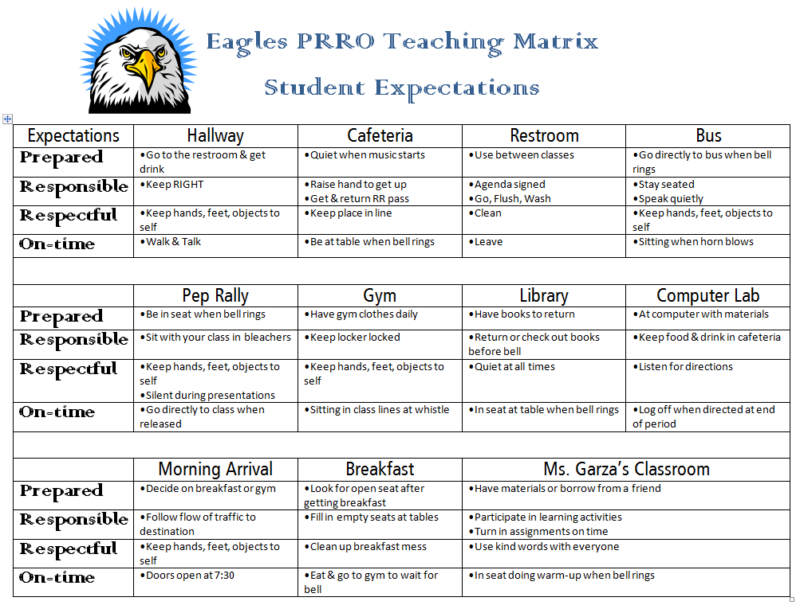
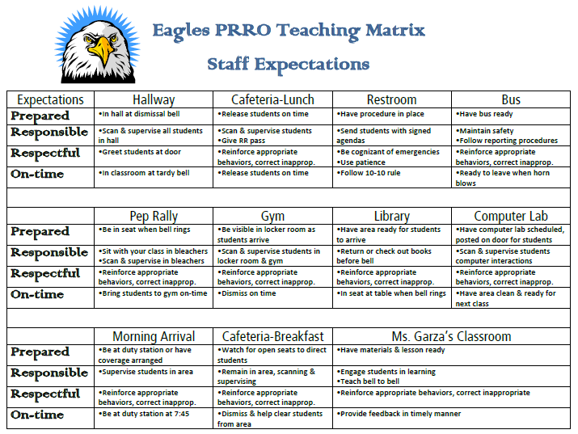

Here is an example based on the PRRO expectations you saw earlier. This behavior matrix includes not only specific areas, but also some common activities the campus had problems with, such as pep rally behavior and morning arrival. In this example, the teacher individualized her classroom rules based on the school-wide expectations of the campus. You can see from this matrix that it is specifically addressing student expectations.
This behavior matrix looks very much like the one we just saw; however, it specifically is addressing staff expectations for the same areas and activities as the students. We said earlier that the school-wide expectations should apply to everyone, adults and students alike, on the campus. This teaching matrix helps staff understand their role as well. This tool also makes it easier for the PBIS team and administrators to determine where problems may exist on the campus. For instance, if the team or administrators review the data and determine that there are problems in the hallway, the team or administrators can take this and easily walk through the hallways during passing to determine if staff are meeting their expectations as well as using the student matrix to determine if students are meeting expectations. This can give you a clear picture of who may need targeted assistance or a booster session in the expectations and specifically any particular rule.
Here are the general guidelines of what goes into the school-wide behavior matrix. First, the school will determine what each expectation looks like in each specific setting. Then, the school will describe the behaviors in a concise and positive manner. We do not want a behavior matrix that goes on for pages – this is not a replacement for the student code of conduct. The choice of wording should be brief and positive. Things like “Walk on the right-hand side of the hallway” would meet these guidelines but “No running,” would not because although it is brief, it is not positively stated. The focus is meant to stay on what behaviors we want to see.
Activity 5-B: Developing Rules

Directions:
- Input the expectations that your team developed in Activity 5-A into the provided Matrix template on the left hand column.
- List several settings or common activities for your campus on the top row of the matrix
- Identify 1 to 3 rules for the setting/activity indicated. Review the rules developed to ensure they meet the guidelines. First complete for students, then if time allows, complete regarding staff behavior as well.
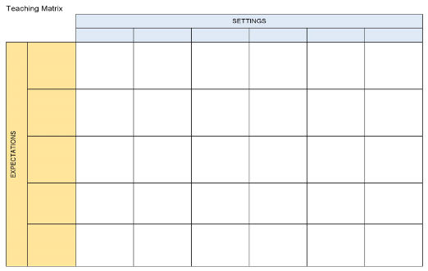

5 – Expectations & Rules
Resource Documents

