**Tier 1 PBIS Team Training Content Guide**

**1 – PBIS Team**

**Implementation Levels**

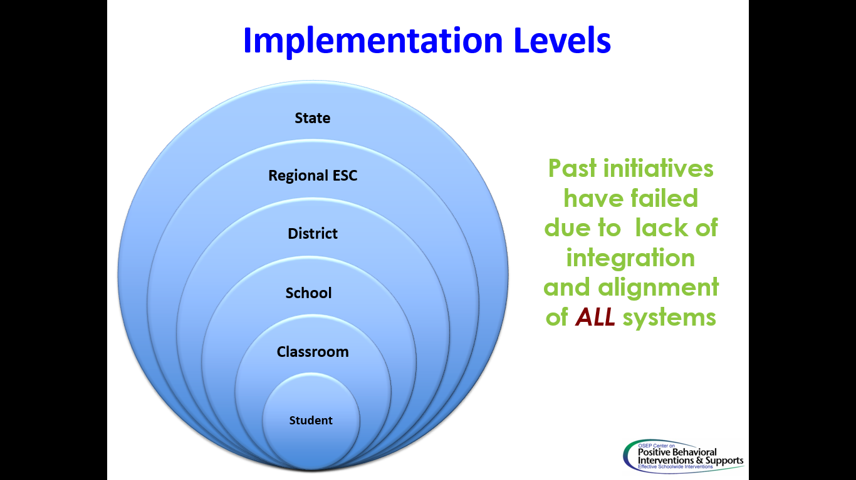Each level reduces the barriers and increases access for the next sub-level. For example, the District Leadership Team reduces barriers for the school/campus PBIS team. You as a school/campus team will focus on reducing the barriers and increasing access for teachers and students.

**Team Discussion**

**Team Profile**

|  |
| --- |
| 1. What is the common language about our school? What do they say about us? |
|  |
| 1. What do you think people experience as part of our school? |
|  |
| 1. What are our common values? |
|  |

**Benchmarks of Quality: PBIS Team**

|  |  |
| --- | --- |
| 1 | Team has administrative support |
| *Administrator(s) attended training, play an active role in the PBIS process, actively communicate their commitment, support the decisions of the PBIS Team, and attend* ***all*** *team meetings.* |
| 2 | **Team has regular meetings (at least monthly)** |
| *Team meets monthly (min. of 9 one-hour meetings each school year).* |
| 3 | **Team has established a clear mission/purpose** |
| *Team has a written purpose/mission statement for the PBS team (commonly completed on the cover sheet of the action plan).* |

*“Teaming for school-wide PBS is the process of ‘‘working as a cohesive, integrated, and representative collection of individuals who lead the systems change and implementation process’’* (OSEP,2004, p. 26).

**PBIS Team: Features & Functions**

|  |
| --- |
| Features |
| 5 – 7 members, broadly representing the campus |
| Assess implementation fidelity |
| Meet at least monthly |

|  |
| --- |
| Functions |
| Take a school-wide perspective |
| Determine baseline of implementation at universal level |
| Plan, coordinate, communicate implementation efforts |

**PBIS Team Representation**

|  |  |
| --- | --- |
| 5 to 7 team members | Administrator as an active member |
| Grade-level representation | Special Education representation |
| Coach/district liaison | 1 to 2 members with behavior expertise |

**Administrator’s Role in Sustainability of PBIS**

Building administrator involvement is the “most important single perceived factor in sustainability of PBIS” according to research by McIntosh, K., Predy, L., Upreti, G., Hurne, A.E. & Matthews, S. (2014)

**PBIS Team Role Descriptions**

|  |  |
| --- | --- |
| **Facilitator** | The facilitator ensures that the group moves smoothly through the task at hand. This person seeks information and opinions, asks for facts and feelings from each team member, and summarizes main points of discussion. This role is very important because the facilitator leads the group through the task. |
| **Data Analyst** | This person should have ready access to available school data, including, but not limited to discipline information, etc. This role is important because data drives problem solving and decision-making. |
| **Recorder/ Minute-Taker** | The recorder writes down the work of the group. This can involve writing words or sentences, drawing pictures, or simply taking notes of an activity. This role is very important because it is necessary to keep a record of the work done |
| **Timekeeper** | This person should have ready access to available school data, including, but not limited to discipline information, etc. This role is important because data drives problem solving and decision-making. |
| **Reporter** | This person is responsible for reporting back the work of their small group to the presenter or to the larger group. This role is very important because this communication to the large group will be crucial in the learning process |

**Activity 1-A: PBIS Team Profile**

**Team Profile**

|  |
| --- |
| Who comprises our PBIS Team? |
|  |
| Are we representative of our students and community? |
|  |
| Do we have the full representation of our staff? |
|  |
| Do we have the talent & skill sets that we need? |
|  |

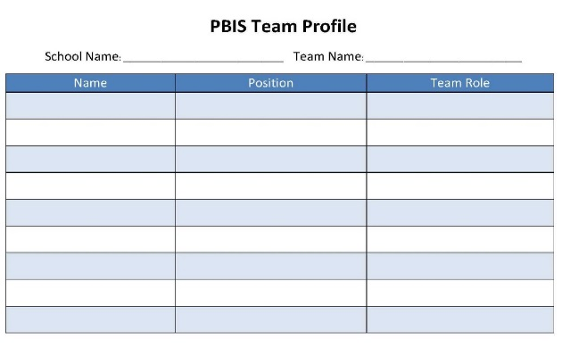

**Establishing a PBIS Team: What is our Team Mission/Purpose?**

A mission/purpose should communicate “why” you exist. It is the optimistic outlook of what you plan to accomplish. While it can be general, you want to be able to revisit it to determine if you are on track, and sometimes that is hard if it is too global.

**Activity 1-B: Developing a PBIS Team Purpose Statement**

**Directions:**

* Use any current mission/vision statement the school already has employed as a guidepost.
* The PBIS Team Purpose Statement should support the overall organizational purpose or mission.
  + The recorder should record a general sense of what the group believes its purpose to be on the “Purpose Statement” section of the PBIS Team Profile in the resources of this section.

**Establishing a PBIS Team: Effective Team Meetings**

**Activity 1-C: Effective Meetings**

**Directions:** Watch the following non-example and example videos of team meetings. Use the T-Chart below to notate the specific things that contribute to an ineffective and effective team meeting.

|  |  |
| --- | --- |
| **Video 1** | **Video 2** |
|  |  |

**Team Discussion**

|  |
| --- |
| What challenges to effective meetings have you experienced in our school? |
|  |
| How can we avoid meeting roadblocks? |
|  |

**3 Key Features of Effective Team Meetings:**

* Team has regularly scheduled team meetings
* Team has developed working agreements
* Team has a meeting process in place

**Effective Teaming: Regularly Scheduled Meetings:**

* Meet at least monthly for 1 hour
* Meet more frequently when planning for implementation
* Extended meetings at year’s end for analysis and planning

**Activity 1-D: PBIS Team Meeting Schedule**

**Directions:**

**Team Meeting Schedule**

Come to a consensus on date/time/length of PBIS team meetings for the upcoming school year. Document in Activity 1-D of the Team Profile in the resources document of this section.

**Effective Teaming: PBIS Team working agreements**

Working agreements or ground rules assist staff to achieve their meeting goals and to increase the productivity and effectiveness of their time. (Garmston & Wellman, 2009)

* Write agreements as a team
* Post agreements
* Review agreements before meeting
* Cue those not using agreements
* Evaluate meeting: what did/did not work & needs to be improved?

**Activity 1-E: PBIS Team Working Agreements**

**Directions:**

Identify working agreements to ensure efficient and effective team meetings. Document in Activity 1-E of the Team Profile in the Resources of this section.

**Effective Team Meetings: PBIS Team Meeting Process**

Meeting minutes serve as documentation and guidance for decisions made during team meetings, including sections to guide and prompt the recording of relevant, accurate and succinct information.

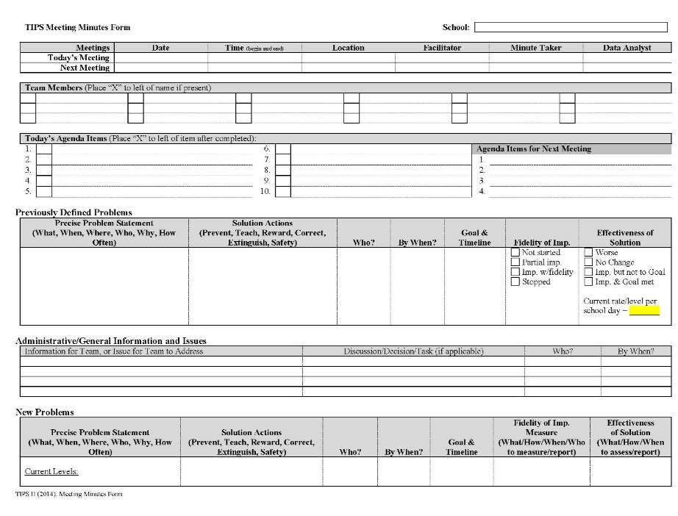

1-PBIS Team

Resource Documents

**Activity 1-A: PBIS Team Profile**

School Name: ______________________________________

|  |  |  |
| --- | --- | --- |
| Name | Position | Team Role |
|  |  |  |
|  |  |  |
|  |  |  |
|  |  |  |
|  |  |  |
|  |  |  |
|  |  |  |
|  |  |  |
|  |  |  |

**Activity 1-B: PBIS Team Purpose Statement**

Purpose Statement:

**Activity 1-D: PBIS Team Meeting Schedule**

|  |  |  |
| --- | --- | --- |
| Meeting Date | Meeting Time | Meeting Location |
|  |  |  |
|  |  |  |
|  |  |  |
|  |  |  |
|  |  |  |
|  |  |  |
|  |  |  |
|  |  |  |
|  |  |  |

*\*\*Reminder to plan longer meetings for initial and year-end planning meetings*

**Activity 1-E: PBIS Team Working Agreements**

|  |  |  |
| --- | --- | --- |
|  |  |  |
|  |  |  |
|  |  |  |
|  |  |  |
|  |  |  |

