**College Preparatory Integrated Mathematics Course I**

**Notebook**

**College Preparatory Integrated Mathematics Course I**

**Learning Objective 1.1**

**Section 1.4**

|  |  |
| --- | --- |
| **Learning Objective 1.1: Add, subtract, multiply and divide, using order of operations, real numbers and manipulate certain expressions including exponential operations.**  **Read Section 1.4 on page 25 in the textbook an answer the questions below.** | |
| **Definitions**   1. In the expression $5^{2}$, the 5 is called the ______________ and the 2 is called the ________________. 2. The symbols ( ), [ ], and { } are examples of _________________ symbols. 3. ____________________notation may be used to write as . 4. **Order of Operations**: Simplify expressions using the order below.   1. If grouping symbols such as ______________ are present, simplify expressions within those first,  starting with the innermost set.  2. Evaluate ___________________expressions.  3. Perform ___________________or _____________________in order from left to right.  4. Perform__________________ or______________________in order from left to right. | |

**Example 1: Simplify each expression.**

**a) $6+3∙9$ b) $4^{3}÷8+3$**

**Example 2: Simplify each expression.**

**a) ${\left(\frac{2}{3}\right)}^{2}∙\left|-8\right|$ b) $\frac{9(14-6)}{\left|-2\right|}$**

**Example 3: Simplify each expression.**

**a) $\frac{36÷9+5}{5^{2}-3}$ b) $4[25-3\left(5+3\right)]$**

**Example 4: Simplify each expression.**

$\frac{6^{2}-5}{3+\left|6-5\right|∙8}$

|  |  |
| --- | --- |
| **Learning Objective 1.1: Evaluating Algebraic Expressions**  **Read page 28 in the textbook an answer the questions below.** | |
| **Definitions**   1. A symbol that is used to represent a number is called a __________________. 2. An ___________________expression is a collection of numbers, variables, operation symbols, and grouping symbols. 3. If we give a specific value to a variable, we can ______________an algebraic expression. 4. An ______________is a mathematical statement that two expressions have equal value. The equal symbol “=” is used to equate the two expressions. 5. A ________________of an equation is a value for the variable that makes the equation true. | |

**Example 5: Evaluate each expression if $x=2$ and $y=5$.**

**a) $2x+y$ b) $\frac{4x}{3y}$ c) $\frac{3}{x}+\frac{x}{y}$ d) $x^{3}+y^{2}$**

|  |  |
| --- | --- |
| **Learning Objective 1.1: Determining Whether a Number is a Solution of an Equation**  **Read page 29 in the textbook an answer the questions below.** | |
| **Definitions**   1. An ______________is a mathematical statement that two expressions have equal value. The equal symbol “=” is used to equate the two expressions. 2. A ________________of an equation is a value for the variable that makes the equation true. | |

**Example 6: Decide whether 4 is a solution of $9x-6=7x$**

|  |  |
| --- | --- |
| **Learning Objective 1.1: Translating Phrases to Expressions and Sentences to Statements**  **Read page 30 in the textbook to fill the table below.** | |
| **Keywords**   |  |  |  |  | | --- | --- | --- | --- | | **Addition (+)** | **Subtraction (- )** | **Multiplication ($∙$)** | **Division ()** | | **Sum** | **Difference of** | **Product** | **Quotient** | |  |  |  |  | |  |  |  |  | |  |  |  |  | |  |  |  |  | |  |  |  |  | | |

**Example 7: Write an algebraic expression that represents each phrase. Let the variable x represent the unknown number.**

**a. Six times a number**

**b. The product of a number and 9**

**c. The sum of 7 and a number**

**d. A number decreased by 8**

**e. Two times a number, plus 3**

**Example 8: Write each sentence as an equation or inequality. Let x represent the unknown number.**

**a) A number is increased by 7 is equal to 13.**

**b) Two less than a number is 11.**

**c) Double a number, added to 9, is not equal to 25.**

**d) Five times 11 is greater than or equal to an unknown number.**

**Homework: Page 33 #19-65; 79-94**

**College Preparatory Integrated Mathematics Course I**

**Learning Objective 1.1**

**Section 1.5**

|  |  |
| --- | --- |
| **Learning Objective 1.1: Adding Real Numbers (Section 1.5 Objective 1)**  **Read Section 1.5 on page 35 in the textbook an answer the questions below.** | |
| **Definitions**   1. **Adding Two Numbers with the Same Sign**   Add their __________absolute values. Use their common signs as the sign of the sum.   1. **Adding Two Numbers with Different Signs** 2. Subtract the _____________absolute value from the ____________absolute value. Use the sign of the number whose absolute value is larger as the sign of the sum. | |

**Example 1: Add.**

**a) $-5+(-8)$ b) $15+(-18)$ c) $-19+20$ d) $-0.6+0.4$**

**Example 2: Add.**

**a) $-\frac{3}{5}+\left(-\frac{2}{5}\right)$ b) $8+\left(-5\right)+(-9)$ c) $\left[-8+5\right]+[-5+\left|-2\right|]$**

|  |
| --- |
| **Learning Objective 1.1: Solving Applications by Adding Real Numbers (Section 1.5 Objective 2)**  **Read page 39 in the textbook.** |

**Example 3: If the temperature was $-7^{°}$ Fahrenheit at 6 a.m., and it rose 4 degrees by 7 a.m and then rose another 7 degrees in the hour from 7 a.m. to 8 a.m., what was the temperature at 8 a.m.?**

|  |  |
| --- | --- |
| **Learning Objective 1.1: Finding the Opposite of a Number (Section 1.5 Objective 3)**  **Read page 39 in the textbook an answer the questions below.** | |
| **Definitions**   1. Two numbers that are the same distance from 0 but lie on opposite sides of ) are called _________________ or additive inverses of each other. 2. If a is a number, then 3. The _________of a number a and its opposite –a is 0. $a+\left(-a\right)=0$ | |

**Example 4: Find the opposite or additive inverse of each number.**

**a) $-\frac{5}{9}$ b) 8 c) 6.2 d) $-3$**

**Example 5: Simplify each expression.**

**a) $-|-15|$ b) $-\left(-\frac{3}{5}\right)$ c) $-(-5y)$**

**Homework: Page 41 #1-59**

**Homework: Page 41 #1-59**

**College Preparatory Integrated Mathematics Course I**

**Learning Objective 1.1**

**Section 1.6**

|  |  |
| --- | --- |
| **Learning Objective 1.1: Subtracting Real Numbers (Section 1.6 Objective 1 and 2)**  **Read Section 1.6 on page 43 in the textbook an answer the questions below.** | |
| **Definitions**   1. **If a and b are real numbers, then $a-b=________________.$** | |

**Example 1: Subtract.**

**a) $-7-6$ b) $-8-(-1)$ c) $9-(-3)$ d) $5-7$**

**Example 2: Subtract.**

**a) $-\frac{5}{8}-\left(-\frac{1}{8}\right)$ b) $-\frac{3}{4}-\frac{1}{5}$ c) $-15-2-\left(-4\right)+7$**

**Example 3: Subtract 5 from $-2$.**

**Example 4: Simplify each expression.**

a) $-4+[\left(-8-3\right)-5]$ b) $\left|-13\right|-3^{2}+[2-\left(-7\right)]$

|  |
| --- |
| **Learning Objective 1.1: Evaluating Algebraic Expressions (Section 1.5 Objective 3)**  **Read page 45 in the textbook.** |

**Example 5: Find the value of each expression when $x=-3 and y=4.$**

**a) $\frac{7-x}{2y+x}$ b) $y^{2}+x$**

|  |
| --- |
| **Learning Objective 1.1: Solving Applications by Subtracting Real Numbers (Section 1.5 Objective 4)**  **Read page 46 in the textbook.** |

**Example 6: On Tuesday morning, a bank account balance was $282. On Thursday, the account balance had dropped to $-\$75.$ Find the overall change in this account balance.**

**Homework: Page 48 #1-69**

**College Preparatory Integrated Mathematics Course I**

**Learning Objective 1.1**

**Section 1.7**

|  |  |
| --- | --- |
| **Learning Objective 1.1: Multiplying Real Numbers (Section 1.7 Objective 1)**  **Read Section 1.7 on page 51 in the textbook an answer the questions below.** | |
| **Definitions**   1. **The product of two numbers with the ___________sign is a positive number.** 2. **The product of two numbers with ________________signs is a negative number.** 3. **If b is a real number, then $b∙0=________.$ Also, $0∙b=0$.** | |

**Example 1: Subtract.**

**a) $8(-5)$ b) $(-3)(-4)$ c) $(-6)(9)$**

**Example 2: Subtract.**

**a) $\left(-\frac{3}{5}\right)∙\left(-\frac{4}{9}\right)$ b) $\left(-\frac{7}{12}\right)\left(-24\right)$ c) $\left(-2\right)\left(-3\right)-(-4)(5)$**

**Example 3: Evaluate.**

a) ${\left(-6\right)}^{2}$ b) $-6^{2}$ c) ${\left(-4\right)}^{3}$ d) $-4^{3}$

|  |
| --- |
| **Learning Objective 1.1: Finding Reciprocals (Section 1.7 Objective 2 &3)**  **Read page 54 in the textbook and answer the questions below.** |
| **Definitions**   1. Two numbers whose product is 1 are called ________________________or multiplicative inverses of each other. 2. If a and b are real numbers and b is not 0, then 3. The product or quotient of two numbers with the same sign is a ______________________number. 4. The product or quotient of two numbers with different signs is a _____________________ number. 5. The ____________ of any nonzero real number and 0 is undefined. In symbols, if $a≠0,\frac{a}{0}$ is undefined. 6. The quotient of _________and any real number except 0 is 0. |

**Example 4: Divide $.$**

**a) $\frac{-18}{-6}$ b) $-\frac{48}{3}$ c) $\frac{3}{5}÷\left(-\frac{1}{2}\right)$ $-\frac{4}{9}÷8$**

**Example 5: Simplify each expression $.$**

**a) $\frac{3{\left(-2\right)}^{2}-9}{-6+3}$ b) $\frac{\left(-8\right)\left(-11\right)-4}{-9-(-4)}$**

**Example 6: A card player had a score of -13 for each of the four games. Find the total score.**

**Homework: Page 59 #1-112**

**College Preparatory Integrated Mathematics Course I**

**Learning Objective 1.1**

**Section 1.8**

|  |  |
| --- | --- |
| **Learning Objective 1.1: Using Commutative, Associative, and Distributive Properties (Section 1.8 Objective 1, 2, and 3)**  **Read Section 1.8 on page 61 in the textbook an answer the questions below.** | |
| **Definitions**  **Commutative Properties**   1. Addition: **a+b=_____________________ .** 2. Multiplication $a∙b=______________$**.**   **Associative Properties**  **3. Addition: $\left(a+b\right)+c=a+(b+c)$.**  **4. Multiplicative: $\left(a∙b\right)∙c=a∙\left(b∙c\right).$**  **Distributive Property**  **1. $a\left(b+c\right)=ab+ac.$** | |

**Example 1: Simplify each expression.**

**a) $\left(5+x\right)+9$ b) $5(-6x)$ c) $5(x-y)$**

**Example 2: Simplify each expression.**

**a) $2(3x-4y-z)$ b) $\frac{1}{2}\left(2x+4\right)+9$ c) $(3-y)∙(-1)$**

**Homework: Page 67 #1-70**

**College Preparatory Integrated Mathematics Course I**

**Learning Objective 1.2**

**Section 5.1**

|  |  |
| --- | --- |
| **Learning Objective 1.2: Evaluating Exponential Expressions (Section 5.1 Objective 1).**  **Read Section 5.1 on page 306 in the textbook an answer the questions below.** | |
| **Definitions**   1. The expression $2^{5}$ is called an _______________expression. 2. It is also called the fifth ___________of 2, or we say that 2 is __________to the fifth power. 3. The __________of an exponential expression is the repeated factor. 4. The ____________is the number of times that the base is used as a factor. 5. Label the base and exponent for the expression below. $5^{6}$ | |

**Example 1: Evaluate each expression.**

**a) $3^{3}$ b) $4^{1}$ c) ${\left(-8\right)}^{2}$ d) $-8^{2}$**

**Example 2: Evaluate each expression.**

**a) ${\left(\frac{3}{4}\right)}^{3}$ b) ${\left(0.3\right)}^{2}$ c) $3∙5^{2}$**

**Example 3: Evaluate each expression for the given value of x.**

**a) $3x^{4};x is 3$ b) $\frac{6}{x^{2}};x is-4$**

|  |  |
| --- | --- |
| **Learning Objective 1.2: Using the Product Rule (Section 5.1 Objective 2).**  **Read Section 5.1 page 308 in the textbook an answer the questions below.** | |
| **Definitions**  **Product Rule for Exponents**  If *m* and *n* are positive integers and *a* is a real number, then  Add exponents. $a^{m}∙a^{n}=a^{}$ Keep common base. | |

**Example 4: Use the product rule to simplify.**

**a) $3^{4}∙3^{6}$ b) $x^{3}∙x^{2}∙x^{6}$ c) ${\left(-2\right)}^{5}∙{\left(-2\right)}^{3}$ d) $b^{3}∙t^{5}$**

**Example 5: Use the product rule to simplify.**

1. $(-5y^{3})(-3y^{4})$**b) $(y^{7}z^{3})(y^{5}z)$ c) $(-m^{4}n^{4})(7mn^{10})$**

|  |  |
| --- | --- |
| **Learning Objective 1.2: Using the Power Rule (Section 5.1 Objective 3).**  **Read Section 5.1 page 310 in the textbook an answer the questions below.** | |
| **Definitions**  **Power Rule for Exponents**  If *m* and *n* are positive integers and *a* is a real number, then  Multiply exponents. ${\left(a^{m}\right)}^{n}=a^{}$ Keep common base. | |

**Example 6: Use the power rule to simplify.**

1. ${\left(z^{3}\right)}^{7}$**b) ${\left(4^{9}\right)}^{2}$ c) $({\left[{\left(-2\right)}^{3}\right]}^{5}$**

|  |  |
| --- | --- |
| **Learning Objective 1.2: Power of a Product Rule and Quotient Rule (Section 5.1 Objective 4).**  **Read Section 5.1 page 310 in the textbook an answer the questions below.** | |
| **Definitions**   1. **Power of a Product Rule**   If *n* is a positive integer and *a* and *b* are real numbers, then   1. **Power of a Quotient Rule**   If *n* is a positive integer and *a* and *c* are real numbers, then ${\left(\frac{a}{c}\right)}^{n}=___________________$ , $c≠0$ | |

**Example 7: Use the power rule to simplify.**

1. ${\left(pr\right)}^{5}$**b) ${\left(6b\right)}^{2}$ c) ${\left(\frac{1}{3}mn^{3}\right)}^{2}$ d) ${\left(-3a^{3}b^{4}c\right)}^{4}$**

**Example 8: Simplify each expression.**

1. ${\left(\frac{x}{y^{2}}\right)}^{5}$**b) ${\left(\frac{2a^{4}}{b^{3}}\right)}^{5}$**

|  |  |
| --- | --- |
| **Learning Objective 1.2: Using the Quotient Rule and Define the Zero Exponent (Section 5.1 Objective 5).**  **Read Section 5.1 page 310 in the textbook an answer the questions below.** | |
| **Definitions**   1. **Quotient Rule for Exponents**   If *m* and *n* are positive integers and *a* is a real number, then $$\frac{a^{m}}{a^{n}}=_________________$$ as long as *a* is not 0.     1. **Zero Exponent $_______=1,$**   as long as *a* is not 0. | |

**Example 9: Use the power rule to simplify.**

1. ${\left(pr\right)}^{5}$**b) ${\left(6b\right)}^{2}$ c) ${\left(\frac{1}{3}mn^{3}\right)}^{2}$ d) ${\left(-3a^{3}b^{4}c\right)}^{4}$**

**College Preparatory Integrated Mathematics Course I**

**Homework: Page 316 #1-61;65-116.**

**Learning Objective 1.2**

**Section 5.5**

|  |  |
| --- | --- |
| **Learning Objective 1.2: Negative Exponents (Section 5.5 Objective 1)**  **Read Section 5.5 on page 344 in the textbook an answer the questions below.** | |
| **Definitions**  **Negative Exponents**  If *a* is a real number other than 0 and *n* is an integer, then $a^{-n}=__________________$ and $\frac{1}{a^{-n}}=$______________ | |

**Example 1: Simplify by writing each expression with positive exponents only.**

**a) $5^{-3}$ b) $3y^{-4}$ c) $3^{-1}+2^{-1}$ d) ${\left(-5\right)}^{-2}$**

**Example 2: Simplify by writing each expression with positive exponents only.**

**a) $\frac{x^{-3}}{x^{2}}$ b) $\frac{5}{y^{-7}}$ c) $\frac{z}{z^{-4}}$ d) ${\left(\frac{5}{9}\right)}^{-2}$**

|  |  |
| --- | --- |
| **Learning Objective 1.2: Simplifying Exponential Expressions (Section 5.5 Objective 2)**  **Read Section 5.5 on page 346 in the textbook an answer the questions below.** | |
| **Definitions**  **Summary of Exponent Rules**  If *m* and *n* are integers and *a, b,* and *c* are real numbers, then:  Product rule for exponents:___________________  Power rule for exponents:____________________  Power of a product:_________________________  Power of a quotient:________________________  Quotient rule for exponents:__________________  Zero exponent:_____________________________  Negative exponent:_________________________ | |

**Example 3: Simplify the following expressions. Write each results using positive exponents only.**

**a) ${\left(a^{4}b^{-3}\right)}^{-5}$ b) $\frac{x^{2}{\left(x^{5}\right)}^{3}}{x^{7}}$ c) ${\left(\frac{5p^{8}}{q}\right)}^{-2}$ d) ${\left(\frac{-3x^{4}y}{x^{2}y^{-2}}\right)}^{3}$**

|  |  |
| --- | --- |
| **Learning Objective 1.2: Writing Numbers in Scientific Notation and Solve problems using scientific notation (Section 5.5 Objective 3 &4)**  **Read Section 5.5 on page 347 in the textbook an answer the questions below.** | |
| **Definitions**  1. A positive number is written in scientific notation if it is written as the product of a number *a*, where $1≤a≤$ 10, and an integer power *r* of 10: __________________________.  2. To Write a Number in Scientific Notation  Step 1.  Step 2.  Step 3.    3. In general, to write a scientific notation number in standard form, move the decimal point to the same number of places as the exponent on 10. If the exponent is _______________, move the decimal point to the right; if the exponent is ______________, move the decimal point to the left. | |

**Example 1: Write each number in scientific notation.**

**a) 0.000007 b) $20,700,000$**

**Example 2: Write each number in scientific notation.**

**a) 0.0043 b) 812,000,000**

**Example 3: Write each number in standard notation, without exponents.**

**a) $3.67×10^{-4}$ b) $8.954×10^{6}$**

**Example 4: Write each number in standard notation, without exponents.**

**a) $2.009×10^{-5}$ b) $4.054×10^{3}$**

**Example 5: More than 2,000,000,000 pencils are manufactured in the United States annually. Write this number in scientific notation. (Source: AbsoluteTrivia.com)**

**Homework: Page 351 #69-90.**

**College Preparatory Integrated Mathematics Course I**

**Learning Objective 1.3**

**Section 8.2**

|  |  |
| --- | --- |
| **Learning Objective 1.3: Find square roots of perfect square numbers (Section 8.2 Objective 2)**  **Read Section 8.2 on page 522 in the textbook an answer the questions below.** | |
| **Definitions**  1. The opposite of squaring a number is taking the _____________________ of a number.  2. The notation $\sqrt{a}$ is used to denote the _______________, or principal, square root of a nonnegative number *a.* | |

**Example 1: Find the square roots.**

**a) $\sqrt{4}$ b) $\sqrt{16}$ c) $\sqrt{49}$ d) $\sqrt{121}$**

**Example 2: Find the square roots.**

**a) $\sqrt{100}$ b) $\sqrt{\frac{1}{16}}$ c) $-\sqrt{64}$ d) $\sqrt{-64}$**

**Example 3: Simplify each expression.**

**a) $44÷(\sqrt{144}+8-2)$ b) $\frac{\sqrt{169}}{52÷10-2}$**

**Homework: Page 525 #19-28.**

**College Preparatory Integrated Mathematics Course I**

**Learning Objective 1.3**

**Section 10.1(Optional)**

|  |  |
| --- | --- |
| **Learning Objective 1.3: Finding Square Roots (Section 10.1 Objective 1)**  **Read Section 10.1 on page 586 in the textbook an answer the questions below.** | |
| **Definitions**   1. If *a* is a nonnegative number, then $\sqrt{a}$  is the ______________, or nonnegative, square root of *a $-\sqrt{a}$*  is the ______________square root of *a* | |

**Example 1: Simplify.**

**a) $\sqrt{49}$ b) $\sqrt{\frac{16}{81}}$ c) $-\sqrt{36}$ d) $\sqrt{-36}$**

**Example 2: Simplify. Assume that all variable represent positive numbers.**

**a) $\sqrt{z^{8}}$ b) $\sqrt{16b^{4}}$**

|  |  |
| --- | --- |
| **Learning Objective 1.3: Approximating Roots (Section 10.1 Objective 2)**  **Read Section 10.1 on page 588 in the textbook an answer the questions below.** | |
| **Definitions**   1. Recall that numbers such as 1, 4, 9, and 25 are called ________________squares. 2. Numbers such as $\sqrt{3}$ are called ___________________numbers and we can find a decimal ______________of it. | |

**Example 3: Use a calculator to approximate $\sqrt{45}$. Round the approximation to three decimal places and check to see that your approximation is reasonable.**

**Homework: Page 593 #1-18.**

**College Preparatory Integrated Mathematics Course I**

**Learning Objective 1.4**

**Section 2.6**

|  |  |
| --- | --- |
| **Learning Objective 1.4: Solve Percent Equations (Section 2.6 Objective 1)**  **Read Section 2.6 on page 126 and write down the four General Strategies for Problem Solving.** | |
| **Definitions**  **General Strategy for Problem Solving**  1.  2.  3.  4. | |

**Example 1: The number 35 is what percent of 56?**

**Example 2: The number 198 is 55% of what number?**

**Example 3: Use the circle graph to answer each question.**

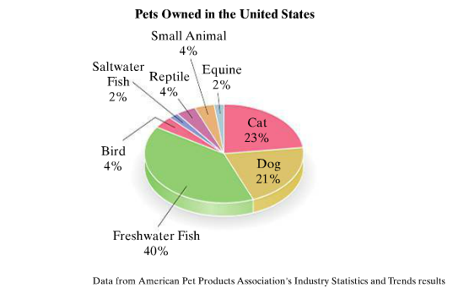

1. **What percent of pets owned in the United States are freshwater fish or saltwater fish?**
2. **What percent of pets owned in the United States are not equines (horses, ponies, etc.)?**
3. **Currently, 377.41 million pets are owned in the United States. How many of these would be dogs? (Round to the nearest tenth of a million.)**

|  |
| --- |
| **Learning Objective 1.4: Solving Discount and Mark-up Problems (Section 2.6 Objective 2)**  **Read Section 2.6 on page 129.**  **Learning Objective 1.4: Solving Percent Increase and Percent Decrease (Section 2.6 Objective 3)**  **Read Section 2.6 on page 130.** |

**Example 2: A used treadmill, originally purchased for $480, was sold at a garage sale at a discount of 85% of the original price. What were the discount and the new price?**

**Example 3: The tuition and fees cost of attending a public two-year college rose from $1900 in 1966 to $2710 in 2011. Find the percent increase. Round to the nearest tenth of a percent.**

|  |
| --- |
| **Learning Objective 1.4: Solving Mixture Problems (Section 2.6 Objective 4)**  **Read Section 2.6 on page 131.** |

**Example 4: Hamida Barash was responsible for refilling the eye wash stations in the lab. She needed 6 litters of 3% strength eyewash to refill the dispensers. The supply room only had 2% and 5% eyewash in stock. How much of each solution should she mix to produce the needed 3% strength eyewash?**

**Homework: Page 525 #1-16; 19-24.**

**College Preparatory Integrated Mathematics Course I**

**Learning Objective 2.1**

**Section 2.3**

|  |  |
| --- | --- |
| **Learning Objective 2.1: Apply a General Strategy for Solving Linear Equation (Section 2.3 Objective 1)**  **Read Section 2.3 on page 95 and write down the General Strategies for Problem Solving.** | |
| **Definitions**  **General Strategy for Solving Linear Equations**  1.  2.  3.  4.  5.    6. | |

**Example 1: Solve: $2\left(4a-9\right)+3=5a-6$**

**Example 2: Solve: $7\left(x-3\right)=-6x$**

**Learning Objective 2.1: Solve Equations Containing Fractions and Decimals (Section 2.3 Objective 2 &3)**

**Read Section 2.3 on page 97 & 98.**

**Example 4: Solve: $\frac{3}{5}x-2=\frac{2}{3}x-1$**

**Example 5: Solve: $\frac{4(y+3)}{3}=5y-7$**

|  |
| --- |
| **Learning Objective 2.1: Recognizing Identities and Equations with No Solution (Section 2.3 Objective 4)**  **Read Section 2.3 on page 99.** |

**Example 6: Solve: $4\left(x+4\right)-x$ = 2(x+11) + x**

**Homework: Page 525 #1-16; 19-24.**

**College Preparatory Integrated Mathematics Course I**

**Learning Objective 2.1**

**Section 2.8**

|  |  |
| --- | --- |
| **Learning Objective 2.1: Graphing Solution Sets to Linear Inequalities and Using Interval Notation (Section 2.8 Objective 1)**  **Read Section 2.8 on page 145 and answer the questions below.** | |
| **Definitions**   1. A ____________ inequality in one variable is an inequality that can be written in the form $ax+b<c$ where *a, b*, and *c* are real numbers and *a* is not 0. 2. A ____________of an inequality is a value of the variable that makes the inequality a true statement. | |

**Example 1: Graph $x<5$. Then write the solutions in interval notation.**

|  |  |
| --- | --- |
| **Learning Objective 2.1: Solving Linear Inequalities ( Section 2.8 Objective 2)**  **Read Section 2.8 on page 146 and answer the questions below.** | |
| **Definitions**   1. If *a, b*, and *c* are real numbers, then $a<b$ and $a+c<b+c$ are _______________ inequalities. 2. If *a, b*, and *c* are real numbers, and *c*  is ______________, then n and are equivalent inequalities. 3. If *a, b*, and *c* are real numbers, and *c*  is ______________, then n $a<b$ and $ac>bc$ are equivalent inequalities. | |

**Example 2: Solve: $x+11≥6$ for x. Graph the solution set and write it in interval notation.**

**Example 3: Solve: $-5x≥-15$. Graph the solution set and write it in interval notation.**

**Example 4: Solve: $3x>-9$. Graph the solution set and write it in interval notation.**

**Solving Linear Inequalities in One Variable**

Step 1.

Step 2.

Step 3.

Step 4.

Step 5.

**Example 5: Solve: $45-7x≤-4$. Graph the solution set and write it in interval notation.**

**Example 6: Solve: $3x+20≤2x+13$. Graph the solution set and write it in interval notation.**

**Example 7: Solve: $3\left(x-4\right)-5≤5\left(x-1\right)-12$. Graph the solution set and write it in interval notation.**

|  |  |
| --- | --- |
| **Learning Objective 2.1: Solving Compound Inequalities (Section 2.8 Objective 3)**  **Read Section 2.8 on page 150 and answer the questions below.** | |
| **Definitions**   1. Inequalities containing one inequality symbol are called ____________inequalities, while inequalities containing two inequality symbols are called ____________inequalities. | |

**Example 8: Graph $-3≤x<1$. Write the solution in interval notation.**

**Example 9: Solve $-4<3x+2≤8$. Graph the solution set and write it in interval notation.**

**Example 10: Solve $1≤\frac{3}{4}x+5<6$. Graph the solution set and write it in interval notation.**

**Homework: Page 154 #1-62.**

**College Preparatory Integrated Mathematics Course I**

**Learning Objective 2.1**

**Section 9.2**

|  |  |
| --- | --- |
| **Learning Objective 2.1: Solving Absolute Value Equations (Section 9.2 Objective 1)**  **Read Section 9.2 on page 559 and answer the questions below.** | |
| **Definitions**   1. If a is a positive number, then is equivalent to $X=a$ or $X=-a$. | |

**Example 1: Solve: $\left|q\right|=3$.**

**Example 2: Solve: $\left|2x-3\right|=5$.**

**Example 3: Solve: $\left|\frac{x}{5}+1\right|=15$.**

**Example 4: Solve: $\left|3x\right|+8=14$.**

**Example 5: Solve: $\left|\frac{5x+3}{4}\right|=-8$.**

**Example 6: Solve: $\left|2x+4\right|=\left|3x-1\right|$.**

**Example 7: Solve: $\left|x-2\right|=\left|8-x\right|$.**

**Homework: Page 563 #1-68.**

**College Preparatory Integrated Mathematics Course I**

**Learning Objective 2.1**

**Section 9.3**

|  |  |
| --- | --- |
| **Learning Objective 2.1: Solving Absolute Value Inequalities of the Form (Section 9.3 Objective 1)**  **Read Section 9.3 on page 565 and answer the questions below.** | |
| **Definitions**   1. If *a* is a _____________ number, then is equivalent to $-a<X<a$. | |

**Example 1: Solve: $\left|x\right|<5$ and graph the solution set.**

**Example 2: Solve for b: $\left|b+1\right|<3$ and graph the solution set.**

**Example 3: Solve for x: $\left|3x-2\right|+5≤9$ and graph the solution set.**

**Example 4: Solve for x: $\left|3x+\frac{5}{8}\right|<-4$.**

**Example 5: Solve for x: $\left|\frac{3(x-2)}{5}\right|≤0$.**

**Example 6: Solve for y: $\left|y+4\right|≥6$.**

**Example 7: Solve: $\left|\frac{x}{2}-3\right|-5>-2$.**

**Homework: Page 568 #1-82.**

**College Preparatory Integrated Mathematics Course I**

**Learning Objective 3.1 & 3.2**

**Section 3.1**

|  |  |
| --- | --- |
| **Learning Objective 3.1: Reading Bar and Line Graphs**  **Read Section 3.1 on page 168 and answer the questions below.** | |
| **Definitions**   1. A _________graph consists of a series of bars arranged vertically or horizontally. 2. A _________graph consists of a series of points connected by a line. It is sometimes called a _____________graph. | |

**Example 1: Use the graph below to answer the following.**

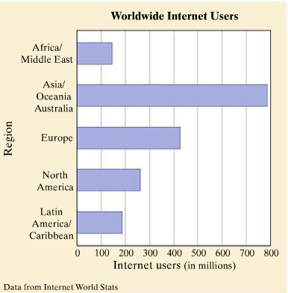

1. **Find the region with the fewest Internet users and approximate the number of users.**
2. **How many more users are in the Asia/Oceania/Australia region than in the Africa/Middle East region?**

**Example 2: Use the graph below to answer the following.**

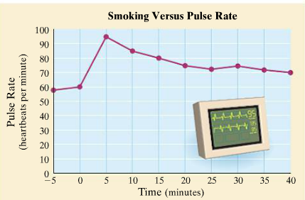

1. **What is the pulse rate 40 minutes after lighting a cigarette?**
2. **What is the pulse rate when the cigarette is being lit?**
3. **When is the pulse rate the highest?**

|  |  |
| --- | --- |
| **Learning Objective 3.1: Defining the Rectangular Coordinate System and Plotting Ordered Pairs of Numbers.**  **Read Section 3.1 on page 171 and answer the questions below.** | |
| **Definitions**   1. The horizontal axis is called the ____________ and the vertical axis is called the ____________. 2. The intersection of the horizontal axis and the vertical axis is a point called the ___________. 3. The axes divide the plane into regions called ___________. There are ______________of these regions. 4. In the ordered pair of numbers (3,2), the number 3 is called the _____________and the number 2 is called the _____________. | |

**Example 3: On a single coordinate system, plot each ordered pair. State in which quadrant, if any each point lies.**

1. $\left(-4,3\right)$**b. $\left(-3,5\right)$ c. $\left(0,4\right)$ d. $\left(-4,-5\right)$ e. $\left(5,5\right)$ f. $\left(3\frac{1}{2},1\frac{1}{2}\right)$**

|  |  |
| --- | --- |
| **Learning Objective 3.1: Determining Whether an Ordered Pair is a Solution**  **Read Section 3.1 on page 174 and answer the questions below.** | |
| **Definitions**   1. In general, an ordered pair is a ___________of an equation in two variables if replacing the variables by the value of the ordered pair results in a true statement. | |

**Example 4:** Determine whether each ordered pair is a solution of the equation $x+3y=6$.

1. $\left(3,1\right)$ b) $\left(6,0\right)$ c) $\left(-2,\frac{2}{3}\right)$

**Example 5:** Complete the following ordered pair solutions for the equation 2 $x-y=8$.

1. $\left(0, \right)$ b) $\left( ,4\right)$ c) $\left(-3, \right)$

**Example 6:**

Complete the table for the equation $y=-4x$. Complete the table for the equation $y=\frac{1}{5}x-2$.

|  |  |
| --- | --- |
| **x** | **y** |
| -10 |  |
| 0 |  |
|  | 0 |

|  |  |
| --- | --- |
| **x** | **y** |
| **-2** |  |
|  | **-12** |
| **0** |  |

**Homework: Page 568 #1-82.**

**College Preparatory Integrated Mathematics Course I**

**Learning Objective 3.2**

**Section 3.2&3.3**

|  |  |
| --- | --- |
| **Learning Objective 3.2: Identifying Linear Equations**  **Read Section 3.2 on page 184 and answer the questions below.** | |
| **Definitions**   1. The equation $x-2y=6$ is called a _______________equation in two variables and the graph of every linear equation in two variables is a _______________. 2. A linear equation in two variables is an equation that can be written in the form $_________________$ where *A, B*, and *C* are real numbers and *A* and *B* are not both 0. The graph of a linear equation in two variables is a straight line. 3. The form $Ax+By=C$ is called ________________form. | |

**Example 1: Determine whether each equation is a linear equation in two variables.**

**a) $3x+2.7y=-5.3$ b) $x^{2}+y=8$ c) $y=12$ d) $5x=-3y$**

|  |
| --- |
| **Learning Objective 3.2: Graphing Linear Equations by Plotting Ordered Pair Solutions**  **Read Section 3.2 on page 185 and answer the questions below.** |

A straight line is determined by just two points. Graphing a linear equation in two variables, then, requires that we find just two of its infinitely many solutions. Once those points are found, then plot the points and draw the line connecting the points. A third solution can be found to check your graph.

**Example 2: Complete the table below by finding three ordered solutions of $x+3y=9$. Then graph the linear equation by plotting the points and draw the line connecting the points.**

|  |  |  |
| --- | --- | --- |
| **x** | y | Ordered Pair |
| -1 |  |  |
| 0 |  |  |
| 1 |  |  |

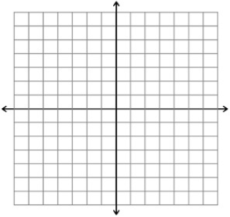

**Example 3: Graph the linear equations.**

**a) $3x-4y=12$ b)**

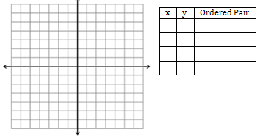 

**Example 4: Graph the linear equations.**

**a) $y=\frac{1}{2}x+3$ b) $x=-2$**

 

**Example 5: Graph the linear equation $y=-2x+3$ and compare this graph with the graph of $y=-2x$ in example 3b.**



|  |  |
| --- | --- |
| **Learning Objective 3.2: Identifying Linear Equations**  **Read Section 3.3 on page 194 and answer the questions below.** | |
| **Definitions**   1. An ____________________of a graph is the x-coordinate of a point where the graph intersects the x-axis. 2. A ______________________of a graph is the y-coordinate of point where the graph intersects the y-axis. | |

**Example 6:** Identify the x- and y-intercepts

|  |  |  |  |
| --- | --- | --- | --- |
| a. |  | b. |  |
| **x-intercept:**  **y-intercept:**  c. d. | | **x-intercept:**  **y-intercept:** | |

 



1. For all x-intercepts in the previous examples what was the value of the y-coordinate?
2. For all y-intercepts in the previous examples what was the value of the x-coordinate?

In conclusion when finding x- and y-intercepts the following is true.

* For the x-intercept, the y-coordinate is always __________________.
* For the y-intercept, the x-coordinate is always ___________________.

|  |  |
| --- | --- |
| **Learning Objective 3.2: Using Intercepts to Graph a Linear Equation**  **Read Section 3.3 on page 195 and answer the questions below.** | |
| **Definitions**  **Finding x- and y-intercepts**  To find the ______________, let y = 0 and solve for x.  To find the ______________, let x =0 and solve for y. | |

**Example 7: Graph $x+2y=-4$ by finding and plotting intercepts.**



**Example 8: Graph $3x=2y+4$ by finding and plotting intercepts.**



**Example 9: Graph $x=-2$.**



**Example 10: Graph $y=2$.**



**Homework: Page 200 #1-54.**

**College Preparatory Integrated Mathematics Course I**

**Learning Objective 2.5**

**Section 3.4**

|  |  |
| --- | --- |
| **Learning Objective 2.5:Finding the slope of a Line Given Two Points of the Line**  **Read Section 3.4 on page202 and answer the questions below.** | |
| **Definitions**   1. In mathematics, the slant or steepness of a line is formally known as its _______________. 2. The slope m of the line containing the points $\left(x_{1}, y_{1}\right) and (x_{2},y_{2})$ is given by   = $m=\frac{rise}{run}=\frac{ change in y}{change in x}=\frac{ }{}$ as long as $x_{2}≠x_{1}$. | |

**Example 1**: Find the slope of the line that passes through the following points, graph the line and determine if the line from left to right is increasing (goes up), decreasing (goes down), vertical or horizontal?

1. (4, –2) and (–1, 5) B. (3, 2) and (4, 6)

1. (3, 2) and (5, 2) D. (4, –2) and (4, 5)

|  |  |
| --- | --- |
| **Learning Objective 2.5:Finding the Slope of a Line Given Its Equation**  **Read Section 3.4 on page202 and answer the questions below.** | |
| **Definitions**   1. **When a linear equation in two variables is written in _____________________form. $y=mx+b$**     ***m* is the slope of the line and $(0, b)$ is the y-intercept of the line.** | |

**Example 2: Find the slope and y-intercept of the line whose equation is $y=\frac{2}{3}x-2.$**

**Example 3: Find the slope and y-intercept of the line whose equation is $5x+2y=8.$**

|  |  |
| --- | --- |
| **Learning Objective 2.5: Finding Slopes of Horizontal and Vertical Lines**  **Read Section 3.4 on page 206 and answer the questions below.** | |
| **Definitions**   1. All ______________lines have slope 0. 2. All ______________lines have undefined slope. | |

**Example 4:** Find the slope of the given lines.

a) $y=3$ b) $x=-4$

|  |  |
| --- | --- |
| **Learning Objective 2.5: Slopes of Parallel and Perpendicular Lines**  **Read Section 3.4 on page 207 and answer the questions below.** | |
| **Definitions**   1. Two lines in the same plane are _______________if they do not intersect. 2. Nonvertical parallel lines have the same ______________and different y-intercepts. 3. Two lines are _________________if they lie in the same plane and meet at a ${90}^{°}$ (right) angle. 4. The product of the slopes of the two perpendicular lines is _______________. 5. Two nonvertical lines are perpendicular if the slope of one is the _______________reciprocal of the slope of the other. | |

**Example 5:** Determine whether each pair of lines is parallel, perpendicular, or neither.

a) $y=-5x+1$ b) $x+y=11$ c) $2x+3y=21$

$x-5y=10$ $2x+y=11$ $6y=-4x-2$

|  |
| --- |
| **Learning Objective 2.5: Slope as a Rate of Change** |

**Example 6: One part of the Mt. Washington (New Hampshire) cog railway rises about 1794 feet over a horizontal distance of 7176 feet. Find the grade of this part of the railway.**

**Homework: Page 212 #1-75.**

**College Preparatory Integrated Mathematics Course I**

**Learning Objective 2.5**

**Section 3.5**

|  |  |
| --- | --- |
| **Learning Objective 2.5:Using the Slope-Intercept Form to Graph an Equation**  **Read Section 3.5 on page217 and answer the questions below.** | |
| **Definitions**   1. **When a linear equation in two variables is written in __________________form, $y=mx+b$**     **Then *m* is the slope of the line and (0, b) is the y-intercept of the line.** | |

The Slope-intercept form can also be used to find the equation of the line and can be used to graph and equation.

To graph the line using slope-intercept form we use the following steps:

1. Plot the y-intercept.

2. Find another point of the graph by using the slope and recalling the slope is .

3. Connect the two points with a straight line.

**Example 1**: Graph the linear function: $y=\frac{2}{3}x-5$**.**

**Example 2**: Graph the linear function: $3x-y=2$**.**

|  |
| --- |
| **Learning Objective 2.5:Using the Slope-Intercept Form to Write an Equation** |

**Example 3:** Find an equation of the line with y-intercept (0, 7) and slope of ½ $.$

|  |  |
| --- | --- |
| **Learning Objective 2.5:Writing an Equation Given Slope and a Point**  **Read Section 3.5 on page219 and answer the questions below.** | |
| **Definitions**   1. **The ________________form of the equation of a line is $y-y_{1}=m(x-x_{1})$ where m is the slope of the line and $(x_{1}, y_{1})$ is a point on the line.** | |

**Example 4: Find an equation of the line passing through (2, 3) with slope 4. Write the equation in standard form: $Ax+By=C.$**

**Example 5: Find the equation of the line through $\left(-1, 6\right)$ and $\left(3,1\right)$. Write the equation in standard form.**

**Example 6: Find the equation of the vertical line through $\left(3, -2\right)$.**

**Example 7: Find the equation of the line parallel to the line $y=-2$ and passing through (4, 3).**

**Example 8: The new Camelot condos were selling at a rate of 30 per month when they were priced at $150,000 each. Lowering the price to $120,000 caused the sales to rise to 50 condos per month.**

1. **Assume that the relationship between the number of condos sold and price is linear, and write an equation describing this relationship. Write the equation in slope-intercept form.**
2. **How should the condos be priced if the developer wishes to sell 60 condos per month?**

**Homework: Page 224 #1-70.**

**College Preparatory Integrated Mathematics Course I**

**Learning Objective 2.5**

**Section 3.6**

|  |  |
| --- | --- |
| **Learning Objective 2.5:Identifying Relations, Domains, and Ranges**  **Read Section 3.6 on page226 and answer the questions below.** | |
| **Definitions**   1. **A set of ordered pairs is called a ___________________.** 2. **The set of all x-coordinates is called the ____________of a relation, and the set of all y-coordinates is called the _______________ of a relation.** 3. **A ______________is a set of ordered pairs that assigns to each x-value exactly one y-value.** | |

**Example 1**: Find the domain and the range of the relation $\{\left(1,3\right), \left(5,0\right), \left(0, -2\right), \left(5, 4\right)\}$**.**

|  |  |
| --- | --- |
| **Learning Objective 2.5:Identifying Functions**  **Read Section 3.6 on page227 and answer the questions below.** | |
| **Definitions**   1. **A ______________is a set of ordered pairs that assigns to each x-value exactly one y-value.** | |

**Example 2**: Determine whether each relation is also a function.

a) {(4,1), (3, -2), (8,5), (-5, 3)} b) {(1,2), (-4, 3), (0,8), (1,4)}

|  |  |
| --- | --- |
| **Learning Objective 2.5:Using the Vertical Line Test**  **Read Section 3.6 on page228 and answer the questions below.** | |
| **Definitions**   1. **If a ______________line can be drawn so that it intersects the graph more than once, the graph is not the graph of a function.** | |

**Example 3: Use the vertical line test to determine whether each graph is the graph of a function.**

**a) b) c) d)**

  

**Example 4: Describe whether the equation describes a function.**

**a) $y=2x$ b) $y=-3x-1$ c) $y=8$ d) $x=2$**

|  |  |
| --- | --- |
| **Learning Objective 2.5:Using Function Notation**  **Read Section 3.6 on page231 and answer the questions below.** | |
| **Definitions**   1. **The variable x is the ______________variable because any value in the domain can be assigned to x.** 2. **The variable y is the _______________variable because its value depends on x.** 3. **The symbol $f(x)$ means function of x and is read ”f of x”. This notation is called _________________notation.** | |

**Example 5: Given $h\left(x\right)=x^{2}+5$, find the following. Then write the corresponding ordered pairs generated.**

**a) $h(2)$ b) a) $h(-5)$ a) $h(0)$**

**Example 6: Find the domain of each function.**

**a) $h\left(x\right)=6x+3$ b) $f\left(x\right)=\frac{1}{x^{2}}$**

**Example 7: Find the domain and the range of each function graphed. Use interval notation.**

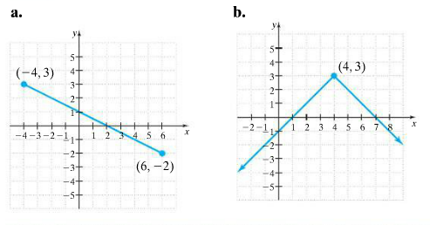

**Homework: Page 234 #1-35; 45-80.**

**College Preparatory Integrated Mathematics Course I**

**Learning Objective 2.5**

**Section 8.1**

|  |  |
| --- | --- |
| **Learning Objective 2.5:Graphing Linear Functions**  **Read Section 8.1 on page511 and answer the questions below.** | |
| **Definitions**   1. **A _____________function is a function that can be written in the form $f\left(x\right)=mx+b$.** | |

If a linear function is solved for y, we can easily use function notation to describe it by replacing y with $f(x)$.

**Example 1**: Graph the linear function: $f\left(x\right)=-2x+5$**.**

**Example 2**: Find an equation of the line with slope $-4$ and y-intercept $\left(0, -3\right)$. Write the equation using function notation.

**Example 3**: Find an equation of the line through points $\left(-1, 2\right) and \left(2, 0\right)$. Write the equation using function notation.

**Example 4**: Write a function that describes the line containing the point $\left(8, -3\right)$ and perpendicular to the line $3x+4y=1$.

**Example 5**: Write a function that describes the line containing the point $\left(8, -3\right)$ and parallel to the line $3x+4y=1$.

**Homework: Page 516 #1-68.**

**College Preparatory Integrated Mathematics Course I**

**Learning Objective 2.3**

**Section 4.1**

|  |  |
| --- | --- |
| **Learning Objective 2.3: Deciding Whether an Ordered Pair is a Solution**  **Read Section 4.1 on page250 and answer the questions below.** | |
| **Definitions**   1. **A _________________of linear equations consists of two or more linear equations.** 2. **A __________________of a system of two equations in two variables is an ordered pair of numbers that is a solution of both equations in the system.** | |

**Example 1:** Consider the system:

$$\left\{\begin{aligned}2x-3y=-4 \\ 2x+y=4 \end{aligned}\right.$$

Determine if each ordered pair is a solution of the system:

(1, 2) b) $(7, 6)$

|  |  |
| --- | --- |
| **Learning Objective 2.3: Solving Systems of Equations by Graphing**  **Read Section 4.1 on page252 and answer the questions below.** | |
| **Definitions**   1. **A system of equations that has at least one solution is said to be _______________system.** 2. **A system that has no solution is said to be an _________________system.** 3. **Two equations are ___________________equations if the two linear equations are different.** 4. **If the graphs of two equations in a system are identical, we call the equations ____________equations.** | |

**Example 2**: Solve the system of equations by graphing:

$$\left\{\begin{aligned}x-y=3 \\ x+2y=18 \end{aligned}\right.$$

**Example 3**: Solve the system of equations by graphing:

$$\left\{\begin{aligned}-4x+3y=-3 \\ y=-5 \end{aligned}\right.$$

**Example 4**: Solve the system of equations by graphing:

$$\left\{\begin{aligned}x-y=4 \\ -2x+2y=-8 \end{aligned}\right.$$

|  |  |
| --- | --- |
| **Learning Objective 2.3: Finding the Number of Solutions of a System without Graphing**  **Read Section 4.1 on page254 and answer the questions below.** | |
| **Definitions:**  **One-Point of Intersection Parallel lines Same line**  **________________solution. _______________solution. ______________solutions**    **Consistent System Inconsistent system Consistent system**  **Independent equations Independent equations Dependent equations** | |

**Example 5**: Without graphing, determine the number of solutions of the system.

$$\left\{\begin{aligned}5x+4y=6 \\ x-y=3 \end{aligned}\right.$$

**Example 6**: Without graphing, determine the number of solutions of the system.

$$\left\{\begin{aligned}-\frac{2}{3}x+y=6 \\ 3y=2x+5 \end{aligned}\right.$$

**Homework: Page 256 #1-56.**

**College Preparatory Integrated Mathematics Course I**

**Learning Objective 2.3**

**Section 4.2**

|  |  |
| --- | --- |
| **Learning Objective 2.3: Using the Substitution Method to solve a system of Linear Equations.**  **Read Section 4.2 on page258 and answer the questions below.** | |
| **Definitions**   1. **A more accurate method for solving a system of equations is called the ______________method.** | |

**Solving a System of Two Linear Equations by the Substitution Method**

Step1.

Step2.

Step3.

Step4.

Step5.

**Example 1:** Solve the system:

$$\left\{\begin{aligned}2x-y=9 \\ x=y+1 \end{aligned}\right.$$

**Example 2**: Solve the system:

$$\left\{\begin{aligned}7x-y=-15 \\ y=2x \end{aligned}\right.$$

**Example 3**: Solve the system:

$$\left\{\begin{aligned}x+3y=6 \\ 2x+3y=10 \end{aligned}\right.$$

**Example 4**: Solve the system:

$$\left\{\begin{aligned}5x+3y=-9 \\ -2x+y=8 \end{aligned}\right.$$

**Example 5**: Solve the system:

$$\left\{\begin{aligned}\frac{1}{4}x-y=2 \\ x=4y+8 \end{aligned}\right.$$

**Example 6**: Solve the system:

$$\left\{\begin{aligned}4x-3y=12 \\ -8x+6y=-30 \end{aligned}\right.$$

**Homework: Page 256 #1-56.**

**Homework: Page 264 #1-38.**

**College Preparatory Integrated Mathematics Course I**

**Learning Objective 2.3**

**Section 4.3**

|  |  |
| --- | --- |
| **Learning Objective 2.3: Using the Addition Method to solve a system of Linear Equations.**  **Read Section 4.3 on page265 and answer the questions below.** | |
| **Definitions**   1. **Another method for solving a system of equations accurately is the ______________method or ____________method.** | |

**Solving a System of Two Linear Equations by the Addition Method**

Step1.

Step2.

Step3.

Step4.

Step5.

Step6.

**Example 1:** Solve the system:

$$\left\{\begin{aligned}x-y=2 \\ x+y=8 \end{aligned}\right.$$

**Example 2**: Solve the system:

$$\left\{\begin{aligned}x-2y=11 \\ 3x-y=13 \end{aligned}\right.$$

**Example 3**: Solve the system:

$$\left\{\begin{aligned}x-3y=5 \\ 2x-6y=-3 \end{aligned}\right.$$

**Example 4**: Solve the system:

$$\left\{\begin{aligned}4x-3y=5 \\ -8x+6y=-10 \end{aligned}\right.$$

**Example 5**: Solve the system:

$$\left\{\begin{aligned}4x+3y=14 \\ 3x-2y=2 \end{aligned}\right.$$

**Example 6**: Solve the system:

$$\left\{\begin{aligned}-2x+\frac{3y}{2}=5 \\ -\frac{x}{2}-\frac{y}{4}=\frac{1}{2} \end{aligned}\right.$$

**Example 7**: Johnston and Betsy Waring have a jar containing 80 coins, all of which are either quarters or nickels. The total value of the coins is $14.60. How many of each type of coin do they have?

**Homework: Page 256 #1-56.**

**Homework: Page 264 #1-56.**

**College Preparatory Integrated Mathematics Course I**

**Learning Objective 2.2**

**Section 6.1**

|  |  |
| --- | --- |
| **Learning Objective 2.2: Finding the Greatest Common Factor of a List of Integers**  **Read Section 6.1 on page374 and answer the questions below.** | |
| **Definitions**   1. **In the product $2∙3$ =6, the numbers 2 and 3 are called ______________ of 6 and $2∙3$ is a __________form of 6.** 2. **The process of writing a polynomial as a product is called _________________the polynomial.** 3. **The ____________of a list of integers is the largest integer that is a factor of all the integers in the list.** | |

**Finding the GCF of a List of Integers**

Step1.

Step2.

Step3.

**Example 1:** Find the GCF of each list of numbers.

1. 36 and 42 b) 35 and 44 c) 12, 16, and 40

|  |  |
| --- | --- |
| **Learning Objective 2.2: Finding the Greatest Common Factor of a List of Terms**  **Read Section 6.1 on page375 and answer the questions below.** | |
| **Definitions**   1. **The ______________of a list of common variables raised to powers is the variable raised to the smallest exponent in the list.** | |

**Example 2:** Find the GCF of each list of terms.

1. $y^{7}, y^{4}, and y^{6}$ c) $x, x^{4}, and x^{2}$

**Example 3:** Find the GCF of each list of terms.

1. $5y^{4}, 15y^{2}, and-20y^{3}$ b) $4x^{2}, x^{3}, and 3x^{8}$ c) $a^{4}b^{2}, a^{3}b^{5}, and a^{2}b^{3}$

|  |
| --- |
| **Learning Objective 2.2: Factoring Out the Greatest Common Factor** |

**Example 4:** Factor each polynomial by factoring out the GCF.

1. $4t+12$ b) $y^{8}+y^{4}$

**Example 5:** Factor $-8b^{6}+16b^{4}-8b^{2}$.

**Example 6:** Factor.

a) $5x^{4}-20x$ b) $\frac{5}{9}z^{5}+\frac{1}{9}z^{4}-\frac{2}{9}z^{3}$ c) $8a^{2}b^{4}-20a^{3}b^{3}+12ab^{3}$

**Example 7:** Factor.

a) $8\left(y-2\right)+x(y-2)$ b) $7xy^{3}\left(p+q\right)-(p+q)$

|  |  |
| --- | --- |
| **Learning Objective 2.2: Factoring by Grouping**  **Read Section 6.1 on page375 and answer the questions below.** | |
| **Definitions**   1. **The ______________of a list of common variables raised to powers is the variable raised to the smallest exponent in the list.** | |

To Factor a Four-Term Polynomial by Grouping

Step1.

Step2.

Step3.

Step4.

**Example 8:** Factor by grouping.

a) $40x^{3}-24x^{2}+15x-9$ b) $2xy+3y^{2}-2x-3y$ c) $7a^{3}+5a^{2}+7a+5$

**Example 9:** Factor by grouping.

a) $4xy+15-12x-5y$ b) $9y-18+y^{3}-4y^{2}$ c) $3xy-3ay-6ax+6a^{2}$

**Homework: Page 380 #1-88.**

**College Preparatory Integrated Mathematics Course I**

**Learning Objective 2.2**

**Section 6.2**

|  |  |
| --- | --- |
| **Learning Objective 2.2: Factoring Trinomials of the Form $x^{2}+bx+c$**  **Read Section 6.2 on page382 and answer the questions below.** | |
| **Definitions**   1. **The factored form of $x^{2}+bx+c$ is $x^{2}+bx+c=(x+\boxed{})(x+\boxed{})$**   The sum of these numbers is b. and the product of these numbers is c. | |

**Example 1:** Factor $x^{2}+5x+6$. **Example 2:** Factor $x^{2}-17x+70$.

**Example 3:** Factor $x^{2}+5x-14$. **Example 4:** Factor $p^{2}-2p-63$.

**Example 5:** Factor $b^{2}+5b+1$. **Example 6:** Factor $x^{2}+7xy+12y^{2}$.

**Example 7:** Factor $x^{4}+13x^{2}+12$. **Example 8:** Factor ${48-14x+x}^{2}$.

**Example 9:** Factor ${4x}^{2}-24x+36$. **Example 10:** Factor ${3y}^{4}-18y^{3}-21y^{2}$.

**Homework: Page 380 #1-70.**

**College Preparatory Integrated Mathematics Course I**

**Learning Objective 2.2**

**Section 6.3**

|  |
| --- |
| **Learning Objective 2.2: Factoring Trinomials of the Form $ax^{2}+bx+c$**  **Read Section 6.3 on page389.** |

**Example 1:** Factor ${2x}^{2}+11x+15$. **Example 2:** Factor $15x^{2}-22x+8$.

**Example 3:** Factor ${4x}^{2}+11x-3$. **Example 4:** Factor $21p^{2}+11pq-2q^{2}$.

**Example 5:** Factor ${2x}^{4}-5x^{2}-7$. **Example 6:** Factor $x^{2}+7xy+12y^{2}$.

**Example 7:** Factor $x^{4}+13x^{2}+12$.

|  |  |
| --- | --- |
| **Learning Objective 2.2: Factoring Out the Greatest Common Factor.**  **Read Section 6.3 on page393.** | |
| **Note:**  **The first step in factoring any polynomial is to look for a common factor to factor out.** | |

**Example 8:** Factor ${3x}^{3}+17x^{2}+10x$.

**Example 9:** Factor ${-8x}^{2}+2x+3$.

|  |  |
| --- | --- |
| **Learning Objective 2.2: Factoring Perfect Square Trinomials.**  **Read Section 6.3 on page393 and answer the questions below.** | |
| **Definition**  **1. A trinomial that is the square of a binomial is called a ____________________square trinomial.**  **2. $a^{2}+2ab+b^{2}=____________$**  **3. $a^{2}-2ab+b^{2}=____________$** | |

**Example 10:** Factor $x^{2}+14x+49$. **Example 11:** Factor ${4x}^{2}+20xy+9y^{2}$.

**Example 12:** Factor ${36n}^{4}-12n^{2}+1$. **Example 13:** Factor ${12x}^{3}-84x^{2}+147x$.

**Homework: Page 395 #1-94.**

**College Preparatory Integrated Mathematics Course I**

**Learning Objective 2.2**

**Section 6.4**

|  |  |
| --- | --- |
| **Learning Objective 2.2: Using the Grouping Method**  **Read Section 6.4 on page397 and answer the questions below.** | |
| **Definitions**   1. **An alternative method that can be used to factor trinomials of the form $ax^{2}+bx+c, a≠1$**   **is called the _____________method.** | |

**To Factor Trinomials by Grouping**

Step 1.

Step 2.

Step 3.

Step 4**.**

**Example 1:** Factor ${5x}^{2}+61x+12$ by grouping.

**Example 2:** Factor $12x^{2}-19x+5$ by grouping.

**Example 3:** Factor $30x^{2}-14x-4$ by grouping.

**Example 4:** Factor $40m^{2}+5m^{3}-35m^{2}$ by grouping.

**Example 5:** Factor ${16x}^{2}+24x+9$.

**Homework: Page 401 #1-54.**

**College Preparatory Integrated Mathematics Course I**

**Learning Objective 2.2**

**Section 6.5**

|  |  |
| --- | --- |
| **Learning Objective 2.2: Factoring the Difference of Two Squares**  **Read Section 6.5 on page 402 and answer the questions below.** | |
| **Definitions**   1. **The binomial $x^{2}-9$ is called a ______________of squares. $a^{2}-b^{2}=_____________________.$** | |

**Example 1:** Factor $x^{2}-81$.

**Example 2:** Factor each difference of squares.

a) $9x^{2}-1$ b) $36a^{2}-49b^{2}$ c) $p^{2}-\frac{25}{36}$

**Example 3:** Factor $p^{4}-q^{10}$.

**Example 4:** Factor each binomial.

a) $z^{4}-81$ b) $m^{2}+49$

**Example 5:** Factor each binomial.

a) $36y^{3}-25y$ b) $80y^{4}-5$

**Example 6:** Factor $-9x^{2}+100$

|  |  |
| --- | --- |
| **Learning Objective 2.2: Factoring the Sum or Difference of Two Cubes**  **Read Section 6.5 on page 405 and answer the questions below.** | |
| **Definitions $a^{3}+b^{3}=______________________$ $a^{3}-b^{3}=_____________________.$** | |

**Example 7:** Factor $x^{3}+64$.

**Example 8:** Factor $x^{3}-125$.

**Example 9:** Factor $27y^{3}+1$.

**Homework: Page 401 #1-54.**

**Homework: Page 380 #1-88.**

**Homework: Page 407 #1-70.**

**College Preparatory Integrated Mathematics Course I**

**Learning Objective 4.1**

**Lines and Angles**

|  |  |
| --- | --- |
| **Learning Objective 4.1: Identifying Lines and Angles** | |
| **Definitions**   1. A_________ has no length, no width, and no height, but it does have location. 2. A_________ is a set of points extending indefinitely in two directions. 3. A_________ is a piece of a line with two endpoints. 4. A_________ is a part of a line with one endpoint. 5. An___________ is made up of two rays that share the same endpoint. 6. The common endpoint is called the _________. 7. An angle can be measured in _____________. 8. An angle that measures is called a ____________ angle. 9. An angle that measures is called a _____________ angle. 10. An angle whose measure is between and is called an _________angle. 11. An angle whose measure is between $90°$ and $180°$ is called an ________angle. | |

**Identify each figure as a line, a ray, a line segment, or an angle. Then name the figure using the given points.**

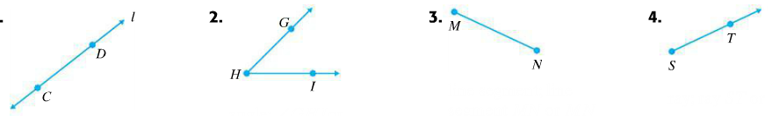

|  |  |
| --- | --- |
| **Learning Objective 4.1: Classifying Angles as Acute, Right, Obtuse, or Straight, Identifying Complementary and Supplementary Angles** | |
| **Definitions**   1. An angle can be measured in _____________. 2. An angle that measures is called a ____________ angle. 3. An angle that measures is called a _____________ angle. 4. An angle whose measure is between and is called an _________angle. 5. An angle whose measure is between and is called an ________angle. 6. Two angles that have a sum of are called ___________angles. 7. Two angles that have a sum of $180°$ are called__________angles. | |

**Classify each angle as acute, right, obtuse, or straight.**

  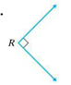 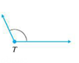

**Find each complementary or supplementary angle as indicated.**

1. **Find the complement of a $23°$ angle.**
2. **Find the supplement of a $150°$ angle.**

**Find the measure of $∠x$ in each figure.**

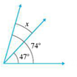 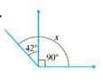 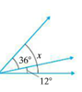

**Find the measure of x, y, and z**.

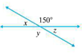 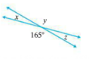 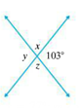

**College Preparatory Integrated Mathematics Course I**

**Learning Objective 4.1**

**Plane Figures and Solids**

|  |  |
| --- | --- |
| **Learning Objective 4.1: Plane Figures and Solids** | |
| **Definitions**   1. A________ plane is a flat surface that extends indefinitely. 2. A__________ figure is a figure that lies on a plane. 3. A _________ is a closed plane figure that basically consists of three or more line segments that meet at their endpoints. 4. A____________ polygon is a one whose sides are all the same length and whose angles are the same measure. 5. The __________ of the measures of the angles of a triangle is . 6. A _________triangle is a triangle with a right angle. 7. A____________ is a special quadrilateral with opposite sides parallel and equal in length. 8. A _____________ is a special parallelogram that has four right angles. 9. A _____________ is a special rectangle that has all four side equal in length. 10. A _____________is a special parallelogram that has all four sides equal in length. 11. A _____________is a quadrilateral with exactly one pair of opposite sides parallel. 12. A____________ is a plane figure that consists of all points that are the same fixed distance from the center. 13. The ___________of a circle is the distance from the center of the circle to any point on the circle. 14. The __________of a circle is the distance across the circle passing through the center. 15. A________ is a figure that lies in space. 16. A_____________ solid is a solid that consists of six sides, or faces, all of which are rectangles. 17. A _________ is a rectangular solid whose six sides are squares. 18. A pyramid, sphere, cylinder, cones are shown below. | |

A polygon is named according to the number of its sides.

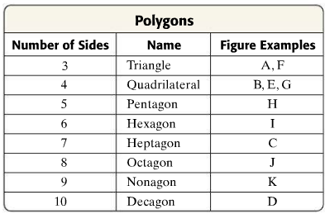

**Identify each polygon**.

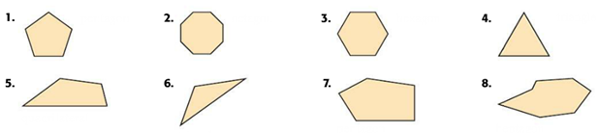

**Classigy each triangle as equilateral, isosceles, or scalene. Also identify any triangles that are also right triangles.**

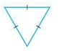   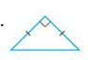

**Find the measure of $∠x$ in each figure.**

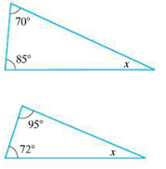 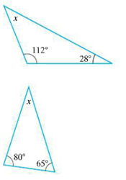 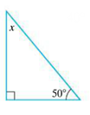

**Identify each solid.**

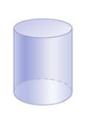 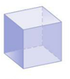 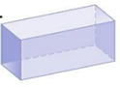 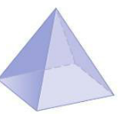

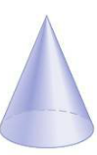 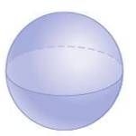  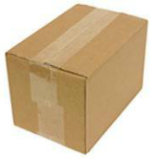

**College Preparatory Integrated Mathematics Course I**

**Learning Objective 4.1**

**Perimeter and Area**

|  |  |
| --- | --- |
| **Learning Objective 4.1: Perimeter and Area** | |
| **Definitions**   1. The _____________of a polygon is the distance around the polygon. That is the sum of the lengths of its sides. 2. **Perimeter of Rectangle = ______________** 3. **Perimeter of Square =_________________** 4. **Perimeter of Triangle = _______________** 5. **Circumference of a Circle = _____________** | |

**Find the perimeter of each figure.**

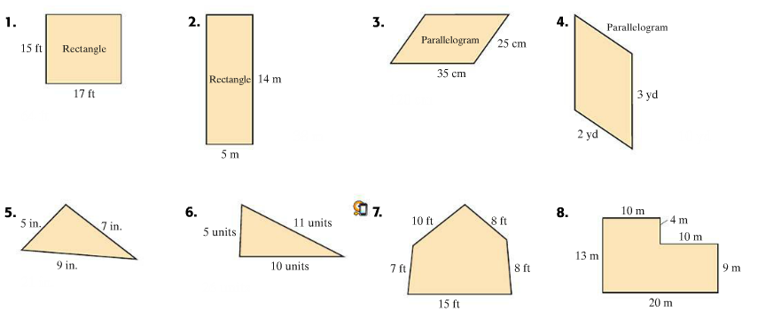

**Find the perimeter of each regular polygon. (The sides of a regular polygon have the same length.)**

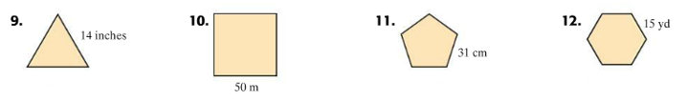

**If a football field is 53 yards wide and 120 yards long, what is the perimeter?**

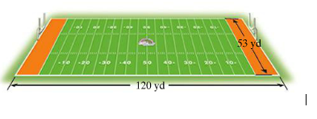

**Find the Perimeter of each figure.**

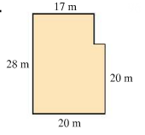 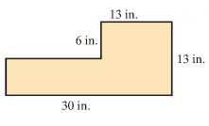 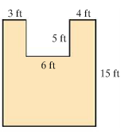

**Find the circumference of each circle. Give the exact circumference and then an approximation. Use $π≈3.14$.**

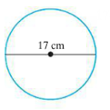 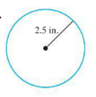 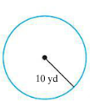 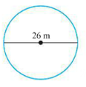

|  |  |
| --- | --- |
| **Learning Objective 4.1: Perimeter and Area** | |
| **Definitions**   1. _____________measures the amount of surface of the region. 2. **Area of Rectangle = ______________** 3. **Area of Square =_________________** 4. **Area of Triangle = _______________** 5. **Area of a Circle = _____________** 6. **Area of a Parallelogram=_____________** 7. **Area of a Trapezoid =________________** | |

**Find the area of each figure.**

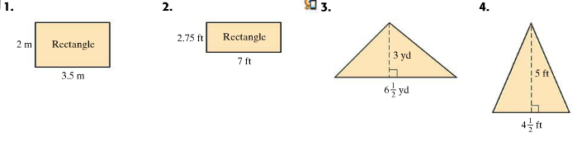

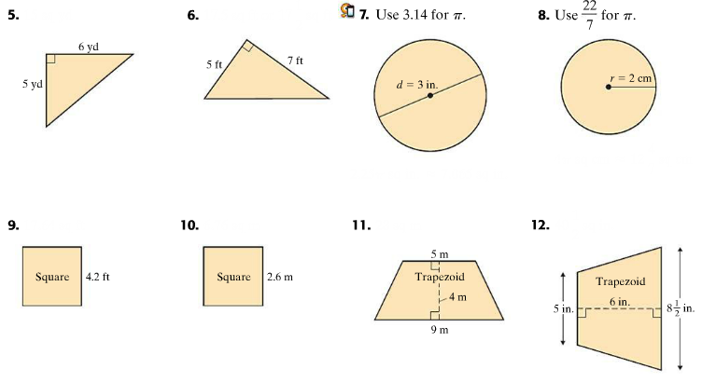

**Find the area of each figure.**

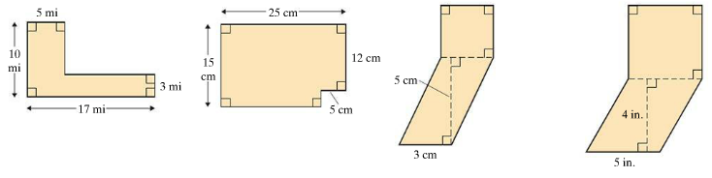

**Example**

**The floor of Terry’s attic is 24 feet by 35 feet. Find how many square feet of insulation are needed to cover the attic floor.**

**College Preparatory Integrated Mathematics Course I**

**Learning Objective 4.1**

**Surface Area and Volume**

|  |  |
| --- | --- |
| **Learning Objective 4.1: Volume** | |
| **Definitions**   1. _____________is the measure of space of a region. 2. The ____________of a polyhedron is the sum of the areas of the faces of the polyhedron. | |

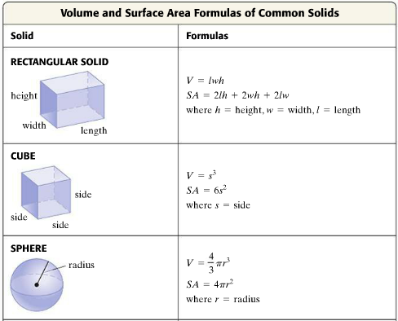

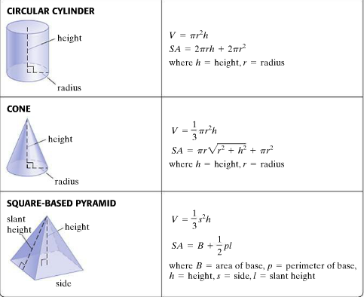

**Find the volume and surface area of each solid.**

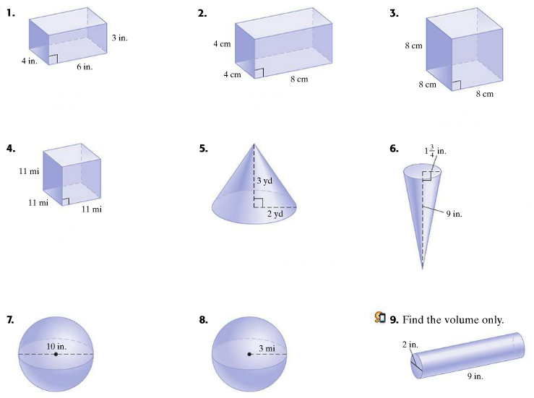

**College Preparatory Integrated Mathematics Course I**

**Learning Objective 4.1**

**Congruent and Similar Triangles**

|  |  |
| --- | --- |
| **Learning Objective 4.1: Congruent and Similar Triangles** | |
| **Definitions**   1. Two triangles are ___________when they have the same shape and the same size. 2. **Angle-Side-Angle (ASA)-**If the measures of two angles of a triangle equal the measures of two angles of another triangle, and the lengths of the sides between each pair of angles are equal, the triangles are congruent. 3. **Side-Side-Side (SSS)-** if the length of the three sides of a triangle are equal the lengths of the corresponding sides of another triangle, the triangles are congruent. 4. **Side-Angle-Side (SAS**)- If the lengths of two sides of a triangle equal the lengths of corresponding sides of another triangle, and the measures of the angles between each pair of sides are equal, the triangles are congruent. 5. Two triangles are _______when they have the same shape but not necessarily the same size. | |

**Determine whether each pair of triangles is congruent. If congruent, state the reason why, such as SSS, SAS, or ASA.**

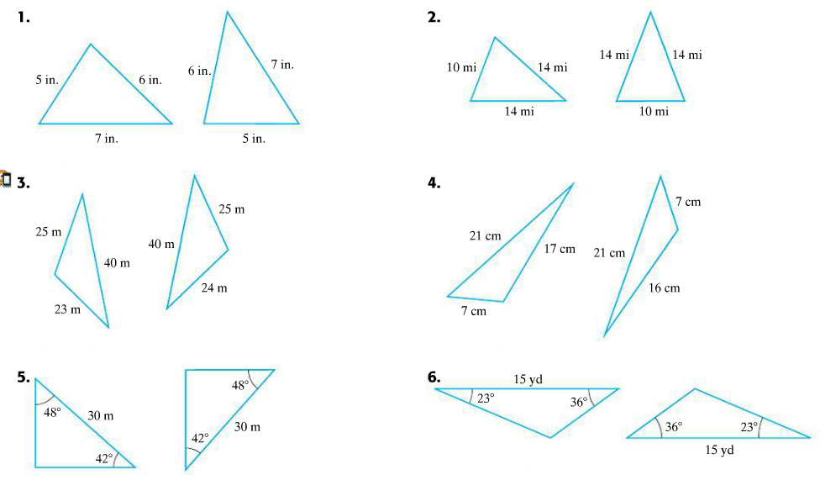

**Find each ratio of the corresponding sides of the given similar triangles.**

**a)**

**b)**

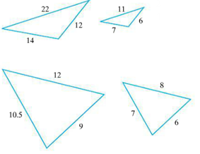 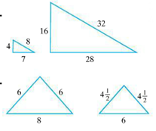

**c)**

**d)**

**Given that the pairs of triangles are similar, find the unknown length of the side labeled n.**

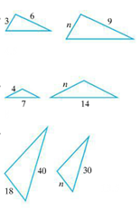 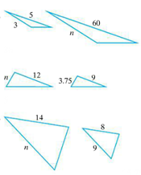 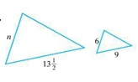

**g)**

**d)**

**e)**

**f)**

**a)**

**b)**

**c)**