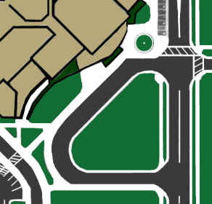
Avoid stopping at mouth of the circle drive. It blocks the view and bogs down the flow of traffic. Pull forward!
Students may only cross the crosswalk with an adult
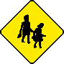



Student Drop Off and Pick Up
Pull forward to use the full length of the curb and sidewalk for safe drop-off and pick-up.
Encourage students to wait to be picked up further down the sidewalk in an area that is less congested than the front doors of the school.

