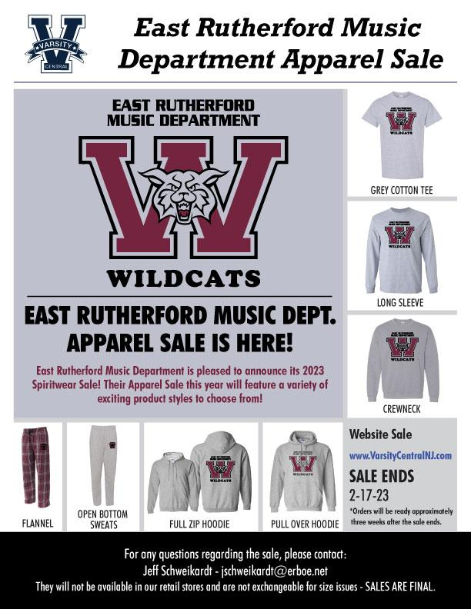

CLICK LINK BELOW FOR ONLINE SALE

[E. Rutherford Music Dept Winter 2023 | VarsityCentralNJ.com](https://www.varsitycentralnj.com/product-category/e-rutherford-music-dept-winter-2023/)

***When placing your order please type your name and the name of the student who you wish to give credit for the sale in the “Order Notes” box***

**(Sweatpants and Pajama bottoms have pockets)**

