**MILITARY VISITS**

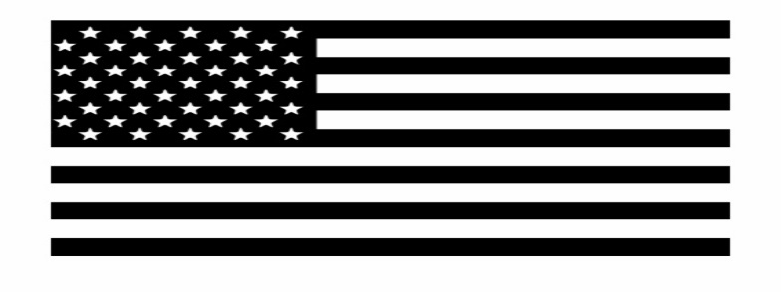

**US ARMY**

May 15th

This will be held in the Main Lobby

