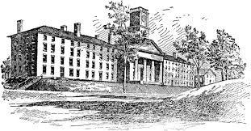

**COLLEGE VISITS**

Wentworth Institute of Technology (MA) – April 7th at 8:10 am

Paul Smith College of Arts & Science (NY) – April 7th at 10:00 am

Lasell University (MA) – April 7th at 12:30

A representative from these colleges will be visiting the Guidance & Counseling office at the dates and times shown. If you are in 11th or 12th grade and are interested in meeting with these college representatives, please sign up at least 24 hours before in the Main Office with Lisa Goslant.