Beaumont ISD



Professional Learning

Plan

### Table of Contents

**Section I 3**

Definition

Rationale and Need for Professional Learning

Goals

Levels of Professional Learning

**Section II 4**

District Mission

Professional Learning Mission

Professional Learning Vision

Standards

Characteristics of a Professional Learning Community

Types of Professional Learning

Results of a Professional Learning Community

**Section III 7**

District Requirements for Professional Learning

SBEC Requirements for Professional Learning

SBEC Requirements for Gifted and Talented Education

English as a Second Language Supplemental Certification

Special Education Certification

Role of Curriculum and Instruction

Policy

State Standards

District Tools

Research Based Effective Practices in Professional Learning

Professional Learning Norms

**Section IV 13**

School Administrators Professional Learning Matrix

All Instructional Staff Members Professional Learning Matrix

Elementary School Professional Learning Matrix

Middle School Professional Learning Matrix

High School Professional Learning Matrix Special Education Professional Learning Matrix

Special Education Professional Learning Matrix

All Instructional Para-Professional Staff Professional Learning Matrix

**Addendums 31**

Printing Professional Learning Certificates from Eduphoria

Requesting Credit for an Outside Course in Eduphoria

*The BISD Professional Learning Plan was developed in 2016 by the BISD Curriculum & Instruction Department. It is continually updated by the BISD Professional Development Planning Committee. The purpose of the Professional Learning Plan is to provide a comprehensive program aligned to BISD goals.*

**Beaumont ISD**

**Professional Learning Plan**

Beaumont ISD (BISD) is committed to ensuring that all personnel have the relevant knowledge, skills, and expertise to perform their work to consistently high standards and to increase student achievement. The District recognizes that training and development are fundamental to ensure the quality of services to students. The District supports a culture of lifelong learning and encourages employees to take ownership of their own Professional Learning.

This document presents the Beaumont Independent School District Comprehensive Professional Learning Plan. Section I presents the definition of Professional Learning, Rationale, and Commitment to being a Learning Community. Section II provides the Mission, Vision and Standards for Professional Learning, and the Types of Professional Learning. Section III provides the Organizational Structure for Professional Learning, and Section IV provides the Professional Learning Matrix.

***Section I***

***Definition, Rationale, Goals, and Levels of Professional Learning***

1. **Definition**

The term "Professional Learning" means a comprehensive, sustained, and intensive approach to improving educators’ effectiveness in raising student achievement. Professional Learning in Beaumont ISD is defined as a process that fosters personal and professional growth for individuals within a respectful, supportive, positive organizational climate. The ultimate goal of the Professional Learning process is increased student learning and continuous, responsible self-renewal for all employees working together to create a quality environment for learning.

It is important to think of Professional Learning activities as encompassing a wide range of professional growth experiences. Professional Learning refers to a systematically planned, comprehensive set of ongoing professional growth activities carried out over time to achieve specific district, school, and departmental improvement objectives.

1. **Rationale and Need for Professional Learning**

Education has entered a challenging and critical era. There continues to be a call for quality and improved accountability. As such, school employees are expected to stay current and adapt to rapid rates of technological, informational, and societal change. To meet these challenges, our employees will regularly seek out new learning opportunities to build upon existing skills. To remain a vital force in a democratic and global society, our employees must serve as models of lifelong learning, joining a community of learners.

The BISD Professional Learning Plan will serve as the vehicle to enable employees to achieve district and campus goals. It will provide both formal and informal learning opportunities to foster professional growth for district employees within a collaborative, innovative, and self-directed organizational climate. The learning opportunities will be aligned to the needs of the students, written curriculum, taught curriculum and tested curriculum.

1. **Goals**

The ultimate goal of the plan is improved student learning and continuous improvement for all employees. The overriding goals are to:

* Provide all employees with the knowledge, skills, and competencies needed to meet the District's goals and initiatives for student success and improvement.
* Develop all levels of employees in the skills, knowledge, and competencies needed to be successful in their current jobs and capable of adapting to future job requirements.
* Develop a common vision and work collaboratively to provide quality learning opportunities for all students.
* Instill within each employee a commitment to lifelong learning.
* Provide employees with career paths for future positions in the District.

1. **Levels of Professional Learning**

The professional learning approach will be designed to implement growth experiences for long-term sustained effects toward student achievement. Three levels of professional learning will be provided:

* District-level professional learning focused on increasing the effectiveness of employees through learning opportunities that lead to the achievement of District goals.
* School or department/grade level professional learning to provide specific opportunities for school and department/grade level goals that are aligned with District goals.
* Individual level professional learning to meet the individual employee's need in alignment with the District goals.

**Section II**

***Mission, Vision, Standards, Characteristics, Types, and Results of Professional Learning***

1. **District Mission**

The mission of the Beaumont Independent School District, as the unifying force of the community, is to guarantee that our graduates possess the necessary skills, values and knowledge to compete successfully as productive citizens in a diverse global society through an educational system characterized by:

• Expectation of success for each person;  
• Optimum application of technology;  
• An appreciation of various cultures;  
• Full involvement of parents, teachers and the community;  
• Respect and care for each other.

1. **Professional Learning Mission**

To develop and provide research-based, best practice, on-going Professional Learning designed to increase expertise for the advancement of student achievement and empower teachers and staff to provide high quality instruction.

1. **Professional Learning Vision**

Develop life-long learning leaders who collaborate within their professional learning community in order to develop expertise, and promote campus based, job-embedded, on-going Professional Learning and meet the instructional needs of all students by building responsive classrooms with relationships, rigor, relevance, and results.

1. **Standards**

The Beaumont Independent School District Professional Learning Plan is based upon the national professional learning organization standards. Learning Forward (formerly known as the National Staff Development Council) is an international association of learning educators who focus solely on the most critical lever in improving schools – building the knowledge and skills of educators(Revised 2015).

Standards for Professional Learning

Professional Learning Communities: Professional learning that increases educator effectiveness and results for all students occurs within learning communities committed to continuous improvement, collective responsibility, and goal alignment.

Leadership: Professional learning that increases educator effectiveness and results for all students requires skillful leaders who develop capacity, and create support systems for professional learning.

Resources: Professional learning that increases educator effectiveness and results for all students requires prioritizing, monitoring, and coordinating resources for educator learning.

Data-Driven: Professional learning that increases educator effectiveness and results for all students uses a variety of sources and types of student, educator, and system data to plan, assess, and evaluate professional learning.

Learning Designs (Research-based): Professional learning that increases educator effectiveness and results for all students integrates theories, research, and models of human learning to achieve its intended outcomes.

Implementation: Professional learning that increases educator effectiveness and results for all students applies research on change and sustains support for implementation of professional learning for long-term change.

Outcomes: Professional learning that increases educator effectiveness and results for all students aligns its outcomes with educator performance and student curriculum standards.

### Characteristics of a Professional Learning Community

The characteristics of professional learning communities in BISD are as follows:

* Shared mission, vision and goals
* Collaborative teams focused on learning
* Collective inquiry into research-based best practices
* Using data for effective change
* Commitment to continuous improvement
* Engaged in authentic learning

### Types of Professional Learning

The types of professional learning in BISD are as follows:

* Study groups among peers focused on a shared need or topic
* District Staff Development Days - district or campus-based professional developing targeting specific needs or district/campus initiatives
* New Teacher Induction and Mentoring Program - designed to assist first year teachers with effective teaching skills, strategies, and support. This includes observations with reflective feedback, coaching and mentoring.
* Sustained on-going teacher support
* District meetings to plan lessons, problem solve, improve performance, and/or learn new strategies
* Faculty, grade-level or departmental meetings focusing on campus and/or district initiatives
* Online training - professional learning conducted via video conferencing or online resources
* Content and/or program training provided by the State, Region ESCs, and other appropriate sources
* Courses - a designated course of study for which district or university credit is provided
* Workshops to delve deeper into content topics
* Workshops focusing on effective instructional strategies
* Conferences - (local, state, national) to broaden knowledge and learn from recognized experts from around the state or country
* Summer Institutes - a professional conference consisting of several focused days or weeks of training designed to provide teachers with deep contextual learning
* Trainer of Trainers - a strand of concentrated study with a commitment to provide professional learning training for the District in the area of concentration; includes training in preparation and delivery of staff development sessions
* Whole-school improvement programs
* Training and/or coaching for targeted specific district and/or campus initiatives

1. **Results of a Professional Learning Community**
2. Educators learn new knowledge and skills
3. Educators use what they learn to improve teaching and leadership
4. Student learning and achievement increases

**Section III**

***Organizational Structure for Professional Learning***

1. **District Requirements for Professional Learning**

Developing on T-TESS, Dimension 4.3: 85% of district designated professional development must be attended.

Professional learning focused on district initiatives as well as professional learning designed to assist each individual teacher is mandatory. BISD sets high expectations for their teachers and continued learning is required.

Teaching staff members are expected to attend two days of professional learning on their own time which is then used as professional learning exchange days during the school year. Failure to attend these two days and return required documentation to the campus principal (or designee) will result in the loss of two days’ pay.

1. **SBEC Requirements for Professional Learning (Certification Renewal)**

All classroom teachers are required to complete at least 150 clock hours of Continuing Professional Education (CPE) during each five-year renewal period. Teachers are encouraged to complete a minimum of 30 clock hours of CPE each year of the renewal period. **NOTE: Only those professional education activities from approved registered providers will be accepted for renewal purposes.**

**Acceptable Continuing Professional Educational Activities**

Types of acceptable Continuing Professional Education (CPE) activities include:

1. participation in institutes, workshops, seminars, and conferences,
2. in-service or staff development which is related to or enhances the professional knowledge and skills of the educator;
3. completion of undergraduate courses in the content area knowledge and skills related to the certificate being renewed, graduate courses, or training programs which are taken through an accredited institution of higher education; (One semester hour of credit earned at an accredited institution of higher education is equivalent to 15 CPE clock hours.)
4. participation in interactive distance learning, video conferencing, or on-line activities or conferences;
5. independent study, not to exceed 20% of the required clock hours, which may include self-study of relevant professional materials (books, journals, periodicals, video/audio tapes, computer software, and on-line information) or authoring a published work;
6. development of curriculum or CPE training materials;
7. teaching or presenting a CPE activity, not to exceed 10% of the required clock hours;

**Acceptable Content Areas of Required Continuing Professional Education Hours**

One semester credit hour earned at an accredited institution of higher education is equivalent to 15 CPE clock hours.

At least 80% of the CPE activities should be directly related to the certificate(s) being renewed and focus on the standards required for the initial issuance of the certificate(s), including:

1. content area knowledge and skills;

2. professional ethics and standards of conduct;

3. Professional Learning, which should encompass topics such as the following:

(A) district and campus priorities and objectives;

(B) child development, including research on how children learn;

(C) discipline management;

(D) applicable federal and state laws;

(E) diversity and special needs of student populations;

(F) increasing and maintaining parental involvement;

(G) integration of technology into educational practices;

(H) ensuring that students read on or above grade level;

(I) diagnosing and removing obstacles to student achievement; and

(J) instructional techniques.

Educators are encouraged to identify CPE activities based on results of the annual appraisal required under TEC, Chapter 21, Subchapter H.

1. **SBEC Requirements for Gifted and Talented Education**

The certification earned through the TExES for Gifted and Talented replaces the Gifted and Talented Endorsement previously available through Texas university education programs. It is a *supplemental* certification for those providing services to students identified as gifted and talented students in Texas.

Texas law requires that educators providing services to gifted/talented students have the following qualifications as stated in the Texas Administrative Code §89.2

**Professional Learning**

School districts shall ensure that:

1. prior to assignment in the program, teachers who provide instruction and services that are a part of the program for gifted students have a minimum of 30 hours of staff development that includes nature and needs of gifted/talented students, assessing student needs, social and emotional needs of gifted/talented students and curriculum and instruction for gifted students;
2. teachers without training required in paragraph (I) of this section who provide instruction and services that are part of the gifted/talented program must complete the 30-hour training requirement within one semester;

3. teachers who provide instruction and services that are a part of the program for gifted students receive a minimum of six hours annually of Professional Learning in gifted education; and

4. administrators and counselors who have authority for program decisions have a minimum of six hours of Professional Learning that includes nature and needs of gifted/talented students and program options.

At the secondary level, gifted and talented students are served in Pre-AP and AP classrooms. Pre-AP and AP teachers must complete the required 30 hours of GT training. Attendance at College Board Summer Institutes will count as 18 hours of curriculum and instruction training.

1. **English as a Second Language Supplemental Certification**

As the demographics change in Texas, teachers must meet the challenge of educating Limited English Proficient {LEP) students. In order to meet this challenge, teachers are highly encouraged to become certified in English as a Second Language (ESL). The ESL supplemental certificate may be added to a valid Texas teacher certificate, special education certificate or a vocational education certificate. Training is provided in-district and at ESCs to prepare participants to take the TExES ESL *Supplemental Certificate Exam* *(#154)* while introducing teaching strategies that will help improve ESL student achievement.

1. **Special Education Certification**

As the demographics change in Texas, teachers must meet the challenge of educating students in special education. In order to meet this challenge, teachers are highly encouraged to become certified in Special Education. The Special Education supplemental certificate may be added to a valid Texas teacher certificate or a vocational education certificate. Training is provided in-district and at ESCs to prepare participants to take the TExES *Supplemental Certificate Exam* while introducing teaching strategies that will help improve student achievement.

1. **The Role of the Professional Development Department is to:**

* Provide training and assistance, as needed, to groups or individuals based upon identified needs and/or campus requests.
* Coordinate resources within the district through collaboration.
* Assist individuals seeking support for their own identified professional or personal growth activities.
* Coordinate all district-sponsored professional learning activities.
* Assist in identification of appropriate resources for planned professional learning opportunities.
* Provide technical assistance, as needed, for groups or individuals implementing professional learning opportunities.
* Ensure that professional learning opportunities are consistent with district goals and initiatives.
* Provide educational information and resources.
* Maintain a calendar of scheduled professional learning activities in Eduphoria.
* Share monthly checklists and Curriculum Professional Development sessions through the district Principal’s Portal, via email to campus Curriculum Coordinators, and at monthly Administrator Meeting sessions.

1. **Policy**

Board policies DMA(LEGAL), DMA(LOCAL), and DMD(LOCAL) contain the parameters for Professional Learning in BISD. DMA(LEGAL) outlines the legally mandated areas of Professional Learning. DMD(LOCAL) outlines the parameters for professional meetings and release times.

1. **State Standards**

The state content standards are outlined and clearly communicated district wide. The Texas Essential Knowledge and Skills (TEKS) are the basis for district-defined student learning goals and curriculum objectives.

Instructional materials and supplemental resources are selected because they align to state standards and are appropriate for the needs of the students.

Educators in each school work collaboratively to provide a continuum of consistent learning experiences specifically designed to meet the needs of the students they serve. Each educator must recognize his/her individual responsibility to all students and align learning activities in their individual classrooms with the district curriculum.

1. **District Tools**

**Eduphoria Workshop** is a web-based Professional Learning Management and Portfolio system that provides immediate registration and confirmation to users. It also provides communication and data collection capabilities.

**Eduphoria Surveys** - All Professional Learning will be evaluated by the participants and results will be used for future improvement and planning efforts.

**Student performance data** will be incorporated into district, campus, and teacher Professional Learning planning.

**Professional Learning Surveys** will be conducted twice yearly, once in the fall to review and evaluate summer and fall Professional Learning and once in the spring to determine needs for future Professional Learning.

**Campus and District Improvement Plans** - Campus and district teams work collaboratively in the improvement process to set measurable campus and district goals based on the profile of determined needs. Professional Learning is aligned in district and campus plans to the identified needs and goals. Time, materials, and other resources are available to help educators meet their Professional Learning goals.

1. **Research Based Effective Practices in Professional Learning**

**Educator Action Plans for Individual Professional Growth**

Educators develop professional learning plans to accomplish individual professional growth goals as well as to meet District expectations.

**Educators Engage in Relevant and Meaningful Professional Growth Activities**

Educators attend high quality professional learning and share new ideas and strategies. Relevant and meaningful professional learning creates changes in teacher and student behaviors that can be measured objectively and results in improvement in student learning.

**Evaluate the Effectiveness of Professional Growth Activities**

As part of the annual evaluation process, educators present evidence of their professional learning in an effort to improve student achievement. Evaluations will be at the individual, campus and district level.

* Individual evaluations will be based on teacher needs as determined by the T-TESS process.
* Campus evaluations will be based on campus-wide data toward meeting campus-specific goals.
* District level evaluations will be based on disaggregated district-level data toward meeting district goals.

**Beaumont ISD**

**Curriculum and Instruction**

**Professional Learning Norms**

* **Register in Eduphoria prior to the session.**
* **Be punctual and remain for the entire session.**
* **Business casual attire is appropriate for Professional Learning inside and outside the district.**
  + **Jeans are not appropriate when attending Professional Learning outside the district.**
* **Sign in at the beginning of the session and after lunch.**
* **Be an engaged participant and willing to share.**
* **Actively listen to each other's ideas and opinions.**
* **Remain focused on the topic or task.**
* **Be respectful of the learning environment and other participants.**
* **Be cognizant of distractions (phones, texting, email, sidebar conversations).**
* **Conduct personal business outside of the meeting and only during breaks.**
* **Take care of yourself.**
* **Clean up your area and make sure all supplies are returned to the presenter.**
* **After the session, complete the survey in Eduphoria and/or the evaluation provided by the presenter to receive Professional Learning credit and a certificate of attendance.**
* **Be willing to share information with peers and implement new learning.**
* **Only workshop participants are allowed in sessions. Due to safety concerns, non-participants will not be allowed to be in sessions nor in common areas outside of sessions.**

**Section IV**

**School Administrators Professional Learning Matrix**

|  |  |
| --- | --- |
| Topic: | Date Completed |
| Instructional Coaching |  |
| * Giving Performance Feedback |  |
| * Setting and Refining Goals |  |
| * Building Capacity as Instructional Leaders |  |
| AP Academy (for Assistant Principals) |  |
| Documentation Training |  |
| Accountability (Lead4Ward) |  |
| Formative and Summative Assessment |  |
| Analysis of data |  |
| * Focus on Action Planning |  |
| * Program Evaluation |  |
| * Intervention Evaluation |  |
| * Applying the Continuous Improvement Process |  |
| * Strategic Goal Setting |  |
| * Effective Use of the CIP |  |
| * School Safety and Security |  |
| Researched Based Learning |  |
| * High Yield Instructional Strategies |  |
| * Sheltered Instruction |  |
| * Balanced Literacy |  |
| * Differentiated Instruction (ELL, Spec. Ed, Advance Academics, 504, RTI) |  |
| * Renaissance Learning |  |
| * Professional Learning Communities (PLCs) |  |
| School Culture Creation and Maintenance |  |
| * CHAMPS/Foundations |  |
| * Campus Culture Sensitivity |  |
| Administrative Leadership |  |
| * Systems |  |
| * Instruction |  |
| * + Lead4ward/STAAR4ward |  |
| * + Campus Professional Development Plan |  |
| * Relational (working with all stakeholders) |  |
| * Fiscal Management |  |
| * Personnel Management |  |
| * Personal Goal Setting, Reflection and Plan For Growth |  |
| Ethical Responsibilities |  |
| Technology Integration into Instruction |  |
| * Technology Integration into Instruction |  |
| * Technology Skills |  |

**All Instructional Staff Members Professional Learning Matrix**

|  |  |  |
| --- | --- | --- |
| Topic: | Participants | |
| New BISD Teachers | Required for All Instructional Staff |
| **Compliance (Required by Law/TEA/Board Policy)** | | |
| T-TESS orientation/training |  | X |
| Bloodborne Pathogens |  | X |
| Sexual Abuse Prevention | X |  |
| Harassment Policy |  | X |
| Suicide Prevention | X |  |
| Food Allergy | X |  |
| Recognition of Maltreatment of Children and Child Abuse Reporting | X |  |
| RTI |  | X |
| **Best Practices for Instructional Staff Members** | | |
| Classroom Management | X | X |
| Navigating the ELPS | X | X |
| Sheltered Instruction | X | X |
| Building Academic Vocabulary | X | X |
| Effective Questioning and High Yield Strategies | X | X |
| High Yield Instructional Strategies | X | X |
| **Technology Suite** | | |
| Eduphoria | X | X |
| • Forethought (Curriculum and Lesson Plans) | X | X |
| • E Star (Special Ed, Section 504, RtI, Bilingual) |  | X |
| • Aware | X | X |
| • Workshop | X | X |
| TEAMS | X | X |
| Classroom Technology | X |  |
| Technology Integration Training |  | X |

**Elementary Professional Learning Matrix**

|  |  |  |  |  |  |
| --- | --- | --- | --- | --- | --- |
| **Subject** | **Basic** | **Intermediate** | | | **Advanced** |
| **Reading/Writing PreK** | **PreKindergarten**  Literacy Instruction   * Introduction to Reading A-Z and RAZ Kids * Comprehensive training and application on iPad usage in the classroom * Effective Teaching using read-alouds * Early Childhood Vocabulary Development * Social and Emotional Development * Emergent Writing/Essentials of Writing * Journaling * Forethought Lesson Planner   Summer Professional Development   * Emergent Writing * Essentials of Writing * Journaling * Effective Teaching Using Small Group Instruction   Assessment Tools   * CIRCLE Progress monitoring * Istation   Pre-K Family Engagement   * Introductory Guide for Parents * Bridging the Gap into Kindergarten Transition * Six Building Blocks of Family Engagement * Child Development | Lead4ward Instructional Strategies and Resources | | |  |
| **Reading/Writing**  **Grades K - 2** | **Kinder - Second Grade**   * Review of Reading/Writing TEKS * Academic Vocabulary * Balanced Literacy (Fountas and Pinnell) * Saxon Phonics Lessons K, 1,2 * Comprehension Toolkit * Beginning Balanced Literacy Training (Reading Workshop, Writing Workshop, Word Study) * Reading A-Z and RAZ Kids * Guided Reading Training * Forethought Lesson Planning * Lead4ward Instructional Strategies and Resources * SRA Reading Mastery and Corrective Reading (Tier II and III Intervention – IR Campuses) * Renaissance Learning (Accelerated Reader, STAR 360, AR 360) * Istation | Review of K-12 Reading/Writing TEKS | | | Review of K-12 Reading/Writing TEKS |
| Writing Academy | | | Guided Writing |
| Empowering Writers | | | Interactive Notebooks |
| Testing As A Genre | | | Abydos |
| Administering and Analyzing Running Records | | | Literature Circles |
| Abydos | | |
| DRA | | |
| Guided Reading | | |
| Resources to Supplement Reading/ELA Adoption | | | | |
| Think Central Website | | | | |
| Write Source Website | | | | |
| **Reading/Writing 3rd - 5th Grade** | Review of K-12 Reading/Writing TEKS | Review of K-12 Reading/Writing TEKS | | | Review of K-12 Reading/Writing TEKS |
| • Academic Vocabulary | Writing Academy | | | Interactive Notebooks |
| • Balanced Literacy  (Fountas and Pinnell)   * Comprehension Toolkit * Word Study * Beginning Balanced Literacy (Reading Workshop, Writing Workshop, Word Study) * Guided Reading Training * Istation * SRA Reading Mastery and Corrective Reading (Tier II and III Intervention – IR Campuses) | Literature Circles | | | Investigations |
| Empowering Writers | | |
| Advanced Guided Reading | | |
| Word Study 3 | | | Abydos |
| Figuring Out Figure 19 | | | Guided Writing |
| * Forethought Lesson Planning * Lead4ward Instructional Strategies and Resources * Renaissance Learning (Accelerated Reader, STAR 360, AR 360) * Istation |
|  | DRA | | | Advanced Guided Reading |
|  |
|  | Administering and Analyzing Running Records | | |  |
| Think Central Website |  | | |
| Write Source Website | | | | |
|  | | | | |
|  | Scholastic Story Works Magazine subscription (5th Grade, all elementary campuses) | | | | |
|  | | | | |
|  |  | | | | |
| **Subject** | **Basic** | | **Intermediate** | | **Advanced** |
| **Science Pre-K - 5** | Science TEKS Overview Grades K -12 | | Science Academies for Grades K – 4, Part 1 (Region IV) | | Sheltered Instruction Techniques for the Elementary Science Classroom (Region IV) |
| Science Safety Training for Elementary (Region IV-Texas Gateway or BISD e-course) | | Science Academies for Grades K-4, Part 2: Earth and Life Science (Region IV) | | DANA Center: Studies in Elementary Science Instruction |
| StemScope (Initial or Update – PreK and Grade 4) | Interactive Notebooks | | | Inquiry-Based Learning (1st timers only) |
| Think Central Website | Supporting STAAR Achievement in Science - Grade 5 (Region V) | | | DIIMSA (VisualRealization. Com and SectorWare, LLC cohort or BISD cohort) |
| The following conferences are recommended: | | | | |
| Conference for the Advancement of Science Teaching (CAST), Region V Mini-CAST | | | | |
|  | * Math TEKS * Academic Vocabulary * Target the Question * TEKS Target Board * Whole Class Instruction * RICE Strategy * Prodigy * Curriculum Preview Sessions * Lead4ward Instructional Strategies and Resources * Renaissance Learning STAR 360 Screening | Small Group Instruction | | | Interactive Notebooks |
| **Math K-2** |
| Informal Assessments | | | Guided Math Individual Conferences |
| Math Workshop | | | RtI for Mathematics |
| Interactive Notebooks | | | Growth Mindset for Math Teachers |
| RtI for Mathematics | | |
|  | Math Manipulatives Training | | | TEA Grades K - 2 Math Academy |
| Number Talks | | | Number Talks |
| Resources to Supplement Math Adoption: | | | | |
| Interactive Math Glossary: Project Share | | | | |
| Revised Math TEKS: Project Share | | | | |
| Think Central Website | | | | |
| CAMT conference when scheduled for Houston | | | | |
| **Math 3 - 5** | * Math TEKS * Academic Vocabulary * Target the Question * TEKS Target Board * Whole Class Instruction * RICE Strategy * Prodigy * Think Through Math * Curriculum Preview Sessions * Lead4ward Instructional Strategies and Resources * Renaissance Learning STAR 360 Screening | Small Group Instruction | | | Interactive Notebooks |
| Informal Assessments | | | Guided Math Individual Conferences |
| Math Workshop | | |
| Personal Financial Literacy | | | Number Talks |
| Interactive Notebooks | | |
| Growth Mindset for Math Teachers |
| Math Manipulatives Training | | | TEA Academy - Grade 3 |
| RtI for Mathematics | | |  |
| Resources to Supplement Math Adoption: | | | | |
| Think Central Website | | | | |
| Revised Math TEKS: Project Share | | | | |
| CAMT conference when scheduled for Houston | | | | |
| Interactive Math Glossary: Project Share | | | | |
| **PreK - 5 Social Studies** | Navigating the Social Studies Curriculum PreK - 5 | | | | |
| Hands On Activities in Social Studies Classrooms | | | | |
| 10 Strategies to Increase Student Engagement in the Social Studies Classroom | | | | |
| How to Create an Interactive Lesson Using Power Point | Curriculum Preview Sessions | | | How to Create a Meaningful Review Sheet from the State Standards |
| The following conferences/PD providers are recommended: | Building Academic Vocabulary | | | Building Academic Vocabulary |
| Fall Conference Texas Council for Social Studies (TCSS) (annually in October) | Navigating the Social Studies Curriculum | | | Navigating the Social Studies Curriculum |
| **K-5 Fine Arts** | Fine Arts Curriculum Review | | | Introduction To New TEKS & Revision of Curriculum to 9 Week sessions | |
| K-5 Art Activities (group discussions and demonstrations) | | | | |
| K-5 Music Selections (group discussions and reading sessions for new music | | | | |
| The following conferences are recommended: | | | | |
| Texas Art Educations Association | | | | |
| Texas Choral Directors Association | | | | |
| Texas Music Educators Association | | | | |
| **Physical Ed.** | Fitness Gram | | | | |
| Curriculum Continuity | | | | |
| The following conference is recommended: |  | | |  |
| Texas Association for Health, Physical Education, Recreation and Dance (TAHPERD) |  | | |  |

**Middle School Professional Learning Matrix**

|  |  |  |  |
| --- | --- | --- | --- |
| **Subject** | **Basic** | **Intermediate** | **Advanced** |
| **ELAR 6th-8th Grade** | K-12 Reading/Writing TEKS | Marzano’s Steps for Vocabulary Acquisition | ELAR Interactive Notebooks |
| Academic Vocabulary | SAR (Short Answer Response) training | SAR (Short Answer Response) training |
| High Yield Instructional Strategies | Figuring Out Figure 19 | Essay Calibration |
| Renaissance Learning (Accelerated Reader, STAR 360, AR 360) | Renaissance Learning (Accelerated Reader, STAR 360, AR 360) | Renaissance Learning (Accelerated Reader, STAR 360, AR 360) |
| Essay Calibration | Essay Calibration | Essay Calibration |
| Reading Response Graphic Organizers | Writing Academy | Laying the Foundation |
| Writing Academy |
| Forethought Lesson Planning | High Yield Instructional Strategies | PreAP Institute |
| Resources to Supplement Reading/ELA Adoption: | | |
| Think Central Website | | |
| Write Source Website | | |
| Scholastic Scope Magazine (purchased for 8th Grade, all campuses) | | |
| Compass Learning | | |
| **Science 6th - 8th** | Online Textbook-Stemscopes | Science Academies for Grades 5-8 (Region IV-Texas Gateway) | Science Academies for Grades 5-8 (Region IV-Texas Gateway) |
| CPO Science Adoption | Thinking Maps in Science | Thinking Maps in Science |
| Interactive Notebooks | Interactive Notebooks | Interactive Notebooks |
| Science foldables | Science foldables | Science foldables |
| Science Safety Training for MS (Online) |  |  |
| K-12 Science TEKS (Online |
| The following conferences/collaboratives are recommended: | | |
| Conference for the Advancement of Science Teaching (CAST), Region V MiniCAST | | |
| Region IV Science Collaborative | | |
| **Math 6-8** | * Math TEKS * Academic Vocabulary * Math Curriculum Preview Trainings * DATA Digs * 8th Grade TI-84 Calculator Training * Think Through Math * Prodigy * Houston A+ Coaching * Renaissance Learning STAR 360 Screening Data * Lead4ward Instructional Strategies and Resources | * For Pre-AP Teachers Pre-AP Institute, Rice University, every 3 years * DATA Digs * RtI for Mathematics * Interactive Notebooks * 8th Grade-TI-84 Calculator Training-Level 2 * Renaissance Learning STAR | * Growth Mindset for Teachers * 8th Grade-TI-84 Calculator Training-Level 3 * Renaissance Learning StAR 360 Screening Data |
| Interactive Math Glossary: Project Share | | |
| Textbook Web Site/Resources | | |
| Resources/Trainings to Supplement Math Adoption | | |
| The following conference is recommended:  Conference for the Advancement of Mathematics Teaching (CMAT) | | |
| **Social Studies 6-8** | Ten Strategies to Increase Engagement in the Classroom | How to Create an Interactive Lesson Using Power Point | AP Teachers: How to Support Students with Writing Response |
| Instructional Strategies that Rock! | Principles of the Constitution | Navigating the Curriculum in AP Courses |
| Building Academic Vocabulary | Investigation Discovery: What does the data show? What are our next steps? |  |
| Hands-On Activities in the Social Studies Classrooms | Data Dig Using Eduphoria Aware |  |
| Curriculum Preview Sessions | Strategic Planning |  |
| Grade 8 STAAR Strategic Planning (series of 4 meetings) | District Secondary Department Head Meetings |  |
| Navigating the Curriculum | G.R.A.P.E.S. – A Content Organizer |  |
| How to Create a Meaningful Review Sheet Using the State Standards |  |  |
| The following conferences/PD providers are recommended: | | |
| Fall Conference Texas Council for Social Studies (TCSS) (annually in October) | | |
| **6th - 8th Grade Fine Arts** | Theater curriculum and vertical alignments grades 6 - 12 (lead by high school director) | Introduction to New TEKS & Revision of Curriculum in 9 Week sessions |  |
| Dance curriculum and vertical alignment grades 7 - 12 (lead by high school head director) | Introduction to New TEKS & Revision of Curriculum in 9 Week sessions |  |
| Choir curriculum and vertical alignment grades 6 - 12 (lead by high school head director) | Introduction to New TEKS & Revision of Curriculum in 9 Week sessions |  |
| Beginner choir materials/expectations review |  |  |
| Beginner band materials/expectations review |  |  |
| Choir 7 - 8 materials selection |  |  |
| Band 7-8 materials selection |  |  |
| Band curriculum and vertical alignment grades 6-12 (lead by high school head director and fine arts director) | Introduction to New TEKS & Revision of Curriculum in 9 Week sessions |  |
| Band-new music reading session |  |  |
| Auditorium Sound and Lighting Workshop (for those that use the Auditorium. Lead by head theater director on each campus) |  |  |
| Art 6 - 8 curriculum review | Introduction to New TEKS & Revision of Curriculum in 9 Week sessions |  |
| Art I (H. S. Credit Review) |  |  |
| The following conferences are recommended: | | |
| Texas Art Educations Association | | |
| Texas Choral Directors Association | | |
| Texas Music Educators Association | | |
| Texas Bandmasters Association | | |
| Texas Educational Theater Association | | |
| Texas Dance Educators Association | | |
| CEDFA-Fine Arts Association | | |
| **LOTE** | The following conference is recommended: | | |
| Texas Foreign Language Association (TFLA Convention) | | |
| **Physical Ed.** | Fitness Gram |  |  |
| Curriculum Continuity |  |  |
| The following conference is recommended: | | |
| Texas Association for Health, Physical Education, Recreation and Dance (TAHPERD) | | |

**High School Professional Learning Matrix**

|  |  |  |  |
| --- | --- | --- | --- |
| **Subject** | **Basic** | **Intermediate** | **Advanced** |
| **ELA** | K-12 Reading/Writing TEKS | K-12 Reading/Writing TEKS | K-12 Reading/Writing TEKS |
| Academic Vocabulary | Marzano’s Steps for Vocabulary Acquisition | Flexible Grouping |
| Writing Academy | Figuring Out Figure 19 | Blended Learning |
| For Pre-AP/AP Teachers: Laying the Foundation |
| Essay Calibration | Interactive Notebooks | For Pre-AP/AP Teachers: Laying the Foundation (NMSI) |
| Writing Portfolios | Writing Portfolios | Interactive Notebooks |
| Writing Portfolios |
| Forethought Lesson Planner | Reading Response Graphic Organizers |
| Reading Response Graphic Organizers |  | Reading Response Graphic Organizers |
| SAR (Short Answer Response) training |
| SAR (Short Answer Response) training |
| Resources to Supplement Reading/ELA Adoption: | | |
| Think Central Website | | |
| Write Source Website | | |
| Apex Learning | | |
| Scholastic Scope Magazine | | |
| **Math** | * Math TEKS * Academic Vocabulary * Math Curriculum Preview Trainings * DATA Digs * TI-84 Calculator Training-Level 1 * Think Through Math (Algebra I) * Think Through Math (Algebra 1) * Houston A+ Coaching * Lead4ward Instructional Strategies and Resources | * For Pre-AP Teachers Pre-AP Institute, Rice University, every 3 years * DATA Digs * RtI for Mathematics * Interactive Notebooks * TI-84 Calculator Training-Level 2 | TI-84 Calculator Training |
| Interactive Math Glossary: Project Share | | |
| Revised Math TEKS: Project Share online courses | | |
| Resources/Training to Supplement Math Adoption materials | | |
| The following conference is recommended:  Conference for the Advancement of Mathematics Teaching | | |
| **Science** | Online Textbook | Texas Gateway Lessons (online) | Laying the Foundation |
| K-12 Science TEKS (Online) | PAP/AP Institute (Rice) | PAP/AP Institute (Rice) |
| Interactive Notebooks | Interactive Notebooks | Interactive Notebooks |
| Science foldables | Thinking Maps in Science |  |
| The following conferences/collaboratives are recommended: | | |
| Conference for the Advancement of Science Teaching (CAST), Region V Mini-CAST | | |
| Region IV Science Conference | | |
| **Social Studies** | K-12 TEKS Overview | Data Dig Using Eduphoria Aware | Inquiry-Based Learning |
| Ten Strategies to Increase Engagement in the Classroom | Inquiry-Based Learning | Interactive Notebooks (& Foldables) |
| Instructional Strategies that Rock! | Interactive Notebooks (& Foldables) | College Board AP Training (Rice Univ) |
| Questioning Strategies & Formative Assessment | Pre-AP Institute (Rice Univ.) | Using DBQs to Build Skills Fluency |
| Building Academic Vocabulary | Lead4ward Social Studies |  |
| Hands-On Activities in the Social Studies Classroom | Differentiation in the Social Studies Classroom |  |
| Ongoing Curriculum Preview Sessions | G.R.A.P.E.S – A Content Organizer |  |
| The following conferences/PD providers are recommended: | | |
| Fall Conference Texas Council for Social Studies (TCSS) (annually in October) | | |
| **Fine Arts** | Theater curriculum and vertical alignments grades 5 - 12 (lead by high school director) |  | Review of TEKS & Revision of Curriculum in 9 Week sessions |
| Dance curriculum and vertical alignment grades 7 - 12 (lead by high school head director) |  | Review of TEKS & Revision of Curriculum in 9 Week sessions |
| Choir curriculum and vertical alignment grades 6 - 12 (lead by high school head director) |  | Review of TEKS & Revision of Curriculum in 9 Week sessions |
| Beginner band materials/expectations review |  |  |
| Band curriculum and vertical alignment grades 6-12 (lead by high school head director and fine arts director) | Review of TEKS & Revision of Curriculum in 9 Week sessions | |
| Auditorium Sound and Lighting Workshop (for those that use the Auditorium. Lead by head theater director on each campus) |  | |
| The following conferences are recommended: | | |
| Texas Art Educations Association | | |
| Texas Choral Directors Association | | |
| Texas Music Educators Association | | |
| Texas Bandmasters Association | | |
| Texas Educational Theater Association | | |
| Texas Dance Educators Association | | |
| CEDFA-Fine Arts Association | | |
| **LOTE** | The following conference is recommended: | | |
| Texas Foreign Language Association (TFLA Convention) | | |
| **CTE** | Summer or Winter Conference-Content Specific (once every 2 years) | | |
| **Physical Ed.** | Fitness Gram |  |  |
| Curriculum Continuity |  |  |
| The following conference is recommended: | | |
| Texas Association for Health, Physical Education, Recreation and Dance (TAHPERD) | | |

**Special Education Professional Learning Matrix**

|  |  |  |  |
| --- | --- | --- | --- |
| Special Ed Teachers | **ARDC Facilitators** | **Assessment Staff** | **Speech** |
| eStar - IEPS, PLAAFPs | eSTAR - entire program | eSTAR - IEPs, FBAs, Assessment | eSTAR - IEPs, FBAs, Assessment |
| Medicaid / SHARS | Medicaid / SHARS | Medicaid / SHARS | Medicaid / SHARS |
| TBSI* (campuses) | Law conference | Ethics | Apraxia |
| CPI | Transportation procedures | Cultural Diversity | ABA |
| Assistive Tech ** | Disability Conditions | Legal Updates | Social / pragmatic language |
| Case management (provided by ARDCFs) | PBMAS / SPP | TBSI | updates on best practices |
| Positive Behavior Supports | CPI | Assessment Instruments | Assessment Instruments |
| ABA | Crisis Intervention | Disability Conditions | Disability Conditions |
| ESY Data Collection Procedures | Data Collection / Analysis | Crisis Intervention | Data Collection / Analysis |
|  | updates on best practices | Data Collection / Analysis | ESY Data Collection Procedures |
|  | graduation requirements | Positive Behavior Supports |  |
|  | Legal Updates | updates on best practices |  |
|  | ABA | ABA |  |
| Safe Lifting Procedures** |  |  |  |
| * = only required one time | | | |
| ** = dependent on assigned students | | | |
| Behavior Coaches / ABCD Teachers | **Related Services (OT/PT)** | **Counselors** | **Nurses** |
| eSTAR - IEPs, FBAs, BIPs | eSTAR - IEPs, Assessment | eSTAR - 504 | eSTAR - RTI / health & transportation form |
| Medicaid / SHARS | Medicaid / SHARS | Medicaid / SHARS | Medicaid / SHARS |
| CPI | Data Collection / Analysis | Suicide response | updates on best practices |
| Case management |  | Crisis intervention | Immunization requirements |
| Data Collection / Analysis |  | Child Abuse | Yearly vision and hearing |
| updates on best practices |  | Counseling curriculum | Scoliosis screening |
| Positive Behavior Supports |  | graduation requirements | Diabetes care plans |
|  |  | updates on best practices |  |
| Dyslexia |  |  |  |
| e-Sped / 504 for dyslexia |  |  |  |
| Neuhaus |  |  |  |

**All Instructional Para-Professional Staff Members**

**Professional Learning Matrix**

|  |  |
| --- | --- |
| **Topics** | |
| ***Compliance (Required by Law/ TEA/Board Policy)*** | |
| Sexual Harassment  Bloodborne Pathogens  Technology Acceptable Use | X  X  X |
| ***Best Practices*** | |
| Highly Qualified Paraprofessional Certification training  Classroom Management  Navigating the ELPS  Building Academic Vocabulary  High Yield Instructional Strategies | X  X  X  X  X |
| ***Content/Program Training***  x | |
| Additional training may be required based upon the job assignment | X |
| ***Technology Suite*** | |
| Eduphoria   * Workshop * Basic Technology Skills | X  X |

**Addendums**

**How to Print Your Certificates from Eduphoria**

1. Login to Eduphoria and using the Workshop tab on the left, click on My Portfolio.

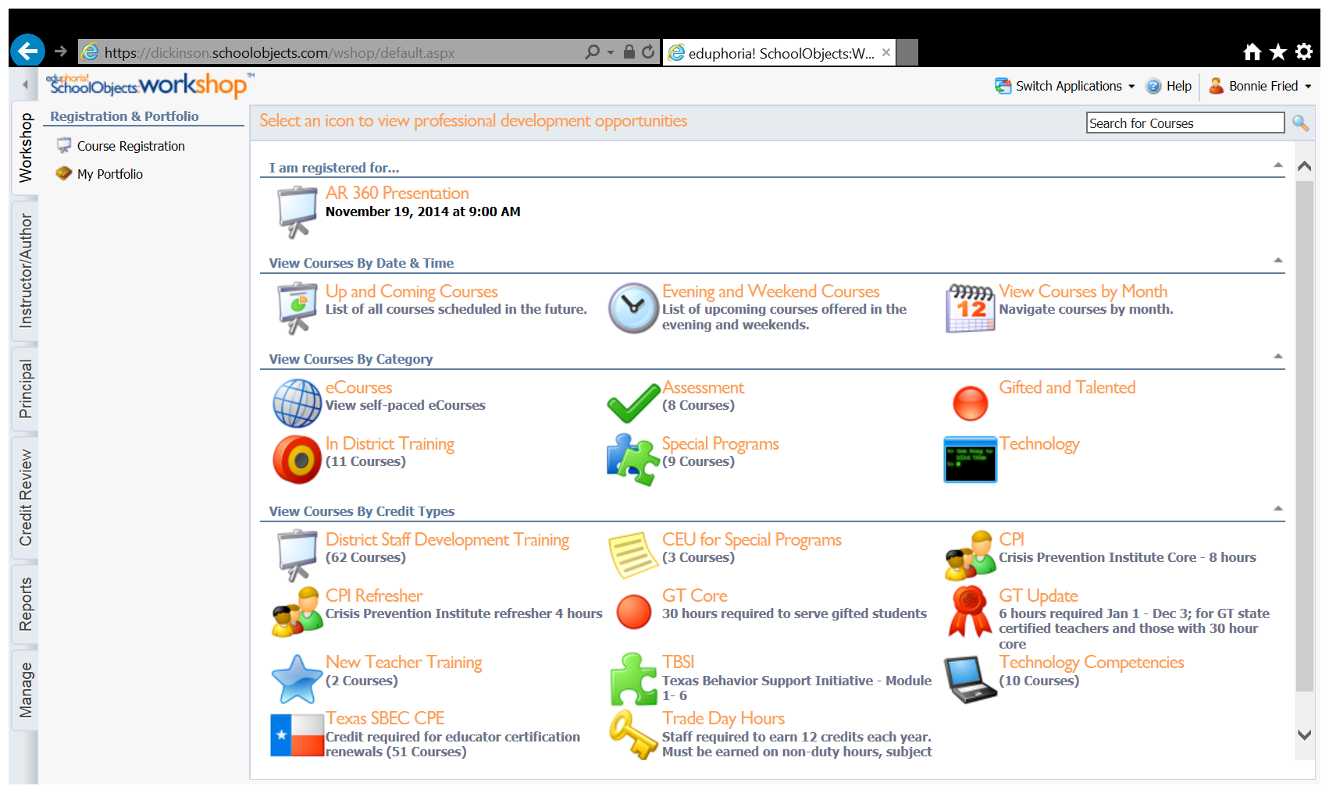

1. Open the class in “My Portfolio” for which you want to print a certificate by clicking on the course. The course information should open.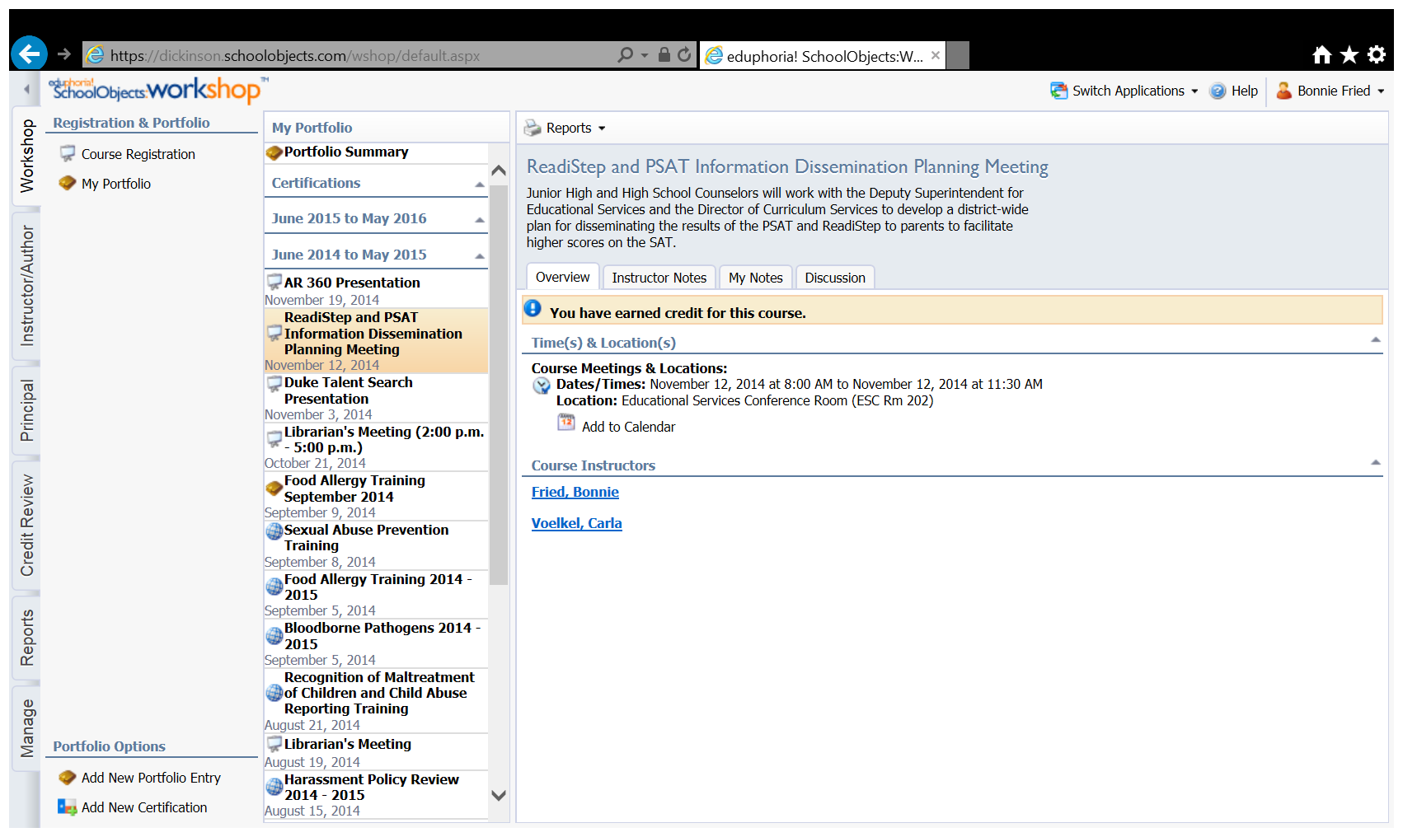
2. Go to Reports at the top of the page and choose Create Certificate.

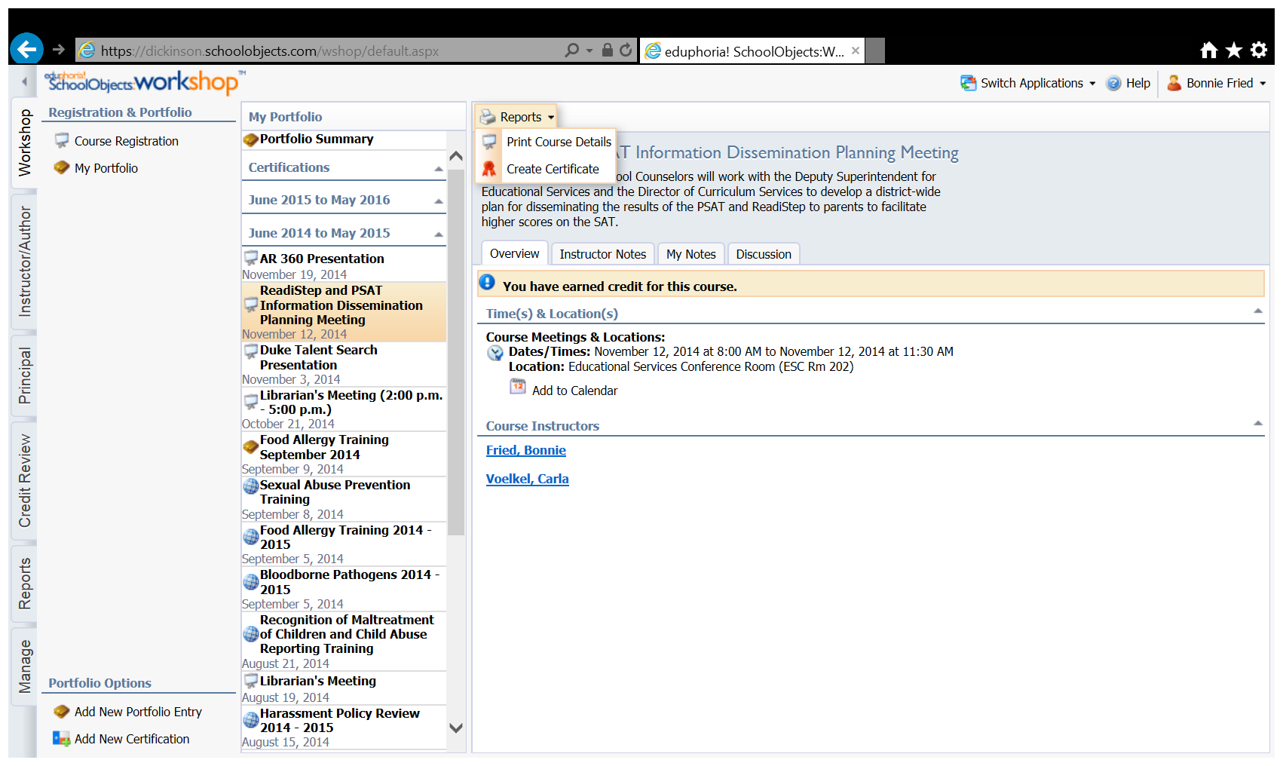

1. Open and Print your certificate.

**Requesting Credit for an Outside Course in Eduphoria**

1. Scan your certificate from the workshop you would like to have credit for and email it to yourself. Save it to your desktop with a name that will connect it to the workshop (i.e. Region IV Nature and Needs).
2. Log into Eduphoria Workshop.
3. Click on My Portfolio in the upper left portion of the screen and then click on Add New Portfolio Entry at the bottom of the screen.

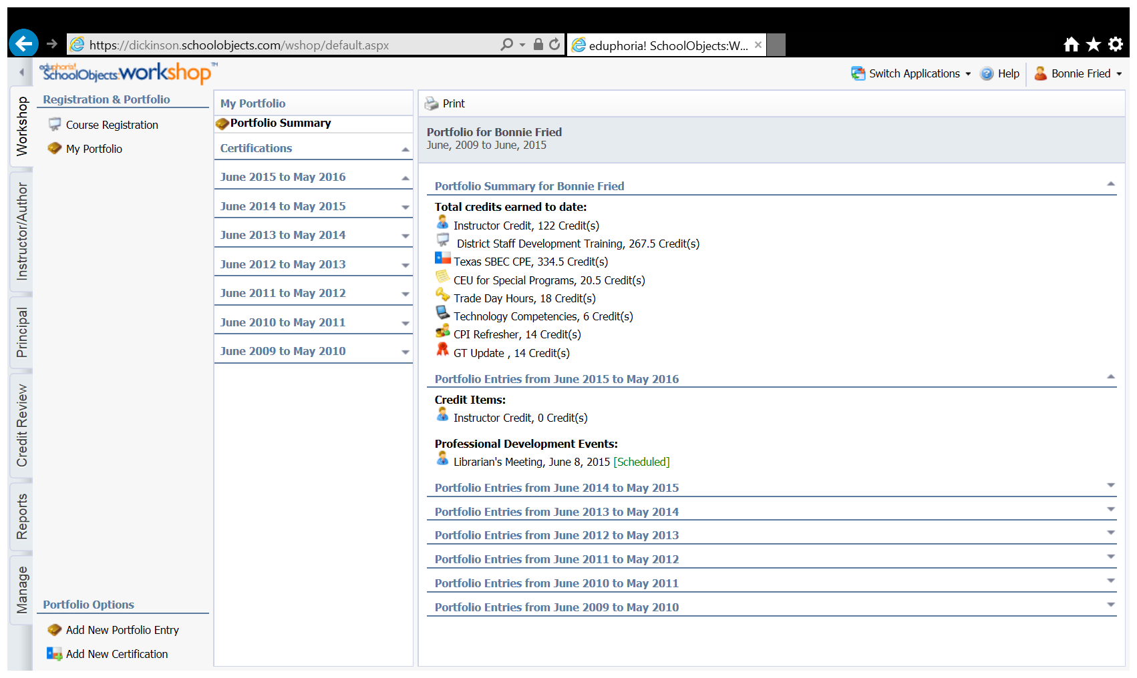

1. Select outside workshop or conference and click next.

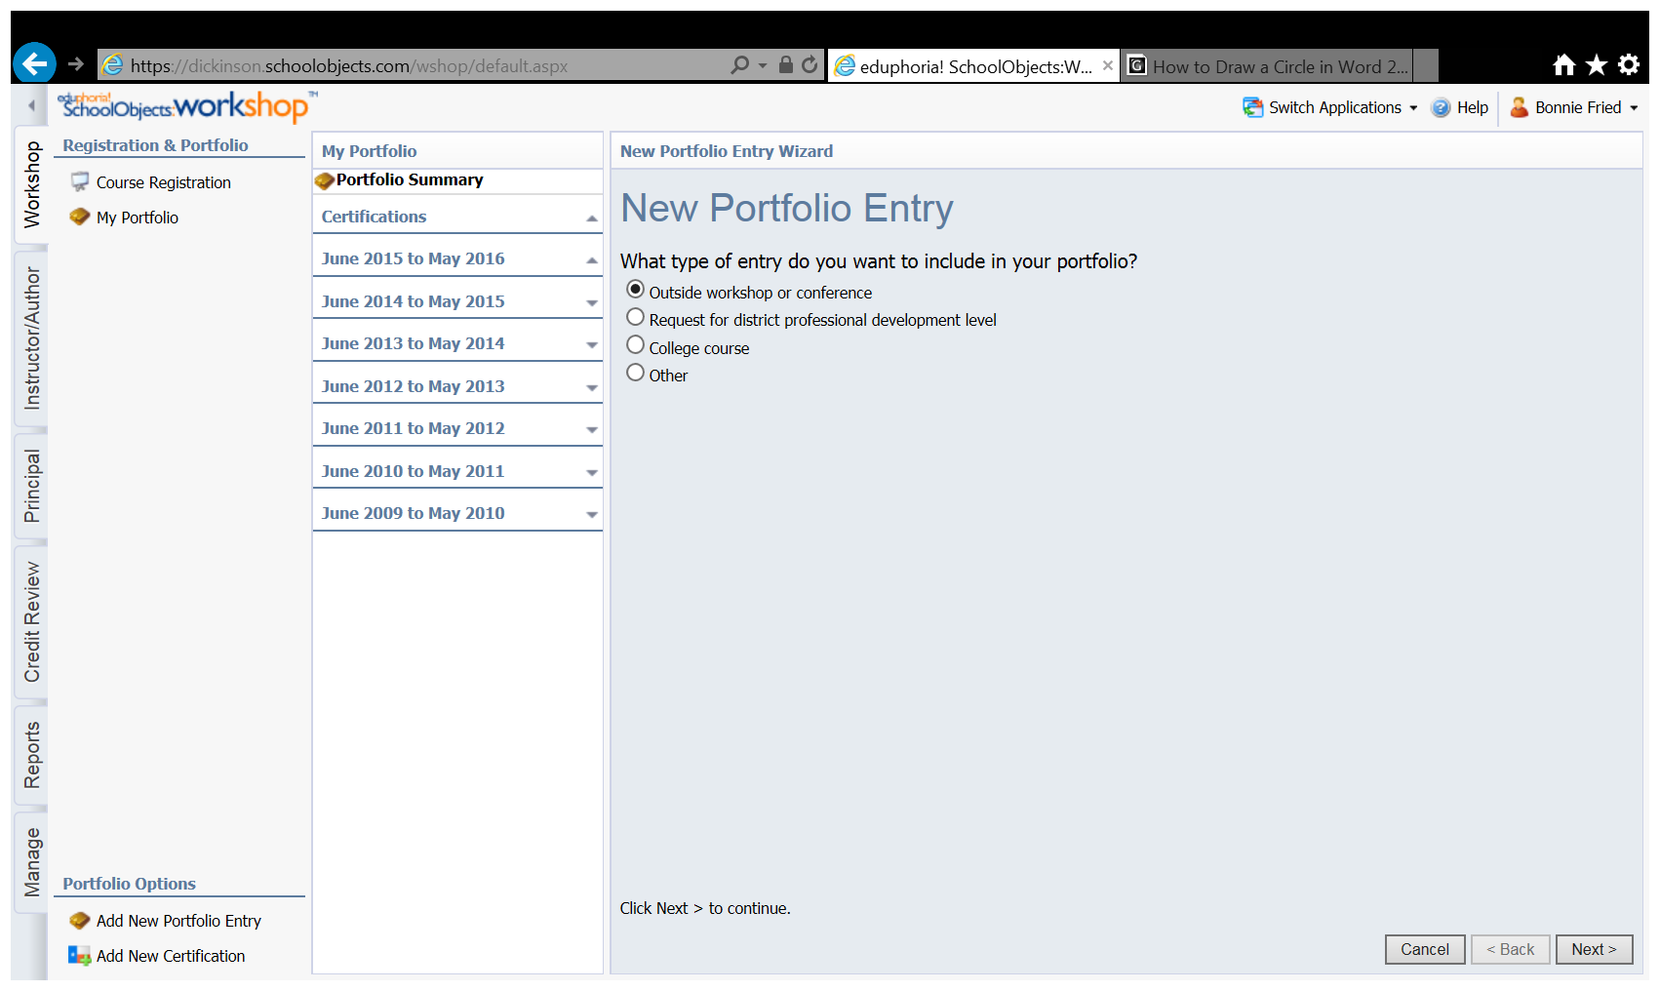

1. Enter a title for the entry and a brief description and click next.

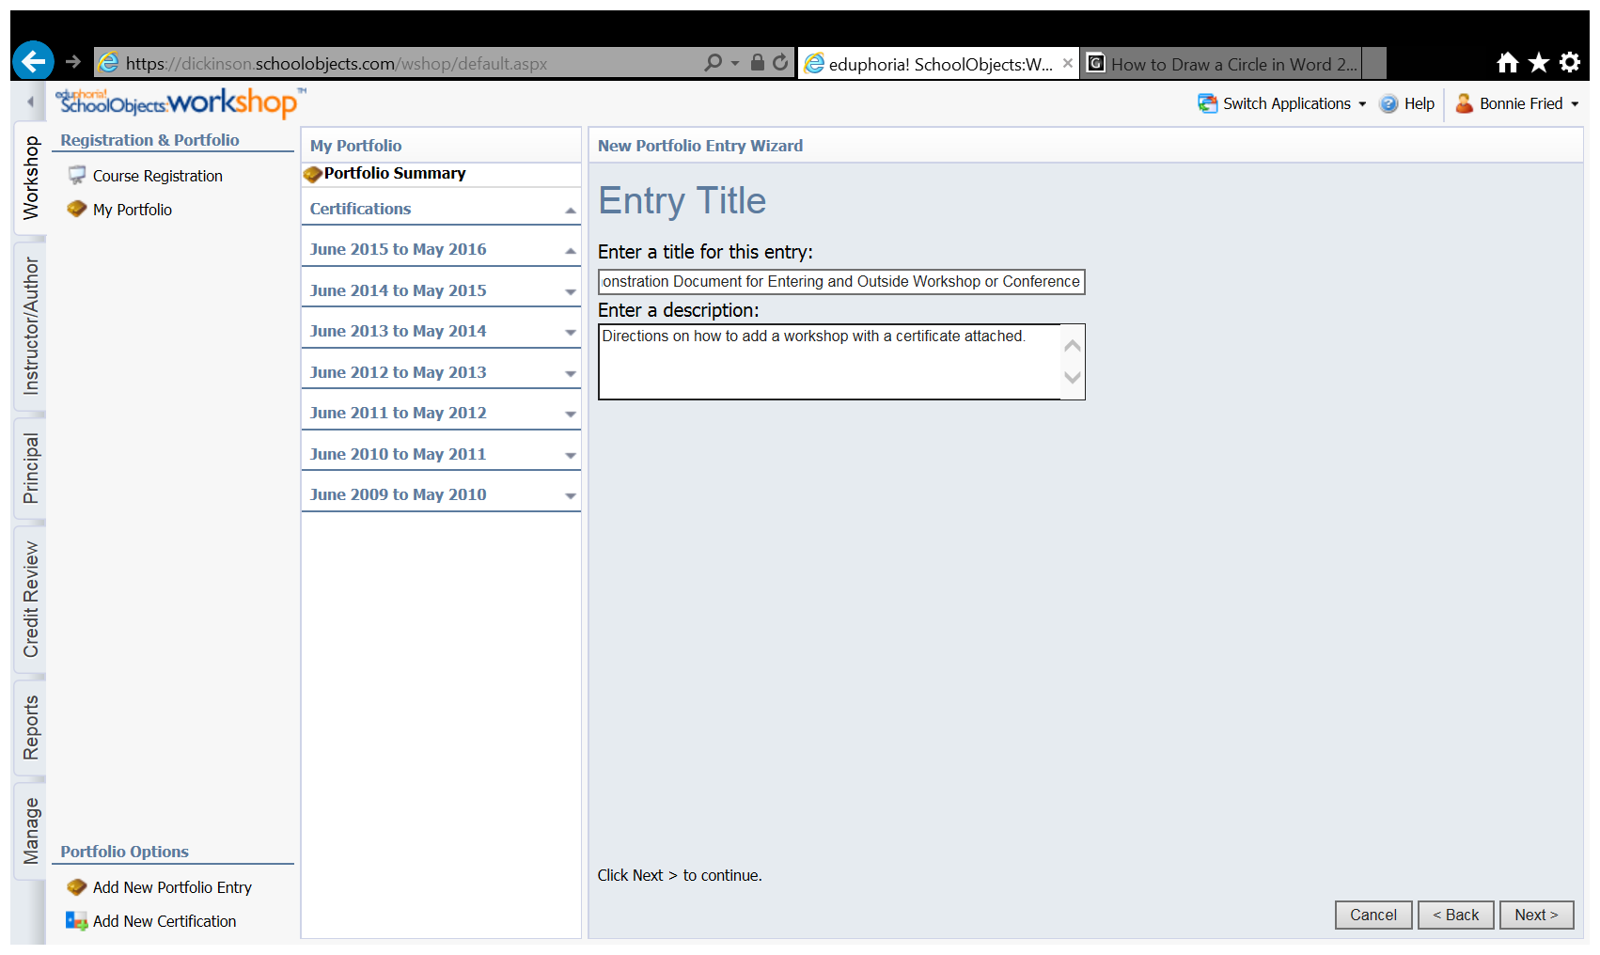

1. Enter the date of the workshop (or the first day of the workshop if it is more than one day) and the time the workshop began. Click Next.

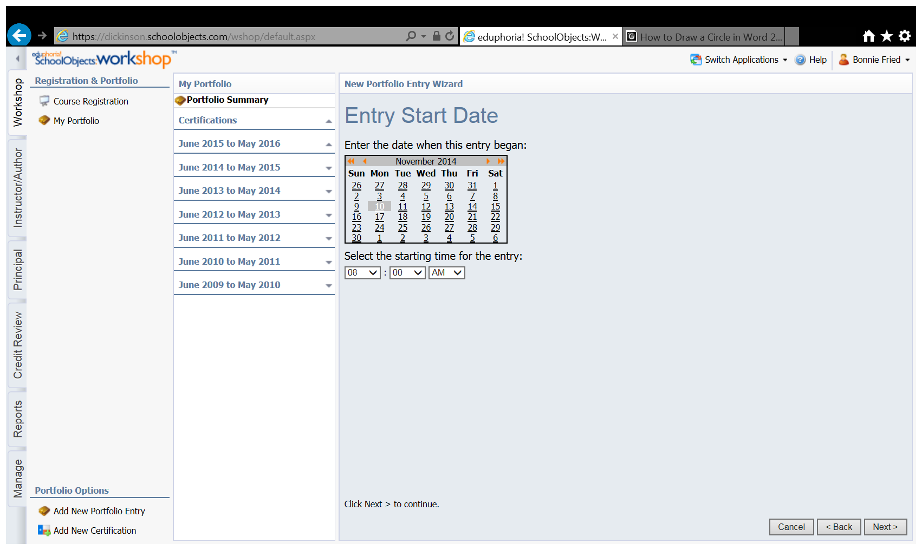

1. Enter the date and time the workshop ended (this is the last date and time for a multi-day workshop).

Click next.

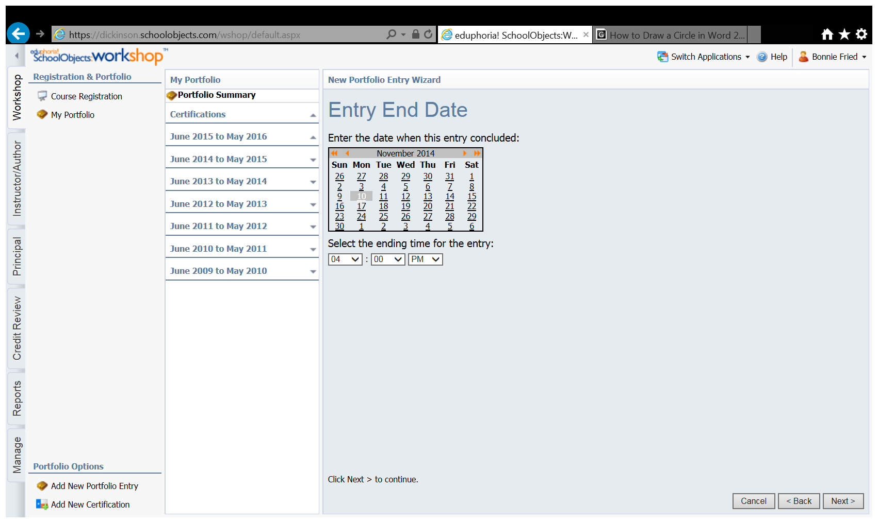

1. Select “yes” you would like to receive district credit for this entry and click next.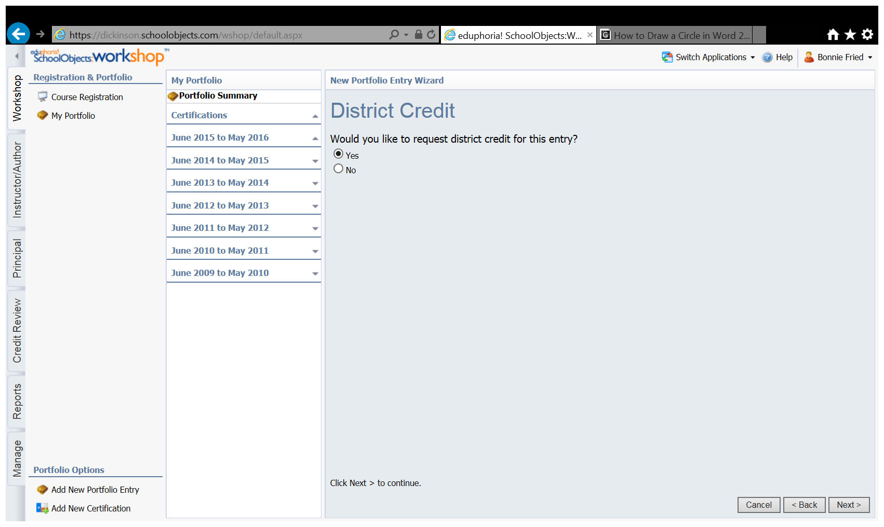
2. Enter the value (number of hours credit) you are requesting in the appropriate category and add any comments you feel would help me determine whether to give credit. Click next

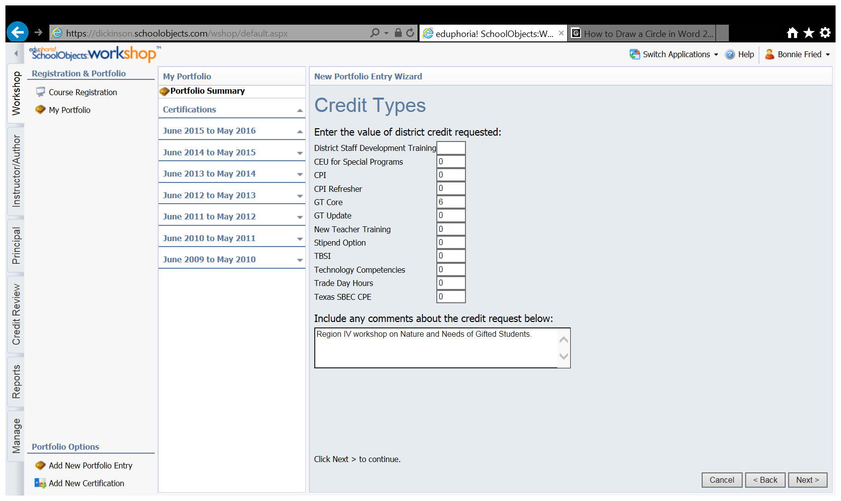

1. Click next on this screen unless you are requesting Texas Technology Applications Standards for Teacher credit.

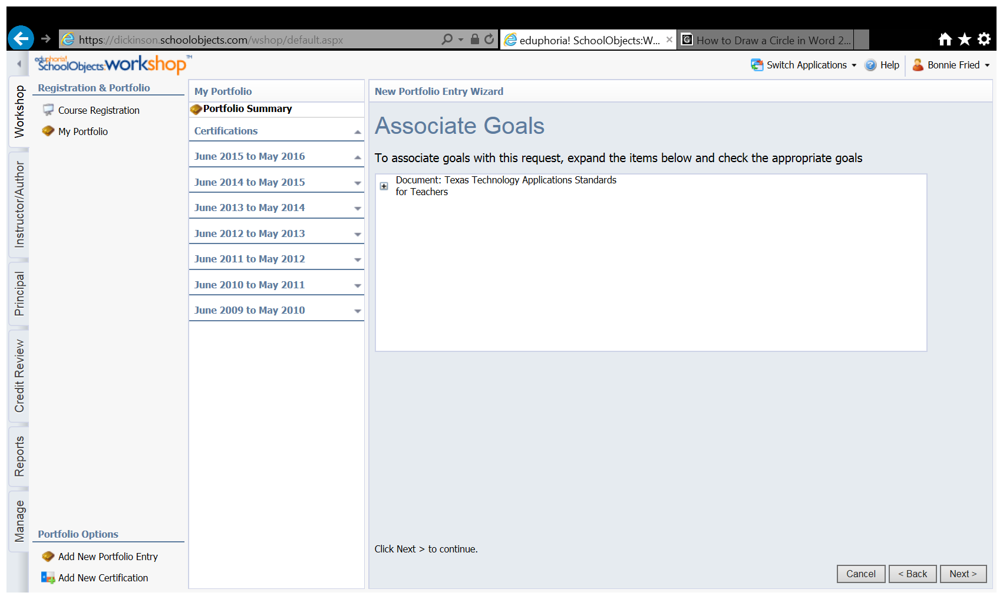

1. **Click at a later time, after I modify the entry.** Click next.

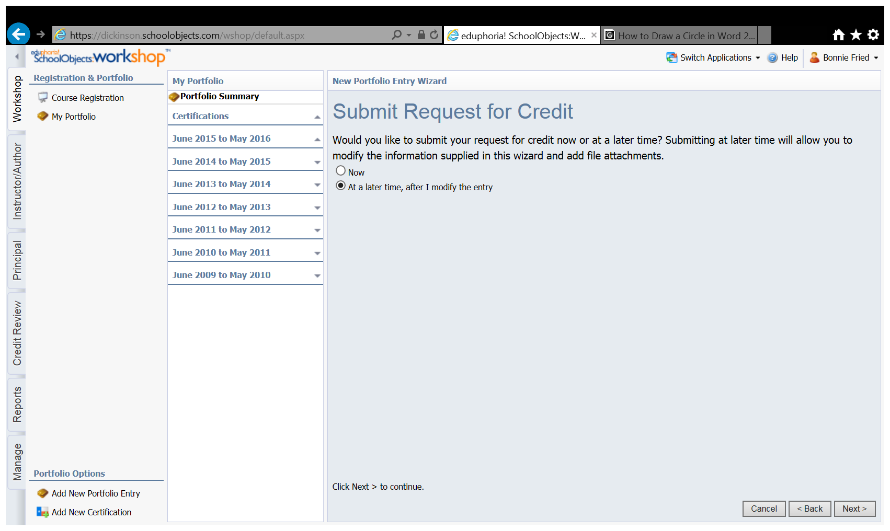

1. Click Finish.

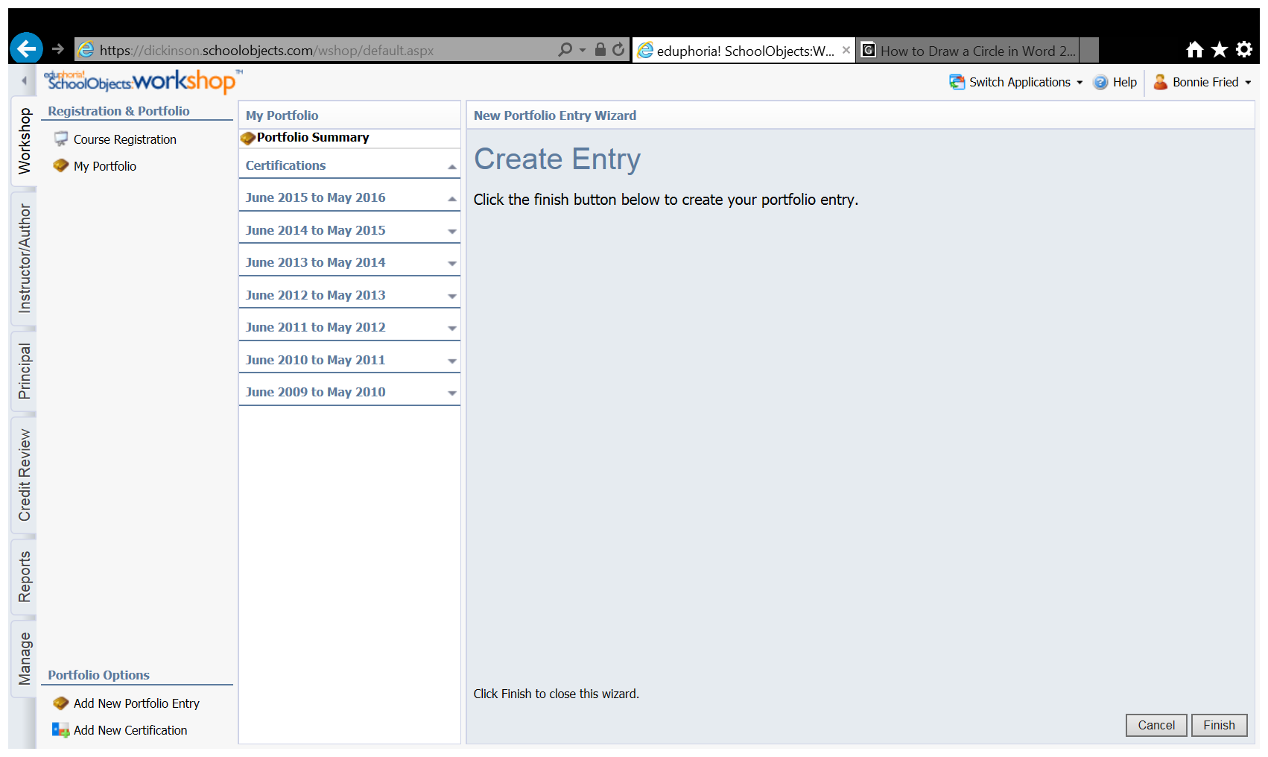

1. In your portfolio, click on the entry you just created. Click on notes.

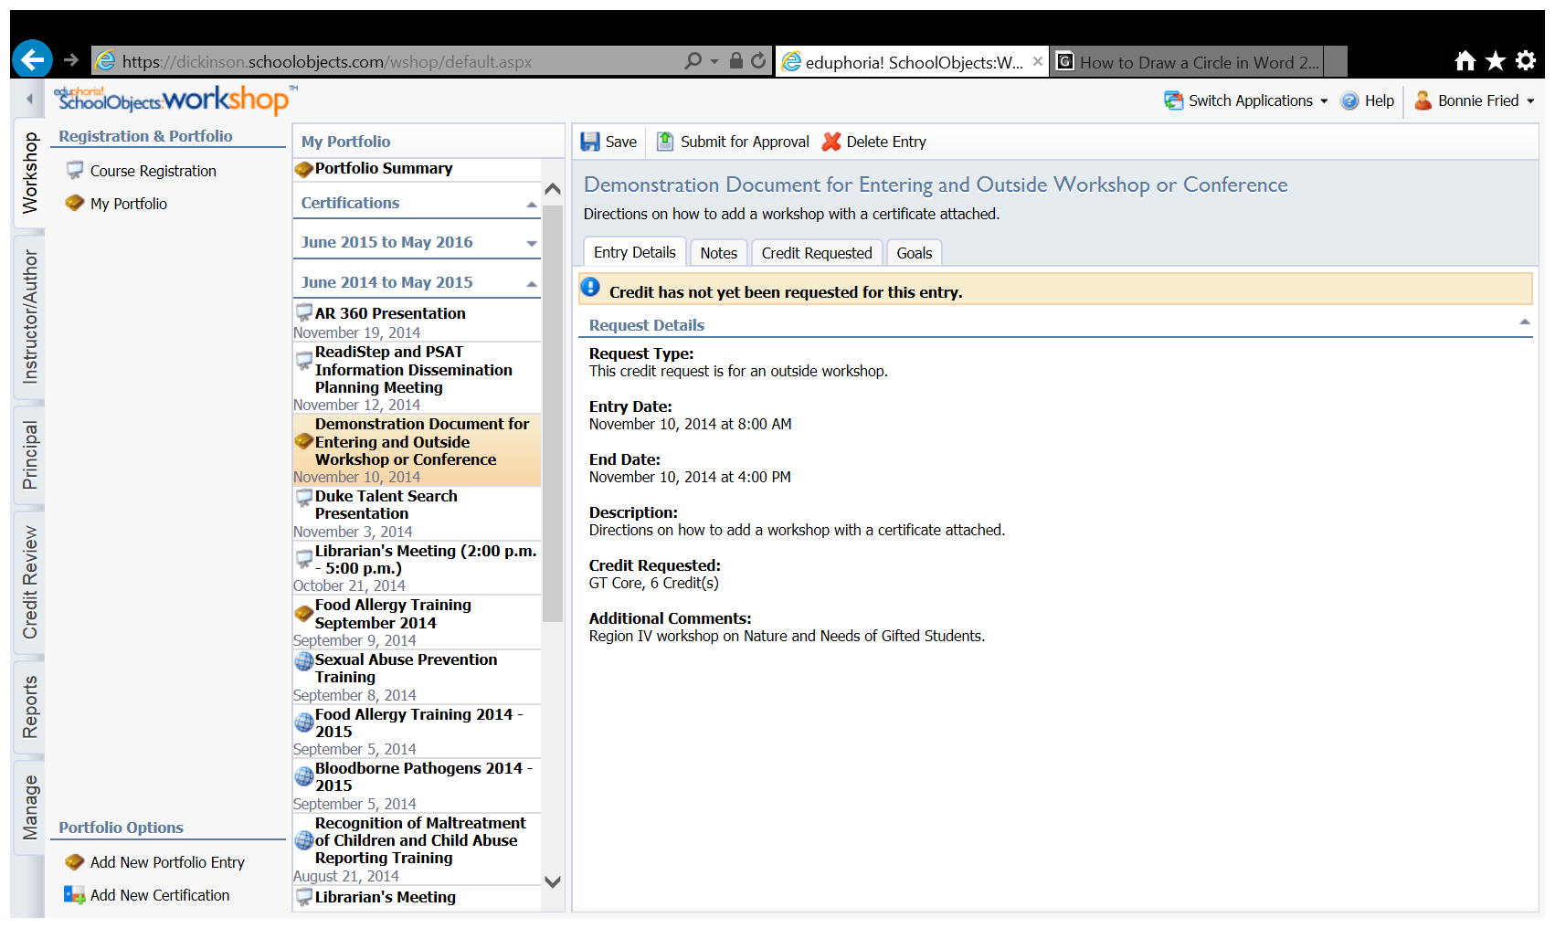

1. Click on the paperclip by portfolio file attachments.

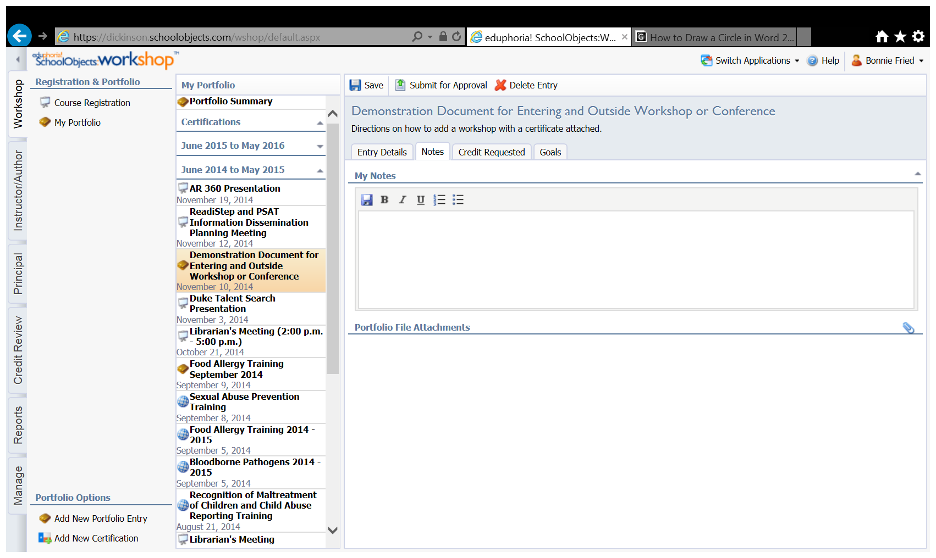

1. Browse your desktop and select the appropriate file. (Remember in step one you saved it to your desktop.) Attach the file to your request.

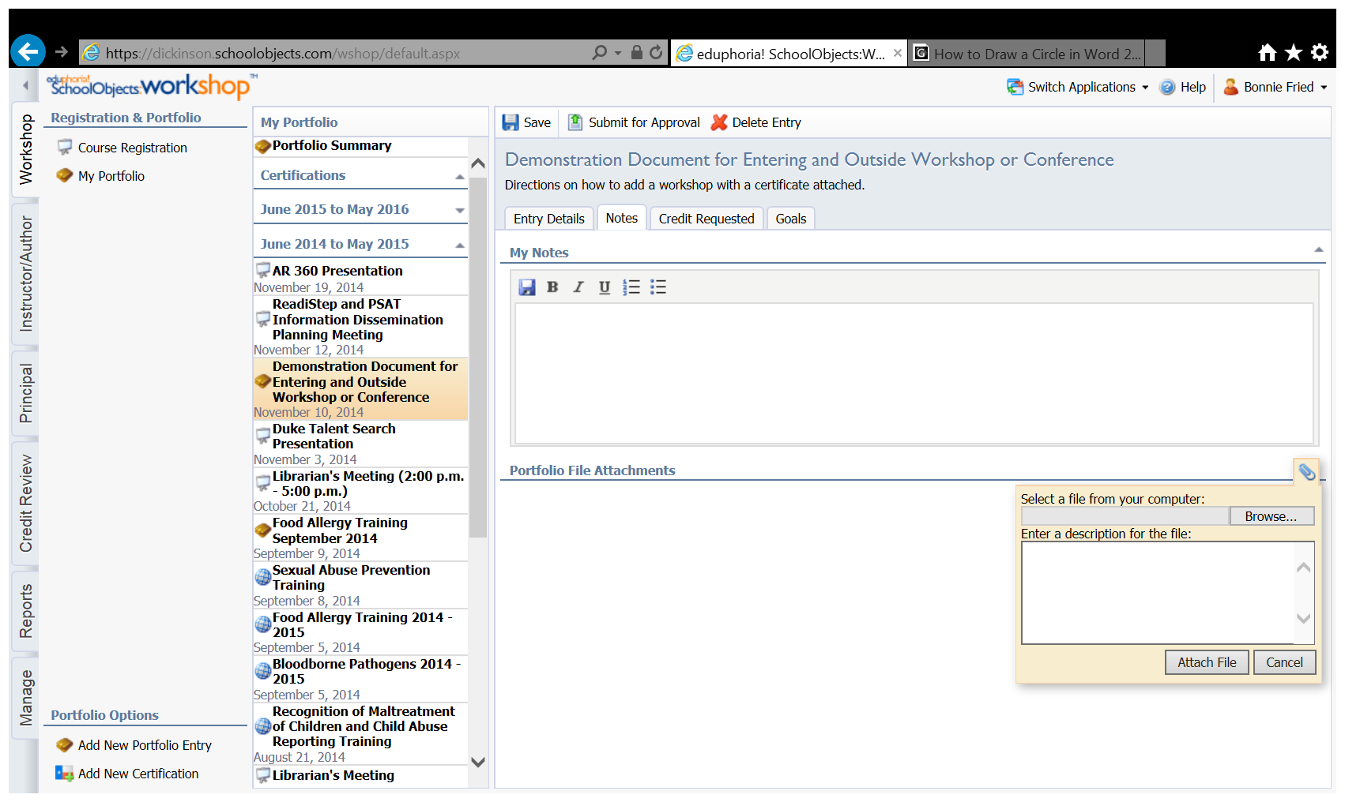

1. Click Save, then click Submit for Approval.

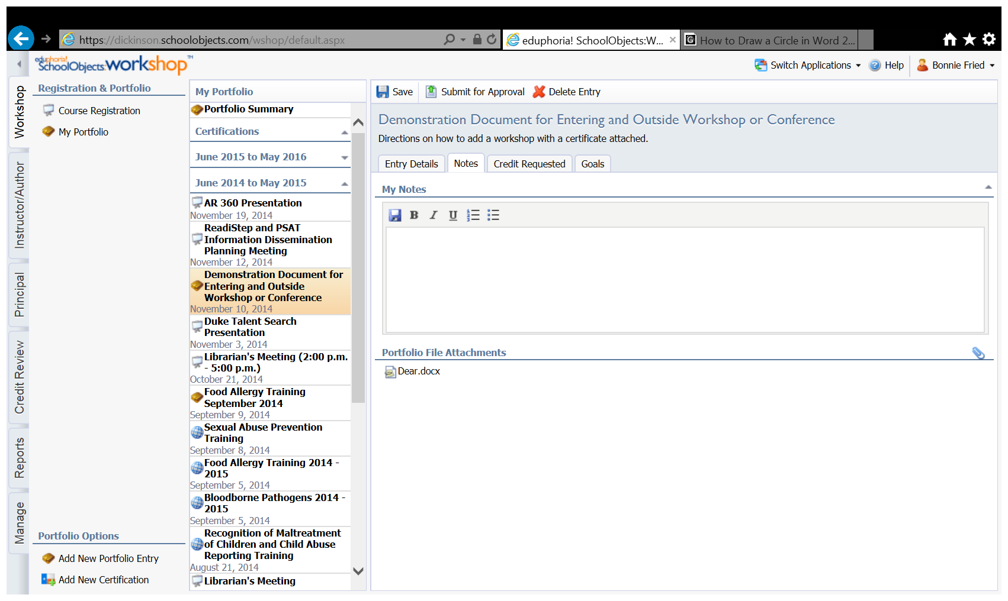

1. You should get a screen that looks like this.

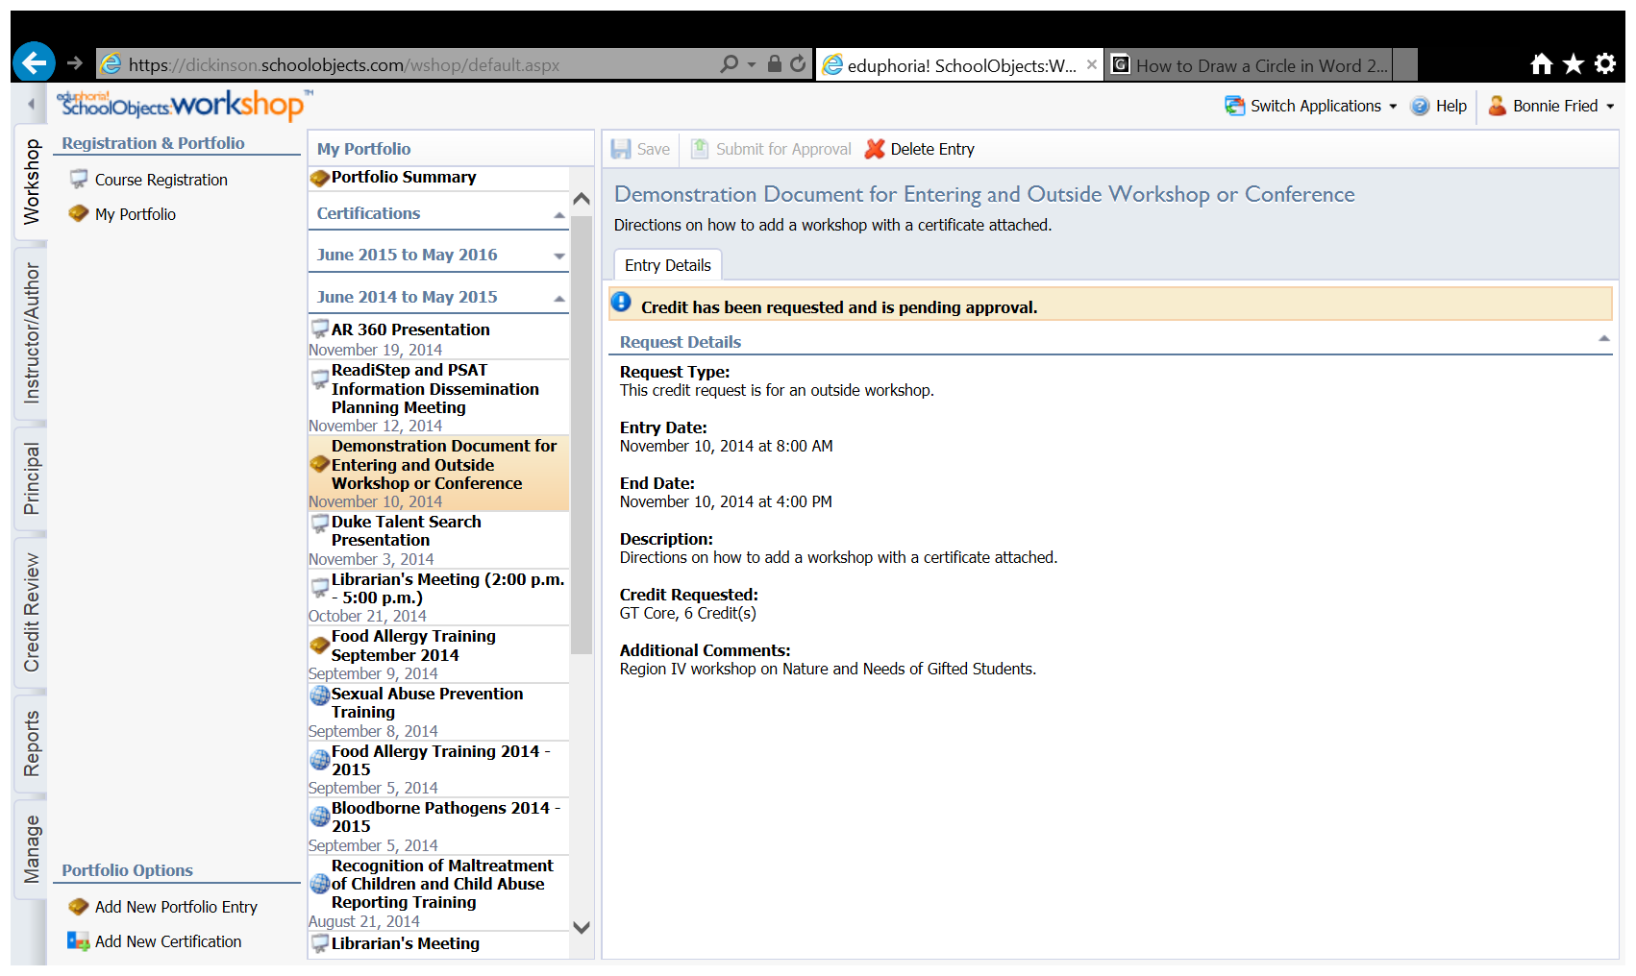

1. Close the workshop..
2. Send the Director of Professional Development an email notifying her of the request.
3. Click on the paperclip by portfolio file attachments.



1. Browse your desktop and select the appropriate file. (Remember in step one you saved it to your desktop.) Attach the file to your request.



1. Click Save, then click Submit for Approval.



1. You should get a screen that looks like this.



1. Close the workshop..
2. Send the Director of Professional Development an email notifying her of the request.