Pinckney School Art

Once a Panther, always a Panther.
That is a saying we passionately live by here at Pinckney.
Pinckney has a deep, illustrious history in Lawrence spanning over 100 years. From its humble beginnings, its time as Pinckney Elementary School, to its existence today as Community Connections at Pinckney, our school has had the incredible fortune to empower an extensive family of leaders, visionaries, educators, scholars, and artists. But Pinckney is far more than more than just a school. Our family of students, teachers, and community members and their work help paint a picture of what it means to be a Panther.
We are beyond grateful for all the extraordinary minds that have enriched our community with their creativity and called Pinckney their home. Creativity and art has been a defining characteristic of our school since its inception. We are proud to share just a small collection of that creative history with you.

The Little Lame Prince
We believe that this painting was given as a gift to Pinckney when the new Art Deco building opened in 1931. Painted by Marjorie Whitney, the piece depicts a scene inspired by The Little Lame Prince and his Travelling Cloak, a story for children written by Dinah Maria Mulock Craik and first published in 1875. Marjorie was the chair of the Design Department at the University of Kansas in the early 1930s and lived in the Pinckney neighborhood.
Along with this piece, Marjorie Whitney has had her other work grace other prominent locales all across Lawrence. Marjorie painted a beautiful wall mural that hangs in the Student Health Services at Watkins Memorial Health Center on the south side of the main KU campus. She designed the facade of the old Watkins Memorial Hospital on campus as well as its original furniture, which is on display at the new hospital.
This painting was restored for Pinckney’s 75th Birthday Celebration by the 2006/2007 staff.

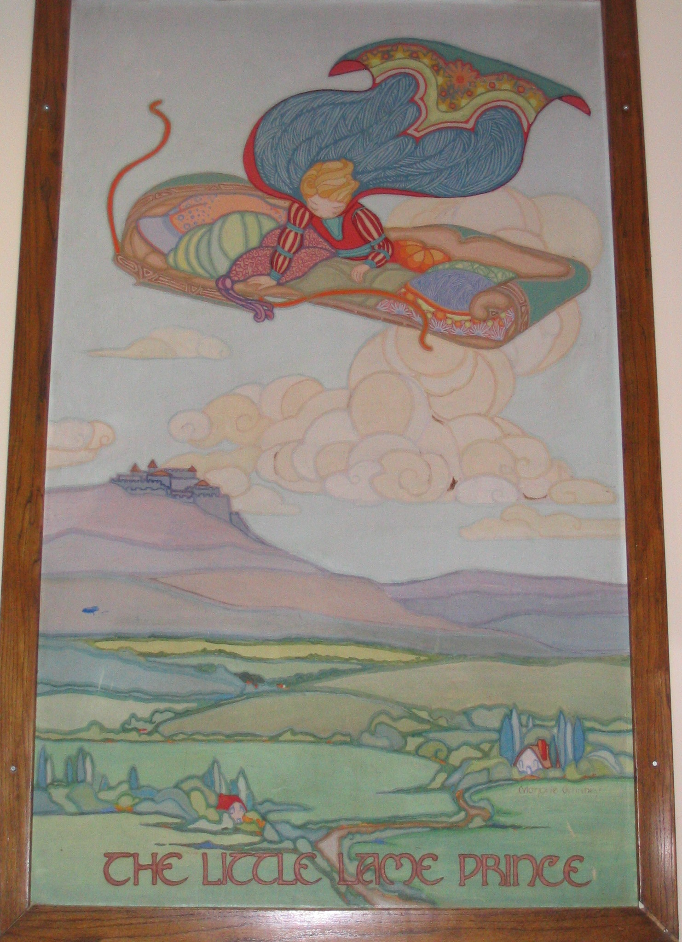

Penny Family
This landscape of rural Kansas farmland was painted in late 1930/early 1940 by teacher, artist, and life-long Lawrencian, Addie Underwood Penny. Addie and her husband, Myrl Nuzum Penny, had five children. All five of the Penny children attended Pinckney Elementary School.

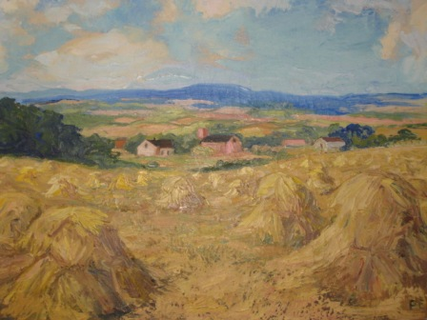

This oil painting, depicting the front of the modern-day Pinckney school building, was created in 1977 by the son of Addie and Myrl Penny, Paul Penny. A veteran of the U.S. Navy, alumnus of Lawrence High School (Class of 1943), and 1952 graduate of the University of Kansas with a Bachelor of Fine Arts degree, Paul shared his mother's talent and passion for art. The former Panther painted the then Pinckney Elementary School building which still stands today in Lawrence on W 6th St. as Community Connections at Pinckney.

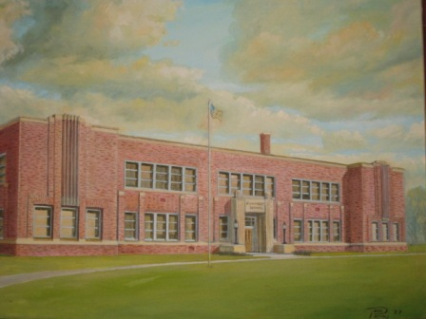
James Smith
This watercolor by James Dean Smith is of the Murphy-Bromelsick House located at 909 Pennsylvania, which was moved to Hobbs Park in 2000. The original brick house was built all the way back in 1866. Bridgett and Timothy Murphy built an addition to the house in 1869 and sold the property to Frederick Bromelsick around 1871, the same year that Pinckney School was being considered. This painting was generously given to Pinckney by James and Jenni Smith as a gift celebrating our 75th birthday in May of 2007. James was a Pinckney student.

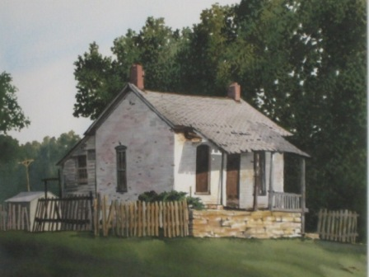

J.R. Hamil
The board accepted this painting in memory of Genevieve West, who championed the education and creativity of Lawrence children, teaching art and music in Lawrence Public Schools for 43 years. Genevieve dedicated her life to being an educator in Lawrence and taught for six years at Centennial and 37 years at Pinckney. Gary Freeman, Pinckney's principal at the time (serving as principal from 1973 to 1996), accepted the watercolor on behalf of the school. Painted by the famous Kansas City watercolor artist J.R. Hamil, the piece portrays an idyllic, dreamlike scene of a one-room schoolhouse stood upon a hill in a surrounding forest.

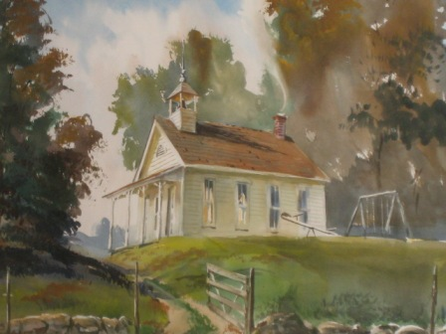

John Talleur
John Talleur was an iconic Lawrence artist and taught in the Fine Arts Department at the University of Kansas. John's work doesn't just have appeal in Kansas, with some of his art being featured at the Smithsonian American Museum of Art. This woodblock print by John shows a robin surrounded by a pattern of leaves and berries and is accompanied by a short poem. The print was to be the first in a series. To our knowledge, this was the only one created.

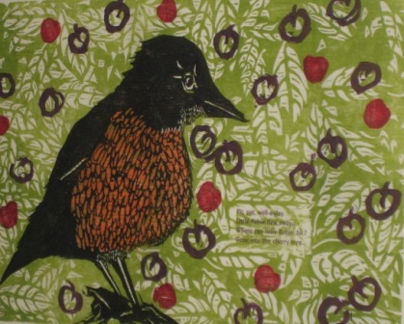

Langston Hughes Mural
This colorful mural can be found today in the hallway near the office at Pinckney. It was a project created by our 2002 Leadership Challenge Student Members under the guidance of our school counselor, Terri Johnson and our business partner, Gould Evans.

The piece is a touching tribute to Pinckney's long-standing history here in Lawrence. Along with a vibrant collage of Pinckney school buildings throughout the years, the famous poet and Pinckney Panther Langston Hughes is depicted in the foreground of the mural. Langston Hughes attended Pinckney School, entering as a second grader in 1909.

