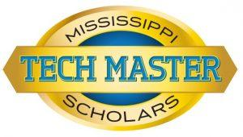

**Tech Master Curriculum**

for Seniors of School Year 2016 and Later

**\*Flexibility to tailor courses to area of interest.**

**ENGLISH LANGUAGE ARTS**

(4 Credits) English

**MATHEMATICS**

*(3 Credits) Math

* Algebra I
* Math above Algebra I (Course has to be related to program of study)

**\*\*Geometry Mandatory**

**SCIENCE**

(3 Credits) Science

* Biology I
* 2 courses above Biology I

**SOCIAL STUDIES**

(3 Credits) Social Studies

* American History
* Government
* MS Studies

**OTHER COURSES**

(1 Credit) Computer

(½ Credit) Health or PE

**ELECTIVES**

(2.5) Electives of your program of study

* 4 CTE Credits in the same area of study
* Must have 21 minimum credits - students can go the 21 or 24 credit route allowing time for internship
* Non-negotiable

**Additional Requirements for Recognition of Mississippi Scholars Tech Master Listed Below:**

* **80 hours of community or volunteer service** during high school for seniors graduating in 2022 and later
* **Minimum of 19 ACT** composite score (overall score) for seniors graduating in 2022 or later)or Minimum 36 ASVAB (Armed Services Vocational Aptitude Battery Test) or Silver Level WorkKeys
* 2.5 high school GPA
* 95% school attendance during high school years
* No out-of school suspension
* Must attain a passing score, as established by the Mississippi Department of Education (MDE), on the Mississippi Career Planning and Assessment System **(CPAS2)** or a passing score on an MDE approved industry certification assessment.

**Mississippi Scholars Tech Master must complete any remaining State-Mandated high school graduation requirements. Dual credit courses are acceptable.**