Dear Students and Parents,

We are so glad you are interested in applying for Robotics for the upcoming 2023-2024 school year!

There will be an interest meeting for parents and students on **Tuesday, March 21st**, in the library at 6 pm.

Robotics is an integrated part of Cyber Foundations (6th & 7th grade) and Computer Science and Engineering (8th grade) classes. Robotics is not an elective. It is an exciting class that requires students to use the engineering design process to build a robot as a team. The teams will compete in challenging competitions. In this class we learn how to code, design a robot to score points during competitions, and record the entire process in our engineering notebook. We will compete at local and possibly state competitions. We also have the potential to compete at the World level.

Robotics is NOT only for gifted students. It is for ANY student with a strong work ethic, leadership, ability to work with teams, perseverance, cooperative, imaginative, self-driven, a good listener and willing to compromise. **This class takes a lot of hard work and commitment**! It is also a **team** - **oriented** class that requires students to work cooperatively with multiple students. Students must follow the attached REC Foundation Code of Conduct. Failure to do so could result in removal of the class.

As competitions approach, there are possibilities of after school or weekend work sessions. **Competitions are usually held on Saturdays and take place all day from 8:00 am until at least 5:00 pm.** Competition days will be communicated in advance so you and your family can plan accordingly if your child is selected to be a part of this class. Attending competitions is a requirement unless approved beforehand. When a student doesn’t attend a competition, it creates possible problems for the rest of the team.

We do our best to ensure that the fees you pay to be in this class provide for all competition fees. This fee is $200.00. However, fundraising is vital to our program and participation is required.

Thanks for your interest!

Sarah Beth Berry

Melissa Rice

**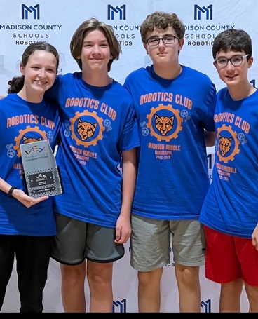***To learn more, visit our Instagram page: madisonmiddlerobotics*

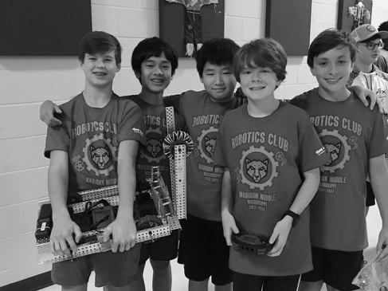



**Code of Conduct**

Behavior and Ethical Standards of the Robotics Education & Competition (REC) Foundation

• Act with integrity, honesty and reliability

• Behave in a respectful and professional manner with team, coaches, and all event and team staff

• Exhibit maturity and class when dealing with difficult and stressful situations

• Respect individual differences

• Follow all rules listed in the current game manual

• Student-centered teams with limited adult assistance

• Safety as a top priority

• Good sportsmanship at all times

**Materials to be Submitted**

**Parents:**

Please complete the forms on the next pages and have your student return it to your teacher or grade level counselor.

1. **Student Information Sheet:** Please complete all information for this school year.
2. **Student/Parent Signature Sheet:** Please initial next to each line indicating that you've read and understand the expectations of your child if they are selected to be in Robotics for the 2023-2024 school year. Both you and your child need to provide signatures acknowledging that you understand the class expectations.

**Students:**

Along with signing the **Student Information Sheet** as described above, please turn in the **2023-2024** **ROBOTICS APPLICATION** form along with your answers on a separate sheet(s) of paper.

**Teachers:**

Students must ask teachers to fill out online evaluations for Robotics. Students will give teachers the evaluation request forms. A link for evaluations will be emailed to teachers. Fifth grade students must have TWO (2) evaluations. Sixth and Seventh grade students must have FOUR (4) evaluations.

Robotics is an exciting opportunity for your child to learn real-world problem solving and networking skills, as well as technology applications! Should you have any questions about our application and the application process, please do not hesitate to email me at[**sberry@madison-schools.com**](mailto:sberry@madison-schools.com)

**\*Completing and turning in this packet does NOT guarantee a spot in robotics. Decisions are made based on teacher evaluations and the number of spaces available.**

**ROBOTICS APPLICATION 2023-2024**

**DUE March 31, 2023 to your Grade Level Counselor or Teacher**

Answer the following questions on a separate piece of paper. You can handwrite the answers (make sure it is legible) to the questions, or type and print them. Please be **detailed** in your responses and answer honestly. This is for students to answer. This is not for parents to answer.

1. Why are you interested in robotics? What do you wish to gain from being in this class?
2. What experience do you have in robotics/STEM/Technology? (Legos, summer camps, coding, TSA events, etc.)
3. Each teammate is required to hold at least two roles on the team. Pick two roles below and explain why you would be a good fit for these roles.
   * 1. **Driver** (Responsible for driving the robot on the field and maximizing points scored.) ·
     2. **Builder** (Assembles the robot, knowledgeable about how the parts go together and can see problems and solutions when building.)
     3. **Coder** (Can write code to make the robot run with driver control and autonomous programming.)
     4. **Notebook** (Works with all jobs to document every aspect of the building process from Day 1.) (All students will write in the notebook, but one student primarily in charge of making sure everything is documented.)
4. How do you feel about working in a group setting? Explain both positive and negative experiences.
5. Imagine your team is working on changing the structure of your robot, but two out of the 4 team members cannot agree on a decision. How would you go about fixing this problem?
6. Imagine a member of your team is not following through on a job they were given, explain how you would go about addressing your teammate in this situation.
7. If you come across a problem in building or coding your robot, what might you do to find out what went wrong? Explain the steps you would take to fix the problem.
8. Because robotics is sometimes a very stressful environment - requiring deadlines and during the competition matches - how do you personally deal with stressful situations?
9. What other activities are you involved in at school and outside of school? (Show choir, soccer, church, etc.).
10. If there is anything else you would like to include, let us know! What makes you stand out? Why should you be in the class

**Student/Parent Signature Sheet**

**\*\* TURN THIS SHEET BACK IN\*\***

**Due March 31, 2023 to your Grade Level Counselor**

**Please initial each line and sign at the bottom of this form (parent and student):**

**________ Class fee will be $200.** Robotics is very expensive and requires many fees for competitions/travel/materials. You may pay this fee online via school bucks (when the new school year begins), cash or check.

**________** No robots or robot parts will be taken home to be worked on unless approved by the teacher. We have 90 minutes of class time all year - this time should be sufficient to build your robot and prepare for competition. If necessary, after school build sessions will be implemented.

**__** Dates for competitions will be given months ahead of time, and every team member should plan to be present at all competitions. If there is a conflict, please notify Mrs. Berry as soon as possible.

**________** Competitions are all day events. They are held on Saturdays starting at 8:00 AM last until at least 5:00 PM. Sometimes, there are also weeknight commitments depending upon how large the competition is.

**________** Students are expected to work hard during every class period. Failure to do so could result in removal from class.

**________** Students will maintain a positive attitude and will support all members on their team and in their class while working cooperatively.

________ Volume should be controlled as classes are being conducted around our classroom.

________ Students will be safe with all tools.

**Student Signature:** **_______________________________________________**

**Parent Signature:** **________________________________________________**

**Student Information Sheet**

**Student Name: ­_______________________________________________**

**Current Grade: ­________**

**Current School: __________________________________**

**Homeroom Teacher: ­______________________________**

**T-shirt size for next year (consider growth):**

**YS YM YL YXL AS AM AL AXL AXXL**

**Parent Contact Information:**

**Mother’s Name: _______________________________________**

**Phone/Cell Number: ­____________________________**

**Email: ­______________________________________________**

**Father’s Name: ________________________________________**

**Phone/Cell Number: ­________________________________**

**Email: ­_______________________________________________**

**TEACHER EVALUATIONS FOR ROBOTICS CANDIDATES**

Students, please choose teachers and have them submit your evaluations to your school counselor by **March 31, 2023.**

**5th Grade Students- Choose *2* teachers**

**6th & 7th Grade Students- Choose *4* teachers**

**Teachers,**

**Thank you so very much for completing these evaluations. Your input is VITAL in appropriate placement for the MMS Robotics program. Please be honest with your input. It will be kept confidential. Neither students nor parents will see your responses. Questions? Email** [**sberry@madison-schools.com**](mailto:sberry@madison-schools.com)

**Links to these evaluations will be emailed to you. If you cannot find them, please email me.**

**Students Name Requesting Evaluation: _____________________________________**

**TEACHER EVALUATIONS FOR ROBOTICS CANDIDATES**

Students, please choose teachers and have them submit your evaluations to your school counselor by **March 31, 2023.**

**5th Grade Students- Choose *2* teachers**

**6th & 7th Grade Students- Choose *4* teachers**

**Teachers,**

**Thank you so very much for completing these evaluations. Your input is VITAL in appropriate placement for the MMS Robotics program. Please be honest with your input. It will be kept confidential. Neither students nor parents will see your responses. Questions? Email** [**sberry@madison-schools.com**](mailto:sberry@madison-schools.com)

**Links to these evaluations will be emailed to you. If you cannot find them, please email me.**

**Students Name Requesting Evaluation: _____________________________________**

**TEACHER EVALUATIONS FOR ROBOTICS CANDIDATES**

Students, please choose teachers and have them submit your evaluations to your school counselor by **March 31, 2023.**

**5th Grade Students- Choose *2* teachers**

**6th & 7th Grade Students- Choose *4* teachers**

**Teachers,**

**Thank you so very much for completing these evaluations. Your input is VITAL in appropriate placement for the MMS Robotics program. Please be honest with your input. It will be kept confidential. Neither students nor parents will see your responses. Questions? Email** [**sberry@madison-schools.com**](mailto:sberry@madison-schools.com)

**Links to these evaluations will be emailed to you. If you cannot find them, please email me.**

**Students Name Requesting Evaluation: _____________________________________**

**TEACHER EVALUATIONS FOR ROBOTICS CANDIDATES**

Students, please choose teachers and have them submit your evaluations to your school counselor by **March 31, 2023.**

**5th Grade Students- Choose *2* teachers**

**6th & 7th Grade Students- Choose *4* teachers**

**Teachers,**

**Thank you so very much for completing these evaluations. Your input is VITAL in appropriate placement for the MMS Robotics program. Please be honest with your input. It will be kept confidential. Neither students nor parents will see your responses. Questions? Email** [**sberry@madison-schools.com**](mailto:sberry@madison-schools.com)

**Links to these evaluations will be emailed to you. If you cannot find them, please email me.**

**Students Name Requesting Evaluation: _____________________________________**