Substance Abuse & Adolescents
Participant Handout
Objectives
By the end of this training, you will be able to:
- Describe the prevalence and impact of substance abuse in adolescents.
- Identify the risk factors and warning signs of substance abuse issues.
- Address an adolescent with a possible substance abuse issue.

Early Stages of Teen Substance Use
Level 1: EXPERIMENTATION | Level 2: MISUSE | Level 3: EARLY ABUSE
First experiences. | Pattern of use develops. | Skilled at hiding use.
Lack of parental knowledge. | Justifications for use (to relax, socialize). | Acquires paraphernalia, plans for use.
Low tolerance. | Seeks mood change. | Increased tolerance.
Experimental, occasional use. | Use mostly only weekends. | Occasional weekday use.
Control & choice are high. | Control & choice are present. | Diminished control & choice.
Low consequences. | Some social & personal consequences. | Increased consequences.

Warning Signs of Substance Abuse
Home | School | General/Other
- Changing attitudes towards rules  - Less participation in family activities  - Isolating, staying in room much of the time  - Talkativeness  - Breaking curfew, sneaking out at night  - Items disappear from home: money, alcohol, medications  - Lying and blaming others for problems  - Depression or overactivity  - Drug-related room decor | - Missed or poorly done assignments  - Decrease in class participation  - Shorter attention span  - Decrease in concentration  - Frequent visits to bathroom or health office  - Frequent tardiness &/or absence  - Sleeping in class  - Disrespectful to teachers  - Suspensions, expulsions  - Dropping out of activities  - Falling grades  - Emotional highs & lows | - Chang in personality, mood swings  - Weight gain/loss  - Erratic sleeping & eating habits  - Dilated pupils, red eyes, use of eye drops or sunglasses  - Short term memory loss  - Drug-related clothing; change in style of dress  - Trouble with the law  ONLINE SIGNS:  - Video consistently off  - Video background shows drug paraphernalia  - Video background shows chaotic living environment

Conversation Starters
- I am concerned about you and care for your safety.
- I am concerned because I have noticed… (your grades are going downhill, you’ve cut class, you missed your curfew, you’ve had several blowups recently, money/alcohol/medications are missing from our home.)
- I know that you may have access to alcohol and drugs.
- When was the last time you used drugs or alcohol or marijuana? How often are you using drugs, drinking alcohol, or smoking weed/vape?
- I think our family needs some help with this issue. I want to get some support for our family.
Notes:
______________________________________________________________________________________________________________________________________________________________________________________________________________________________________________________________________________________________________________________________________________________________________________________________________________________________________________________________________________________________________________________________________________________________________________________________________________________________________________________________________________________________________________________________________________________________________________________________________________________________________________________________________________________________________________________________________________________________________________________________________
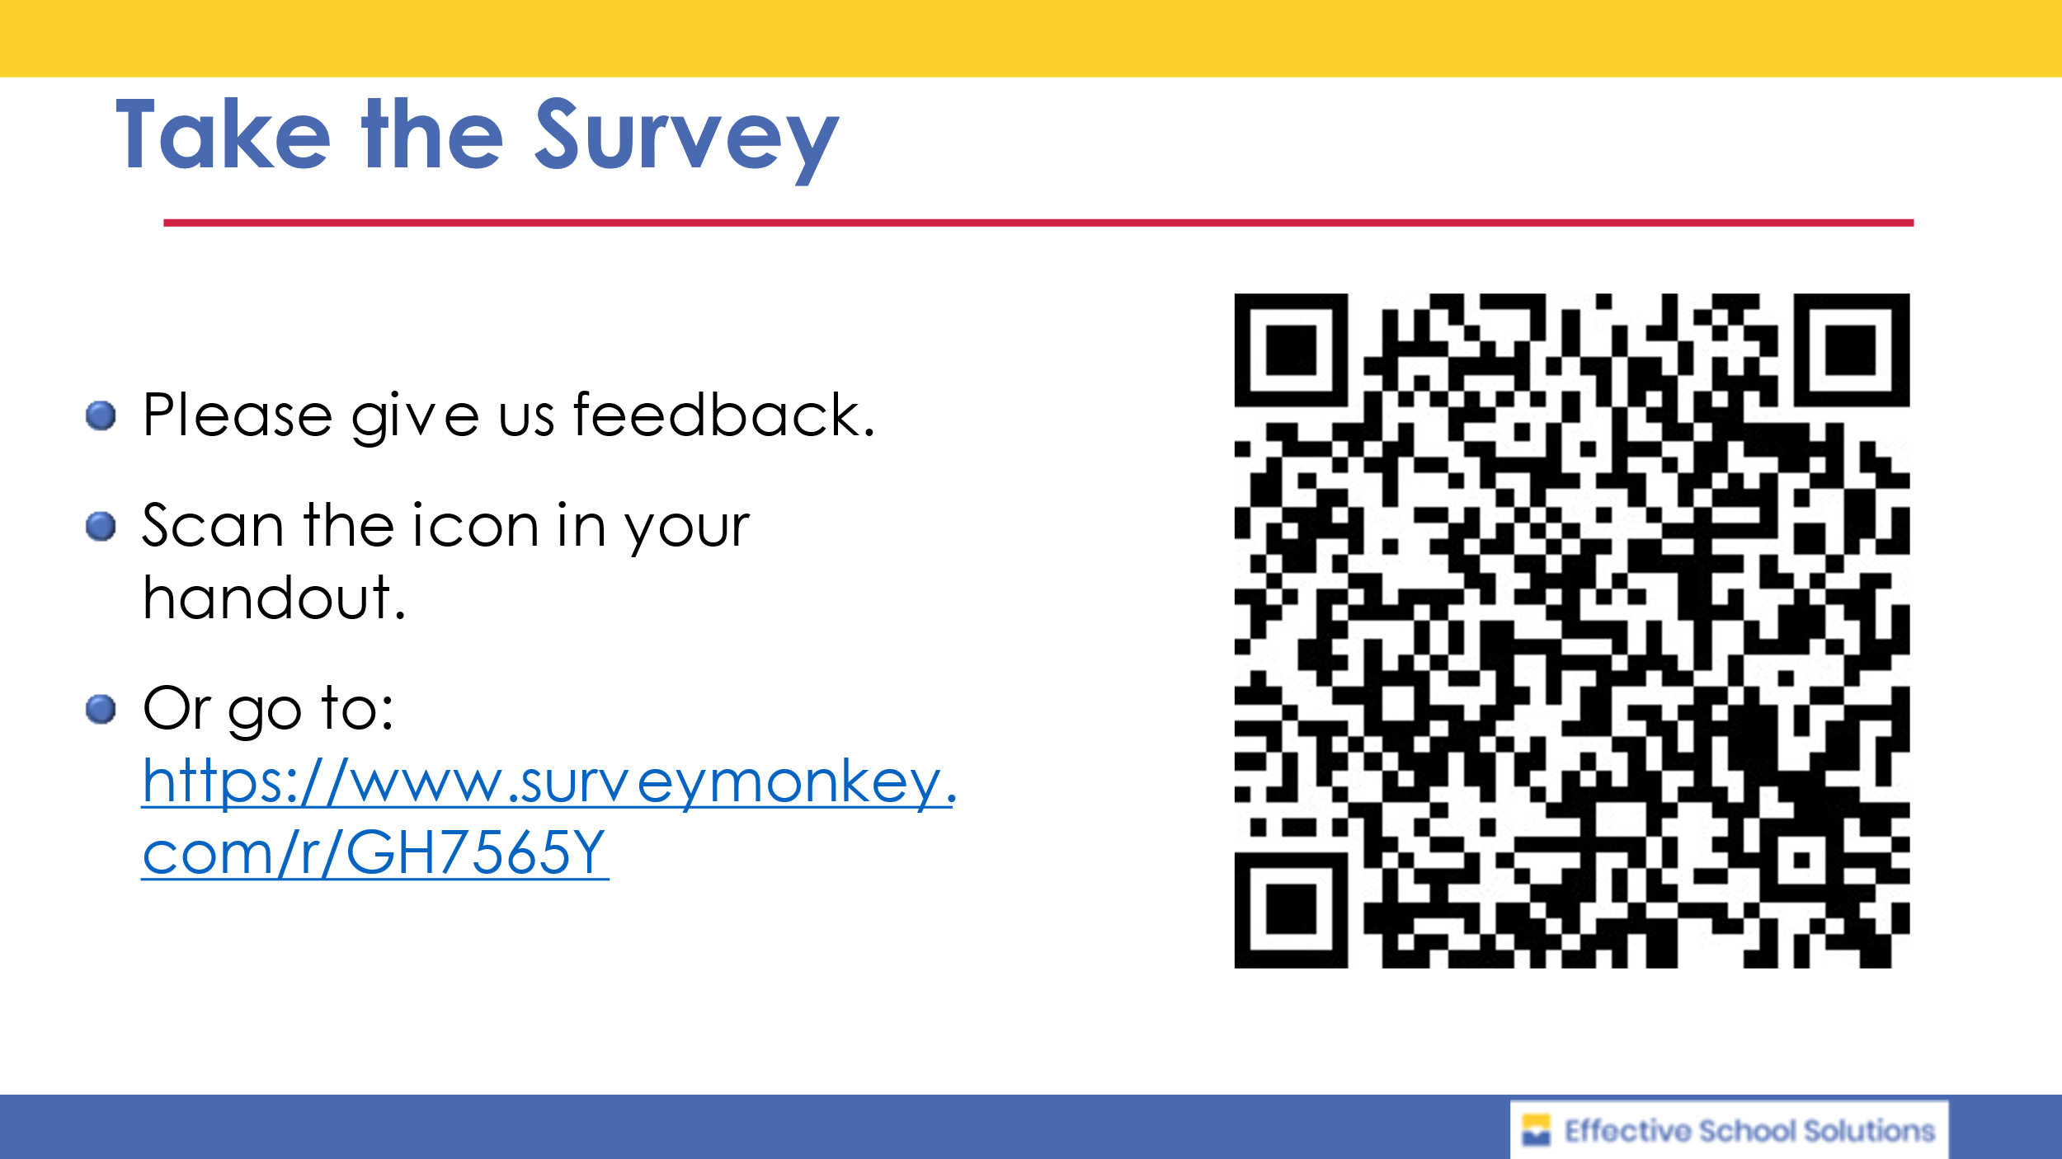

Resources
Brundage, Suzanne and Carol Levine, “The Ripple Effect: National and State Estimates of the U.S. Opioid Epidemic’s Impact on Children.” 2019, United Hospital Fund of NYC.
Fullilove MT, Fullilove RE, Smith M, et al. “Violence, trauma, and post-traumatic stress disorder among women drug users.” Trauma Stress. 1993;6(4):533-543.
Garland EL, Pettus-Davis C, Howard MO. “Self-medication among traumatized youth: structural equation modeling of pathways between trauma history, substance misuse, and psychological distress.” J Behav Med. 2013;36(2):175-185.
National Center for Drug Abuse Statistics https://drugabusestatistics.org/teen-drug-use/
National Child Traumatic Stress Network https://www.nctsn.org
Substance Abuse & Mental Health Services National Hotline: 1-800-662-HELP (4357)
Substance Abuse & Mental Health Services Administration, “A Treatment Improvement Protocol: Trauma-Informed Care in Behavioral Health Services.” Rockville, MD, 2014
Wingo AP, Ressler KJ, Bradley B. “Resilience characteristics mitigate tendency for harmful alcohol and illicit drug use in adults with a history of childhood abuse: a cross-sectional study of 2024 inner-city men and women.” J Psychiatr Res. 2014;51:93-99.

