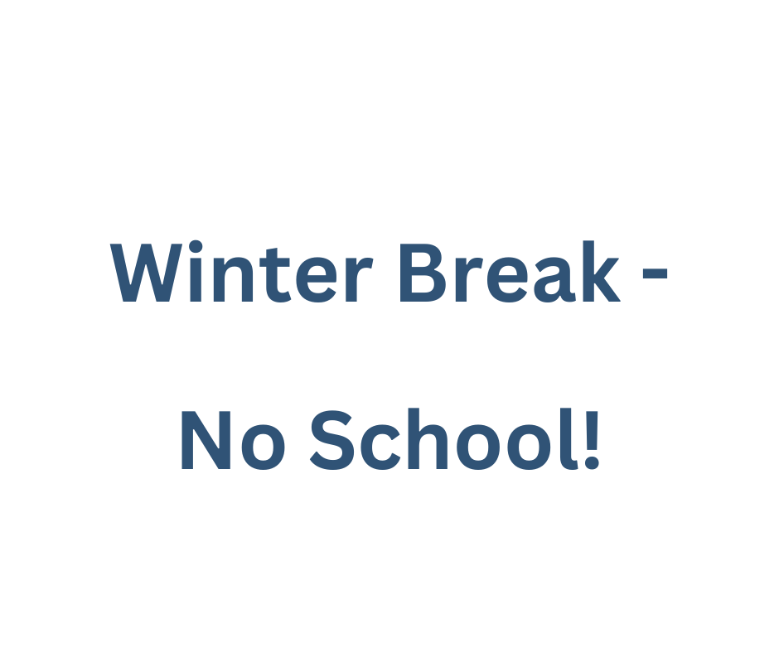­­­ 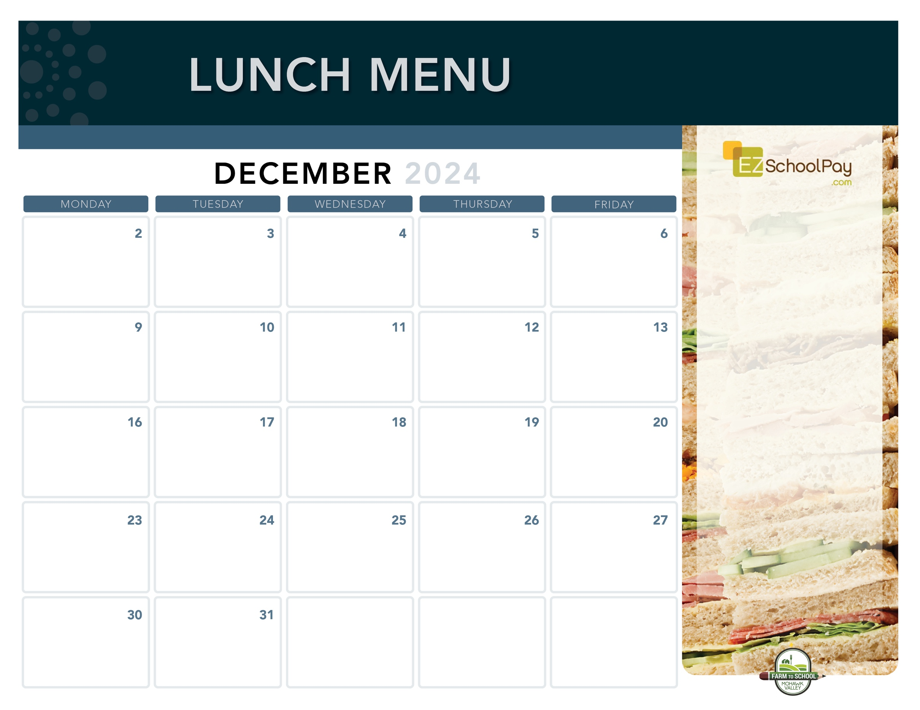

**11:30 Dismissal**

**Parent/Teacher Conferences**

**No Lunches Served**

**11:30 Dismissal**

**Parent/Teacher Conferences**

**No Lunches Served**

**Pizza Party!**

Cheesy Cheese or

Garlic Pizza

Fresh Green Salad

Oreo Whip

**Sauquoit Valley Elementary School**

**Italian Dunkers with Dipping Sauce**

Deli Ham Sandwich

Green Beans

**Max Pizza Sticks**

Deli Ham Sandwich

Green Beans

**Boneless**

**Chicken Bites**

**Plain or Teriyaki**

**Dinner Roll**

Tuna Salad Sandwich

Broccoli

**Crispy Chicken or Chicken Parm Sandwich**

Tuna Salad Sandwich

Broccoli

**Homestyle**

**Plain or Garlic Parm Tenders**

Goldfish Crackers

Tuna Salad Sandwich

Broccoli

**Chili with**

**Tortilla Chips**

Deli Turkey Sandwich

Corn

Miss Mila’s Cookie

**Dip N’ Sip**

**Grilled Cheese Sandwich &**

**Tomato Soup**

Mixed Deli Sandwich

Maple Glazed Carrots

**Mozzarella Sticks**

**with Dipping Sauce**

Deli Ham Sandwich

Rainbow Carrots

**Brunch for Lunch!**

French Toast Sticks

Breakfast Sausage

Mixed Deli Sandwich

Golden Hashbrown

**Taco Tuesday**

Beef Tacos

Lettuce, Tomato & Cheese Cup

Deli Turkey Sandwich

Street Corn Salad

**Nachos**

**& Queso**

Deli Turkey Sandwich

Corn

**Pizza Party!**

Cheesy Cheese or

Pepperoni Pizza

Fresh Green Salad

**Available Daily**

Fresh Entree Salads

Party Plates

Peanut Butter & Jelly Sandwich

Fresh Sandwiches and Wraps

Assorted Fresh Fruit

Vegetable Cruncher Cups

Variety of Fresh Fruit & Juice

Ice Cold New York State Milk

**Local Items this Month**

Milk, Yogurt, Meatballs, Corn, Green Beans, Rainbow Carrots, Potatoes, Miss Mila’s Cookie

Local items are indicated with a star on the menu

OHM BOCES Food Service is an Equal Opportunity Employer.

Lunch is Free | Menu is subject to change | For more information, contact hdussault@oneida-boces.org