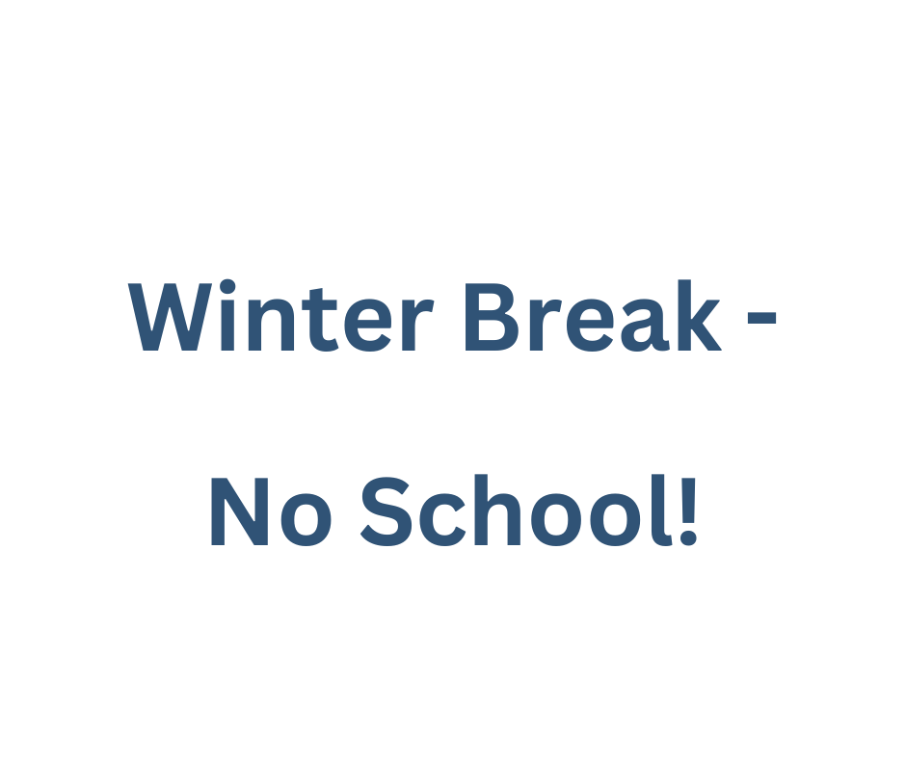­­­ 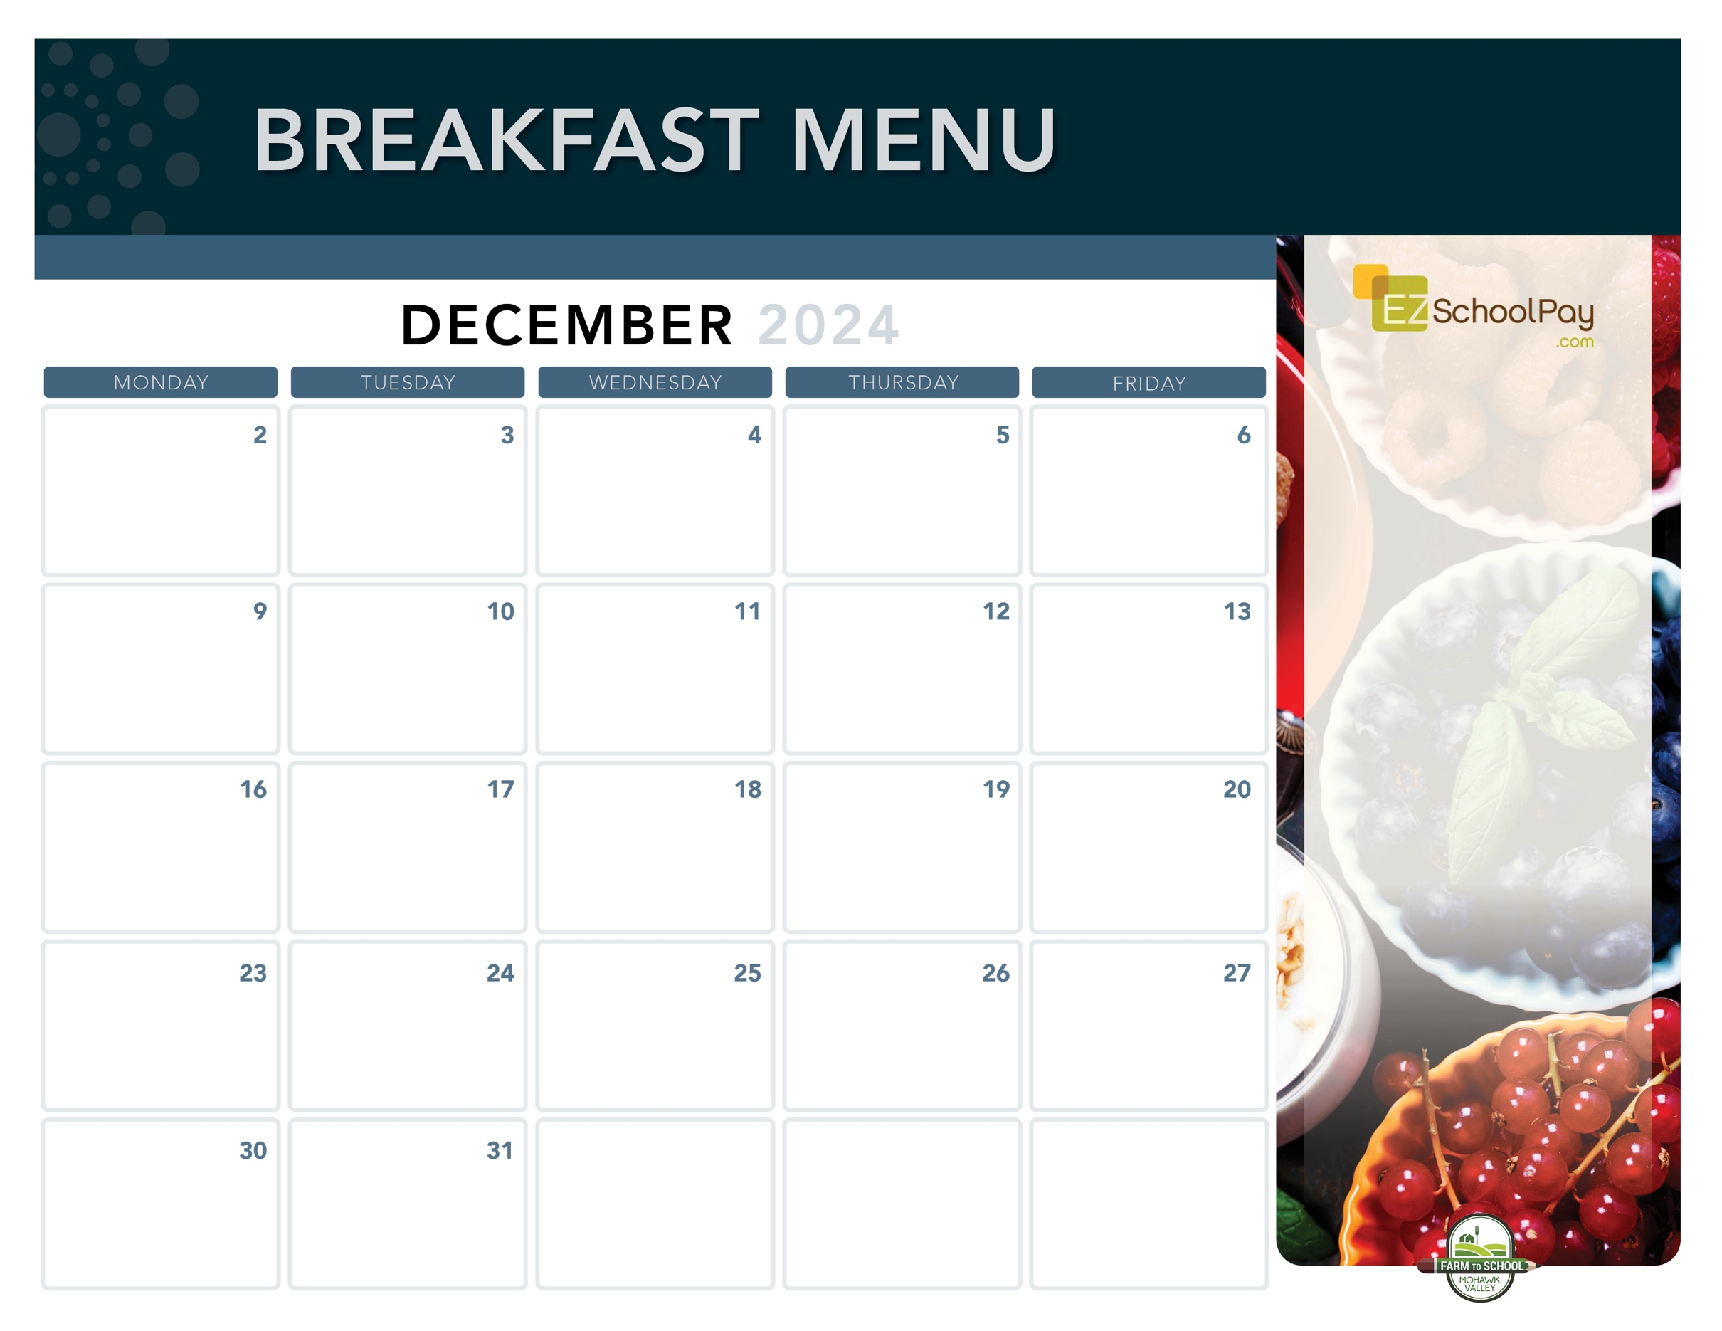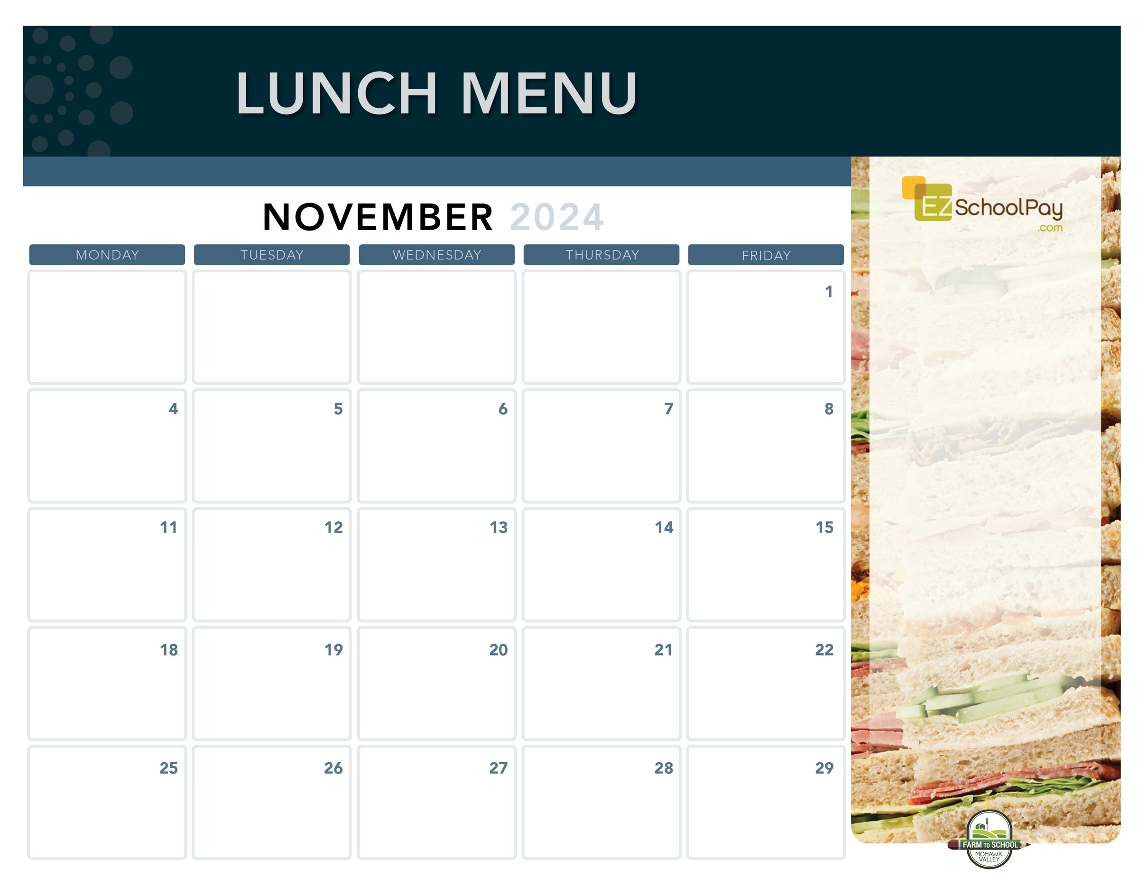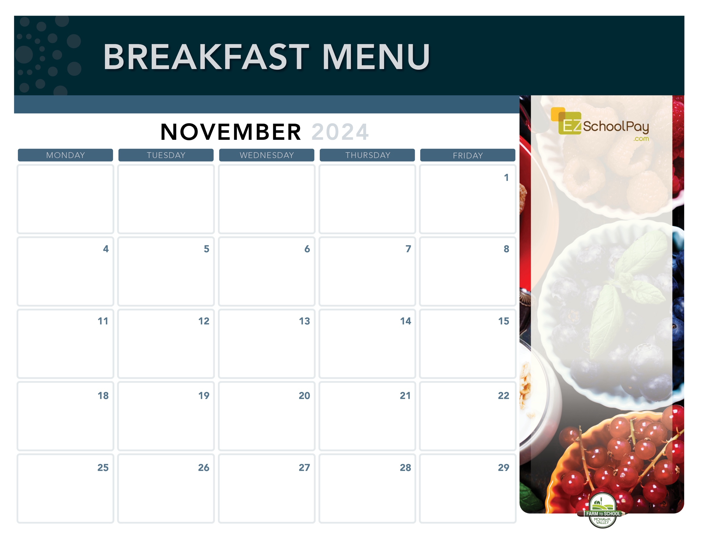

Mini   
Cinni

**11:30 Dismissal**

**Parent/Teacher Conferences**

**No Lunches Served**

Nature Valley

Oatmeal Round

**11:30 Dismissal**

**Parent/Teacher Conferences**

**No Lunches Served**

Good Morning

Wraps

**Sauquoit Valley Elementary School**

**Available Daily**

-Yogurt

-Assorted Whole

Grain Cereals

-Fresh Fruit

-Chilled Fruit Juice

-Ice-Cold New

York State Milk

OHM BOCES Food Service is an Equal Opportunity Employer.

Snackin’  
Waffle

Whole Grain

Pancakes

Whole Grain Bagel

with Cream Cheese

Breakfast

Pizza

Assorted Whole

Grain Muffins

& Yogurt

Whole Grain Bagel

with Cream Cheese

Snackin’  
Waffle

Zee Zee

Bar

Apple

Frudel

Yogurt

Parfait

Mini

Cinni

Breakfast

Sandwich

Breakfast is Free | Menu is subject to change | For more information, contact hdussault@oneida-boces.org