COMING TO CREEK
A Handbook for Parents of Freshmen and New Students
Entering Cherry Creek High School

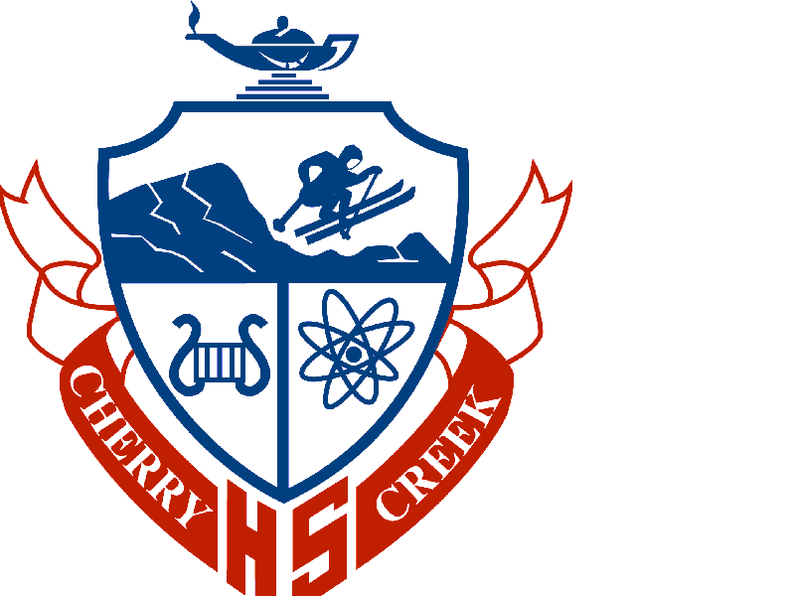

Prepared by the CCHS Counseling Department
Cherry Creek High School
9300 East Union Avenue
Greenwood Village, CO 80111
Revised 11/24

GREETINGS FROM THE COUNSELING DEPARTMENT OF

Cherry Creek High School

What's Different at Cherry Creek High School? 3
Discipline 5
Attendance 5
Students Who Achieve 5
So, Where is Everything? 6
Campus Map 7
Resources for Help 8
Other Important Information 10
Academic and Elective Programs 11
Graduation Requirements 12
How Do I Contact Teachers? 13
Summer School 14
Night School 14
CCHS Website Resources 14
Frequently Called Numbers 16

High school is a very exciting time for all students. It is a time to learn, to grow, and to find one's passion. When your students walk the halls of Cherry Creek High School, they will encounter incredible variety and diversity in their classmates, their teachers, and in the clubs, sports, and activities available to them. We hope that all of our students take advantage of the rich range of opportunities that Cherry Creek High School offers to them.

High school is also a time when students begin to learn to advocate for themselves. The faculty at Cherry Creek High School make it a priority to be available to meet with students who are asking for help and have posted office hours for this reason. As a parent, you can encourage your student to take advantage of all the help that is available at Cherry Creek High School.

We hope that this handbook will be a valuable resource as you guide your student through their first year at Creek.

What’s Different at CCHS?

School Year Structure: CCHS follows a quarter/semester model. Two quarters make up a semester, and two semesters make up a school year. We feel this model best prepares our students for success in college because most colleges in the country follow this format.

Open Campus: CCHS parents have the option of granting off-campus privileges to their students. Off-campus privileges allow students to leave school grounds during free periods when they often visit nearby restaurants and businesses. Designated by a coded ID, off-campus privileges are a family decision and can be rescinded at any time by parents or school deans. Students who do not have off-campus privileges eat lunch on campus at our cafeteria. All students spend other free time during the school day in our library, meeting with teachers, in a department resource center, or outside on school grounds. Please note, open campus privileges may be restricted for freshmen.

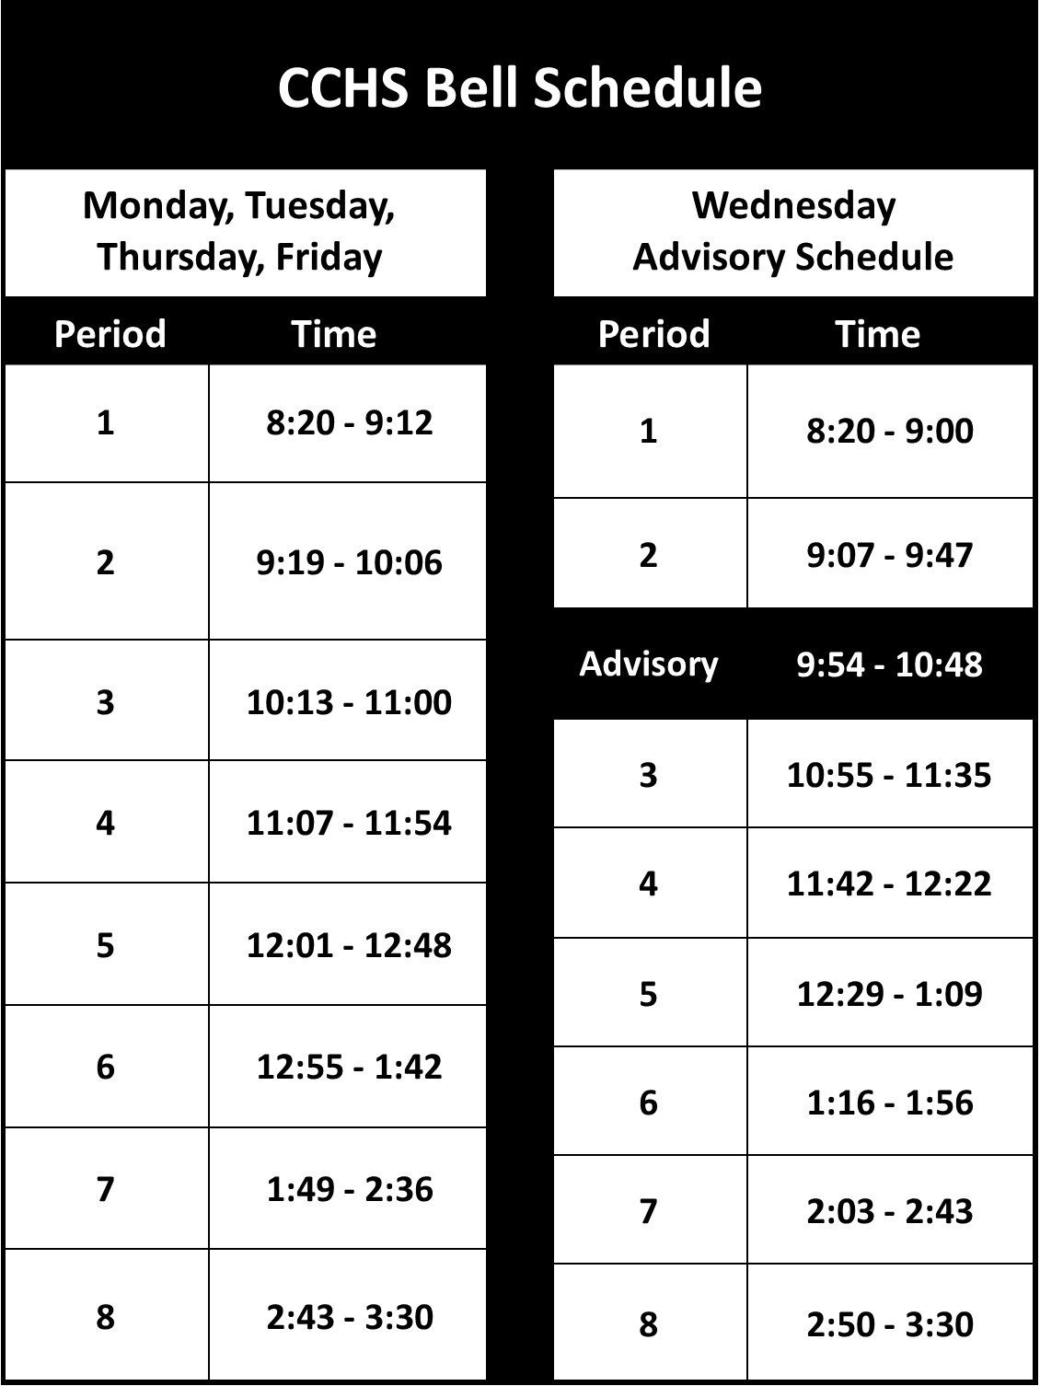
Lunch/Bell Schedule: Each day at CCHS, period 1 begins at 8:20 a.m. and period 8 ends at 3:30. The school day on Mondays, Tuesdays, Thursdays and Fridays consists of eight 47-minute class periods. Wednesdays are a little different: periods 1-8 are shortened slightly to accommodate an Advisory period between 2nd and 3rd periods. This smaller class allows students to connect with a staff member in a non-academic setting for support and connection, with the goal of enhanced climate, culture, health and wellness throughout the school. All students are assigned an Advisory class.

A student’s lunch is a full class period when they do not have class. Freshmen usually have lunch period 4 and sophomores usually have lunch period 6; juniors and seniors usually have lunch during period 5.

Schedule Changes: Students should choose classes carefully as schedule changes are often not possible or can be very difficult to make. Level changes are often first discussed with the teacher or school counselor, and then are completed through each department coordinator. Different types of schedule changes have various restrictions. (Schedule change dates/deadlines can be found in the Bear Facts, which is available on the CCHS website.)

Level changes (when a student moves to a more appropriate level of difficulty in any academic class) are allowed during the school year when the teacher, parent, department coordinator, counselor, and student are in agreement that a student is inappropriately placed. Of course, these changes should ideally be made as early in a semester as possible and deadlines apply.

Dropping classes can be done at any time during the school year, with various restrictions, deadlines, and consequences. Freshmen and sophomores must maintain at least six classes; juniors and seniors must have at least five classes in their schedules. In addition, Cherry Creek School District policy requires that all students be enrolled in at least four academic core classes each semester. Students cannot drop a class if, by doing so, they drop below either the required number of classes or the required number of academic core classes.
Semester exams: Many CCHS teachers give comprehensive exams at the end of each semester. Our graduates will see this type of exam in college, and as part of our mission to prepare them for future academic success, we give them important experience with these exams. Many teachers test students over an entire semester’s material. (Exam schedule is found on our website, under testing.)

Semester grades: Semester grades are the only grades entered on the high school transcript and are therefore used to determine the cumulative GPA and to award credit. Generally, semester grades are the cumulative average of all grades earned in a course over the semester, including the semester exam grade. Since formulas differ between teachers, students should have a clear understanding of how their teachers determine their semester grades.

Cumulative Grade Point Average (GPA): At CCHS, the semester grade for each class is entered onto a student’s high school transcript, and at the end of each semester, all current and previous semester grades are averaged together to create a new cumulative GPA. By the end of four years of high school, the cumulative GPA reflects eight semesters of grades. Cumulative GPA can play a significant role in the college admissions process.

Weighted Grades: Students in honors or Advanced Placement (AP) classes earn weighted grades. The difference between weighted and unweighted grades in terms of grade point value is as follows:

Unweighted Grade Points Weighted Grade Points
A=4 grade points A=5 grade points
B=3 grade points B=4 grade points
C=2 grade points C=3 grade points
D=1 grade point D=1 grade point
F=0 grade points F=0 grade points

Semester report cards and transcripts reflect both weighted and unweighted grade point averages for each semester of study.

Bear Facts: An electronic copy of the Bear Facts will be made available to all students. It contains a comprehensive guide to ALL CCHS’s policies and procedures.

Daily Planner: Incoming freshmen and students who are new to Creek will receive a daily planner, which is useful in keeping track of homework assignments and deadlines for each class. Organization is an essential skill for success in high school, and using the daily planner is an excellent way to stay on top of homework and deadlines.

Voicemail/Email: Each teacher has an office phone number and email address. If a teacher is unavailable, messages can be left with an officemate, with the department secretary, or on voicemail. With some teachers, email can be the most effective way to communicate. Email addresses and phone numbers are available on the CCHS website.

PowerSchool: Grades and attendance can be monitored at any time in the school year via PowerSchool, which is accessed through the CCHS website.

Discipline

An assistant principal and five deans handle discipline at CCHS. Students are alphabetically assigned to a dean. Our philosophy of discipline is based on the belief that students should be allowed to make choices and to stand accountable for their decisions. It is our expectation that students will make positive decisions affecting their lives. The administration endeavors to place as few encumbrances on a student’s liberty as possible, because we feel that the majority of our students act responsibly and conduct themselves in a manner which will not disrupt or distract from the educational environment on our campus. When students do make a poor choice, we believe we have established a positive environment in which they can learn from the mistake and receive whatever help is necessary to effect a positive modification of this behavior pattern. A very detailed discussion of discipline policies can be found in the Bear Facts.

Attendance

Attendance is a critical part of the educational process at CCHS. Students who are absent miss experiences that cannot be re-created through make-up work and quick or private discussions with the teacher. Interaction between student and teacher and between student and student is critical to learning. The correlation between good grades and attendance is strong. When a student does have to miss a class, it is imperative that they get make-up work as soon as possible (for example, that evening, from a classmate) and that they go in to see their teacher(s) immediately upon returning to school to clarify any confusion. Particularly at CCHS, classes move so rapidly that missed days can quickly create an overwhelming situation if the student is too lax about getting caught up. When a student is occasionally absent, they should check with a classmate or teacher to find out the missed work. If a student is absent or will be absent for five days or more, the parent should contact the student’s counselor who will serve as liaison between the teachers and the family. A parent can then pick up the homework. This process requires at least a 24-hour time period from the day of the request. A very detailed discussion of all attendance policies can also be found in the Bear Facts.

Students Who Achieve…

In Academics…
- Are organized:
  - Develop and maintain different notebooks for each class, and keep each notebook organized.
  - Use a day-planner/calendar to keep track of deadlines for daily homework, tests, and long term projects.
- Finish homework every night without being reminded.
- Briefly review homework and lecture notes in addition to doing homework each night.
- Begin studying for tests well in advance (not just the night before).
- Are willing to see teachers one-on-one for extra help within a day or two of not understanding something in class.
- Pay attention during class.

In Athletics…
- Take the risk to join a team (if a no-cut sport) or to try out for a team (if a cut sport); join with a friend or join to make a friend.
- Stay organized with time (allocate homework time each day in addition to practice).
- Use at least one full off period each day to do homework, many times both off periods.
- Maintain grades to stay eligible.
- Get athletic and medical forms in on time.

In Clubs/Activities…
- Take the risk to show up for a club meeting (again, join with a friend or join to make a friend).
- Take the initiative to find out when and where a club meets (information is available at the Club Fair, on wall posters, in announcements, in the Activities Office, or from the adult sponsor).
- Arrange for transportation home (carpooling with other club members is very common, but a pre-arranged ride home for the first meeting or two is necessary).
- Attend club meetings and events, and also engage with other students in the club.

So, Where is Everything?

The Cherry Creek High School campus can seem large and overwhelming to first-time visitors. It may be very helpful for you, as parents, to know that our students quickly become very adept at learning their way around, and after only a couple of days our freshmen and new students are old hands at finding their way around campus.

But we believe it is very useful for you to know how our campus is organized and where to find the various departments, faculty, and offices. Our campus comprises four main buildings and each building houses at least one administrator and one dean. Going from east to west:

The East Building houses the English and social studies departments, Student Achievement Services, and the East Gymnasium. The East Clinic, Attendance Office, and Security Office are also located in this building.

The Fine Arts Building includes all of the music programs, art, speech and debate, theater classes and the Fine Arts Theater, which is our campus auditorium.

The Information Center (IC) Building is attached to the Fine Arts Building by a covered walkway. On the main floor are the World Language Resource Center, the Counseling Center, the Post Graduate Center, the Information Center Lounge, the Union Street Journal office, the yearbook office, the Bear Necessities bookstore, the Registrar’s Office, and the Activities Office. On the upper level of the Information Center Building are the Library, the Technology Center and the Community Meeting Rooms.

The West Building contains the business, math, science, and physical education departments, the West Café and the Office of the Principal. In addition, the West Clinic, the swimming pool, the North and South Gymnasiums, Shillinglaw Lecture Center, and the Bookkeeping and Athletic Offices are located in the West Building.
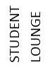
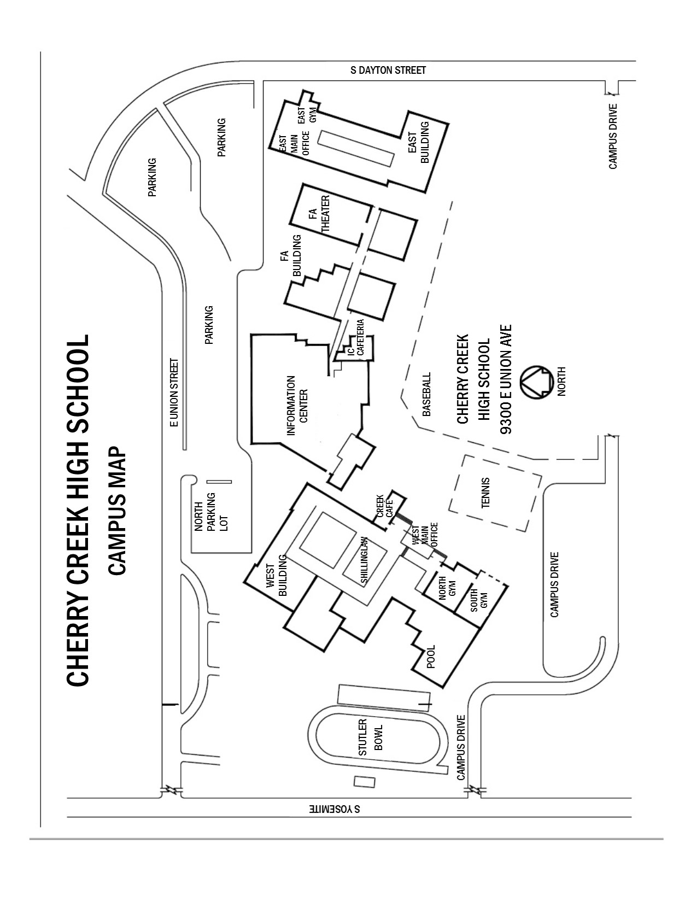

Resources, or Where Do I Go for Help?

Activities Director (Activities Office): Supervises Student Senate and the more than 90 clubs and activities available to Cherry Creek High School students. This office puts out student announcements, provides student IDs, and oversees any after school activity that is not an athletic program. This office is located in the Information Center Building.

Athletic Director (Athletic Office): Responsible for scheduling and overseeing the athletic programs at Cherry Creek High School. All applications for participation in athletics are handled through this office, which is located in the West Building.

Bear Facts – An Electronic Handbook for Creek Students and Their Parents: Contains information about all aspects of life at Cherry Creek High School including academic, athletic, attendance, and discipline policies and procedures. Students and parents can access the handbook and information on the CCHS website, cherrycreek.cherrycreekschools.org.

Bear Necessities Book Store: Offers Creek students one-stop shopping for school supplies, books, cards, snacks, Creek clothing and all sorts of Creek logo items. Also, many teachers order their supplemental textbooks through this store, making it very convenient and inexpensive for students to purchase these items. Bear Necessities is located in the Information Center Building.

Case Managers: Students staffed into Student Achievement Services are assigned a case manager who works with that student as long as they are qualified for the services. Case Managers' offices are in the Student Achievement Services Department in the East Building.

Cherry Creek High School Website (cherrycreekschools.org/cherrycreek): Information regarding all aspects of Cherry Creek High School can be found here. A more detailed description of the website appears later in this handbook.

Club Fair: Held in September, this is a time for students to visit information tables sponsored by many of the clubs at Cherry Creek High School. All of our students are encouraged to find activities to join.

Counselors: Most students are assigned to a counselor alphabetically by last name. There are also Gifted and Talented Resource counselors, who are assigned a caseload of students identified as GT across the alphabet (although not all GT students are assigned to a GT counselor). Counselors function as academic coaches, mentors, “guides-on-the-side,” and resources to students, parents and faculty. Students can make appointments to see their counselors by contacting one of the secretaries in the Counseling Center, located in the Information Center Building. Students with immediate questions will find our On Call Counselor available to help during 4th, 5th, and 6th periods most days. For both students and parents, email is an excellent way to communicate with the counselor. Email addresses are available on the CCHS website.

Deans: Students are assigned to a dean alphabetically by last name. Cherry Creek High School has five deans with offices in each building on the campus. Deans are responsible for discipline and attendance.

Department Coordinators: Department Coordinators are responsible for the teachers in each of their respective Resource Centers and have offices in each of the departments located throughout the campus.

Department Resource Centers: Places where students can go to do homework, meet with their teacher, meet with teachers who are available to tutor, make up tests, or meet with the department coordinator. The English/Social Studies Resource Center is in East Building, the World Language Resource Center is in IC Building, and the Math/Science Resource Center is in West Building.

Library and Technology Center (LTC): A teaching library, the Library and Technology Center can accommodate two classes simultaneously in the main library, two classes in computer labs, and two classes in meeting rooms. Students are encouraged to use the LTC during unscheduled time for individual and small group study. Four group-study rooms, one quiet-study room and 22 individual-study carrels provide areas for students to work. A quiet area near the windows is a great spot for relaxing and reading. Students also work in the LTC individually or in groups on research and a variety of applications and multimedia presentations. The library is generally open Monday through Thursday from 8 a.m. to 4:30 p.m. and Friday from 8 a.m. to 3:30 p.m., and students and staff make excellent and enthusiastic use of the many resources available. The heart of the campus, our library has been twice recognized as the National School Library Media Program of the Year by the American Association of School Librarians. No other high school library in the nation has won this award twice.

PTCO: Parent/Teacher/Community Organization for Cherry Creek High School. We are very fortunate to have an active parent group that encourages all Creek parents to get involved.

Peer Ambassadors: Senior students who have been trained to work with new students and with students who are having personal or academic difficulties. Peer Ambassadors are scheduled into the Counseling Center every period of the day and see students by appointment and on a drop-in basis.

Post Graduate Center: Located in the Information Center Building, this center is available to any student or parent who would like to access the myriad resources available for college planning, career exploration, and ACT and SAT test information and preparation.

PowerSchool: Students and parents can monitor grades, attendance, and assignment completion through PowerSchool, as well as can communicate with teachers via email. PowerSchool is accessed through the CCHS website using your assigned username and password.

Principal: Administrative leader of the school who oversees staff and programs. With offices in the West Building, the principal is available to meet with students and/or parents. Appointments can be made with the secretary in the West Main Office.

Assistant Principals: Part of the administrative faculty, they have duties as assigned. Their offices are located in each building on the campus.

Registrar’s Office: Has an assistant principal and staff in charge of registration, check-in, schedule changes, transcripts, and report cards. The Registrar's Office is located at the entrance to the Information Center Building.
Registration Guide: A full listing and description of every course and program offered at Cherry Creek High School, available on the CCHS website at the beginning of pre-registration.

School Nurse Clinics: Available in East and West Buildings. The East Building nurse maintains health records for students with last names from A-La and the West Building nurse keeps records for Le-Z. Students can see the nurse in either building for health-related issues and medication administration.

School Psychologists: Consult with teachers and counselors regarding personal and academic issues affecting students; conduct testing and evaluation; and are available as a resource for students and families.

Teachers: Have scheduled time in each day for lesson planning and to work with students. Office hours are usually posted and students are encouraged to access help from their own teachers or to inquire about getting help in the Resource Center(s).

Tutorial Assistance:
  - National Honor Society provides student tutors in person Monday –Thursday, 3:30 p.m.-4:30 p.m., in the Smith Library with no appointment necessary; and online with no appointment necessary Sunday – Thursday, 7 p.m. – 8 p.m. (link available on Schoology).
  - Peer Ambassadors (senior students) are available for academic “coaching” in the Counseling Department every period in the school day.
  - All core subject departments as well as English Language Support offer drop in tutoring with teachers, available various days/times. Please check the CCHS website under Students ➔ Tutoring Resources for schedules.
  - Spanish Honor Society provides students who offer tutoring services in person daily from 3:30 p.m. – 4 :30 p.m. in the Smith Library with no appointment necessary. French Honor Society may also provide this service; check the CCHS website tutoring information to check.
  - Please check the CCHS website under Students ➔ Tutoring Resources for any changes/additions to these tutoring resources.

Other Important Information

Backpacks are allowed everywhere on campus.

Cafeteria is available in the West Building. It is open Monday-Friday and serves breakfast and lunch. Please contact District Food and Nutrition Services with any questions at (720) 886-7175.

Cell Phone use (talking on) is permitted outside of the buildings or in the cafeterias. Cell phones are not permitted in classrooms unless a teacher gives permission to the student or class as a whole. Violators are referred to their dean for disciplinary action.

Check-in is the week before school starts. On their designated day, students submit information forms and emergency cards, receive locker assignments, have school pictures taken for their ID, and receive their schedules. Information regarding check-in is emailed to families before school starts.
Creek 101, 201, 301, and 401 are curricula used by the Counseling Department. Creek 101 contains orientation and transition information for freshmen. Students are encouraged to explore potential careers in Creek 201 sophomore year, research colleges in Creek 301 junior year, and complete the college application process or pursue post-grad career path options during Creek 401 senior year. Each grade level completes tasks that are required by the state’s ICAP plan.

Lockers are located throughout the campus and are available to students during check-in before school starts. Lockers are assigned first to seniors, then juniors, sophomores, and freshmen. Freshman lockers can be found in every building but are generally located in the East and IC buildings. Students are encouraged to establish a routine of visiting their lockers only occasionally during the day to drop off and pick up books as needed.

Meal Accounts are available in the West Café and provide a wonderful service for students who prefer not to carry their lunch or money on a daily basis. Breakfast and lunch are available; both are offered at free and/or reduced rates for those who qualify. For information about free and reduced services, menus and dietary information, payment options and more, visit www.CCSDCafe.org.

Off Campus Pass is permission for a student to leave campus during the school day. The permission form is included in the online registration packet. Students with off campus permission have IDs that are color-coded.

Off Periods are times when students are not in class. Cherry Creek High School runs an eight-period day and freshmen are required to take at least six classes each day. Off periods can be spent eating lunch, doing homework in the Library Technology Center or Resource Centers, or meeting with teachers to get extra help. Students with off campus passes have the option of leaving the campus during off periods.

School IDs are the official identification card for Cherry Creek High School students and must be carried at all times. Students may also use the Minga app on a mobile device to carry an electronic school ID. IDs are available during check-in before school starts. If lost, replacement IDs are available in the Activities Office for a fee.

Academic and Elective Programs

Academic Courses
The academic program at Cherry Creek High School offers an extensive array of courses in each of the five academic areas: English, mathematics, science, social studies, and world language. Freshman students from our feeder middle schools are usually recommended for classes by their eighth grade teachers. Students coming to Cherry Creek from schools outside of our feeder schools will be placed in our academic program during a late May or early August registration session with the high school counselors using, among other information, test scores and their most recent transcript.

Freshmen can take world language either as a continuation of a language studied in middle school (with a recommendation from their middle school world language teacher) or they can begin one of our languages at level 1. World language is part of a strong academic program. However, academic readiness varies from student to student and some students choose to delay world language study until the tenth grade.

Honors courses lead to a variety of options in our Advanced Placement (AP) classes. Our students can take AP courses (usually in the junior or senior year) in one, two, three, four, or all five academic disciplines. The advantage of an AP program is the flexibility that it allows students to pick and choose acceleration in one area and not another. Cherry Creek High School offers 33 AP courses that may allow students to earn college credit.

Colleges encourage students to challenge themselves to the limit of their capabilities, even if that means no Honors or AP classes. Students and their parents should decide how much acceleration, if any, is appropriate. For examples of the scope and sequence of academic classes available to students, check the flow charts available on the CCHS website under Our School ➔ Post Grad ➔ Freshmen Advisory ➔ Department Flow Charts.

Elective Courses
Cherry Creek High School's electives program is as varied as our academic options. Multiple levels of courses in art, music, business, consumer and family studies, technology, theater, and physical education provide wonderful opportunities for students to satisfy graduation requirements, pursue an existing passion, or prepare for upcoming collegiate or professional work. For students not yet exposed to these areas, the elective programs also offer wonderful support and encouragement for them to explore something new.

Students who have an interest in an elective area need to be aware of pre-requisites for many of the upper-level courses. The Four Year Plan completed as part of Creek 101 or in Creek Seminar is a great place to outline a working draft for the academic and elective programs to guarantee that students have the opportunity to take the courses they desire.

What Are the Graduation Requirements?

Credit is earned each time a student earns a passing (D- or higher) semester grade (this is not the quarter progress grade or semester exam grade, but the overall semester grade). Each passing semester grade earns a half credit (.5); thus, if a student passes six classes first semester, he would earn three credits (6 x .5 = 3.0), and passing six more classes second semester would earn an additional three credits.

Graduation from CCHS is based on a student earning a minimum of 22 credits, making sure the following minimum departmental credit requirements are met:

English 4.0 credits
Social Studies 3.0 credits
(Must include 1.0 US History and .5 American Government)
Mathematics 3.0 credits
Science 3.0 credits
World Language 0.0 credits
Physical Education 1.5 credits
Fine Arts or CTE 1.5 credits
Health 0.5 credits
Elective Offerings 5.5 credits
TOTAL 22.0 credits
Any additional credit earned beyond the minimum required contributes to a student’s overall credit total (i.e., world language and additional math, science, social studies, P.E., etc.). When a student has earned at least 22 credits and has met all the specific departmental requirements listed above, he or she can graduate.

In addition, beginning with the class of 2022, all graduates are also required to demonstrate college and career readiness via one of the approved methods outlined in the chart below.

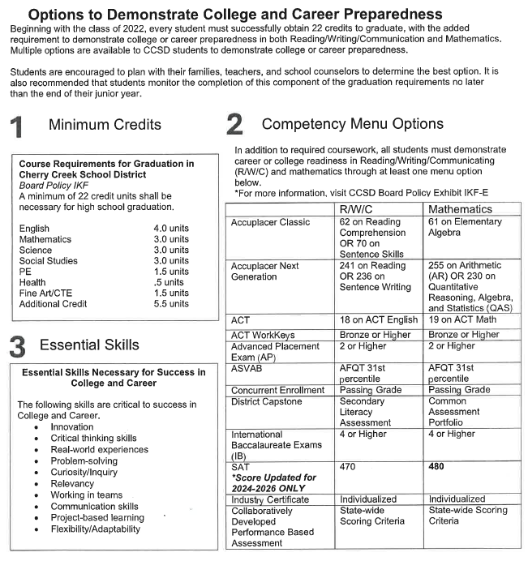

It is also important to note that students who have not earned the minimum graduation requirements by the end of their senior year do not graduate. Some students can make up credit deficiencies in summer school; others must return to CCHS for additional semester(s).

The Colorado Commission on Higher Education has created a pre-collegiate course completion requirement. Students should plan to complete the following HEAR requirements as preparation for entering one of Colorado’s four-year public colleges or universities. Completion of the HEAR requirements does not guarantee admission.

English 4 years
Math (Algebra I or higher) 4 years
Science (2 years must be lab courses) 3 years
Social Studies 3 years
Foreign Language 1 year
Additional Academic Electives 2 years
TOTAL 17 units

As always, check in the CCHS Registration Guide and/or with your child’s counselor to verify CCHS graduation requirements and Colorado’s pre-collegiate requirements. Remember, too, that for many years, the vast majority of CCHS students have graduated with credits that would meet or exceed the HEAR pre-collegiate curriculum requirements.

How Do I Contact Teachers?

The ability to communicate with your student’s teachers and counselor will be important as your child begins high school. Many students make a seamless transition to high school and need little, if any, intervention from their parents. However, the freshman year (more than at any other time in high school) is often a time when parents need to be in touch with their student’s teachers. Parents may communicate with teachers by telephone, voicemail, and/or email. Contact information is available on the school’s website (cherrycreekschools.org/cherrycreek) through PowerSchool, which also makes it easy to monitor grades, attendance, and homework completion.

Summer School: Who Goes and Why?

Academic classes including English, history, math, and science are offered through in person and online summer school. In person summer school is considered remedial; the online option offers credit recovery and progression options. These classes are offered through Cherry Creek Elevation to any student who has matriculated to high school and is needing to make up a course due to a low (D) or failing (F) grade. Students wanting to repeat a course in the summer to replace a low or failing grade should take the course during the summer immediately following that school year.

In the case of a failing grade, we encourage students to be mindful of graduation requirements and to consider summer school to avoid falling behind in meeting graduation requirements.

Our Cherry Creek Innovation Campus also offers summer school opportunities.

Please refer to the Bear Facts Handbook for more information about summer school. The summer school registration info is available online on the Cherry Creek School District website in the spring.
Night School

Night school is also available at the Endeavor Academy and is an additional opportunity for students to improve grades or recover credits. Please ask your counselor about this program if you are interested. Enrollment takes place at the beginning of each semester.

CCHS Website Resources

The CCHS website (cherrycreekschools.org/cherrycreek) offers a variety of information about our school. On this multi-layered site, you will find information under the following headings:

- Our School includes general info about Creek along with links to attendance info, check in procedures, bell schedules and calendars, info for alumni, mental health and suicide prevention info, bell schedule, health clinic info, school delay and closure info and more.

- Academics includes links to the academic departments at CCHS, with course lists, master schedules, departmental flow charts, and faculty/staff contact information by department.

- Students contains links to the Bear Facts electronic handbook, parking, testing dates, and more, along with links to the Library, Naviance and Post Grad, info about summer assignments and tutoring, and help on how to request transcripts. Senior information is also found on the Students page.

- Parents includes links to information about food and nutrition services, our health clinics, the PASS team, school safety, PTCO, testing dates, English classes and Spanish resources, and more.

- Activities and Clubs contains a page listing all clubs at Cherry Creek High School with a description of each. There are also links to more information about Prom, Homecoming, graduation, yearbook, fine art events, student government, and more.

- Athletics contains calendars, registration information, coach contact information, summer camps and much more. The site also features highlights and news from the many CCHS athletic programs.

- Counseling/Mental Health is found under the Our School tab, and has links to counseling resources including the Safe2Tell number, mental health staff and resources, counselor contact information, and more.

- Post Grad is found under the Our School tab, and describes the Creek 101, 201, 301 and 401 curricula. There is also a link to the Post Grad website, which is a great resource for everything college and post-high school plans.

- Naviance is a website that allows students and families to investigate, research, track, and plan for the college admission process. It is an integral part of Creek 101, 201, 301, 401, and the Counseling Department’s curriculum. Find Naviance under the Students tab or the Post Grad tab.

- CreekM@il is the student email system (each student receives an address). School announcements, club/activity information, and classroom communication are just a few examples of important school communication delivered via CreekM@il.

- Library is a link to Cherry Creek High School’s library homepage, where students and faculty have access to an extensive collection of online curricular resources. Students are given a user name and password to access the subscription databases from home. Full-text archived journal, magazine and newspaper articles, encyclopedias, and reference materials are available 24 hours a day and 7 days a week. The Cherry Creek School District book catalog, class project websites, booklists, and research help are also provided. Find Library under the Our School tab.

- About Creek includes the CCHS Mission, Vision and History, links to our school profile, campus maps, the Bear Necessities store and more. Find About Creek under the Our School tab.

- Registrar includes the Registration Guide, master schedule, new student enrollment info and how to order transcripts. Find Registrar under the Our School tab.

- PowerSchool is a link to the log-in page for PowerSchool, where you can view your student’s schedule, grades, and attendance. Go to my.cherrycreekschools.org ➔ Sign in using your parent account ➔ Make sure you are in the myParentLinks tab ➔ Click on the PowerSchool Parents tile.

- Safe2Tell – Anonymously report anything that concerns or threatens you, your friends, your family or your community at Safe2tell.org or by phone at 1.877.542.7233. The Safe2Tell button at the top right of the CCHS website takes you to the Safe2Tell website.

- Week at Creek – A weekly digest of what’s happening at school. This includes upcoming details about scheduling, testing, volunteer opportunities, transportation, athletics, PTCO, club and interest meetings, Did You Know info, graduation, celebrations and other important info happening at Creek. Parents and students receive a Week at Creek email every Friday.

Frequently Called Numbers

Activities Office (720) 554-2393

Activities (720) 554-2390

Art Department (720) 554-2312

Attendance Office (720) 554-2242

Athletic Department (720) 554-2461

Bookkeeping Office (720) 554-2396

Business Department (720) 554-2412

Counseling Office (720) 554-2250, 2260

Deans’ Offices:

A-Da (720) 554-2378

Db-Ho (720) 554-2328

Hp-Me (720) 554-2208

Mf-Sa (720) 554-2416

Sb-Z (720) 554-2203

English Department (720) 554-2333

Fine Arts Department (720) 554-2307

Fine Arts Theater (720) 554-2306

Foreign Language Department (720) 554-2296

Library and Technology Center (720) 554-2398

Main Office (East Bldg.) (720) 554-2222

Main Office (West Bldg.) (720) 554-2285

Math Department (720) 554-2372

Nurse (East Bldg.) (720) 554-2206

Nurse (West Bldg.) (720) 554-2220

Physical Education Department (720) 554-2471

Post Grad Center (720) 554-2291, 2340

Registrar’s Office (720) 554-2343

Security (720) 554-2287

Science Department (720) 554-2372

Social Studies Department (720) 554-2333

Special Education Department (720) 554-2219

