Get involved (and stay informed) with Creek PTCO!
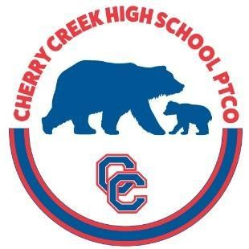
Meetings
The Creek PTCO holds many great meetings for parents. Meeting dates can be found on the CCHS website calendar or on our PTCO webpage (click on “Parents” on the CCHS website).
PTCO General Meetings – the PTCO holds approximately 6 meetings a year. Most meetings feature student performers or a keynote speaker. Principal Silva gives the latest update on the “State of Creek” and answers questions from parents.
Lunch with the Principal Meetings - these monthly meetings are a great opportunity to get the latest updates from Principal Silva and ask questions in a smaller setting.

Volunteering
Creek PTCO Exec Board and Committee Chairs: We are always looking for great volunteers. Slating for our open exec board and committee chairs positions for the 2025-2026 school year will begin this January. If you are interested, please email us at CreekPTCO@gmail.com.
Fall Check-in: Before school starts in August, Creek will hold check-in for students. Parents are needed to help make check-in run more smoothly. A Check-in Volunteer signup genius link will be emailed to parents this summer.
First Fridays: Come be part of our new staff appreciation program, no cooking required! Volunteers help distribute treats to teachers. Look for a signup genius in “Week at Creek” in the fall.

PTCO Communications
All PTCO information is published in Creek’s weekly newsletter, “Week at Creek”, and on the
CCHS website (click on “Parents”). Email us any time at CreekPTCO@gmail.com

