



PARENT HANDBOOK

MICHAEL CHIPMAN - PRINCIPAL

**IMPORTANT PHONE NUMBERS**

**OFFICE** . . . . . . . . . . . . . . . **720.886.3600 ATTENDANCE 720.886.3695**

**FAX** . . . . . . . . . . . . . . . . . . **720.886.3687 DISTRICT WEATHER LINE 720.554.4701**

SCHOOL WEBSITE: https://www.cherrycreekschools.org/canyoncreek

This guide provides some useful information about the philosophy, policies, and operation of Canyon Creek Elementary School. It is a supplement to the district "Student Conduct & Discipline, Rights & Responsibilities" publicatio n.

If you have any quest ions about the school's operation or your child's educational program, contact the school office at **720.886.3600.**

**6070 SOUTH VERSAILLES PARKWAY** I **AURORA, COLORADO 80015**

**GENERAL INFORMATION**

# SCHOOL HOURS

* School starts at 8:00 a.m. and is dismissed at 2:45 p.m. except on Wednesdays.
* Every **Wednesday** will be an early dismissal day. Those students who ride the bus, will be picked up at 1:45 and be delivered to their usual bus stop. If they go to aftercare they will report to the cafeteria after being dismissed at 1:45.
* Children are not to arrive on the school grounds before 7:45 a.m. as there is no supervision prior to that time .

# ABSENCE POLICY

For better communication between home and school, please follow this procedure when your child is absent from school:

* Call the attendance line @ 720.886.3695.
* Homework will be prepared for students who are absent two or more days. Please call the teacher before 7:45 a.m. so homework can be ready at the end of that school day.
* During State October Count (October 2) only: When your child returns after an absence, he/she should bring a note indicating the dates and reason for absence.
* Attendance is not only important for your child , it is mandated by law.

# VISITING THE SCHOOL

Parents are encouraged to visit their children's classrooms or any of the district's other instructional facilities. This is one of the best ways to be informed about what is going on at school. (As a matter of courtesy, it is requested that parents call the teacher at least one day ahead of time to schedule a visit.)

***For the safety of our children, visitors must enter through the front door and check in at the office before visiting a classroom. We will request photo identification.*** Younger children are discouraged from visiting class ­ rooms with their parents, but certainly may join their brothers or sisters during lunch with a parent . Parents are welcome to come and eat lunch with their child. Please call the dining room before 8:00 A.M . if you plan to buy lunch when you visit.

# SIGNING IN/OUT

Parents, please remember to sign in when entering the building through the front door. Even though you may be in the building quite frequently, it is still very important that you sign in . We will have a sign-in sheet by the

front office window . Please remember **we will ask for identification;** don't be offended by this since it is for the safety of our children .

# TAKING CHILDREN OUT OF SCHOOL DURING THE DAY

In the event you need to take your child out of school during the day, please follow this procedure :

* **YOU MUST** check in at the office and sign your child out. Office person­ nel will call your child from the classroom; **PHOTO IDENTIFICATION IS REQUIRED.** When someone other than the parent or legal guardian , or someone not listed in PowerSchool as authorized to sign out a child, **we must have written permission from a parent, AND AGAIN,**

**PHOTO IDENTIFICATION IS REQUIRED.**

# DINING ROOM

We serve breakfast and lunch in our cafeteria. This year all breakfast and lunch meals are free to **EVERY** student regardless of need. All meals come with a choice of white or chocolate milk at no additional charge.

**Breakfast** is served from 7:30 - 8:00.

**A La Carte Lunchroom Choices**

Our lunchroom offers various a la carte choices ranging in price from

$.50 to $1.25. These a la carte items (i.e. ice cream, cookies, chips, juice, snacks) may be paid for with cash or from a student's lunch account. They are NOT included in the free meals. Money can be added to their account using cash, check or Titan School Solutions (family .titanl 2.com).

*If you do not want your student to use the credit account for a la carte items, let the cafeteria manager know . She will mark the computer card , and the student will only be able to pay cash for these items.*

***To avoid the loss of sack lunches and lunch boxes, please put***

***children's names on them.***

# SCHOOL PARTIES AND GIFTS

Only school-sponsored parties are permi tted. We celebrate Winter holidays and Valentine's Day. Birthday party invitations may not be distr ib­ uted at school unless there is one for each student in the class.

The presenting of gifts to teachers on such occasions as birthdays and Holidays is discouraged by District Policy. Personal letters expressing grati­ tude and appreciation are always welcome and mean as much or more to the staff member involved . This should not be interpreted as discouraging gifts in unusual situations. Rather, it is intended to avoid feelings of obligation and pressure for both students and teachers.

**PLEASE DO NOT BRING DOGS ON SCHOOL GROUNDS DURING SCHOOL HOURS!**

# STUDENTS WHO WALK TO CANYON CREEK

To ensure the safety of every child, please review the following. Students should:

* Cross at crosswalks only. We have crossing guards for our students'

safety.

* Walk when on school grounds. Please do not ride bikes, scooters, or roller blades until you are safely off the property.
* Walk with a buddy whenever possible!
* Never talk to strangers in cars or who are walking on streets.

If parents are taking their children to school, please consider the following :

* Our children follow our examples. If we take the time to cross only at crosswalks, our children will do that when we aren't able to be with them.
* It is never okay to park in no parking zones, by red curbs, or in cross­

walks . We appreciate you helping us out by following these rules.

* Driving slowly during arrival and dismissal times is imperative. Be aware that students may dart out between cars at any time.

# CELL PHONE POLICY

Cell phones MUST be turned OFF and stored in students' backpacks during school hours. Students who bring cell phones to school do so at their own risk.



# BICYCLES

At Canyon Creek, we recommend that only children nine years or older be permitted to ride bikes to school. Bicycles must be walked on the school grounds. Bicycles should be locked to the bicycle racks. Please remember that the school cannot be responsible for bicycles brought to school. For safety, we strongly encourage our students to wear a bicycle helmet.

# SCOOTERS/ROLLERBLADES

Our expectations are that students who bring rollerblades or scooters to school will follow our guidelines for bicycles. Students need to walk from the crosswalk to the building and back again after school. They should walk across the street. If students exit through the back of the building, they need to walk to the edge of the property before rollerblading or riding their

scooters. Students should wear the appropriate safety equipment. The school is not responsible for lost or stolen items. Due to damage incurred and for safety reasons, skateboards are not permitted.

# TELEPHONE, ADDRESS CHANGE

If there is a change in your phone number or emergency contacts, *please update this information online* at: my.cherrycreekschools.org. This information is very important in case your child becomes ill or i njured .

# PARENT TEACHER ORGANIZATION

The purpose of this organization is to promote the welfare of our children by better enhancing the communication between parents, teachers , and school offici als. The membership consists of all parents and guardians of the children enrolled at Canyon Creek and members of the faculty. The orga­ nization collects no dues. The business of the PTO is conducted at monthly meetings. All parents and teachers are encouraged to attend these meet in gs.

# VOLUNTEER WORK

The parents/guardians of Canyon Creek students are encouraged to be in ­ volved in many volunteer activities at our school. Some of these are as follows:

|  |  |  |
| --- | --- | --- |
| * Book Fair * Classroom Volunteers | * Room Parents * Social Events * Hospitality | * School Performances * Media Center Volunteers * Field Day |

# SCHOOL NURSE

We have a full time nurse at Canyon Creek. She is available to administer first aid, provide temporary care for ill children, and dispense medication. However, you know your children better than anyone. If your child has a fever over 101 degrees, please keep him/her home. Of course, if children are feeling very ill without a fever, they should also stay home.

# MEDICATIONS

Medications are usually justified in some chronic health conditions or short­ term illnesses. According to Cherry Creek School District policy, prescription medications will be administered **only** on the written orders of a physician . Nonprescription medications require a signed note from a parent or guard­ ian. *Prescription medication must be in the original container appropriately labeled by the pharmacy or physician stating the name of the student, the*

*medication, the dosage and the time the medication is given. All medica­ tions must be brought to the school nurse in the original container accom­ panied by the appropriate signed permission form.* The permission form to administer medication at school is available in the school clinic.

# CONNECT-ED

Is an automated community communications system used for emergency and non-emergency messages. Please listen to the entire message before contacting the office with questions.

# DRESS CODE

A safe and disciplined learning environment is essential to a quality learning program. District wide standards on student attire are intended to help students concentrate on schoolwork, reduce discipline problems,

and improve school order and safety. The Board of Education recognizes that students have a right to express themselves through dress and personal appearance; however, students shall not wear apparel that is deemed disrup­ tive or potentially disruptive to the classroom environment or the mainte­ nance of a safe and orderly school.

Any student deemed in violation of the dress code shall be required to change into appropriate clothing or make arrangements to have appropriate clothing brought to school immediately.

The following items are not acceptable in the school building, on school

grounds, or at school activities:

* Inappropriately sheer, tight, short or low-cut clothing which bares or exposes traditionally private parts of the body.
* Clothing, paraphernalia, grooming, jewelry, hair coloring, accessories,

or body adornments that are or contain any words or pictures that are obscene, libelous, sexual, or gang related; or that promote any activity prohibited by the student code of conduct, including the use of drugs, tobacco, alcohol, or weapons; or that threaten the safety or welfare of any person, or otherwise disrupt the teaching learning process.

Not many of these dress code issues arise at the elementary school level; however, we do want to warn parents that our students do not always make wise choices in clothing. Since our students have recess every day, often in inclement weather, and may have physical education classes, it is best to follow these guidelines:

* Students shall not wear exposed spaghetti straps, show bare midriffs, or wear shorts/skirts shorter than the tips of their fingers when arms and hands are extended to their sides.
* Students should have shoes suitable for running and playing every day;

some shoes (ex: flip flops) can be hazardous on the playground.

* Students should have appropriate outdoor clothing (rain jackets, winter coats, mittens or gloves, hats) with them each day. Recess is only canceled in the event of extremely inclement weather.
* Jewelry that may catch on playground equipment (d angling, earrings,

long necklaces) may not be appropriate for school. Items that are noisy, like multiple bracelets, are not a good idea either.

* Hats /caps are to be removed while in the school building.

Please mark your student's belongings with his or her name. Items go astray on a daily basis. We also recommend that valuable jewelry or belong­ ings stay at home where they are safe.

# STORM EMERGENCY SCHEDULE

The district Master Calendar determines the Storm / Eme rgency Schedule. Please check it for details. Briefly, the District will announce by local radio and television stations any closure of school due to weather or other emer­ gency conditions. Parents are urged to make the necessary emergency plans with their children in the event school is cancelled for that day.

**At other times, the District may announce adjustments in the start and/ or dismissal times of our school. Local radio and television stations will announce these changes. Look for Cherry Creek or CCSD** #5. **Our storm emergency late start time is 9:00 a.m. and all Canyon Creek before­ school activities will be cancelled.**

**In an effort to keep our phone lines open during emergency weather situations, please listen to your radio or television and do not call the school, instead call the weather line, at 720-554-4701.**

The entire text of any school district policy and /or regulation is available upon request from the principal's office at the school or from the district administration office located at 4700 S. Yosemite Street, Greenwood Vil­ lage, CO 80111. Additionally, all district policies may be accessed via the Cherry Creek School District web site located at: [**www.cherrycreekschools.org**](http://www.cherrycreekschools.org/)



**HONESTY: We are ethical, fair, honorable, trusting, trustworthy, and have integrity.**

**HIGH EXPECTATIONS:** We expect excellence. Our students will demonstrate academic achieve­ ment and will grow as learners. We recognize literacy as one of the foundations of education. We are collaborative, committed, reliable, and logical in our actions. We strive for academic, social, and emotional balance for ourselves and our students.

**MUTUAL RESPECT:** We are tolerant, understanding, kind, nurturing, empathetic, and compas­ sionate. We honor the dignity of people and celebrate the differences among us.

**JOY:** We encourage laughter, playfulness, enthusiasm, fun, love, and passion for what we do.

**SAFETY:** We will do all we can to create and maintain an environment that is physically and psy­ chologically safe. We are fair and supportive. We believe that risk-taking should be the rule and not the exception.

Adopted by the Board of Education December 9, 2019

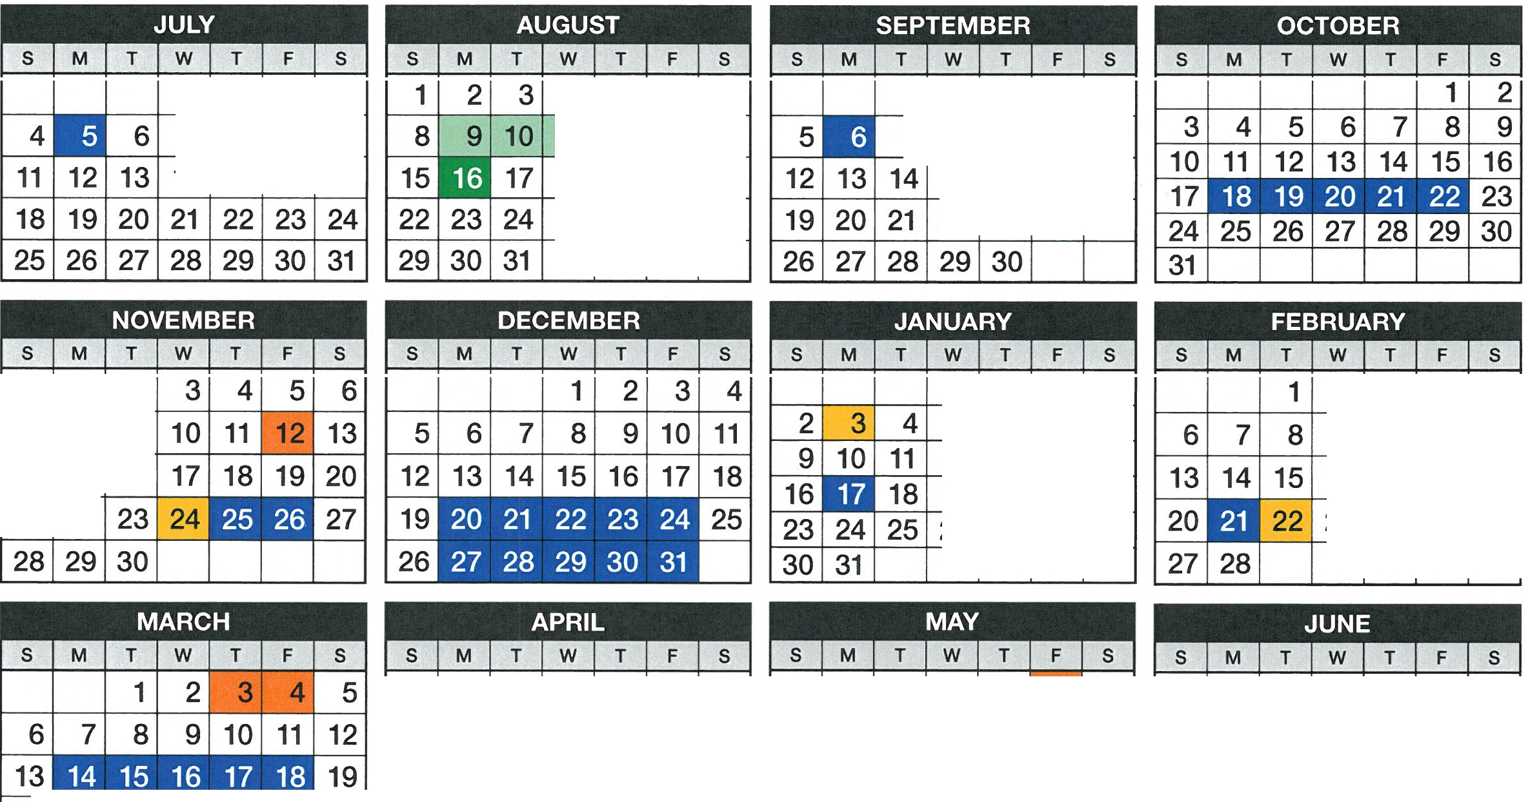

1

1 1

1 1

1

1

1

31 1

1

1 1 1

I I I

1

1

1 1

1 1

I

1

1

I

1 I

8 1

I

I

**3 4**

**10 11**

5

**1 2**

6 7 8 9

**12 13 14 15 16**

**1 2** 3 **4**

**8** 9 **10 11**

**15 16 17 18**

**20 21 22 23 24 25 26**

**27 28 29 30 31**

**17 18 19 20 21 22 23**

**24 25 26 27 28 29 30**

5 6 7

**12 13 14**

**19 20 21 22 23 24 25**

**26 27 28 29 30**

**Cherry Creek School District 2021-2022 School Year Calendar**

**ALL SCHOOLS**

|  |  |  |  |
| --- | --- | --- | --- |
|  | 1 | 2 | 3 |
| 7 | 8 | 9 | 10 |
| 14 | 15 | 16 | 17 |

|  |  |  |  |
| --- | --- | --- | --- |
| 4 | 51 | 6 | 7 |
| **11** | I 12I | 13I | 14 |
| 18 | I 19 | I 20 | I 21 |
| 25 | I 26 | I 27 | I 28 |
|  |  |  |  |

|  |  |  |  |  |
| --- | --- | --- | --- | --- |
| 1 | | 2 | 3 | 4 |
| 7 | 8  15 | 9  **16** | 10  **17** | 11  **18** |
| 22 | | 23 | 24 | 25 |

|  |  |  |
| --- | --- | --- |
|  | 1 | I 2 |
| 7 | 81 | 9 |
| 14 | 1 5 | 116 |
| 21 | I 22 | |

|  |  |  |  |
| --- | --- | --- | --- |
|  |  |  | 1 |
| 5 | 6 | 7 | 8 |
| 1 2 | 13 | 1 4 | 15 |
| 19 | I 20 | 21 | 22 |
| 26 | 27 | I 28 | I 29 |
|  |  |  |  |

|  |  |  |  |
| --- | --- | --- | --- |
| 21 | 31 | 41 | 5 |
| 91 | 101 | 11 | I 12 |
| 161 | 171 | 181 | 19 |
| 23 | I 24 | I 25 | I 26 |
|  |  |  |  |

|  |  |  |  |  |  |  |
| --- | --- | --- | --- | --- | --- | --- |
| **1** | **2** | 3 | **4** | 5 | **6** | **7** |
| **8** | **9 10** | | **11** | **12** | **13** | **14** |
| **15** | **16** | **17** | **18** | **19** | **20** | **21** |
| **22** | **23** | **24** | **25** | **26** |  | **28** |
| **29** | I 31 | |  |  |  |  |

* No School for Students and Staff

Days marked with colors below are non-pupil contact days:

* Last day of School
* School Starts
* Teacher Work Days Prior to Start of School
* K-8 Non-contact/conferences

K-12 Non-contact

If for any reason the school district must close schools for more than two days, this adopted 2021-2022 calendar will be amended by the Board of Education to provide additional school days.