Summersill Elementary School

**Schoolwide Behavior Support Plan**

2024-2025

**Schoolwide Implementation (Tier 1)**

**Positive Office Referrals**: Students receive positive office referrals for positive behaviors staff notice. Staff may fill out a positive office referral for any student on campus and turn it into Ms. Bright by Thursday morning. Every Friday morning, these student names will be announced, and students will receive a small treat.

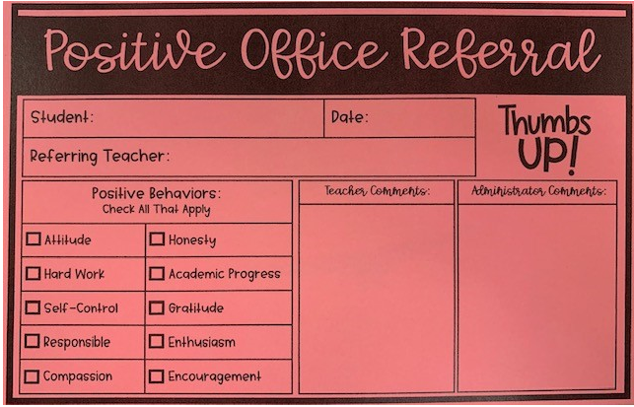

**Positive Home Communication**: Telephone calls, e-mails, and/or notes homes to all families for positive behaviors noticed. Every classroom teacher will contact every student’s parent/guardian within the first month of school. Teachers will choose 2 students to make a positive phone call each month and will be verified via an Excel doc.

**Positive Behavior Rewards**: Students will be rewarded for good behavior at every interim report and end of grading period. Class Dojo, 3-5 Behavior Notebooks, and Educator’s Handbook will be utilized to determine which student receives a reward.

**Eagle Support Team**: An intervention team will utilize the MTSS process to create educational behavioral interventions, based on academic and behavioral data.

**Classroom Behavior Plans**: Each classroom will follow the classroom management plan set in place by the advisory team. Details of this plan can be found on page 5.

**Habits of Mind Behavior Matrix**: Each hallway and common area will display the Habits of Mind Behavior Matrix. All staff will be required to review and reference this matrix with students as their behavior expectations.

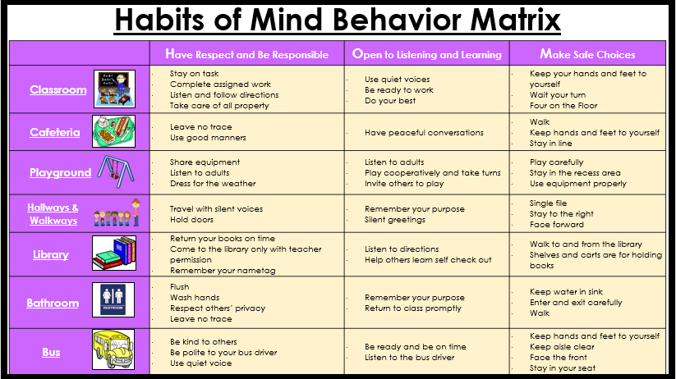

**Schoolwide Rules**

Each classroom, hallway, and common area will display the schoolwide rules poster.

These rules will be utilized as a crucial part of the behavior system that each classroom will follow.

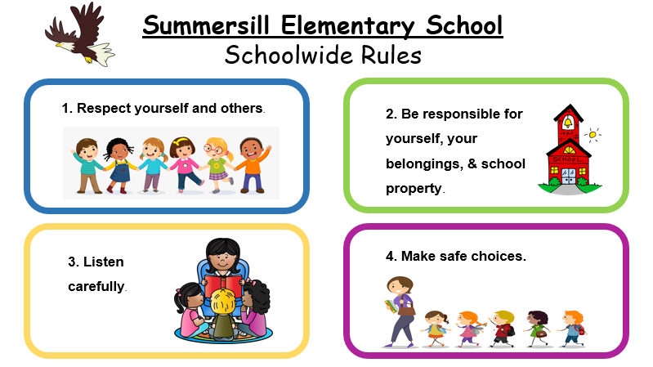

Classroom Implementation (Tier 1)

**Beginning of the Year Expectations**

Each teacher will utilize the first 4 weeks of schools to explicitly teach and interactively model (i.e. Looks like, Sounds like, Feels like) the common areas:

* Morning Routine
  + Exiting the bus/car
  + Entering the school
  + Entering the classroom or breakfast
* Behavior Expectations (as outlined in this plan)
* Hallways and Walkways
* Bathroom and Water Fountains
* Recess
* Cafeteria
* Safety Procedures (evacuation, fire drill, tornado drill, lock downs)
* Specials
* Assemblies
* Field Trips
* Dismissal Procedures
* Bus Expectations/Procedures

**Schedule**: Every classroom will utilize a Daily Check-In Journal (provided) as a way to check with students and build upon their emotional intelligence and social skills. The Check-In Journal will be filled out during the morning time as “morning work.”

* Every Monday (or Tuesday if Monday is not a school day), after announcements, teachers will hold a restorative circle utilizing Circle Prompt cards and Check-In Journal prompts.
* In January, teachers will hold a restorative circle every Monday and Friday morning after announcements.
* Every Wednesday, after announcements, teachers will implement a HOM lesson and/or activity based on the Habit of the Month.

**Positive Family Contacts**: All staff are encouraged to make positive phone calls and/or write positive notes/e-mails at a ratio greater than contacting about concern. Every classroom teacher will contact every student’s parent/guardian within the first month of school. Teachers will choose 2 students to make a positive phone call each monthly and will be verified on a communication log.

**Classroom Behavior Posters**: Each classroom will display the 4 Schoolwide Rules Poster and the HOM Behavior Matrix in a clear manner, allowing any staff visible access upon entering the classroom.

**Responding to Student Misbehavior:** All staff will follow the appropriate steps to respond to student misbehavior. These steps can be found on page 6. A list of teacher-handled vs. admin-handled behaviors can also be found on page 7.

Classroom Behavior System

**Classroom Behavior System:**

Each classroom will implement the following:

* The 4 Schoolwide Rules
* The HOM Behavior Matrix
* The Teacher Implemented Consequences will be followed as students break rules.
* K-2 Teachers will utilize Class Dojo as their behavior tracking system. Teachers will add administration, special teachers, resource teachers, and other necessary staff as contributors. Teachers will create the 4 schoolwide rules as the behaviors students need to earn and lose points. Each student should display both positive and negative points.
* 3-5 Teachers will utilize the provided Behavior Notebook to track behaviors the students have broken. Students will enter their own information as they break rules. Specials teachers will utilize this same process.

Each classroom will ensure easy access to their behavior system as well as have the following posted: Schoolwide Rules, Behavior Matrix, and steps of the teacher implemented consequences. Each grade level team will also create a cohesive positive behavior system.

**All behavior plans implemented by IEP and/or Eagle Support Team will take precedence over this classroom behavior system. All teachers involved with the student should be in the know of this separate behavior plan.

**Teacher Implemented Consequences**:

These are the consequences a teacher puts in place, in this order, when a student breaks a rule.

1. Verbal Warning
2. Moved to a designated Reflection Area in the classroom, where a 5-minute timer is set, and the student will continue to do as the class is doing.
3. Moved to a designated colleague’s classroom, where a 10-minute timer is set, and the student will complete a Behavior Reflection Sheet. Teacher or IA will review the reflection sheet with the student. Student may stay beyond the 10-minute timer only if he/she needs additional time to regulate themselves.
4. Phone call to parent/guardian as well as submitting a Minor write up in Educator’s Handbook.
5. Major Office Referral submitted in Educator’s Handbook.

**Resource Teachers and Specials Teachers** will carry on/continue with where student is at on the behavior plan in the regular classroom during the time the resource/specials teacher is working with him/her. Wherever the behavior occurs, that teacher is responsible for contacting the parent if needed.

**Habits of Mind Celebrations:** Each student will have the opportunity to attend the HOM celebration at the end of each nine weeks. Teachers will track who is eligible to attend via Class Dojo, 3-5 Behavior Notebook, and Educator’s Handbook. When completing the HOM Celebration form, consider the following:

* One Minor/Level 2 write up = 1 strike
* Three Minor/Level 2 write ups = 5 strikes
* One Office/Level 3 write up = 5 strikes
* 5 Strikes = Not attending

**Principals List/Honor Roll:**

Principals List/Honor Roll will be based on content areas where students receive an actual grade (ELA/Reading, Math, Science, Social Studies). Subjects that only provide for a S, N, U should not be considered when determining Principals List/Honor Roll.

Conduct, citizenship, specials can be included as criteria for selection in academic honor societies or other recognition programs such as Buddy 2 Buddy, that are designed to recognize the student as a whole.

Tiered Levels of Discipline Infractions

|  |  |  |
| --- | --- | --- |
| **Level 1:** Teacher conference with student/classroom consequence. | **Level 2:** Create (minor) incident in Educator’s Handbook. Teacher makes contact with parent and print a copy of parent letter to send home. | **Level 3:** Create office referral in Educator’s Handbook. (Call the office) |
| 1. Horseplay 2. Tripping 3. Unkind words 4. Distracting behaviors 5. Food/Drink in room 6. Touching other (harmless) 7. Cutting line 8. Unprepared for class 9. Out of seat 10. Passing notes 11. Running in building 12. Off-task 13. Playing in restrooms 14. Not using playground equipment properly 15. Profanity (mild or 1st offense) 16. Bad manners 17. Throwing objects 18. Incomplete work 19. Talking in line/hallway 20. Sleeping 21. Cheating 22. Disrespect to staff (mild) 23. Technology infraction (off task) | 1. Horseplay resulting in injury 2. Yelling 3. Tantrums 4. Constant teasing (not bullying) 5. Bickering among students 6. Wandering in hallways 7. Repeated cheating 8. Violating safety rules 9. Incomplete class work (documented as habitual) 10. Refusal to follow directions. 11. Stealing (i.e., candy, pencil, homework) 12. Misuse of school property 13. Forgery 14. Profanity (not mild) 15. Technology infraction (repeatedly off task; negligent care) 16. Repeated Level 1 infractions 17. Communicating threats | 1. Drugs (illegal paraphernalia) 2. Coming to school under the influence of drugs/alcohol 3. Exposing self to others 4. Sexual harassment 5. Assaults of any kind 6. Threats involving physical harm 7. Throwing objects with the intent to injure 8. Inappropriate sexual contact 9. Stealing (i.e., money, school property) 10. Cheating (EOG) 11. Leaving school without permission 12. Vandalism or arson 13. Bullying 14. Cursing out staff/students 15. Extreme oppositional defiant behaviors 16. Pulling the fire alarm 17. Racial slurs 18. Rude/disrespectful gestures 19. Chronic lying 20. Fighting 21. Repeated level 2 infractions |