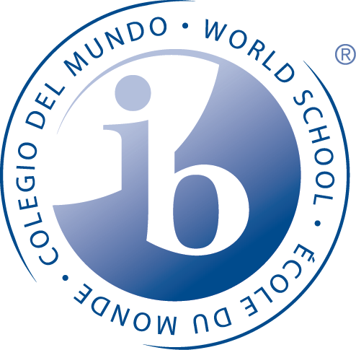

CHANDLER HIGH SCHOOL EST. 1914
INTERNATIONAL BACCALAUREATE WORLD SCHOOL
“ SCHOOL OF CHAMPIONS”

What is IB?

The International Baccalaureate Diploma Programme is an academically challenging and balanced program of education with final examinations that prepares students, aged 16 to 19, for success at the university level and life beyond.
The Diploma Programme prepares students for effective participation in a rapidly evolving and increasingly global society as they:

develop physically, intellectually, emotionally and ethically
acquire breadth and depth of knowledge and understanding, studying courses from 6 subject groups
develop the skills and a positive attitude toward learning that will prepare them for higher education
study at least two languages and increase understanding of cultures, including their own
make connections across traditional academic disciplines and explore the nature of knowledge through the program’s unique Theory of Knowledge course
undertake in-depth research into an area of interest through the lens of one or more academic disciplines in the extended essay
enhance their personal and interpersonal development through creativity, action and service (CAS)

The Career Programme prepares students to engage in career-related learning while gaining transferable and lifelong skills in applied knowledge, critical thinking, communication, and cross-cultural engagement.
For CP students, DP courses provide the theoretical underpinning and academic rigour of the programme; the career-related study further supports the programme’s academic strength and provides practical, real-world approaches to learning; and the CP core helps them to develop skills and competencies required for lifelong learning.
IB students will focus on a career related area of study, such as computer science, architecture, culinary, film, visual arts, auto tech, early childhood development, theater, etc…

What does IB look like at Chandler High School?
- Students can be a part of the IB - Middle Years Programme (MYP) in the 9th and 10th grade. During this time they are taking Honors courses, completing community service and working on a personal project during sophomore year.
- A student does not have to be an MYP student in order to become a Diploma Candidate. However, about 70% of our Diploma Candidates have been MYP students.
- As 11th and 12th graders, students move from ‘Honors’ courses to IB-labeled courses.
- There is a support system of teachers, counselors, IB-MYP Coordinator, IB-DP Coordinator, IB-CP Coordinator, fellow students as mentors and parents to allow for student success in the program.
- In their junior and senior year, IB candidates complete assessments that can lead to college credit and, after successfully completing the full two-year program, the IB Career Certificate or full IB Diploma.
To learn more about IB at CHS:
MYP (9th and 10th grade)
Trevor Hammond
hammond.trevor@cusd80.com
480-812-7788

Diploma Programme (11th and 12th grade)
Tricia Bodroghy
bodroghy.patricia@cusd80.com
480-812-7990

Career Programme (11th and 12th grade)
Courtney Kemp
kemp.courtney@cusd80.com
480-812-7789

What are the characteristics of an IB learner?
All IB courses focus on the whole student and the following ten aspects of the “Learner Profile”:

Inquirers Open-minded
Knowledgeable Caring
Thinkers Risk-takers
Communicators Balanced
Principled Reflective

As the core elements of the IB curriculum, these attributes help create students that are very prepared to be successful in college and beyond.

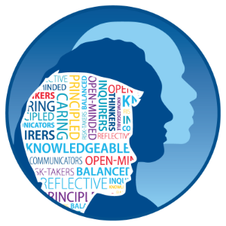

Quality assurance and professional development
Any school, or group of schools, wishing to offer one or more International Baccalaureate programmes as an IB World School must first be authorized. Chandler High School began the authorization process in 1982, graduating our first IB Diploma Candidates in 1985. The requirements are the same for all schools, and the procedure is designed to ensure that schools are well prepared to implement the programme successfully. All IB World Schools are required to participate in an ongoing process of review and development, using the same programme standards and practices.

As part of its ongoing commitment to the development of a highly skilled global learning community, the IB provides a wide range of high-quality professional development opportunities to help new, experienced and expert school leaders and educators understand, support, and successfully deliver IB programmes reflecting IB standards and practices. All IB teachers at CHS receive regular training and work in collaborative groups both at the school and with teachers from around the world.

Why do universities value IB students?
IB students are prepared for academic success.
- IB students are more likely than others to enroll in and graduate from selective higher education institutions.
- Based on their experiences, IB students possess a broader range of skills that enhance their ability to adapt and contribute to university life.
- IB students demonstrate a level of emotional and intellectual maturity for managing the demands of challenging coursework and make meaningful contributions.
- They have extensive experience doing independent research and presenting what they have learned through presentations, papers and other projects.
- They think critically and draw on diverse perspectives that reflect an international outlook.
- Participation in the IB Diploma Program shows that students have excelled in multiple and diverse academic challenges and is a strong predictor for success in university.


CHS IB Graduates are attending:
Air Force
ASU
Boston College
Chaminade University of Honolulu
Concordia University
Duke
East Tennessee University
Embry-Riddle
Fordham
GCU
Howard University
Indiana University
MIT
NAU
Northwestern University
Navy
Regis
Louisiana State University
Texas Tech
U of A
University of Oregon
Vanguard University
USC
University of Michigan

JUST TO NAME A FEW……. And they received over $8.5 million in scholarship offers!
CHS IB Diploma Graduates
complete their degree(s) in four years or less.
They attended:
U of A
ASU
USC
Princeton
NYU
Puget Sound
Emerson
Texas Tech
NAU
York
U of Penn
Brown
Harding
Stanford
and majored in …
Biological Sciences
Religion
Molecular and Cellular Biology
Physiology
Film and Television
Politics and Government
Computer Science
Economics
Optical Sciences and Engineering
Biochemistry
Writing, Literature and Publishing
Biology
Chemical Engineering
Political Science
Computer Science
Public Health
Human Biology
Supply Chain and Accounting
Management Information Systems

