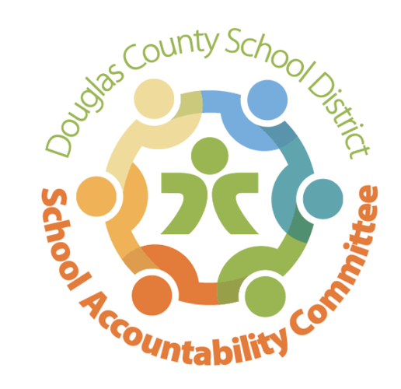2024-2025

Ranch View Middle School

School Accountability Committee (SAC)

**Agenda for meeting on:**

Date: 11/11/24

Time: 4:15-5:15

Location: RVMS Library

**Meeting Logistics:** Erin Turley (3 minutes)

* Introductions & Quorum
* Approve prior Meeting Minutes

**Celebrations:** Erin Kyllo (10 minutes)

* Parent/Teacher conferences (9/17 & 9/18)
* Community Service Day (10/4)
* Fall Dance (10/25)
* Fall Sports wrap-up
* Pod War monthly update
* RVMS After School Clubs
* School Wide Fundraiser (10/22-10/28) Goal: $95,000
  + Plan for fundraising dollars

**New Business:** Erin Kyllo (40 minutes)

* Enrollment Numbers (Count day 10/1)
* Open Enrollment begins 11/1
  + Coffee Talks: 11/5 9:00-10:00 & 11/13 4:15-5:15 & 2/6 1:30-2:30
* Staff Update
* iREADY Testing (2nd Round): 12/2 & 12/3
* Unified Improvement Plan - School-wide Area of Focus/Professional Development
* School-wide Happenings:
  + Winter Sports
  + Winter Play: “The Greek Mythology Olympiaganza” 11/14 & 11/15
  + Turkey Trot: 11/22
  + Thanksgiving Break: 11/25-11/29
  + Winter Break: 12/20-1/6
  + Passport to Excellence: 1/23 5:00-7:00

**Standing Reports:** (20 minutes)

* Teacher Report: Craig Moody
* DAC (District Accountability Committee): Kate Thorne
* PIT Crew (Parent Teacher Organization) Report: Jenny Huettl
  + Halloween Fun Run (10/26)
  + Tom’s Coffee Truck (10/31)
  + Restaurant Nights
  + Boo Gram for all
  + Upcoming November/December happenings
* Community Report: Jenny Parks
* Principal’s Wrap-Up: Erin Kyllo

**Open forum for guests:** Chair (5 minutes), Community Members (3 min. max)

**Next SAC Meeting: January 27th @ 4:15 in the RVMS Library**