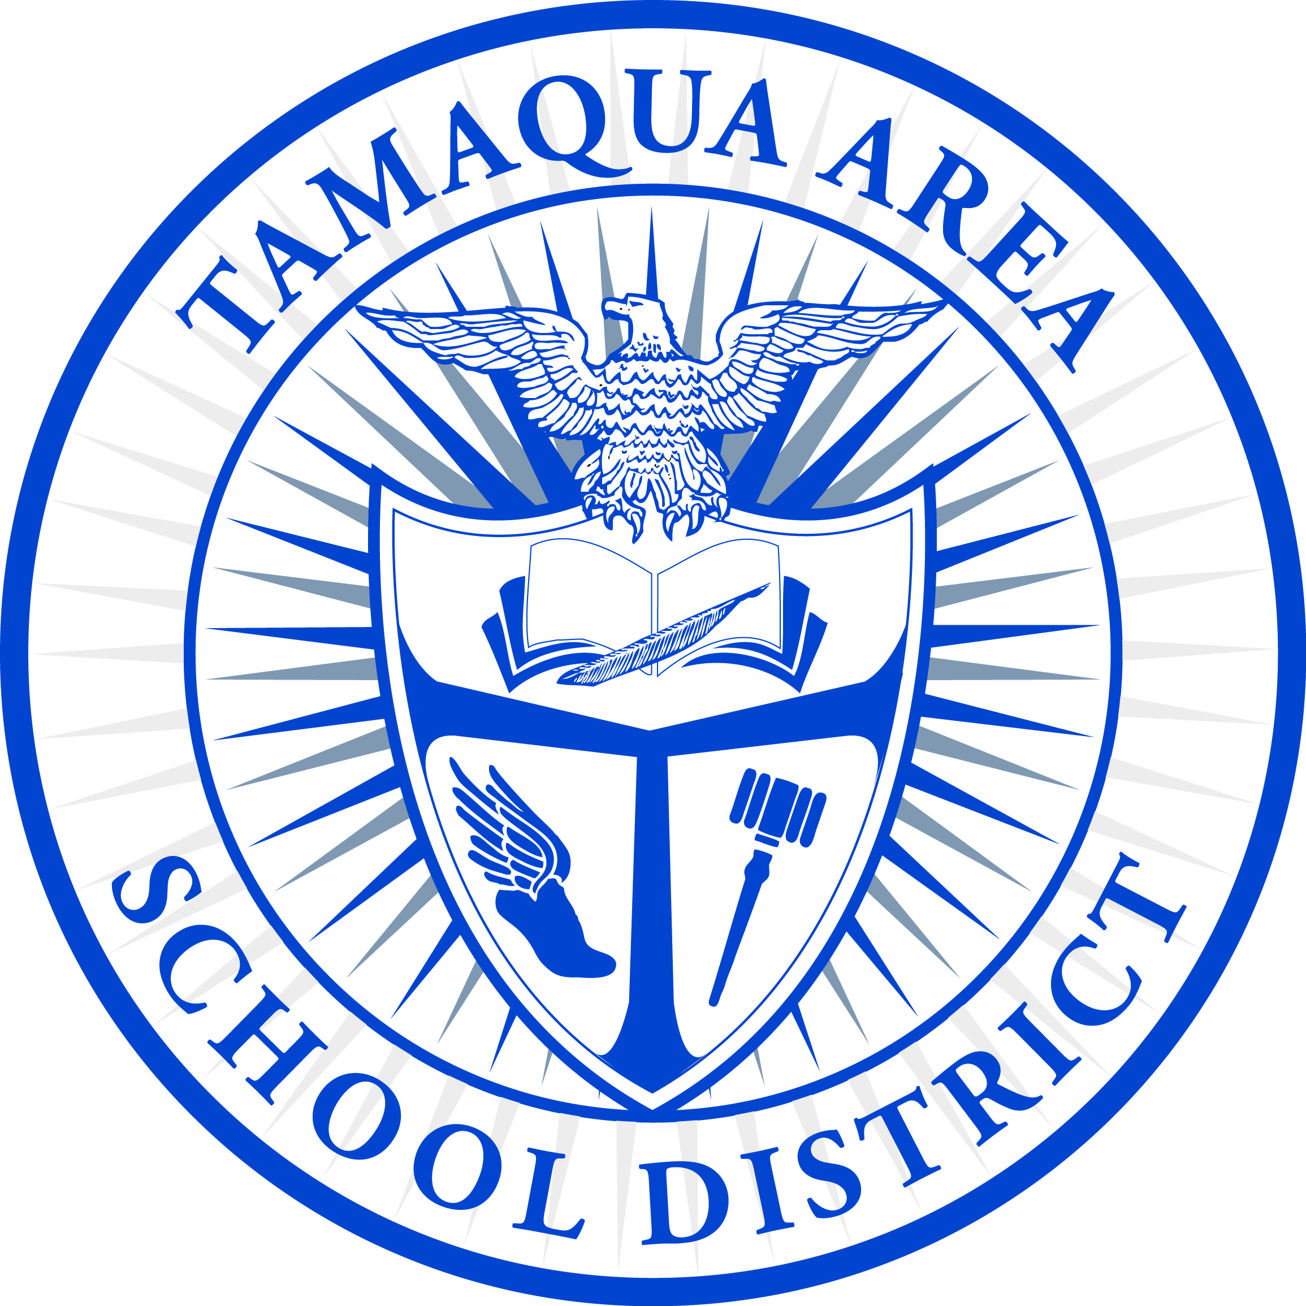

Tamaqua Area High School

TAHS Final Exam Schedule – SENIORS *May 16, 17, 20, 2024*

Dear Parents and Students:

Students are only required to be in school for their final exams. Lunch will be provided for any Senior who wishes to remain in the building. Bus transportation will be provided at the regularly scheduled time. If you would like your student to remain in the high school during non-exam periods, please contact the office at 570.668.1901.

**May 16 (All Exams will be in the HS Café)**

Period 1-7:40-8:45

Period 2- 8:50-9:55

Lunch 10:40-12:10

Period 3 -12:55-2:00

**May 17 (All Exams will be in the HS Café)**

Period 4-7:40-8:45

Period 5- 8:50-9:55

Lunch 10:40-12:10

Period 6 -12:55-2:00

**May 20 (All Exams will be in the HS Café)**

Period 7-7:40-8:45

Period 8- 8:50-9:55

Lunch 10:40-12:10

Period 9 -12:55-2:

Transportation at 2:25 (All days)

500 Penn Street

Tamaqua, PA 18252

Phone: (570) 668-1901

Fax: (570) 668-2970

Tamaqua Area Middle School

502 Penn Street

Tamaqua, PA 18252

Phone: (570) 668-1210

Fax: (570) 668-5027

Tamaqua Elementary School

Boyle Avenue

Tamaqua, PA 18252

Phone: (570) 668-3306

Fax: (570) 668-3235

West Penn Elementary School

185 School Drive

New Ringgold, PA 17960

Phone: (570) 386-5051

Fax: (570) 386-3226

Tamaqua Area School District | 138 West Broad Street | Box 112 | Tamaqua, PA 18252

Phone: (570) 668-2570 | Fax: (570) 668-6850 | Online: www.tamaqua.k12.pa.us