Schuylkill League Championship results:
2. Tamaqua
7 Mia Jones, Sr* 22:46 7:20
9 Samantha Plasha, So* 22:54 7:23
13 Cali Frantz, Fr* 23:22 7:32
15 Isabella Jones, So* 23:33 7:36
23 Ava Jones, Fr* 24:23 7:52
33 Lyla Clemson, Fr* 25:21 8:11
37 Hailey Williams, Sr* 26:54 8:41

3. Tamaqua
3 Levi Kunkel, So 17:07 5:31
7 Anthony Marchetti, So 17:22 5:36
17 Stephen Keiffer, Jr 17:49 5:45
25 Adam Schock, So 18:30 5:58
27 Jesse Gormley, Jr 18:39 6:01
42 Logan Morgans, Fr 19:44 6:22
44 Brody Boyce, So 19:51 6:24

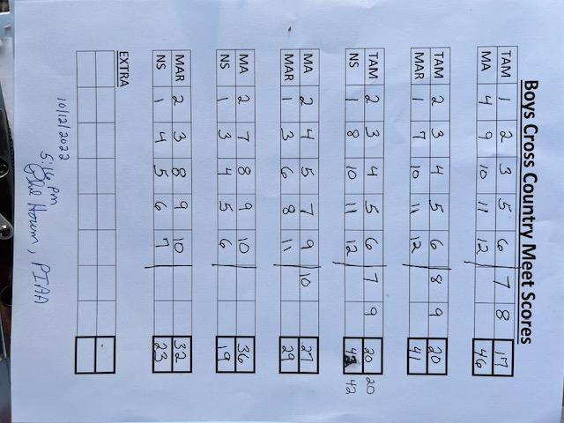

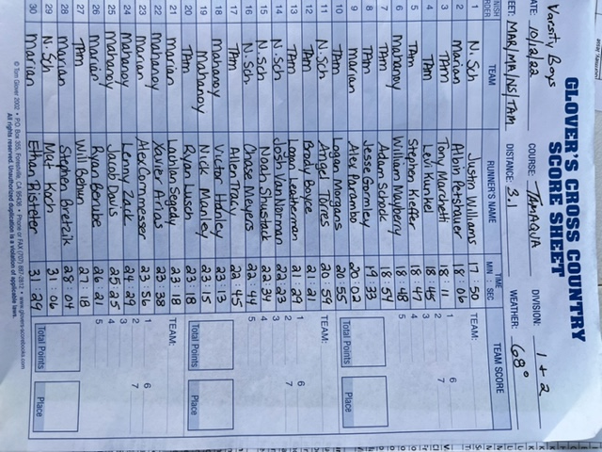
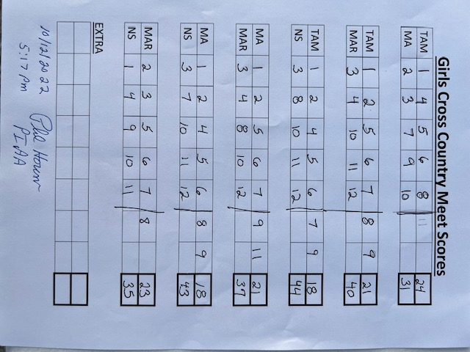
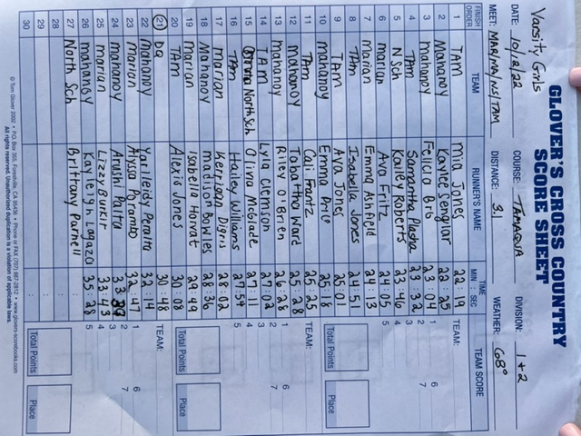
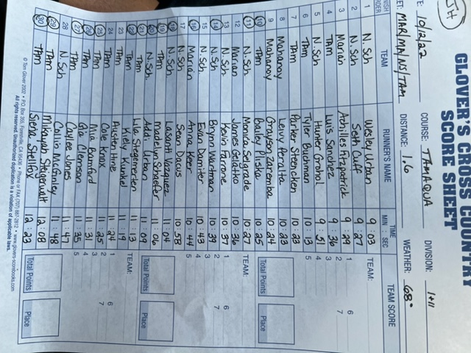
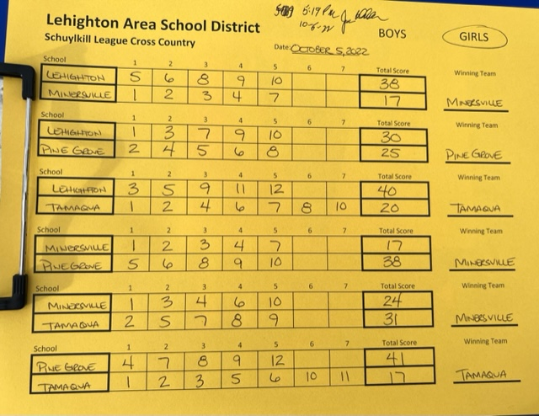

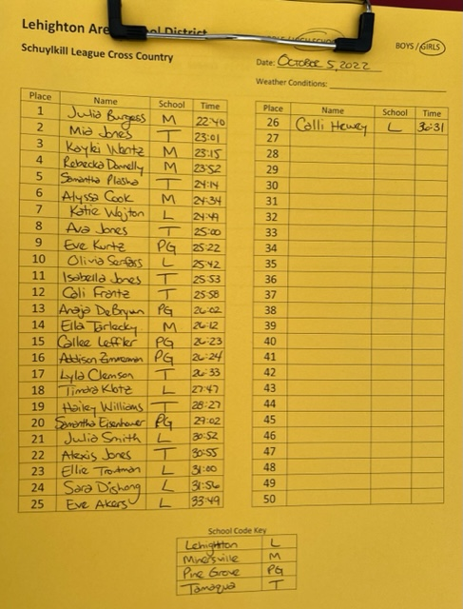
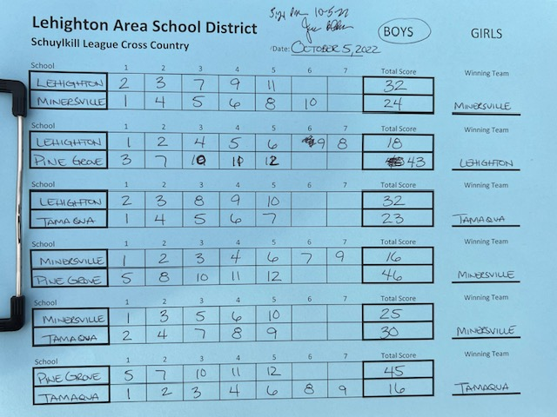

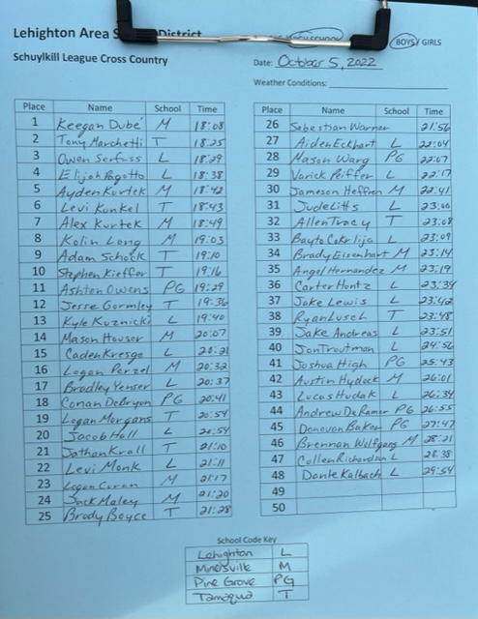

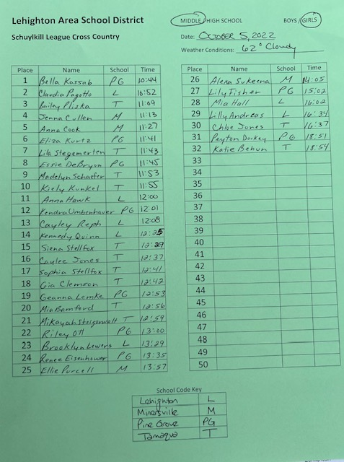

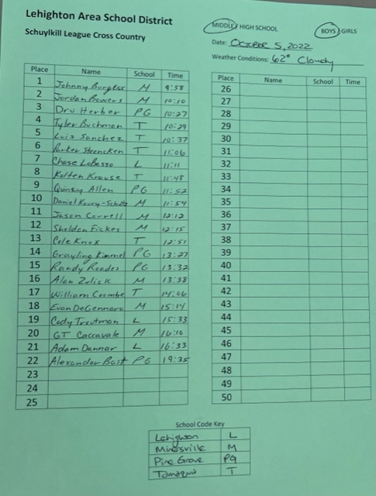

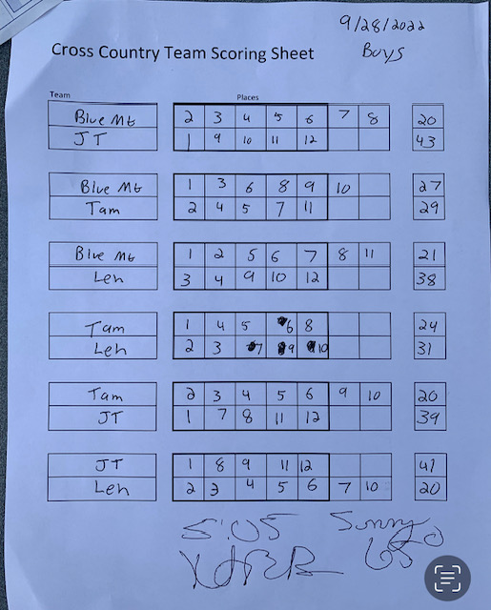

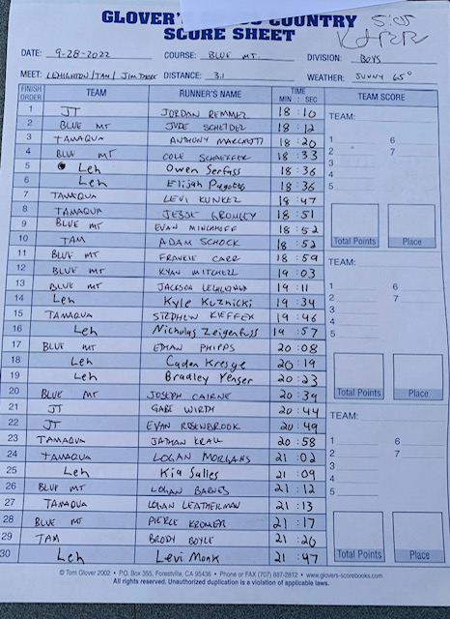

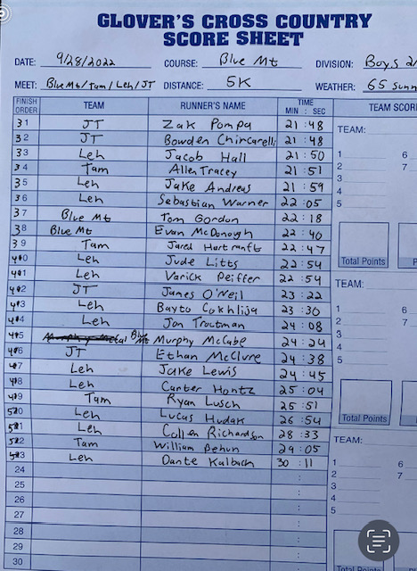

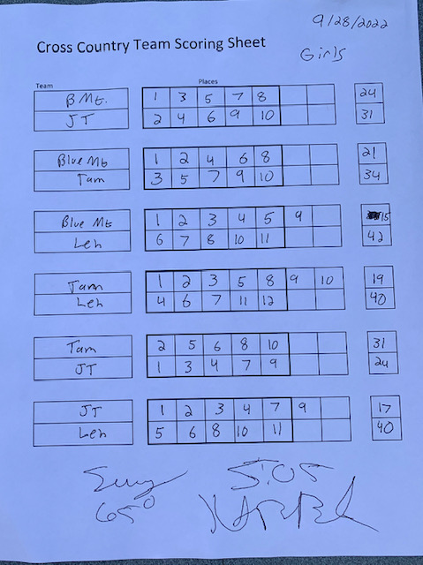

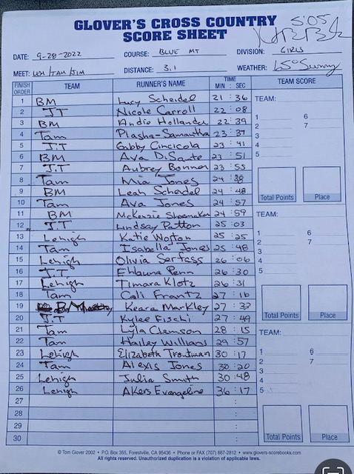

PGA Invite  Place | Athlete | Time
1 | Nate Goldsborough(Fleetwood) | 17:05
2 | Keegan Dube(Miners) | 17:34
3 | Anthony Marchetti(Tamaqua) | 17:53
4 | Levi Kunkel(Tamaqua) | 18:03
5 | Kolin Long(Miners) | 18:09
6 | Joseph Rossi(Nativity) | 18:09
7 | Wyatt Leitzel(Tri-Valley) | 18:13
8 | Tyler Shunk(Nor Leb) | 18:16
9 | Ayden Kurtek(Miners) | 18:21
10 | Alex Kurtek(Miners) | 18:25
11 | Stephen Kieffer(Tamaqua) | 18:30
12 | Ashton Owens(PGA) | 18:38
13 | Sean Carpenter(Fleetwood) | 18:41
14 | Conan DeBryun(PGA) | 18:42
15 | Luke Hentz(Nor Leb) | 18:56
16 | Caleb Sanders(Nor Leb) | 19:12
17 | Josiah Kelly(Nor Leb) | 19:16
18 | Brett Reed(Tri-Valley) | 19:20
19 | Mason Houser(Miners) | 19:20
20 | Logan Perzel(Miners) | 19:36
21 | Owen Wolfgang(Tri-Valley) | 19:40
22 | Trevor Fredericks(Hamburg) | 19:45
23 | Brady Boyce(Tamaqua) | 19:58
24 | Logan Morgans(Tamaqua) | 20:00
25 | Brandon Smith(Nativity) | 20:01
26 | Tucker Reiber (Nor Leb) | 20:26
27 | Sean Seven(Sch Haven) | 20:47
28 | Joseph Escobales(Nor Leb) | 20:55
29 | Logan Curran(Miners) | 20:59
30 | David Boyer(Nor Leb) | 21:07
31 | Braden Hall(Tri-Valley) | 21:17
32 | RuoHan Chen(Fleetwood) | 21:20
33 | Nevin Kile(Fleetwood) | 21:28
34 | Jack Maley(Miners) | 21:29
35 | Allen Tracey(Tamaqua) | 21:29
36 | Jameson Heffron(Miners) | 21:34
37 | Skylar McGinity(Nor Leb) | 21:46
38 | John Salensky(Fleetwood) | 21:50
39 | Braden Nattress(Fleetwood) | 21:53
40 | Connor Tucci(Fleetwood) | 22:00
41 | Mason Warg(PGA) | 22:01
42 | Collin Kuhns(Hamburg) | 22:06
43 | Luke Garvey(Sch Haven) | 22:08
44 | Sawyer Smith(Hamburg) | 22:08
45 | Camrin Ney(Sch Haven) | 22:17
46 | Benjamin Clemmer(NorLeb) | 22:47
47 | Billy Burke(Nativity) | 22:51
48 | Jared Bruber(Fleetwood) | 23:01
49 | Evan Rollman(Hamburg) | 23:05
50 | Ty Jozefick(Hamburg) | 23:16
51 | Stanley Gorski(Nativity) | 23:20
52 | Jared Hartranft(Tamaqua) | 23:21
53 | Connor Readinger(Tri-Valley) | 23:32
54 | Joshua Felker(Fleetwood) | 23:43
55 | Alek Gorski(Nativity) | 24:48:00
56 | Ethan Flemming(PGA) | 25:07:00
57 | George Lopez(Shend Valley) | 25:19:00
58 | Bryan Garcia(Shend Valley) | 25:26:00
59 | Andrew DeRamer(PGA) | 26:14:00
60 | Nick Sagan(Nativity) | 26:55:00
61 | William Behun(Tamaqua) | 27:10:00
62 | Joanthan Melgar(Hamburg) | 27:31:00
63 | Jacob Schmeitz(Tri-Valley) | 27:43:00
64 | Connor Troxell(Nor Leb) | 28:14:00
65 | John Boctor(Shend Valley) | 28:24:00
66 | Johnny Schmeltz(Tri-Valley) | 29:52:00
Place | Name | Time
1 | Anna Schaeffer (Sch Haven) | 21:31
2 | Julia Burgess (Miners) | 22:31
3 | Mia Jones (Tamaqua) | 22:34
4 | Melissa Malarky (Nativity) | 22:40
5 | Kaylei Wentz(Miners) | 22:58
6 | Samantha Plaska (Tamaqua) | 23:16
7 | Alyssa Cook (Miners) | 23:26
8 | Rebeka Donnely (Miners) | 23:30
9 | Sunni Krill (PGA) | 24:09:00
10 | Isabella Jones (Tamqua) | 24:12:00
11 | Isabella Hughes(Sch Haven) | 25:00:00
12 | Eve Kurtz(PGA) | 25:07:00
13 | Alexis Schreckengast(Nor Leb) | 25:08:00
14 | Brianna Gulden(Shend Valley) | 25:09:00
15 | Layla Baker(Nor Leb) | 25:14:00
16 | Ella Tarlecky(Miners) | 25:14:00
17 | Samara Yule(Sch Haven) | 25:41:00
18 | Arianna Ventura(Fleetwood) | 25:45:00
19 | Alyssa Marlowe(Nor Leb) | 25:47:00
20 | Ava Jones(Tamaqua) | 25:53:00
21 | Ellie Wolfgang(Tri-Valley) | 25:54:00
22 | Lauren Murray(Nor Leb) | 25:59:00
23 | Shannon Govern(Hamburg) | 26:15:00
24 | Callee Leffler(PGA) | 26:43:00
25 | Cali Frantz(Tamaqua) | 26:44:00
26 | Addison Zimmerman(PGA) | 26:44:00
27 | Anaja DeBryun(PGA) | 26:50:00
28 | Lyla Clemson(Tamaqua) | 27:07:00
29 | Sammantha Eisenhower(PGA) | 27:07:00
30 | Bailee Edwards(PGA) | 27:26:00
31 | Lilianna Arce(Fleetwood) | 27:32:00
32 | Kiera Perkins (Fleetwood) | 28:14:00
33 | Abby Purcell(Tri-Valley) | 29:58:00
34 | Marlowe Reimert(Fleetwood) | 30:13:00
35 | Alexis Jones(Tamaqua) | 30:45:00
36 | Taylor Bast(PGA) | 31:12:00
37 | Josephine Kropp(Shend Valey) | 36:43:00

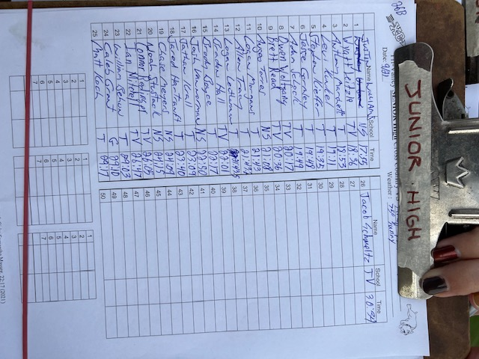
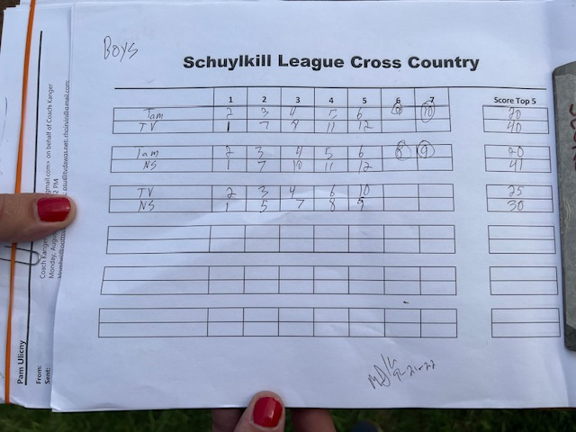

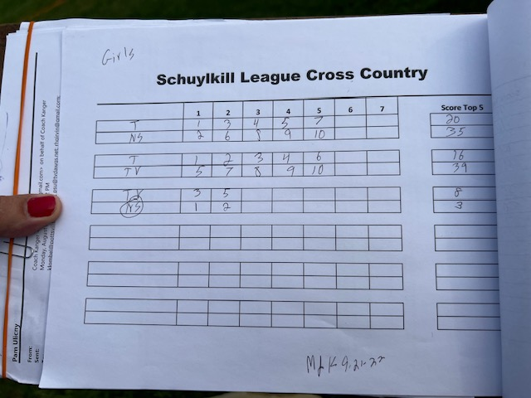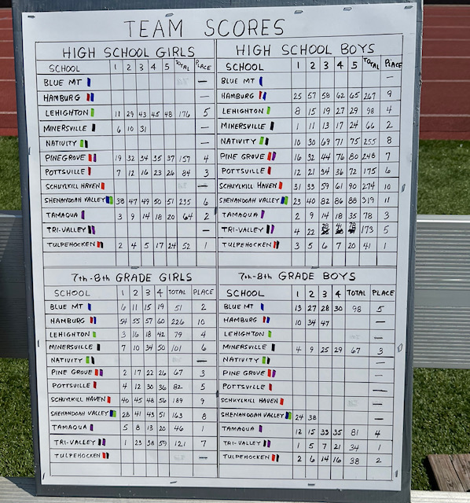

Sch Haven Invite

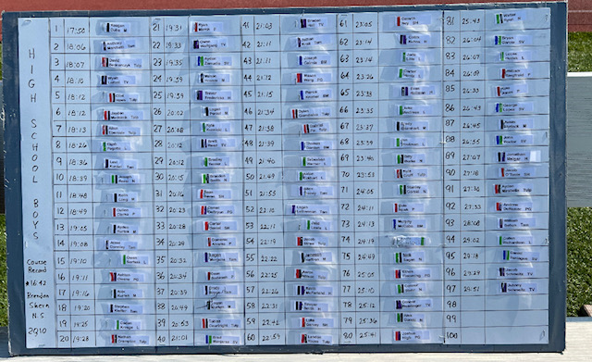

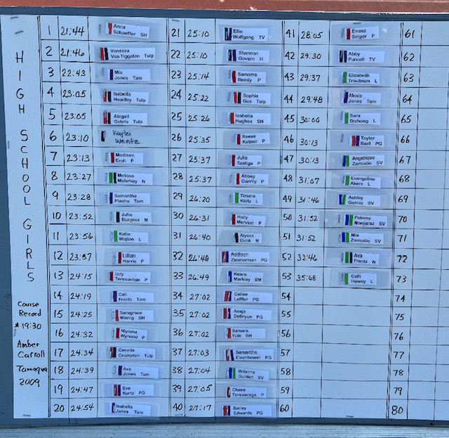
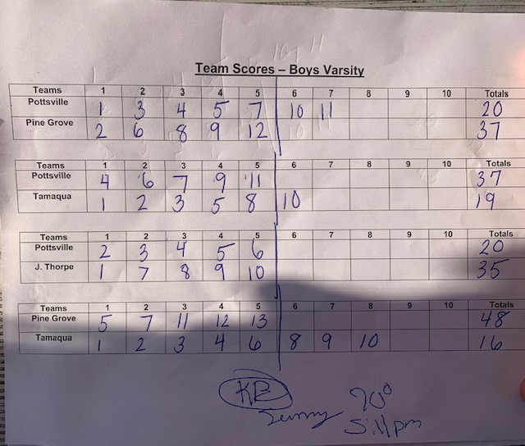

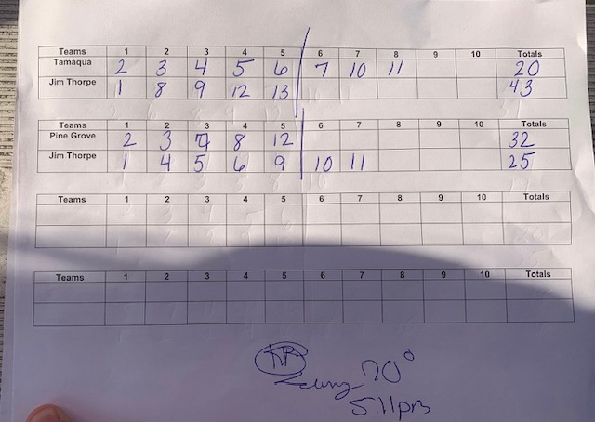

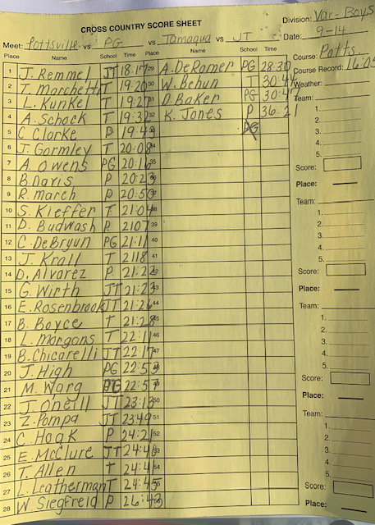

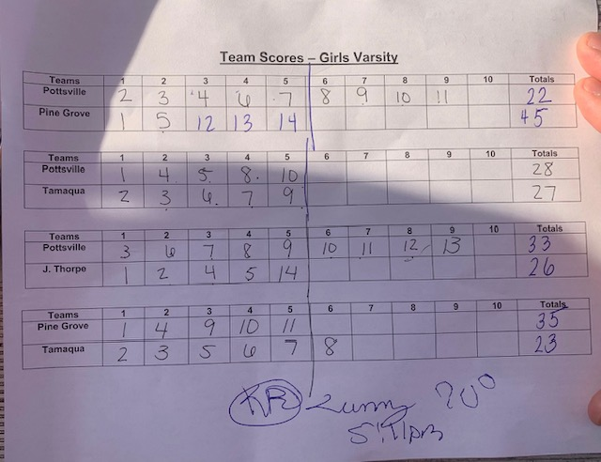

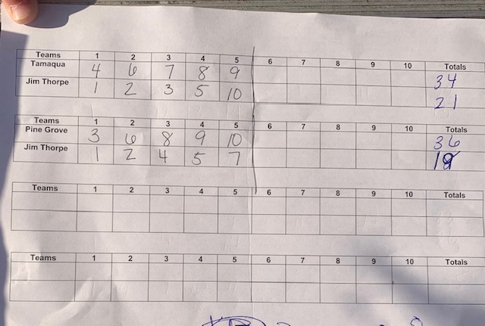

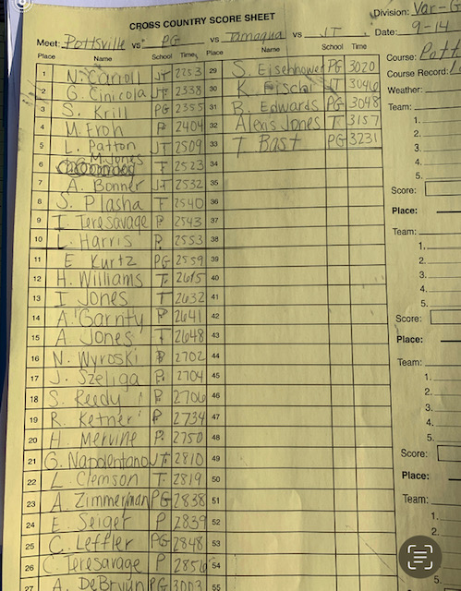

DeSales University Invite results:
﻿
https://pa.milesplit.com/meets/488710-43rd-annual-centaur-invitational-2022/results#.YxzpAy8pChA

See me below
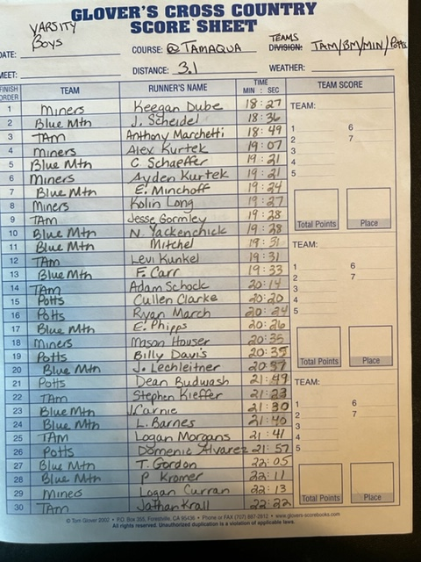
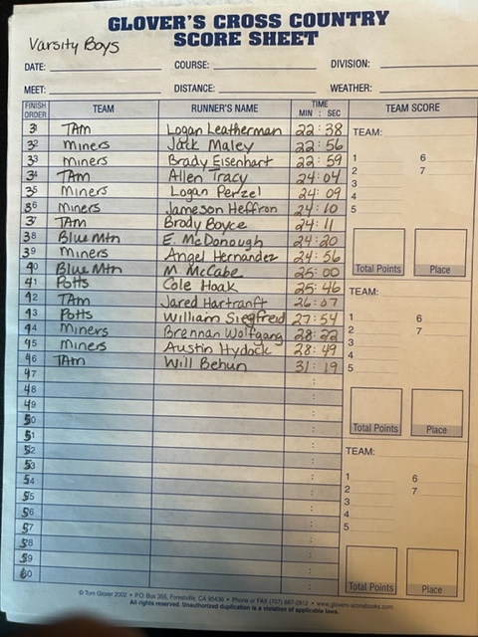
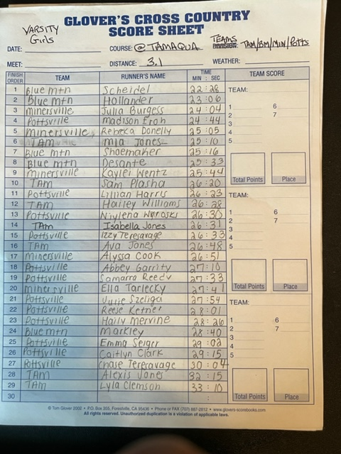
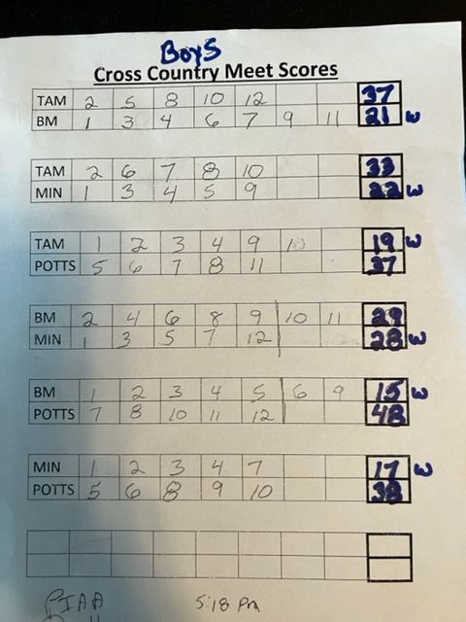
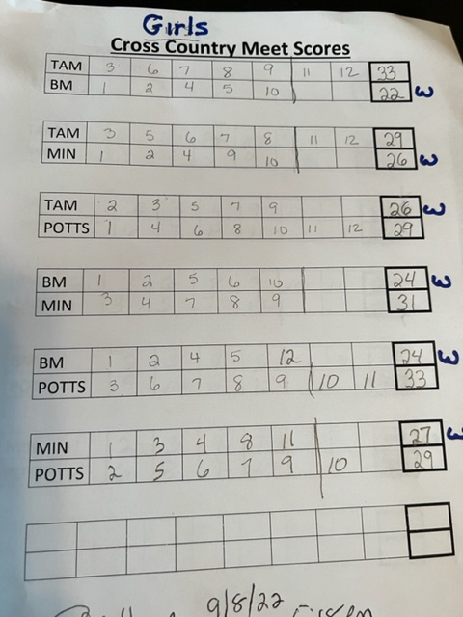
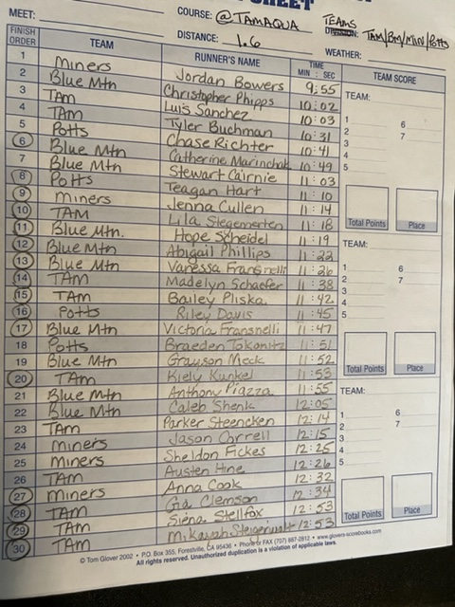
At Northampton Invite:

