SCHUYLKILL LEAGUE SOCCER GAME REPORT

Reporting School: Tamaqua Date of Game: 10/16/17

Location: Tamaqua

League Non-league Yes Boys
(Circle One) (Circle One)

Scoring
 | School | 1 | 2 | OT | OT | Final
Visitors | Catasauqua | 2 | 1 | 0 | 0 | 3
Home | Tamaqua | 3 | 0 | 0 | 1 | 4

Scoring Summary
School | Half | Goal | Assist | Assist
Tamaqua | 1st | Tyler Steigerwalt | Ian Davis | 7:29
Catty | 1st | Steven Ritter |  | 16:06
Catty | 1st | Steven Ritter |  | 27:07
Tamaqua | 1st | Jacob Rudy | Derian Stianche | 31:55
Tamaqua | 1st | Michael Schlanta | Nathaniel Noftz | 36:49
Catty | 2nd | Steven Ritter |  | 53:15
Tamaqua | 2nd OT | Derian Stianche | Penalty Kick | 99:56
Shots |  | Catty-8 Tam-14 | JV Score | 1-1 Tie
Corner Kick |  | Tam-9 Leh-5

Goalkeeper Stats
School | Keeper | Saves | Goals
Tamaqua | Reese Szabo | 5 | 3
Catty | Shane Dolon | 6 | 4

SCHUYLKILL LEAGUE SOCCER GAME REPORT

Reporting School: Tamaqua Date of Game: 10/12/17

Location: Lehighton

League Yes Non-league Boys
(Circle One) (Circle One)

Scoring
 | School | 1 | 2 | OT | OT | Final
Visitors | Tamaqua | 1 | 3 |  |  | 4
Home | Lehighton | 1 | 0 |  |  | 1

Scoring Summary
School | Half | Goal | Assist | Assist
Tamaqua | 1st | Derian Stianche | T. Steigerwalt | 13:54
Lehighton | 1st | Conor Hanley | Brandon Schnell | 25:50
Tamaqua | 2nd | Luke Verta | Stianche | 67:28
Tamaqua | 2nd | Nathaniel Noftz | Stianche | 70:57
Tamaqua | 2nd | Tyler Steigerwalt |  | 79:51
Shots |  | Leh-14 Tam-14 | JV Score | 3-1 Lehighton
Corner Kick |  | Tam-4 Leh-2

Goalkeeper Stats
School | Keeper | Saves | Goals
Tamaqua | Reese Szabo | 8 | 1
Lehighton | Zach Andrews | 7 | 4

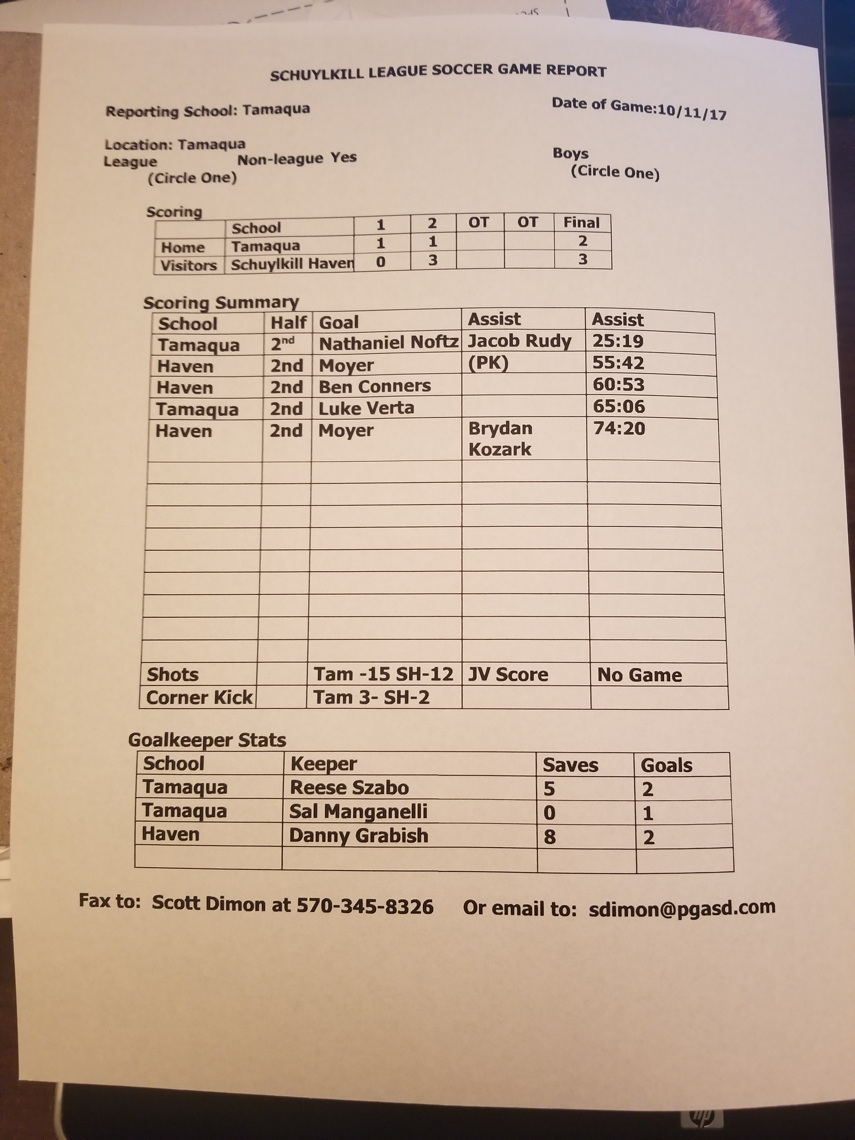

SCHUYLKILL LEAGUE SOCCER GAME REPORT

Reporting School: Tamaqua Date of Game:10/10/17

Location: Tamaqua
League Yes Non-league Boys
(Circle One) (Circle One)

Scoring
 | School | 1 | 2 | OT | OT | Final
Home | Tamaqua | 0 | 2 |  |  | 2
Visitors | Pine Grove | 0 | 1 |  |  | 1

Scoring Summary
School | Half | Goal | Assist | Assist
Tamaqua | 2nd | Jacob Rudy |  | 40:15
Tamaqua | 2nd | Brian Milot | Jacob Rudy | 43:40
Pine Grove | 2nd | Mitchell Lesh |  | 77:01
Shots |  | Tam -10 PG-6 | JV Score | 2-0 Pine Grove
Corner Kick |  | Tam 6- PG-4

Goalkeeper Stats
School | Keeper | Saves | Goals
Tamaqua | Reese Szabo | 3 | 1
Pine Grove | Jason Soper | 7 | 2

SCHUYLKILL LEAGUE SOCCER GAME REPORT

Reporting School: Tamaqua Date of Game:10/07/16

Location: Tamaqua

League Yes league Boys
(Circle One) (Circle One)

Scoring
 | School | 1 | 2 | OT | OT | Final
Visitors | Pottsville | 1 | 4 |  |  | 4
Home | Tamaqua | 0 | 0 |  |  | 0

Scoring Summary
School | Half | Goal | Assist | Assist
Pottsville | 1st | Colllin Ebling | Kyle Eckly | 9:10
Pottsville | 2nd | Luke Joyce | Colllin Ebling | 40:23
Pottsville | 2nd | Luke Joyce |  | 47:50
Pottsville | 2nd | Victor Ortiz |  | 52:45
Pottsville | 2nd | Luke Joyce |  | 79:29
Shots | Tam | 8
 | Pott | 14
Corner Kicks | Tam | 5
 | Pott | 4
JV Score | Tam | 0
 | Pott | 3

Goalkeeper Stats
School | Keeper | Saves | Goals
Tamaqua | Reese Szabo | 7 | 5
Pottsville | Tobias Serrian | 6 | 0

SCHUYLKILL LEAGUE SOCCER GAME REPORT

Reporting School: Tamaqua Date of Game: 10/5/17
Location: Tamaqua
League Non-league Yes Boys Yes Girls
(Circle One) (Circle One)

Scoring
 | School | 1 | 2 | OT | OT | Final
Visitors | Tamaqua | 6 | 2 |  |  | 8
Home | Northern Lehigh | 1 | 3 |  |  | 4

Scoring Summary
School | Half | Goal | Assist | Assist
Tamaqua | 1st | Ian Davis |  | 3:55
Tamaqua | 1st | Derian Stianche |  | 13:16
Tamaqua | 1st | Derian Stianche | Jacob Rudy | 17:55
Tamaqua | 1st | Own Goal |  | 21:33
Tamaqua | 1st | Nathaniel Noftz | Luke Verta | 23:26
N. Lehigh | 1st | Josh Sollars | Grant Olewine | 30:03
Tamaqua | 1st | Jacob Rudy | Tyler Steigerwalt | 37:02
Tamaqua | 2nd | Jacob Rudy |  | 49:25
Tamaqua | 2nd | Brian Milot |  | 49:59
N. Lehigh | 2nd | Josh Sollars |  | 54:54
N. Lehigh | 2nd | Quinton Mack | Josh Sollars | 59:32
N. Lehigh | 2nd | Josh Sollars |  | 60:12
Shots | Tam | 15
 | NL | 8 | No JV game.
Corner Kicks | Tam | 8
 | NL | 3

Goalkeeper Stats
School | Keeper | Saves | Goals
Tamaqua | Reese Szabo (starter) | 2 | 1
N. Lehigh | Wesley Delans (starter) | 1 | 6
Tamaqua | Sal Manganelli | 2 | 3
N. Lehigh | Kenneth Dyer | 3 | 2

SCHUYLKILL LEAGUE SOCCER GAME REPORT

Reporting School: Jim Thorpe
Date of Game: 10/4/2017
Location: Tamaqua
League Yes Non-league Boys Yes Girls
(Circle One) (Circle One)

Scoring
 | Name of School | 1 | 2 | OT | OT | Final
Visitors | Tamaqua | 1 | 2 |  |  | 3
Home | Jim Thorpe | 1 | 5 |  |  | 6

Scoring Summary
School | Half | Goal | Assist | Assist
Tamaqua | 1st | Derian Stianche | Tyler Steigerwalt | 15:09
Jim Thorpe | 2nd | Thor Huth | Alex Putt | 32:20
Tamaqua | 2nd | Ian Davis | Nathaniel Noftz | 40:31
Jim Thorpe | 2nd | Chris Williams |  | 44:45
Jim Thorpe | 2nd | Preston Lawrence | Coyote Acevedo | 60:57
Jim Thorpe | 2nd | Jack Morris |  | 65:42
Jim Thorpe | 2nd | Ryder Wallace | Chris Williams | 75:21
Jim Thorpe | 2nd | Chris Williams | Thomas Dein | 76:23
Tamaqua | 2nd | Tyler Steigerwalt | Nathaniel Noftz | 78:55
Corner Kicks: | Tam | 3 | Shots: | Tam- 9
 | JT | 4 |  | JT – 13
JV Score: | Tam | 0
 | JT | 5

Goalkeeper Stats
School | Keeper | Saves | Goals
Tamaqua | Reese Szabo | 6 | 6
Jim Thorpe | Kingsley Ehling | 4 | 3

SCHUYLKILL LEAGUE SOCCER GAME REPORT

Reporting School: Tamaqua
Date of Game: 10/03/2017
Location: Nativity
League Non-league Yes Boys Yes Girls
(Circle One) (Circle One)

Scoring
 | Name of School | 1 | 2 | OT | OT | Final
Visitors | Tamaqua | 0 | 0 |  |  | 0
Home | Nativity | 4 | 3 |  |  | 7

Scoring Summary
School | Half | Goal | Assist | Assist
Nativity | 1st | Cristian Vazquez | David Vazquez | 10:01
Nativity | 1st | Cristian Vazquez |  | 15:05
Nativity | 1st | David Vazquez |  | 26:11
Nativity | 1st | Cristian Vazquez | Soulignaphanh | 35:51
Nativity | 2nd | Cristian Vazquez |  | 58:31
Nativity | 2nd | Jimmy Soulignaphanh |  | 68:33
Nativity | 2nd | Maddox Dauksis |  | 73:40
Corner Kicks: | Tam | 2 | Shots: | Tam- 10
 | Nat | 3 |  | Nat – 14
JV Score: | Tam | 2
 | Nat | 2

Goalkeeper Stats
School | Keeper | Saves | Goals
Tamaqua | Reese Szabo | 7 | 6
Tamaqua | Salvatore Manganelli | 1 | 1
Nativity | Billy Cole | 5 | 0

SCHUYLKILL LEAGUE SOCCER GAME REPORT

Reporting School: Tamaqua
Date of Game: 9/28/2017
Location: Tamaqua
League Yes Non-league Boys Yes Girls
(Circle One) (Circle One)

Scoring
 | Name of School | 1 | 2 | OT | OT | Final
Visitors | Blue Mountain | 5 | 3 |  |  | 8
Home | Tamaqua | 0 | 0 |  |  | 0

Scoring Summary
School | Half | Goal | Assist | Assist
Blue Mt | 1st | Jonathon Ellilott | Patrick Seefeldt | 1:06
Blue Mt | 1st | Carlos Colindres | Piro Cubranich | 12:39
Blue Mt | 1st | Owen Oakley | Chase Weizer | 27:50
Blue Mt | 1st | Carter Leiby |  | 37:08
Blue Mt | 1st | Zach Boyer |  | 38:27
Blue Mt | 2nd | Piro Cubranich | Patrick Seefeldt | 42:37
Blue Mt | 2nd | Carlos Colindres |  | 44:48
Blue Mt | 2nd | Alex Ketch | (PK) | 63:18
Corner Kicks: | Tam | 3 | Shots: | Tam- 4
 | BM | 4 |  | Blue Mt –16
JV Score: | Tam | 0
 | BM | 5

Goalkeeper Stats
School | Keeper | Saves | Goals
Tamaqua | Reese Szabo | 7 | 8
Blue Mountain | Blake Lipko | 2 | 0

SCHUYLKILL LEAGUE SOCCER GAME REPORT

Reporting School: Tamaqua
Date of Game: 9/26/2017
Location: North Schuylkill
League Yes Non-league Boys Yes Girls
(Circle One) (Circle One)

Scoring
 | Name of School | 1 | 2 | OT | OT | Final
Visitors | Tamaqua | 4 | 3 |  |  | 7
Home | North Schuylkill | 0 | 0 |  |  | 0

Scoring Summary
School | Half | Goal | Assist | Assist
Tamaqua | 1st | Jacob Rudy | Nathaniel Noftz
Tamaqua | 1st | Jacob Rudy | Derian Stianche
Tamaqua | 1st | Jacob Rudy | Derian Stianche
Tamaqua | 1st | Derian Stianche |  | unassisted
Tamaqua | 2nd | Ian Davis | Jacob Rudy
Tamaqua | 2nd | Derian Stianche | Luke Verta
Tamaqua | 2nd | Derian Stianche | Nathaniel Noftz
Corner Kicks: | Tam | 4
 | NS | 4

Goalkeeper Stats
School | Keeper | Saves | Goals
Tamaqua | Reese Szabo | 2 | 0
Tamaqua | Salvatore Manganelli | 5 | 0
N. Schuylkill | Kevin Kovatch | 2 | 7
 | Shots: NS:7 Tam:9

SCHUYLKILL LEAGUE SOCCER GAME REPORT

Reporting School: Tamaqua Date of Game: 9/23/17

Location: Tamaqua

League Yes Non-league Boys
(Circle One) (Circle One)

Scoring
 | School | 1 | 2 | OT | OT | Final
Visitors | Lehighton | 1 | 2 |  |  | 3
Home | Tamaqua | 0 | 0 |  |  | 0

Scoring Summary
School | Half | Goal | Assist | Assist
Lehighton | 1st | Patrick Lawler |  | 4:37
Lehighton | 1st | Isaiah Everett |  | 48:47
Lehighton | 1st | Isaiah Everett |  | 79:02
Shots |  | Leh-17 Tam-7 | JV Score | 2-0 Lehighton
Corner Kick |  | Tam-2 Leh-3

Goalkeeper Stats
School | Keeper | Saves | Goals
Tamaqua | Reese Szabo | 11 | 1
Tamaqua | Sal Manganelli | 4 | 2
Lehighton | Zach Andrews | 6 | 0

SCHUYLKILL LEAGUE SOCCER GAME REPORT

Reporting School: Tamaqua
Date of Game: 9/21/2017
Location: Tamaqua
League Non-league Yes Boys Yes Girls
(Circle One) (Circle One)

Scoring
 | Name of School | 1 | 2 | OT | OT | Final
Visitors | Tamaqua | 1 | 3 | 0 |  | 4
Home | Palmerton | 2 | 2 | 1 |  | 5

Scoring Summary
School | Half | Goal | Assist | Assist
Palmerton | 1st | Mattis Willuhn |  | 18:47
Palmerton | 1st | Jesse Dekorte | Conner Russo | 23:49
Tamaqua | 1st | Derian Stianche | Jacob Rudy | 37:40
Palmerton | 2nd | Jonathan Perloni |  | 40:55
Palmerton | 2nd | Jarrett Long |  | 56:17
Tamaqua | 2nd | Derian Stianche | Jacob Rudy | 59:25
Tamaqua | 2nd | Derian Stianche | Ian Davis | 66:26
Tamaqua | 2nd | Nathaniel Noftz | Derian Stianche | 69:08
Palmerton | OT | Jonathan Perloni |  | 83:40
Corner Kicks: | Tam | 2
 | Palm | 3
JV Score: | Tam | 0
 | Palm | 2

Goalkeeper Stats
School | Keeper | Saves | Goals
Tamaqua | Reese Szabo | 12 | 5
Palmerton | Ryan Yacone | 4 | 4
 | Shots Palm: 21 Tam: 14

SCHUYLKILL LEAGUE SOCCER GAME REPORT

Reporting School: Tamaqua Date of Game:09/20/17

Location: Pine Grove
League Yes Non-league Boys
(Circle One) (Circle One)

Scoring
 | School | 1 | 2 | OT | OT | Final
Home | Pine Grove | 1 | 3 |  |  | 4
Visitors | Tamaqua | 1 | 0 |  |  | 1

Scoring Summary
School | Half | Goal | Assist | Assist
Tamaqua | 1st | Nathaniel Noftz | Derian Stianchie | 12:45
Pine Grove | 1st | Bryce Weber | Weaver | 29:40
Pine Grove | 2nd | Bryce Weber |  | 46:00
Pine Grove | 2nd | Alex Witmer | Weaver | 59:08
Pine Grove | 2nd | Bryce Weber |  | 69:02
Shots |  | Tam -7 PG-10 | JV Score | 2-1 Pine Grove
Corner Kick |  | Tam 3- PG-5

Goalkeeper Stats
School | Keeper | Saves | Goals
Tamaqua | Salvatore Manganelli | 5 | 4
Pine Grove | Jason Soper | 6 | 1

SCHUYLKILL LEAGUE SOCCER GAME REPORT

Reporting School: Tamaqua
Date of Game: 9/19/2017
Location: Tamaqua
League Yes Non-league Boys Yes Girls
(Circle One) (Circle One)

Scoring
 | Name of School | 1 | 2 | OT | OT | Final
Visitors | North Schuylkill | 0 | 0 |  |  | 0
Home | Tamaqua | 2 | 2 |  |  | 4

Scoring Summary
School | Half | Goal | Assist | Assist
Tamaqua | 1st | Derian Stianche | Brian Milot | (11:30)
Tamaqua | 1st | Derian Stianche | Ian Davis | (26:22)
Tamaqua | 2nd | Jacob Rudy | Unassisted | (43:15)
Tamaqua | 2nd | Jacob Rudy | PK | (56:54)
Shots | NS | 4
 | Tam | 16
Corner Kicks: | Tam | 7
 | NS | 3

Goalkeeper Stats
School | Keeper | Saves | Goals
Tamaqua | Mason Dolinsky | 2 | 0
N. Schuylkill | Kovatch | 12 | 4

SCHUYLKILL LEAGUE SOCCER GAME REPORT

Reporting School: Tamaqua
Date of Game: 9/14/2017
Location: Tamaqua
League Yes Non-league Boys Yes Girls
(Circle One) (Circle One)

Scoring
 | Name of School | 1 | 2 | OT | OT | Final
Visitors | Jim Thorpe | 1 | 1 |  |  | 2
Home | Tamaqua | 0 | 0 |  |  | 0

Scoring Summary
School | Half | Goal | Assist | Assist
Jim Thorpe | 1st | Alex Putt | Chris Williams | 35:35
Jim Thorpe | 2nd | Ryder Wallace | Free Kick | 63:57
Corner Kicks: | Tam | 3 | Shots: | Tam- 5
 | JT | 4 |  | JT – 10
JV Score: | Tam | 2
 | JT | 1

Goalkeeper Stats
School | Keeper | Saves | Goals
Tamaqua | Mason Dolinsky | 4 | 2
Jim Thorpe | Kingsley Ehling | 3 | 0

SCHUYLKILL LEAGUE SOCCER GAME REPORT

Reporting School: Tamaqua
Date of Game: 9/07/2017
Location: Blue Mountain
League Yes Non-league Boys Yes Girls
(Circle One) (Circle One)

Scoring
 | Name of School | 1 | 2 | OT | OT | Final
Visitors | Tamaqua | 0 | 1 |  |  | 1
Home | Blue Mountain | 0 | 2 |  |  | 2

Scoring Summary
School | Half | Goal | Assist | Assist
Blue Mt | 2nd | Colindres | Elliot | (45:51)
Blue Mt | 2nd | Oakley |  | (78:06)
Tamaqua | 2nd | Ian Davis | Derian Stianche | (79:02)
Corner Kicks: | Tam | 2 | Shots: | Tam- 5
 | BM | 4 |  | Blue Mt – 8
JV Score: | Tam | 0
 | BM | 5

Goalkeeper Stats
School | Keeper | Saves | Goals
Tamaqua | Mason Dolinsky | 4 | 2
Blue Mountain | Blake Lipko | 2 | 1

SCHUYLKILL LEAGUE SOCCER GAME REPORT

Reporting School: Tamaqua
Date of Game: 09/2/17
Location: Tamaqua
League Yes Non-league Boys Yes Girls
(Circle One) (Circle One)

Scoring
 | Name of School | 1 | 2 | OT | OT | Final
Visitors | Tamaqua | 5 | 1 |  |  | 6
Home | Minersville | 0 | 0 |  |  | 0

Scoring Summary
School | Half | Goal | Assist | Assist
Tamaqua | 1st | Derian Stianche | Brian Milot | 7:02
Tamaqua | 1st | Nathaniel Noftz | Derian Stianche | 14:45
Tamaqua | 1st | Ian Davis | Derian Stianche | 16:44
Tamaqua | 1st | Derian Stianche | Jacob Rudy | 27:41
Tamaqua | 1st | Brian Milot | Nathaniel Noftz | 32:55
Tamaqua | 2nd | Brian Milot |  | 45:41
Corner Kicks | 1 | Minersville
 | 3 | Tamaqua | JV Score | Tamaqua - 3
Shots | 7 | Minersville |  | Minersville - 3
 | 14 | Tamaqua

Goalkeeper Stats
School | Keeper | Saves | Goals
Tamaqua | Mason Dolinsky | 4 | 0
Minersville | Joe Purcell | 6 | 6

In addition to sending to the newspapers, please send to Scott Dimon at:

sdimon@pgasd.com

