Fredericksburg ISD Partnership

Meeting Agenda

Monday, October 7, 2024 @ 1:00pm

Zoom- https://alamo.zoom.us/j/92390543280

**Member attendance:** Lori Maxey, Cayle Koennecke, Carrie Turner-Gray, Sophia Solano, Abel Gonzales, Dean Perez, Anetia Ports, Sara Flores-Chase, Pamela Gauna-Peoples

|  |  |  |  |
| --- | --- | --- | --- |
| Important Dates | |  | Quick Links |
| Midterm EA/Grades Due | **Monday, October 21, 2024** |  | [**CCRSM ECHS Blueprint**](https://www.texasccrsm.org/models/echs/echs-blueprint) |
| College Closed (EDD) | **Friday, October 25, 2024** |  | [Path to ECHS Designation Visual](https://drive.google.com/file/d/1kb-sceVUszuTBCJCoqhcLyXSoXCFocd5/view) |
| Spring 25 Rosters Due | **Monday, October 28, 2024** |  | [2024-2025 NLC Academic Calendar](https://www.alamo.edu/contentassets/a308471438db4746a76f00d44279643a/academic-calendar-2024-2025.pdf) |
| Last date to withdraw | **Friday, November 15, 2024** |  | [NLC Core Curriculum](https://mynlccatalog.alamo.edu/content.php?catoid=260&navoid=19864) |
| Final Grades Due | **Monday, December 16, 2024** |  | [ECHS - Fredericksburg High School (fisd.org)](https://fhs.fisd.org/echs#:~:text=Fredericksburg%20ECHS%20will%20provide%20the%20opportunity%20for%20you%20to%20take) |

**Onboarding & Enrollment (SFC)**

1. Team Introductions
2. Questions/Shares:
   * Review the crosswalk for possible change of Math/Sciences for a medical/healthcare pathway.
   * TEA ECHS Renewal application (LM) - Field of Study & Transfer Institutions (TAGS)
     + Dean Perez will share some recent updates which will support the responses for adding to the application.
3. Recruiting Schedule/Timeline –
   * Sessions I can support (i.e. Parent info. session, middle school visits)?
   * End of November – Will meet to solidify dates and extend an invitation to SFC
4. [Official Withdrawal Form](https://alamo0-my.sharepoint.com/:b:/g/personal/nlc-hsprograms_alamo_edu/EdF2HGT-bN9AmP6SUe09XagBsxF2dklTgoAU6vxSnlb6DA?e=h3NdZR) - (SS sent form 9/17)
   * Please utilize this form for withdrawal requests through November 15, 2025
   * Please email requests to the team, the HSP advisor will review and process if all checked off
   * CK Question: Process for students exiting the program:
     + Withdrawal form needed if within the start of term and last day of withdrawal date.
     + No form needed if class(es) have concluded, however, please send email communication to the team.
5. Six-Drop Rule does not apply to ECHS/DC however,
6. 3-Peat Out of State Tuition applies (3rd attempt courses)
   * [TEA FAQ Resource](https://tea.texas.gov/sites/default/files/Dual_Credit_FAQ.pdf#:~:text=Dual%20credit%20is%20a%20system%20in%20which%20an%20eligible%20high)
7. All consent forms have been received
8. Remaining Student ID’s have been processed, will mail to DST address:
   * 234 Friendship Lane, Fredericksburg, TX 78624
   * Attn: Lori Maxcey
9. [Nighthawk Winterfest,](https://www.alamo.edu/nlc/experience-nlc/community/nighthawkwinterfest/) Friday, December 6, 5:30pm-8:30pm @Northeast Lakeview College
   * Free Admission, food trucks, games, vendors (vendor pricing varies), activities, Santa photo, fireworks and more

**Academics (CTG)**

* + Steering Committee Meetings – Fall and Spring
* November 18, 2024
  + Important Academic Dates (Fall 2024)
* FL24 midterm early alerts 10/21
* Last day to withdraw 11/15
* Final grades due 12/16
* Follow up on Part of Term (POT) for Spring 2025

|  |  |  |
| --- | --- | --- |
| **Faculty Semester Deadlines** | **16 weeks Part of Term** | **18 weeks Part of Term** |
| First day of class | Jan. 21, 2025 | Jan. 21, 2025 |
| Midterms & Midterm Alert | March 24, 2025 | April 1, 2025 |
| End of Part of Term | May 17, 2025 | May 30, 2025 |
| Final Grades Due | May 19, 2025 | June 2, 2025 |

* + Verify Spring 2025 Courses and Sections

|  |  |  |  |  |  |  |  |  |  |  |
| --- | --- | --- | --- | --- | --- | --- | --- | --- | --- | --- |
| **CRN** | **Subject** | **Course Number** | **Section Number** | **Part of Term** | **Meeting Days** | **Meeting Times** | **Location** | **Instructor** | **Notes** | **Enrollment Cap** |
| 49432 | BCIS | 1305 | 046 | 16 week | Online | Online | Fred. ECHS | NLC Faculty | AlamoBooks+ ; Fredericksburg Only | 30 |

* + Fall 2025-Spring 2026 Schedule Build
  + Professional development
    - August 8, 2025 – Staff will meet from 9-12, and faculty will meet from 9-4. Breakfast and sign-in will be from 8:30 to 9:00. We will provide lunch for the faculty.

**Advising (SS) ssolano15@alamo.edu**

* Advising touchpoints

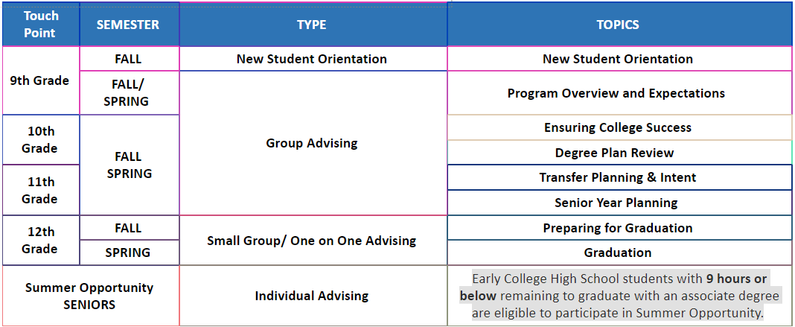

* Campus visits for Early Alerts, Midterms, Finals, ISP/Transfer discussions
  + [Crosswalk for website (finalsite.net)](https://resources.finalsite.net/images/v1707149373/fisdorg/b8ihcdsx37l0c4bwy6sc/ECHSCrosswalkforwebsite.pdf)
  + [ECHS - Fredericksburg High School (fisd.org)](https://fhs.fisd.org/echs#:~:text=Fredericksburg%20ECHS%20will%20provide%20the%20opportunity%20for%20you%20to%20take)
* Facilitator access to view academic progress > Connect with Carrie TG

**Resource:** TSI Reporting: [TSI report run instructions.pdf](https://alamo0-my.sharepoint.com/:b:/g/personal/nlc-hsprograms_alamo_edu/EZAT3vRYjqpNnUBRsuVFyQYBAob7_-oQgN7vJz0Q-e2dCw?e=dCKFVQ) | [TSI score upload template.xlsx](https://alamo0-my.sharepoint.com/:x:/r/personal/nlc-hsprograms_alamo_edu/_layouts/15/Doc.aspx?sourcedoc=%7BF24D02BC-8EAB-4825-8597-7B837809863D%7D&file=TSI%20score%20upload%20template.xlsx&action=default&mobileredirect=true)

* Please email to Sara Flores-Chase

CK - 10/22 - Scheduled Test Date at FECHS

Nelda Howton – Educate Texas Coach –

* Dr. Gonzales confirmed New Coach is Sara Croft

**Recurring Partnership Meetings** - Every 1st and 3rd Monday, 1:00pm - 2:00pm