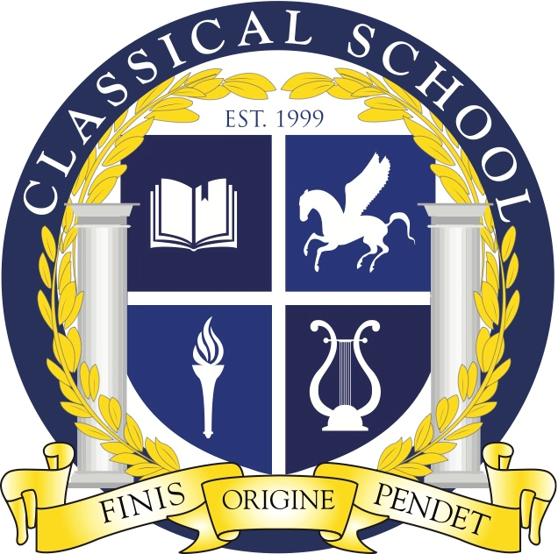
Classical Charter School Association

3310 N. Durkee St.; Appleton, WI 54911
Phone: (920) 852-5525; Fax: (920) 852-5526
http://classical.aasd.k12.wi.us/

CCSA BOARD STRATEGIC PLANNING AGENDA

June 10th, 2024
7:30 pm – 8:45 pm
Location: Classical School - Ms. Foley’s Room
Google Meet Info - https://meet.google.com/ejy-srhk-yhb

- Call to Order at Classical School
- Roll Call
- Welcome Guest Attendee(s)
- Classical School Mission: Building a just and excellent educational foundation
- Public Comment
- Approval of Meeting Documents
- Agenda – 6/10/24
- Meeting Minutes - 5/24/24
- Point of information- 3rd grade reading book list
- Al Brant update
- Building update discussion
- Strategic Plan / Ways of Working
- Roles & Responsibilities
- Compliance Committee Members
- Meeting Date- Jan. 9, 2025
- Closed session – vote for new board member candidates
- Motion to Adjourn

