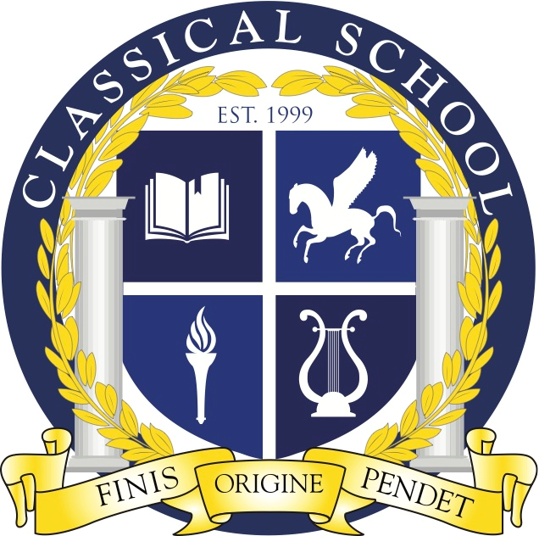
Classical Charter School Association

3310 N. Durkee St.; Appleton, WI 54911
Phone: (920) 852-5525; Fax: (920) 852-5526
http://classical.aasd.k12.wi.us/

CCSA BOARD MEETING AGENDA

October 23th, 2024
8:00 pm – 8:30 pm

Virtual Meet Info:
https://meet.google.com/ddc-kwuz-zqf

- Call to Order at Classical School
- Roll Call
- Welcome Guest Attendee(s)
- Classical School Mission: Building a just and excellent educational foundation
- Public Comment
- Approval of Meeting Documents
  - Agenda- 10/23/24
  - Meeting Minutes- 10/10/24
- Finance Update
- Gala Budget Vote
- Closed Session- Special Board Topic
- Motion to Adjourn

