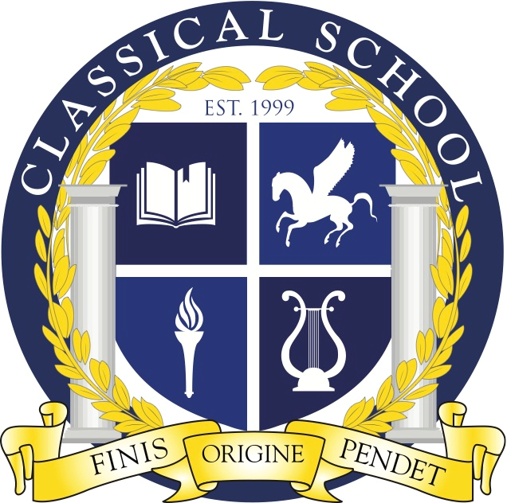
Classical Charter School Association

3310 N. Durkee St.; Appleton, WI 54911
Phone: (920) 852-5525; Fax: (920) 852-5526
http://classical.aasd.k12.wi.us/

CCSA BOARD MEETING AGENDA

October 10th, 2024
6:30 pm – 8:30 pm
Location: Classical School
Virtual Meet Info:
https://us02web.zoom.us/j/83542197085?pwd=i7wXzAkfbEez0hdnLkelblXjVhalWg.1

- Call to Order at Classical School
- Roll Call
- Welcome Guest Attendee(s)
- Classical School Mission: Building a just and excellent educational foundation
- Public Comment
- Approval of Meeting Documents
  - Agenda- 10/10/24
  - Meeting Minutes- 9/12/24
- Administrative Update
- Fall Fest Recap
- Finance Update
- Pegasus Project
- Act 20 Update
  - Upcoming PLC
- Enrollment Update
- Other Board Business
- Motion to Adjourn

