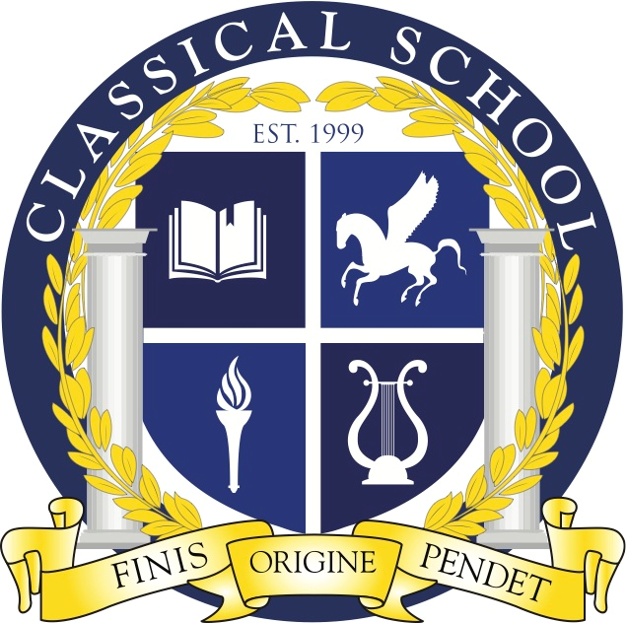
Classical Charter School Association

3310 N. Durkee St.; Appleton, WI 54911
Phone: (920) 852-5525; Fax: (920) 852-5526
http://classical.aasd.k12.wi.us/

CCSA BOARD STRATEGIC PLANNING AGENDA

September 12th, 2024
6:30 pm – 8:30 pm
Location: Classical School
Virtual Meet Info:
https://us02web.zoom.us/j/84352642739?pwd=irwTaWbfQnzVbBMEKQnzNaHI8XbDid.1

- Call to Order at Classical School
- Roll Call
- Welcome Guest Attendee(s)
- Classical School Mission: Building a just and excellent educational foundation
- Public Comment
- Approval of Meeting Documents
  - Agenda- 9/12/24
  - Meeting Minutes- 8/15/24
- Administrative Update
- Board Member Changes
- CSS Update
- Second Step Approvals
- Fall Fest Update
  - Budget
- Finance Update
- Art/Band Room Fundraiser
- Fundraising Ideas
  - Give Smart
  - Culver’s etc.
- Incoming Students Call List
- Other Board Business
- Motion to Adjourn

