January 2022 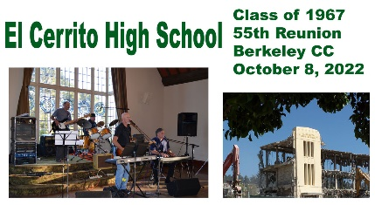

Dear Gaucho Classmates,

All those who attended ECHS during the years of 1965-1969 are invited to join the 55th Reunion Activities of the Class of 1967. In 1965 we looked UP TO the seniors as role models. In 1967 we WERE the senior role models.

Please come to this 55th Reunion of the Class of 1967 to share memories.

Although most of you have received the “Save the Date” announcement, this is your Official Invitation. Below is the schedule of events.

- Friday evening, 10/7/22 – Informal gathering at a location to be determined.

- Saturday evening, 10/8/22 – Dinner and dancing to the Nite Owls at the Berkeley Country Club (formerly Mira Vista Country Club) located at 7901 Cutting Blvd, El Cerrito, CA 94530. The event will take place from 5:00 PM until 11:30 p.m.

- Sunday, daytime, 10/9/22 – Picnic at Arlington Park.
Food will be available, gratis, 11:00 a.m.

CDC Covid procedures will be in place.

Please contact Roddy Lee if you have questions.

Go Gauchos,

Roddy Lee

1967 Committee members:
Helen Cardiff, John Cowee, Joe deVille, Marc Dronkers, Sue Goodnow, Shirley Carlson Gotelli, Craig Kubey, Scott MacKenzie, Gail Russell Martin, Terry Murray, Kim Volpe Riley, Jonathan Rogers, Laurie Dekker Salatich, Linda Sandifur, Janet Duer Smith, Leslie Barnes Solanen, Margaret (Maggi) Norris Specker, John Sproul, Nancy Thollaug Webber
Cost: $135.00 per person. Deadline September 1, 2022.
Mail your payment to:
ECHS 1967 c/o Roddy Lee, 3333 Rossmoor Parkway Manor #1. Walnut Creek, CA 94595.
(PayPal available, let us know and we will send you an invoice.)
Contact: ECHS1967@aol.com or 925-954-1861.

Visit our website: https://www.wccusd.net/Page/11951

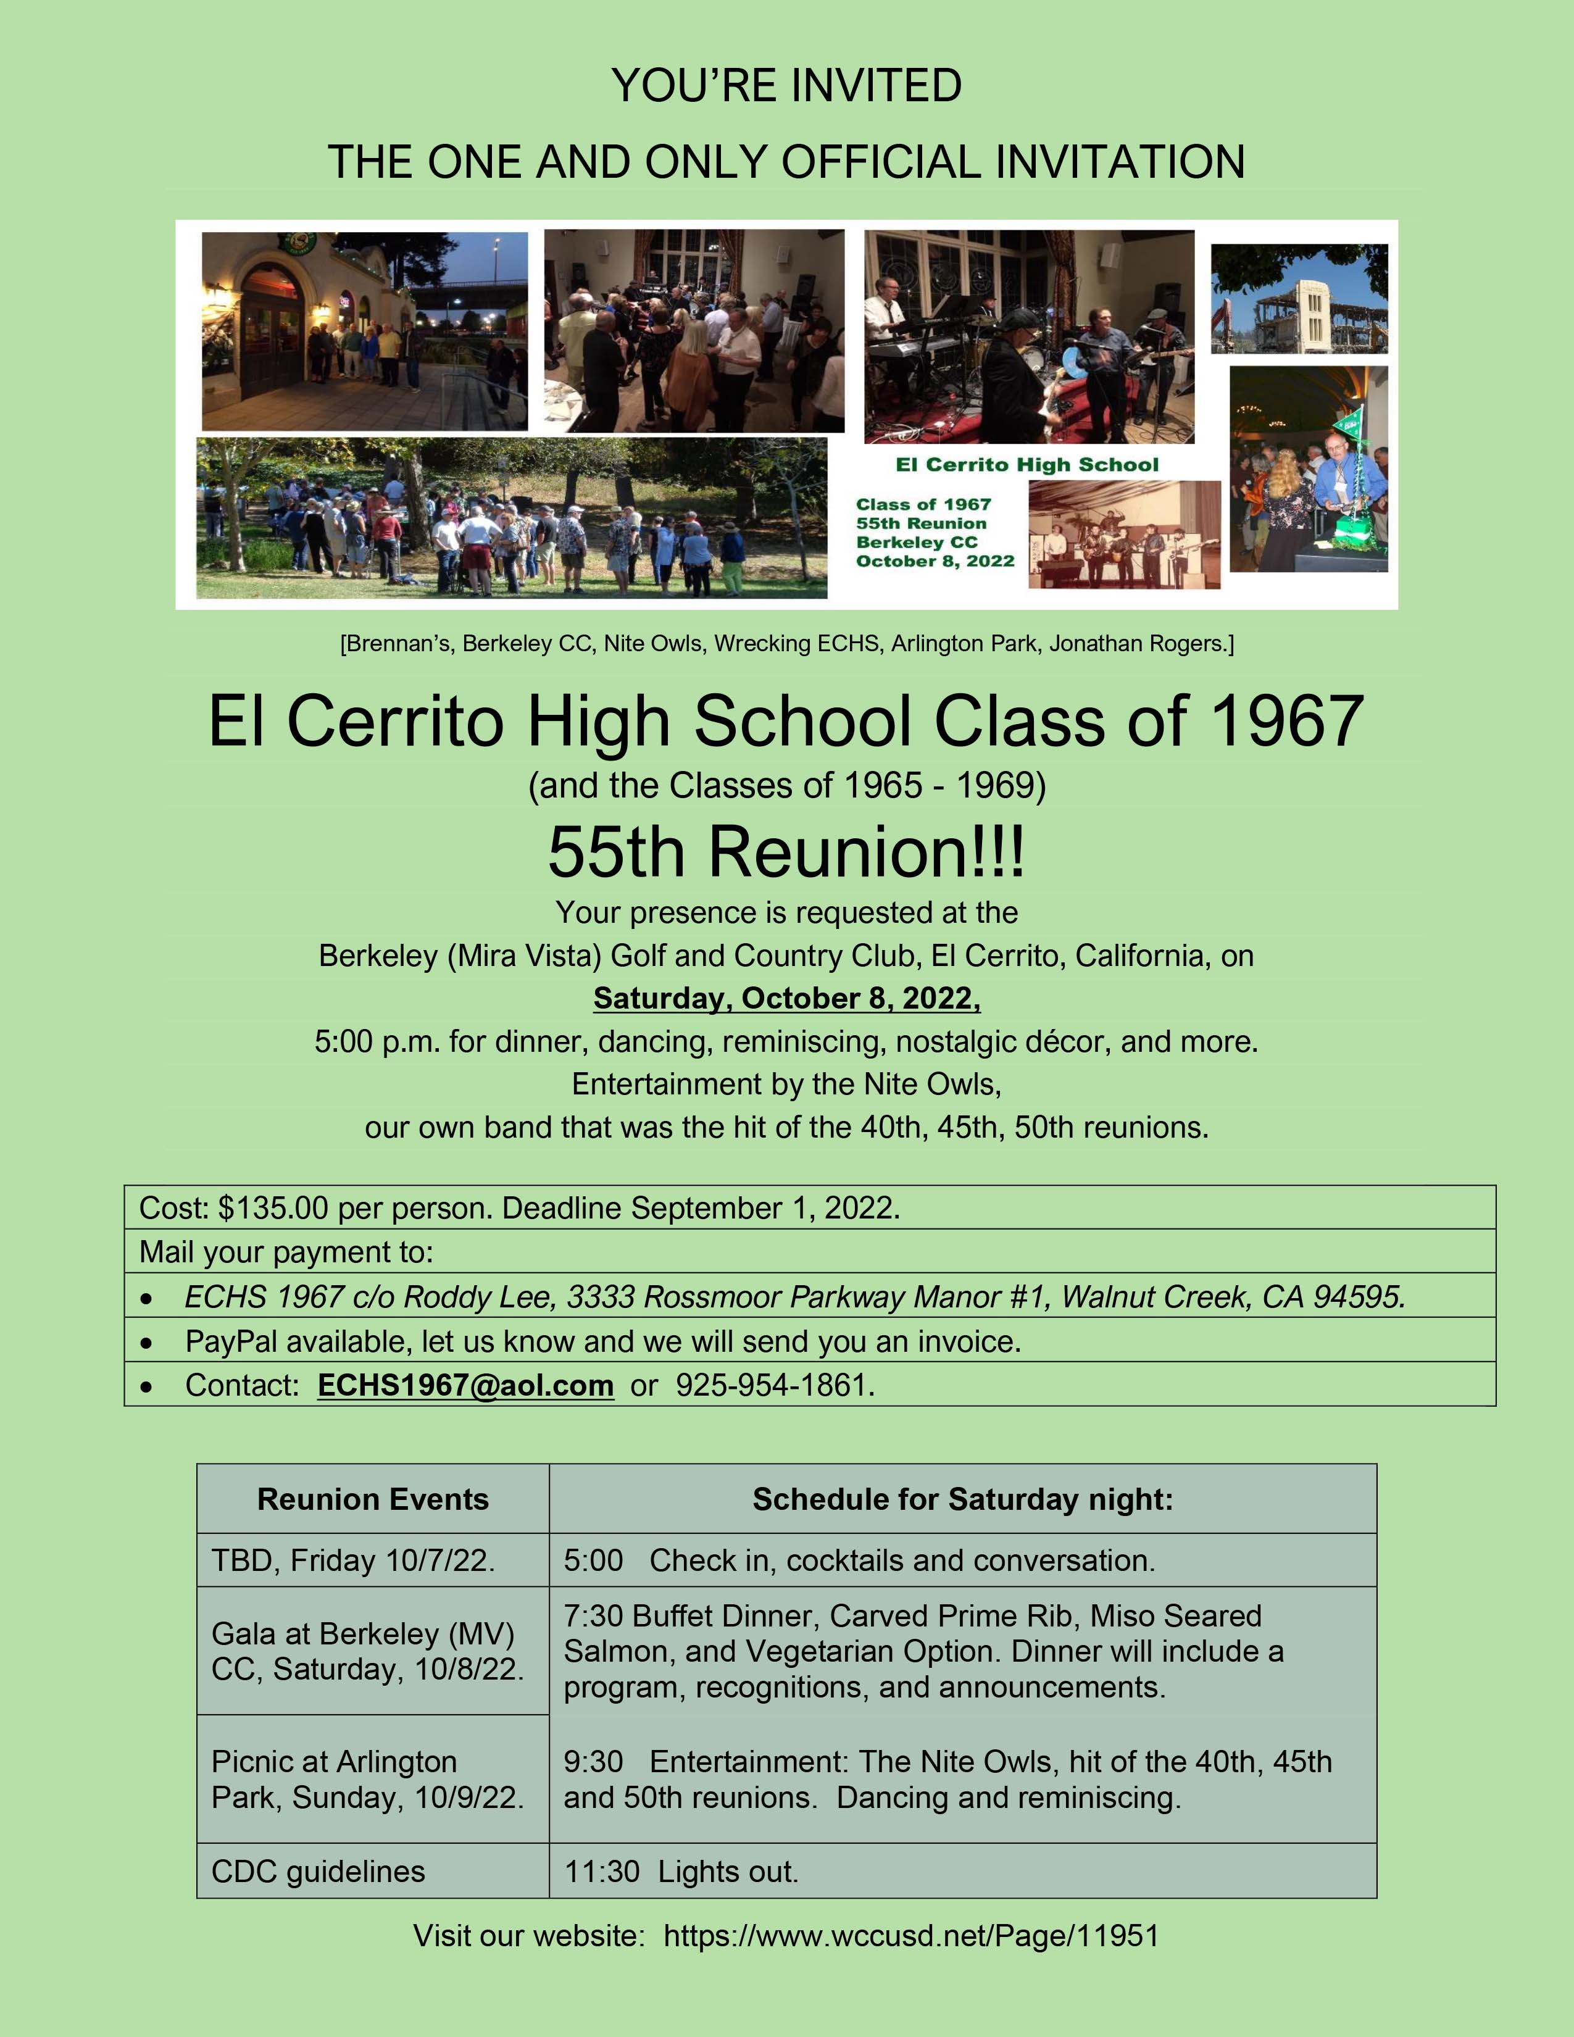

The Weekend Package
Pre-Reunion Activities, Friday evening, October 7, 2022.
- Informal gathering at a location to be determined."

Reunion Dinner-Dance, Saturday, October 8, 2022, 5:00 p.m. Berkeley (MV) Country Club.

- Cocktails and conversation, 5:00 p.m.
- Drinks, hors d'oeuvres, catching up on 55 years.
- Dinner featuring three entrees - Prime Rib, Salmon, Vegetarian Option.
- Dinner will include a program, recognitions, and announcements.
- Entertainment: The Nite Owls.
- Dancing and reminiscing.
- Lights out 11:30 p.m.

Arlington Park Picnic, Sunday, October 9, 2022, El Cerrito, California: 11 a.m.
- Hamburgers, Salmon Burgers, Potato Salad, Chips and Drinks will be provided, gratis.

Dinner Menu

- Appetizers
- Buffet Dinner
- Tossed Caesar Salad with Romaine, parmesan cheese, croutons, and classic Caesar dressing
- Fresh Roma Tomato Salad with Roasted peppers fresh mozzarella and basil
- Carved Prime Rib with Au Jus and Creamy Horse Radish
- Miso Seared Salmon
- Vegetarian Option
- Garlic Mashed Potatoes
- Chefs Roasted Seasonal Vegetables
- Rolls & Butter
- Chefs Choice Dessert
- 36 Bottled Red or White Table Wine
- Coffee/Tea/Water service

