OFFICIAL MINUTES

Special Meeting March 25, 2015 library conference room

Members Present: Frascella, Fleischman, Jackson-McCarty, Jim Boberg, McCauley – via teleconference, Kazmierczak
Absent: Frank
Others Present: Lawton, O’Brien, Boberg

I. CALL TO ORDER

Regular Meeting called to order at 8:15 am with Frascella presiding.

II. PLEDGE OF ALLEGIANCE to the UNITED STATES FLAG

III. ADOPT AGENDA

Moved by Boberg, Seconded by Jackson-McCarty to adopt the agenda as stated.

Additions: none
Deletions: none
Changes: none

6 ayes, 0 nays, motion accepted

IV. Correspondence/BOE information
none

V. PUBLIC COMMENTS
none

VI. PRESENTATIONS
none

VII. REPORTS
none

VIII. CONSENT AGENDA
none

IV. PERSONNEL
none

Special Meeting March 25, 2015 page 2

X. OLD BUSINESS:
none

XI. NEW BUSINESS:

A. Moved by Fleischman, Seconded by Jackson-McCarty to approve

A REFUNDING BOND RESOLUTION DATED MARCH 25, 2015 AUTHORIZING THE ISSUANCE OF REFUNDING BONDS IN AN AGGREGATE PRINCIPAL AMOUNT NOT TO EXCEED $2,200,000 OF THE WEST VALLEY CENTRAL SCHOOL DISTRICT, CATTARAUGUS COUNTY, NEW YORK, PURSUANT TO THE LOCAL FINANCE LAW AND PROVIDING FOR OTHER MATTERS IN RELATION THERETO.

WHEREAS, the West Valley Central School District, Cattaraugus County, New York (the “District”) heretofore issued its School District Refunding (Serial) Bonds, 2005 in the original aggregate principal amount of $8,145,000, with $1,985,000 of such bonds being scheduled to mature in the years 2016 through 2019, inclusive (collectively, the “Refunded Bonds”); and
WHEREAS, in order for the District to realize the potential for certain long-term debt service savings with respect to the Refunded Bonds, the Board of Education of the District (the “Board”) has determined, after consultation with the District’s Superintendent of Schools and Business Official, and the financial advisory and bond counsel firms retained by the District, that it would be prudent for the District to consider the current refunding (i.e., refinancing) of the Refunded Bonds; and
WHEREAS, the Refunded Bonds maturing in 2016 through 2019 are, by their terms, subject to the possibility of call for redemption prior to their stated maturity dates, and the District has determined to conduct such a call at the earliest possible opportunity (that being June 15, 2015); and
WHEREAS, the Refunded Bonds were issued pursuant to a bond resolution that was adopted by the Board on May 9, 2005 (the “Bond Resolution”), authorizing the issuance of bonds to refinance certain bonds of the District that were issued in 1999 to pay the costs of certain objects or purposes in and for the District, as more fully set forth in the Bond Resolution, the terms of which are incorporated herein by this reference; and
WHEREAS, the District has the power and authority to issue refunding bonds of the District for the purpose of undertaking a current refunding of (and thereby refinancing) the Refunded Bonds at more favorable rates of interest, including provision for the payment of
Special Meeting March 25, 2015 page 3

incidental costs of issuance in connection therewith, pursuant to the provisions of Section 90.00 of the Local Finance Law (the “Refunding Law”); and
WHEREAS, the District has received a draft refunding financial plan, updated as of February 19, 2015 (the “Refunding Financial Plan”), from Roosevelt & Cross Incorporated (the “Underwriter”) in connection with the proposed refunding of the Refunded Bonds and such Refunding Financial Plan is attached hereto as Exhibit A; and
WHEREAS, the Board has reviewed and considered the Refunding Financial Plan in consultation with the Superintendent of Schools and the Business Official of the District, and the financial advisory and bond counsel firms retained by the District; and
WHEREAS, the District desires to undertake a current refunding (i.e., refinancing) of the Refunded Bonds by issuing certain new refunding bonds and selling such bonds at private sale to the Underwriter; and
WHEREAS, Section 90.00 of the Local Finance Law requires that the District adopt a refunding bond resolution that includes a refunding financial plan setting forth all of the pertinent details in connection with the proposed refunding transaction;
NOW, THEREFORE, BE IT RESOLVED, by the Board (by the favorable vote of not less than two-thirds of all the members of the Board) as follows:

SECTION 1. Based on the recommendation of Fiscal Advisors & Marketing, Inc., the financial advisory firm retained by the District, the Board hereby determines to undertake an current refunding of the Refunded Bonds, through the issuance of refunding bonds of the District, such refunding bonds to be offered and sold at private sale to the Underwriter under arrangements that are to be in general accord with the Refunding Financial Plan.

SECTION 2. For the object or purpose of refunding all of the Refunded Bonds, including providing moneys which, together with the interest earned from the investment of certain of the proceeds of the refunding bonds herein authorized, shall be sufficient to pay (A) the outstanding principal amount of the Refunded Bonds, (B) the aggregate amount of unmatured interest payable on the Refunded Bonds to and including the date(s) on which the Refunded Bonds mature or are redeemed in accordance with the Refunding Financial Plan, (C) redemption premiums (if any) payable on the Refunded Bonds as of such redemption date(s) and (D) the costs and expenses incidental to the issuance of the refunding bonds herein authorized, including, but not limited to, the fees and costs of the financial advisory and bond counsel firms retained by the District, there are hereby authorized to be issued the School District Refunding Bonds, 2015 of the District in an aggregate principal amount not to exceed $2,200,000 pursuant to the provisions of Section 90.00 of the Local Finance Law (the “Refunding Bonds”), it being anticipated that the principal amount of Refunding Bonds actually to be issued will be approximately $2,050,000, as described in the Refunding Financial Plan and in Section 5 hereof. The Refunding Bonds shall be dated such date as shall hereafter be determined by the President

Special Meeting March 25, 2015 page 4

of the Board pursuant to Section 5 hereof, shall be of the denominations of $5,000 or any integral multiple thereof not exceeding the principal amount of each respective maturity, and shall mature annually and shall bear interest semi-annually thereafter on such dates as shall be determined by the President of the Board pursuant to Section 5 hereof, at the rate or rates of interest per annum as may be necessary to sell the same, all as shall be determined by the President of the Board.

SECTION 3. The Refunding Bonds shall be executed in the name of the District by the manual or facsimile signature of the President of the Board, and a facsimile of its corporate seal shall be imprinted thereon and attested by the District Clerk. The Refunding Bonds shall contain

the recital required by Section 90.00 of the Local Finance Law and the recital of validity clause provided for in Section 52.00 of the Local Finance Law and shall otherwise be in such form, and contain such recitals, as the President of the Board shall determine.

SECTION 4. It is hereby determined that:

(A) The maximum amount of the Refunding Bonds authorized to be issued pursuant to this resolution does not exceed the limitation imposed by the Local Finance Law;

(B) The maximum period of probable usefulness permitted by law at the time of the issuance of the Refunded Bonds for each of the objects or purposes for which the Refunded Bonds were issued is as shown upon Exhibit B; and

(C) The last installment of the Refunding Bonds will mature not later than the expiration of the maximum period of probable usefulness of each of the objects or purposes for which the Refunded Bonds were issued, or in the alternative, the weighted average remaining period of probable usefulness of the objects or purposes (or classes of objects or purposes) financed with the Refunded Bonds or the weighted average remaining period of probable usefulness of all objects or purposes (or classes of objects or purposes) financed with the Refunded Bonds, in accordance with the provisions of the Local Finance Law.
SECTION 5. The Refunding Financial Plan, showing the sources and amounts of all moneys required to accomplish such refunding, the estimated present value of the total debt service savings (if any) and the basis for the computation of the aforesaid estimated present value of total debt service savings, are set forth in Exhibit A attached hereto and made a part of this resolution. The Refunding Financial Plan has been prepared based upon the assumption that the Refunding Bonds will be issued in the principal amount of $2,050,000 and that the Refunding Bonds will mature, be of such terms, and bear interest as set forth in Exhibit A. This Board recognizes that the amount of the Refunding Bonds, and the maturities, terms, and interest rate or rates borne by the Refunding Bonds to be issued by the District will most probably be different from such assumptions and that the final Refunding Financial Plan will also most probably be different from that attached hereto as Exhibit A. The President of the Board is hereby authorized and directed to determine the amount of the Refunded Bonds to be refunded, the details as to the
Special Meeting March 25, 2015 page 5

redemption of the Refunded Bonds, including the date and the amount of such redemption or redemptions, the amount of the Refunding Bonds to be issued, the date of such bonds and the date of issue, maturities and terms thereof, the provisions relating to any redemption of the Refunding Bonds prior to maturity, whether the Refunding Bonds will be insured by a policy or policies of municipal bond insurance or otherwise enhanced by a credit enhancement facility or facilities, the escrow arrangements (if any) to be entered into with respect to the proceeds of the Refunding Bonds, the terms of the private sale of the Refunding Bonds to the Underwriter, the amount of the annual installments of the Refunding Bonds to be paid pursuant to the Local Finance Law, whether the Refunding Bonds shall be sold at a discount in the manner authorized by Section 57.00(e) of the Local Finance Law, and the rate or rates of interest to be borne thereby, and to prepare, or cause to be prepared, a final Refunding Financial Plan for the Refunding Bonds, and all powers in connection therewith are hereby delegated to the President of the Board; provided that the terms of the Refunding Bonds to be issued, including the rate or rates of interest borne thereby, shall comply with the requirements of the Refunding Law. The President of the Board shall file a copy of his or her certificate determining the details of the Refunding Bonds and the final Refunding Financial Plan with the District Clerk not later than ten (10) days after the delivery of the Refunding Bonds, as herein provided.

SECTION 6. The President of the Board is hereby delegated all powers of this Board with respect to agreements for credit enhancement, derived from and pursuant to Section 168.00 of the Local Finance Law, for such Refunding Bonds, including, but not limited to the determination of the provider of such credit enhancement facility or facilities and the terms and contents of any agreement or agreements related thereto.

SECTION 7. The faith and credit of the District are hereby irrevocably pledged for the payment of the principal of and interest on the Refunding Bonds as the same respectively become due and payable. An annual appropriation shall be made in each year sufficient to pay the principal of and interest on such Refunding Bonds becoming due and payable in such year. There shall annually be levied on all the taxable real property of the District a tax sufficient to pay the principal of and interest on such Refunding Bonds as the same become due and payable.

SECTION 8. That portion of such proceeds from the sale of the Refunding Bonds, together with interest earned thereon, which shall be required for the payment of the principal of and interest on the Refunded Bonds, including any redemption premiums, in accordance with the Refunding Financial Plan, shall be irrevocably committed and pledged to such purpose and the holders of the Refunded Bonds shall have a lien upon such moneys and the investments thereof. All interest earned from the investment of such moneys not required for such payments on the Refunded Bonds shall be irrevocably committed and pledged to the payment of the principal of and interest on the Refunding Bonds, or such portion thereof as shall be required by the Refunding Financial Plan, and the holders of such Refunding Bonds shall have a lien upon such moneys. The pledges and liens provided for herein shall become valid and binding upon the issuance of the Refunding Bonds and the moneys and investments representing proceeds of the Refunding Bonds held by the District (or its designated escrow holder, if one is appointed to hold the proceeds of the Refunding Bonds) shall immediately be subject thereto without any further act. Such pledges and liens shall be valid and binding against all parties having claims of any
Special Meeting March 25, 2015 page 6

kind in tort, contract or otherwise against the District irrespective of whether such parties have notice thereof. Neither this resolution nor any other instrument relating to such pledge and liens need be filed or recorded.

SECTION 9. In accordance with the provisions of Sections 50.00 and 53.00 of the Local Finance Law, the Board hereby authorizes and directs the President of the Board to call in and redeem all of the Refunded Bonds which are subject to prior redemption according to their terms on their earliest allowable redemption date in accordance with the terms of the Refunding Financial Plan. The sum to be paid therefor on such redemption date shall be the par value thereof, the accrued interest thereon to the redemption date and the required redemption premiums (if any) payable with respect thereto. The President of the Board is further authorized and directed to cause notice of such call for redemption in the name of the District by mailing such notice to the registered holders of the Refunded Bonds not more than sixty (60) days nor less than thirty (30) days prior to such redemption date. Upon the issuance of the Refunding Bonds, the election to call in and redeem the outstanding Refunded Bonds shall become irrevocable and the provisions of this Section shall constitute a covenant with the holders, from time to time, of the Refunding Bonds, provided that this Section may be amended from time to time as may be necessary to comply with the requirements of paragraph a of Section 53.00 of the Local Finance Law, as the same may be amended from time to time.

SECTION 10. The President of the Board is further authorized to take such actions and execute such documents as may be necessary to ensure the continued status of the interest on the Refunding Bonds as excludable from gross income for federal income tax purposes pursuant to Section 103 of the Internal Revenue Code of 1986, as amended (the “Code”) and, if applicable, to designate the Refunding Bonds authorized by this resolution as “qualified tax-exempt obligations” in accordance with Section 265 of the Code.

SECTION 11. The President of the Board is further authorized to enter into a continuing disclosure agreement with the initial purchaser of the Refunding Bonds authorized by this resolution, if required, containing provisions which are satisfactory to such purchaser in compliance with the provisions of Rule 15c2-12, promulgated by the Securities and Exchange Commission pursuant to the Securities Exchange Act of 1934.

SECTION 12. In the absence or unavailability of the President of the Board, the Vice President of the Board is hereby specifically authorized to exercise the powers delegated to the President of the Board in this resolution.

SECTION 13. The District hereby determines that the issuance of the Refunding Bonds is a Type II action that will not have a significant effect on the environment and, therefore, no other determination or procedures under the State Environmental Quality Review Act (“SEQR”) is required.

SECTION 14. Subject to compliance with the provisions of the Refunding Law, the Refunding Bonds shall be sold at private sale to the Underwriter, and the President of the Board is hereby authorized to conduct such private sale in accordance with the provisions of the
Special Meeting March 25, 2015 page 7

Refunding Law and all other applicable statutes and regulations, and to make all final decisions with respect to or arising out of such private sale. The President of the Board is hereby authorized to execute and deliver a bond purchase agreement with the Underwriter for the Refunding Bonds, in the name and on behalf of the District, providing for the terms and conditions of the sale and delivery of the Refunding Bonds to the Underwriter. After the Refunding Bonds have been duly executed, they shall be delivered by the President of the Board to the purchaser of the Refunding Bonds, in accordance with the terms of such bond purchase agreement, upon the receipt by the District of the applicable purchase price, including any premium or accrued interest.

SECTION 15. The President of the Board and the District Clerk and all other officers, employees and agents of the District are hereby authorized and directed for and on behalf of the District to execute and deliver all certificates and other documents, perform all acts and do all things required or contemplated to be executed, performed or done by this resolution or any document or agreement approved hereby.

SECTION 16. All other matters pertaining to the terms and manner and details of issuance of the Refunding Bonds shall be determined by the President of the Board and all powers in connection therewith are hereby delegated to the President of the Board.

SECTION 17. The District Clerk is hereby authorized and directed to publish this resolution, or a summary thereof, together with a notice in substantially the form provided by Section 81.00 of the Local Finance Law, in the official newspaper(s) of the District for such publication. The validity of the Refunding Bonds may be contested only if:

(1) (a) Such obligations are authorized for an object or purpose for which such District is not authorized to expend money, or

(b) The provisions of law which should be complied with at the date of publication of this resolution are not substantially complied with,

and an action, suit or proceeding contesting such validity is commenced within twenty days after the date of such publication; or

(2) Such obligations are authorized in violation of the provisions of the Constitution of New York

SECTION 18. This resolution shall take effect immediately upon its adoption.
The question of the adoption of the foregoing resolution was duly put to vote on a roll call, which resulted as follows:
AYES:
NOES:
Special Meeting March 25, 2015 page 8

ABSENT:
The foregoing resolution was thereupon declared duly adopted.
EXHIBIT A
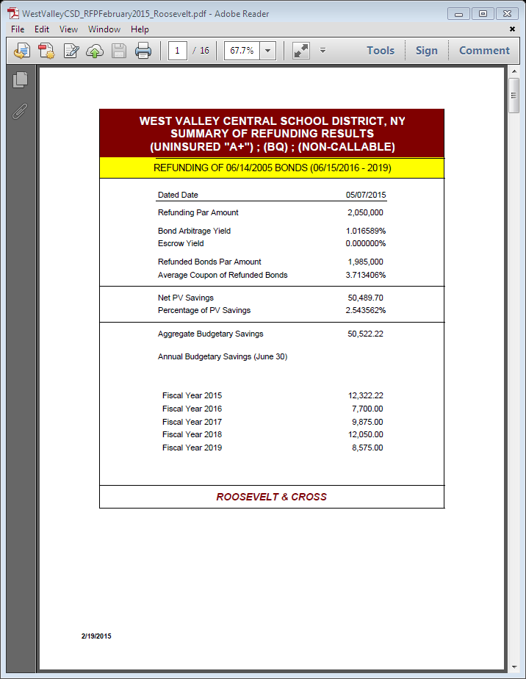
REFUNDING FINANCIAL PLAN
PREPARED BY ROOSEVELT & CROSS INCORPORATED
February 19, 2015

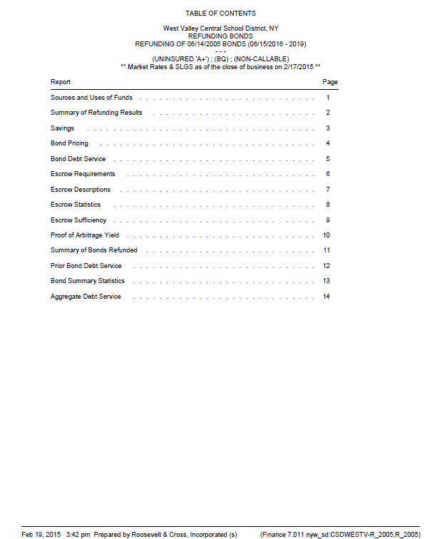

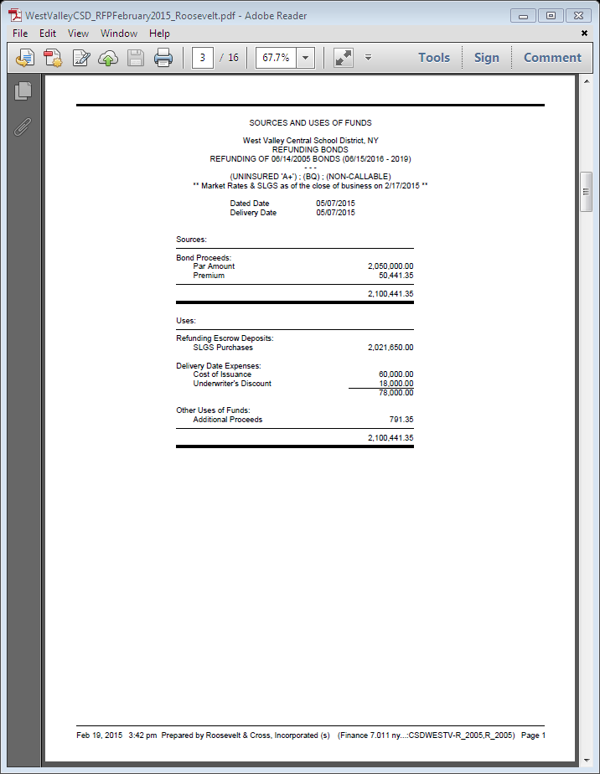

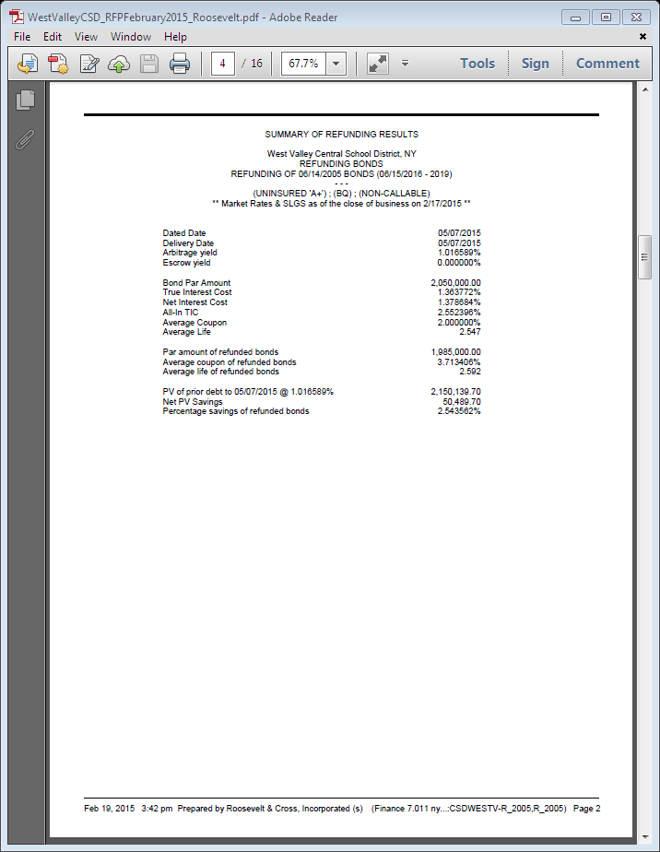

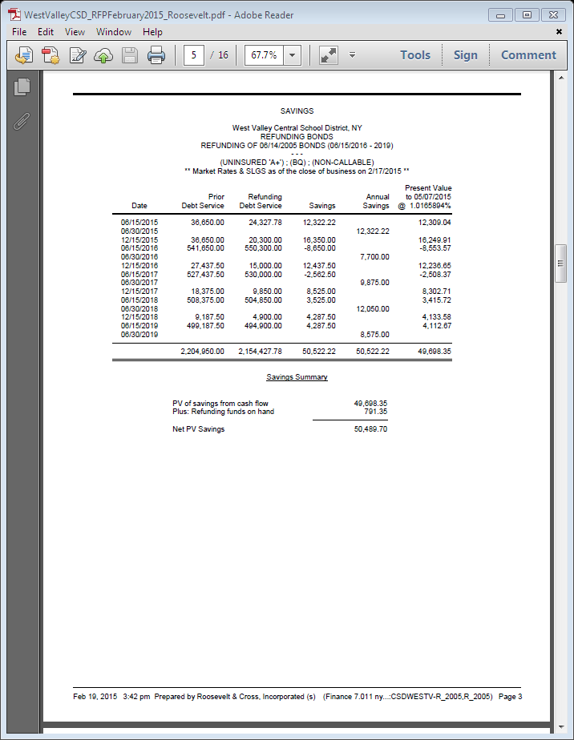

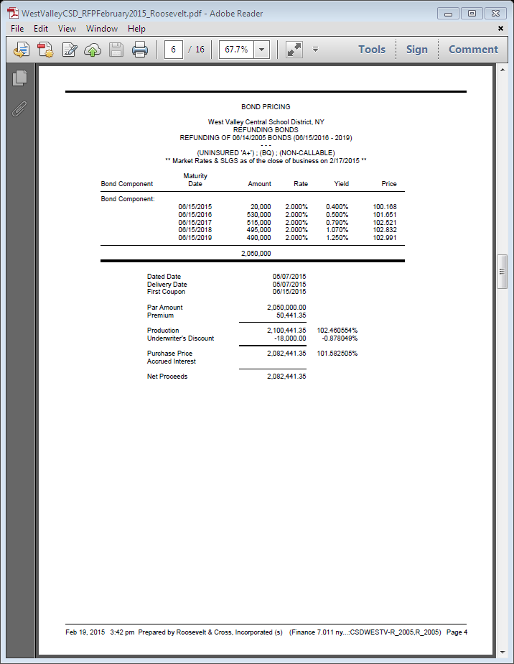
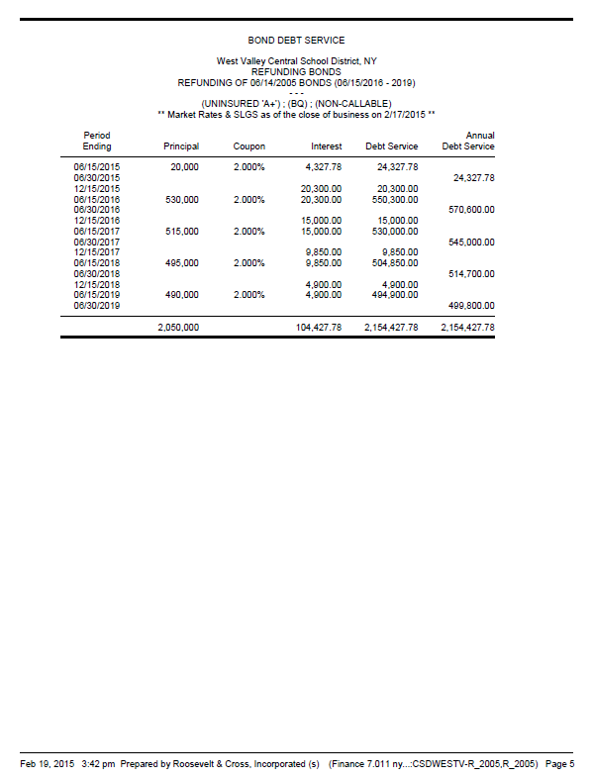
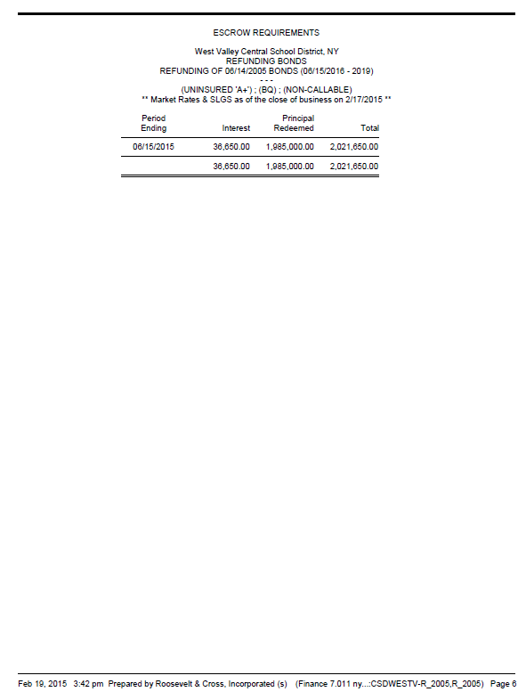

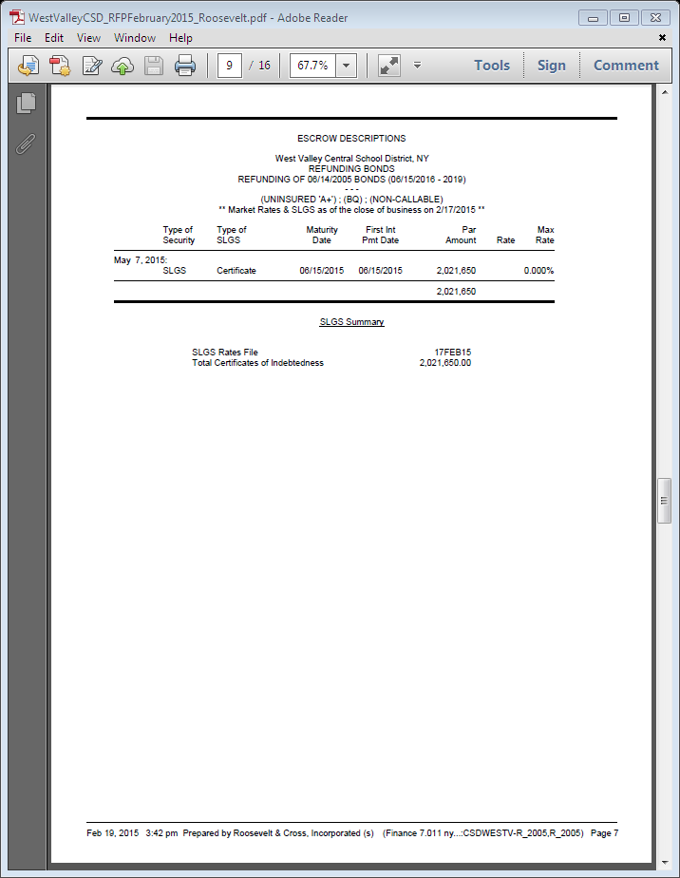

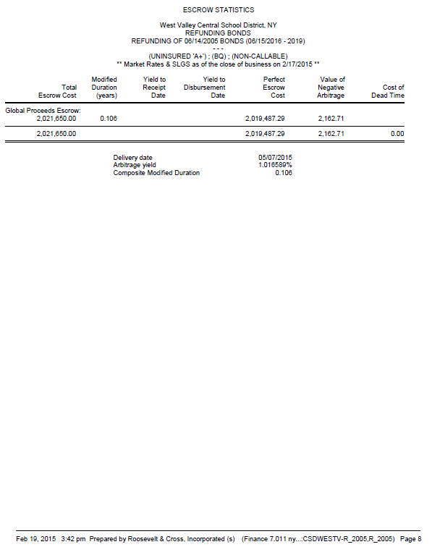

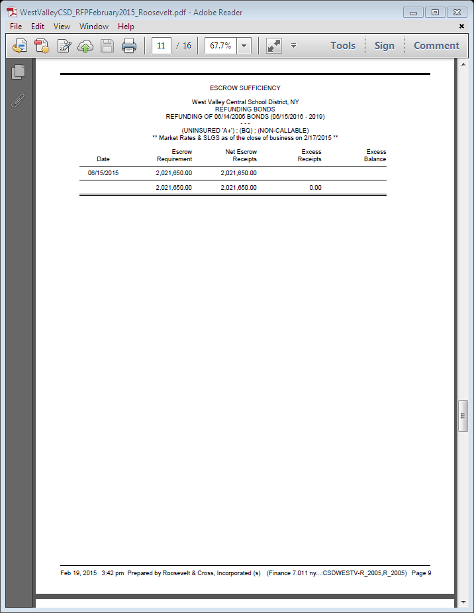

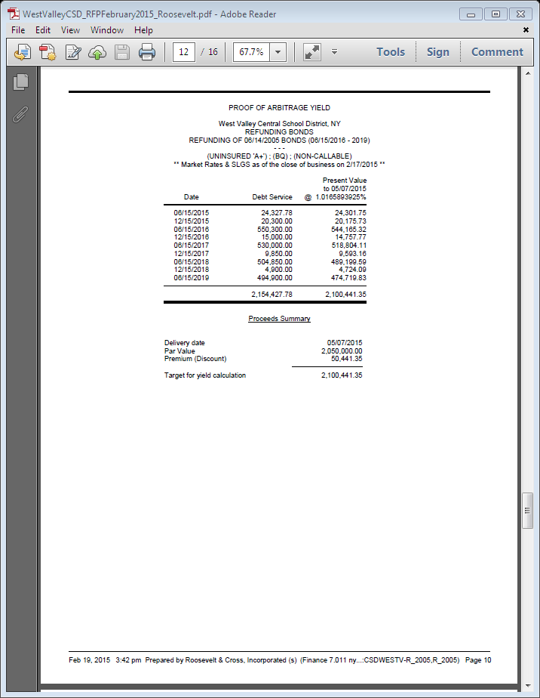

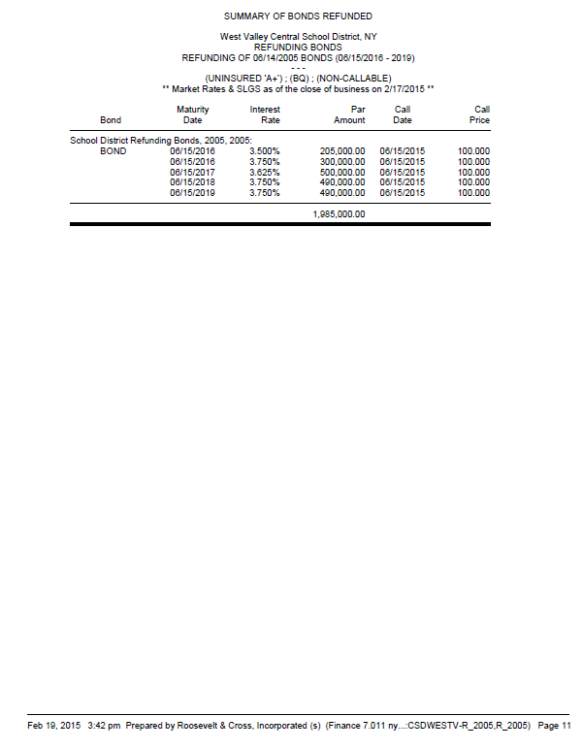

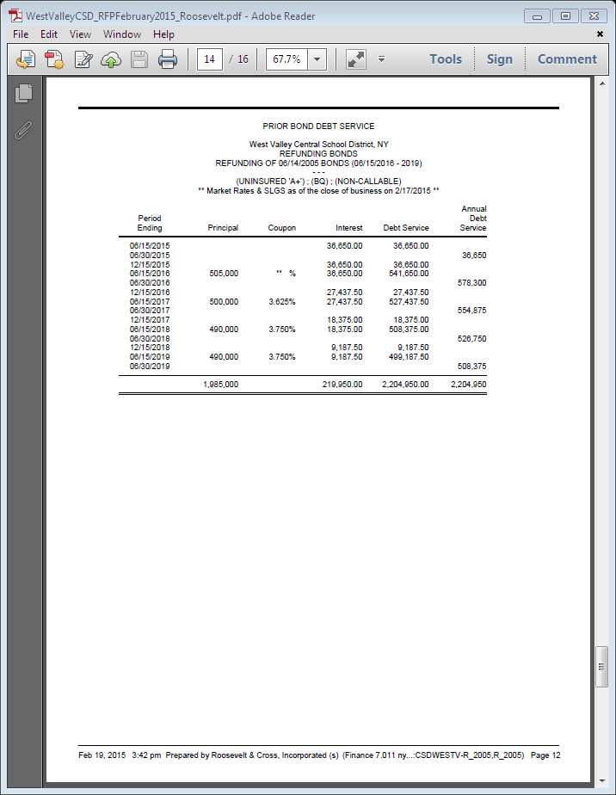

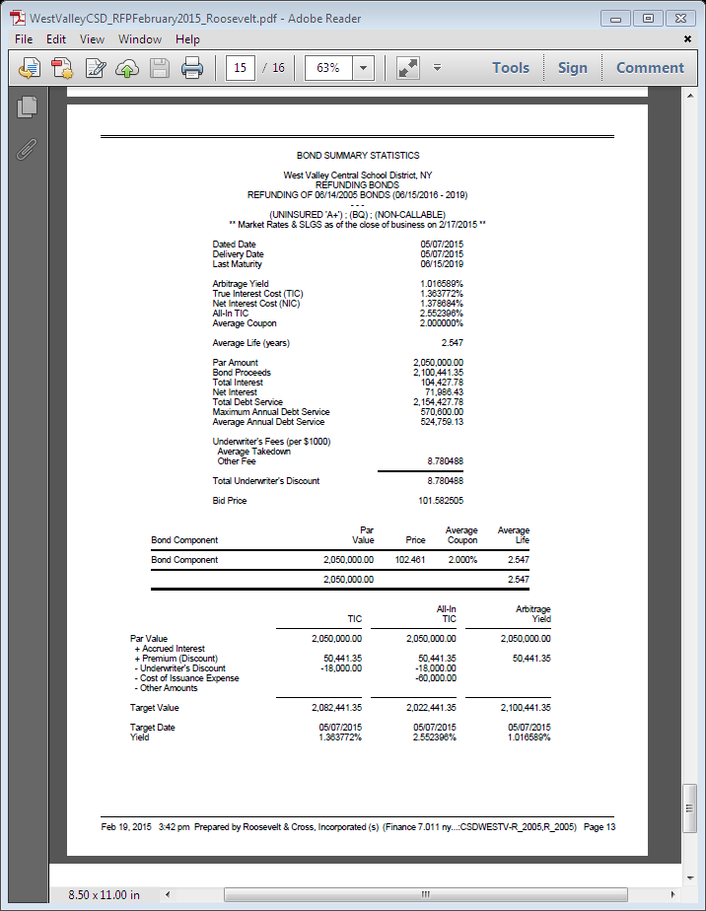

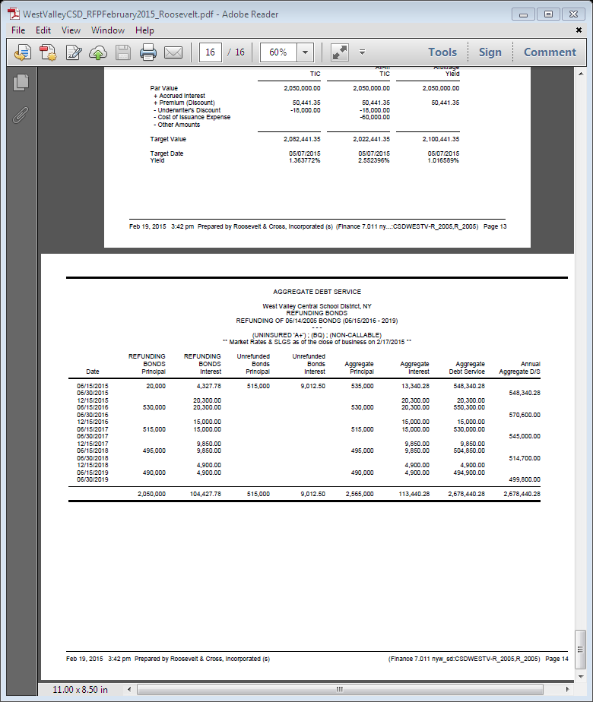

Page 24

EXHIBIT B
DESCRIPTION OF OBJECTS OR PURPOSES

Refunded Bonds

Dated Date | Object or Purpose | Original  Amount | Outstanding Amount
June 14, 2005 | Refunding of Serial Bonds of the District issued in 1999 | $8,145,000 | $1,985,000 (for the 2016-2019 maturities that are to be refunded)

District Clerk conducted the vote by a roll call as follows:

Kazmierczak-aye, Jackson-McCarty-aye, Frank-absent, Boberg-aye, Fleischman-aye, McCauley-aye, Frascella-aye

Total 6-Ayes 0-Nays, motion accepted

XII. Moved by Kazmierczak, Seconded by Jackson-McCarty to ADJOURN at 8:19am
6 ayes, 0 nays, motion accepted

_____________________________
District Clerk

