OFFICIAL MINUTES

Regular Meeting March 23, 2015 library conference room

Members Present: Frascella, Kazmierczak, Frank, and Dennis McCauley (via teleconference)
Absent: Jackson-McCarty, Jim Boberg, Fleischman
Others Present: Lawton, O’Brien, Boberg, Amy Butler, Shawna Gugino, Springville Journal reporter - Max Borsuk

I. CALL TO ORDER
Regular Meeting called to order at 7:04pm with Frascella presiding.

II. PLEDGE OF ALLEGIANCE to the UNITED STATES FLAG

III. ADOPT AGENDA

Moved by Frank, Seconded by McCauley to approve the amended agenda

Additions: none
Deletions: NB item (F)
Changes: none

4 ayes, 0 nays, motion accepted

IV. Correspondence/BOE information

Eric read a letter that he received from Joseph Giglio thanking him for the visit in his office at the Legislative Office Building in Albany.

V. PUBLIC COMMENTS

none

VI. PRESENTATIONS

none

VII. REPORTS

A. Superintendent, Eric Lawton reported on the listed agenda items. With only 4 BOE members present at tonight’s meeting, item (F) under new business has been deleted. The refunding bond resolution must be adopted by at least a two-thirds (2/3) vote of the entire Board of Education, not just those in attendance. In other words, there
Regular Meeting March 23, 2015 page 2

must be five or more affirmative votes. The sooner the board sets a special public meeting to vote on this resolution the better because there are time restraints. The special public meeting will be held Wednesday, March 25th at 8am in the library conference room. There is enough time to notify the public. He attended a wonderful ceremony and dinner at Ellicottville BOCES for the induction of one of our seniors into the National Technical Honor Society. Ashley Blackmon was inducted and is the president. Congrats to Ashley and her family. Mike has received letters and phone calls from parents regarding their children opting out of the upcoming assessments and the need to come in to discuss their decision with Mr. Amodeo. The parents that have come in to speak to Dan have been very pleased with the discussion.

Dan Amodeo entered the meeting at 7:30pm

Dan stated that his reason for wanting parents to come in to meet with him about their students opting out was not to tell them they could not do this, but to gather information on the reasons and convey it to the state when we are asked why our students opted out.

B. Principal, Daniel Amodeo reported that there have been several rallies against the 3-8 assessments, common core and Governor Cuomo’s educational reform agenda. He is anticipating that this will impact the number of students that may refuse to take these assessments. He fielded a phone call from an education advocate regarding my newsletter article. In short some of our parents reached out and were concerned that WVCS would not allow students to refuse and that there would be consequences for those children who refused. Contrary to their concerns, there was nothing in my newsletter that stated those things would happen. The advocate was encouraged and stated he would provide our parents with the information he gave to ease their concerns.
Ashley Martin has taken over for Mrs. Abbey and it has been a very smooth transition.

C. Business Official, Ann O’Brien reported on the Instructional, Pupil Service and Undistributed section of the budget. Two resolutions on the agenda associated with the bus and mini-van purchase.
The audit committee met on Thursday, March 12th. They are recommending asking the voters to approve a capital reserve in the amount of $950,000. We would be able to fund this amount on time only. Once we used a portion it could not be replenished without voter approval. The goal would be to transfer unexpended funds from this year and transfer additional funds from the unemployment reserve into the newly created capital reserve (if approved) at the end of this school year. Creation of this reserve will allow us to do additional capital work without increasing taxes.
Included on the agenda is a rather lengthy resolution with respect to the bond refunding. We anticipate saving approximately $50,522 over the remaining term of the bond.

Regular Meeting March 23, 2015 page 3

VIII. CONSENT AGENDA

A. Moved by Frank, Seconded by McCauley to approve the unofficial minutes from February 23, 2015 regular meeting and March 4, 2015 special meeting.
4 ayes, 0 nays, motion accepted

Moved by Kazmierczak, Seconded by Frank to Consider voting on items B – I policy changes as one motion:

B. Approved the second and final reading of the Board Policy “Policy and Administrative Regulations” #1410 under the By-Laws section of the Policy Manual.

C. Approved the second and final reading of the Board Policy “Emergency School Closings” #3510 revised under the Community Relations section of the Policy Manual.

D. Approved the second and final reading of the Board Policy “District Investments” #5220 revised under the Non-Instructional/Business Operations section of the Policy Manual

E. Approved the second and final reading of the Board Policy “Use of school district trademarks and service marks” #5633 new under the Non-Instructional /Business Operations section of the Policy Manual

F. Approved the second and final reading of the Board Policy “Entitlement to Attend – Age and Residency” #7130 revised under the Students section of the Policy Manual.

G. Approved the second and final reading of the Board Policy “Non-Resident Students” #7132 revised under the Students section of the Policy Manual.

H. Approved the second and final reading of the Board Policy “Immunization of Students” #7511 revised under the Students section of the Policy Manual.
.
I. Approved the second and final reading of the Board Policy “Preschool Special Education Program” #7614 revised under the Students section of the Policy Manual

4 ayes, 0 nays, motion accepted

Regular Meeting March 23, 2015 page 4

IV. PERSONNEL

A. Moved by Frank, Seconded by McCauley to accept the resignation of Cara Abbey from the position of 8th grade advisor and NJHS advisor, effective March 12, 2015. 4 ayes, 0 nays, motion accepted

B. Moved by Kazmierczak, Seconded by Frank to approve Amy Butler to the
position of NJHS advisor, effective March 13, 2015 until the end of the 2014/2015 school year. 4 ayes, 0 nays, motion accepted

C. Moved by McCauley, Seconded by Kazmierczak to approve Bonnie Hess to the position of 8th grade advisor, effective March 13, 2015 until the end of the 2014/2015 school year. 4 ayes, 0 nays, motion accepted

D. Moved by Frank, Seconded by Kazmierczak to approve Aron Cole as the Girls’ Modified Softball coach for the 2015 spring sports season; pay is according to the WVCS/WVTA contract. 4 ayes, 0 nays, motion accepted

E. Moved by Kazmierczak, Seconded by Frank to approve Brenna Green, student of West Valley, as a substitute cleaner, working on an on call basis. As a student she is exempt from fingerprint requirements. 4 ayes, 0 nays, motion accepted

F. Moved by Frank, Seconded by Kazmierczak to approve Trisha Thomas as the assistant track coach for the 2015 spring sports season, pending fingerprint clearance. 4 ayes, 0 nays, motion accepted

X. OLD BUSINESS:

none

XI. NEW BUSINESS:

A. Moved by Frank, Seconded by Kazmierczak to approve CSE recommendations. 4 ayes, 0 nays, motion accepted

B. Moved by Kazmierczak, Seconded by McCauley to approve Mrs. Charlotte McLaughlin and Mrs. Virginia Reed as registrars for voter registration day on May 6th, 2015 and as registrars and supervisors of the voting process during the Annual Budget Vote/election of BOE members/Bus purchase/capital reserve proposition on May 19th, 2015. Approve David Thiel as voting machine inspector for the setup of the voting machine and the day of the vote. The rate of pay will remain the same as last year ($75.00 per person/day). 4 ayes, 0 nays, motion accepted

Regular Meeting March 23, 2015 page 5

C. Moved by Kazmierczak, Seconded by Frank to approve Mrs.Tracy Ploetz as a substitute registrar for voter registration day on May 6th, 2015 and as a registrar of the voting process during the Annual Budget Vote/BOE election of members on May 19th 2015. She will be available on an as needed basis and the rate of pay will be $75.00 for the day. 4 ayes, 0 nays, motion accepted

D. Moved by Kazmierczak, Seconded by McCauley to approve the West Valley Board of Education to include the purchase of (1) 65 passenger school bus at a cost not to exceed $108,000 as part of its annual budget vote. 4 ayes, 0 nays, motion accepted

E. Moved by Frank, Seconded by Frascella to approve replacing the 2006 Chevy Impala with a 2015 Dodge Grand Caravan SE. The car needs to be replaced as it is not able to pass NYSDOT inspection again. 4 ayes, 0 nays, motion accepted

F. - MOTION DELETED-

Consider a motion to approve
A REFUNDING BOND RESOLUTION DATED MARCH 23, 2015 AUTHORIZING THE ISSUANCE OF REFUNDING BONDS IN AN AGGREGATE PRINCIPAL AMOUNT NOT TO EXCEED $2,200,000 OF THE WEST VALLEY CENTRAL SCHOOL DISTRICT, CATTARAUGUS COUNTY, NEW YORK, PURSUANT TO THE LOCAL FINANCE LAW AND PROVIDING FOR OTHER MATTERS IN RELATION THERETO.

WHEREAS, the West Valley Central School District, Cattaraugus County, New York (the “District”) heretofore issued its School District Refunding (Serial) Bonds, 2005 in the original aggregate principal amount of $8,145,000, with $1,985,000 of such bonds being scheduled to mature in the years 2016 through 2019, inclusive (collectively, the “Refunded Bonds”); and
WHEREAS, in order for the District to realize the potential for certain long-term debt service savings with respect to the Refunded Bonds, the Board of Education of the District (the “Board”) has determined, after consultation with the District’s Superintendent of Schools and Business Official, and the financial advisory and bond counsel firms retained by the District, that it would be prudent for the District to consider the current refunding (i.e., refinancing) of the Refunded Bonds; and
WHEREAS, the Refunded Bonds maturing in 2016 through 2019 are, by their terms, subject to the possibility of call for redemption prior to their stated maturity dates, and the District has determined to conduct such a call at the earliest possible opportunity (that being June 15, 2015); and
Regular Meeting March 23, 2015 page 6

WHEREAS, the Refunded Bonds were issued pursuant to a bond resolution that was adopted by the Board on May 9, 2005 (the “Bond Resolution”), authorizing the issuance of bonds to refinance certain bonds of the District that were issued in 1999 to pay the costs of certain objects or purposes in and for the District, as more fully set forth in the Bond Resolution, the terms of which are incorporated herein by this reference; and
WHEREAS, the District has the power and authority to issue refunding bonds of the District for the purpose of undertaking a current refunding of (and thereby refinancing) the Refunded Bonds at more favorable rates of interest, including provision for the payment of incidental costs of issuance in connection therewith, pursuant to the provisions of Section 90.00 of the Local Finance Law (the “Refunding Law”); and
WHEREAS, the District has received a draft refunding financial plan, updated as of February 19, 2015 (the “Refunding Financial Plan”), from Roosevelt & Cross Incorporated (the “Underwriter”) in connection with the proposed refunding of the Refunded Bonds and such Refunding Financial Plan is attached hereto as Exhibit A; and
WHEREAS, the Board has reviewed and considered the Refunding Financial Plan in consultation with the Superintendent of Schools and the Business Official of the District, and the financial advisory and bond counsel firms retained by the District; and
WHEREAS, the District desires to undertake a current refunding (i.e., refinancing) of the Refunded Bonds by issuing certain new refunding bonds and selling such bonds at private sale to the Underwriter; and
WHEREAS, Section 90.00 of the Local Finance Law requires that the District adopt a refunding bond resolution that includes a refunding financial plan setting forth all of the pertinent details in connection with the proposed refunding transaction;
NOW, THEREFORE, BE IT RESOLVED, by the Board (by the favorable vote of not less than two-thirds of all the members of the Board) as follows:

SECTION 1. Based on the recommendation of Fiscal Advisors & Marketing, Inc., the financial advisory firm retained by the District, the Board hereby determines to undertake an current refunding of the Refunded Bonds, through the issuance of refunding bonds of the District, such refunding bonds to be offered and sold at private sale to the Underwriter under arrangements that are to be in general accord with the Refunding Financial Plan.

SECTION 2. For the object or purpose of refunding all of the Refunded Bonds, including providing moneys which, together with the interest earned from the investment of certain of the proceeds of the refunding bonds herein authorized, shall be sufficient to pay (A) the outstanding principal amount of the Refunded Bonds, (B) the aggregate amount of unmatured interest payable on the Refunded Bonds to and including the date(s) on which the Refunded Bonds mature or are redeemed in accordance with the Refunding Financial Plan, (C) redemption premiums (if any) payable on the Refunded Bonds as of such redemption date(s) and (D) the
Regular Meeting March 23, 2015 page 7

costs and expenses incidental to the issuance of the refunding bonds herein authorized, including, but not limited to, the fees and costs of the financial advisory and bond counsel firms retained by the District, there are hereby authorized to be issued the School District Refunding Bonds, 2015 of the District in an aggregate principal amount not to exceed $2,200,000 pursuant to the provisions of Section 90.00 of the Local Finance Law (the “Refunding Bonds”), it being anticipated that the principal amount of Refunding Bonds actually to be issued will be approximately $2,050,000, as described in the Refunding Financial Plan and in Section 5 hereof. The Refunding Bonds shall be dated such date as shall hereafter be determined by the President of the Board pursuant to Section 5 hereof, shall be of the denominations of $5,000 or any integral multiple thereof not exceeding the principal amount of each respective maturity, and shall mature annually and shall bear interest semi-annually thereafter on such dates as shall be determined by the President of the Board pursuant to Section 5 hereof, at the rate or rates of interest per annum as may be necessary to sell the same, all as shall be determined by the President of the Board.

SECTION 3. The Refunding Bonds shall be executed in the name of the District by the manual or facsimile signature of the President of the Board, and a facsimile of its corporate seal shall be imprinted thereon and attested by the District Clerk. The Refunding Bonds shall contain the recital required by Section 90.00 of the Local Finance Law and the recital of validity clause provided for in Section 52.00 of the Local Finance Law and shall otherwise be in such form, and contain such recitals, as the President of the Board shall determine.

SECTION 4. It is hereby determined that:

(A) The maximum amount of the Refunding Bonds authorized to be issued pursuant to this resolution does not exceed the limitation imposed by the Local Finance Law;

(B) The maximum period of probable usefulness permitted by law at the time of the issuance of the Refunded Bonds for each of the objects or purposes for which the Refunded Bonds were issued is as shown upon Exhibit B; and

(C) The last installment of the Refunding Bonds will mature not later than the expiration of the maximum period of probable usefulness of each of the objects or purposes for which the Refunded Bonds were issued, or in the alternative, the weighted average remaining period of probable usefulness of the objects or purposes (or classes of objects or purposes) financed with the Refunded Bonds or the weighted average remaining period of probable usefulness of all objects or purposes (or classes of objects or purposes) financed with the Refunded Bonds, in accordance with the provisions of the Local Finance Law.

SECTION 5. The Refunding Financial Plan, showing the sources and amounts of all moneys required to accomplish such refunding, the estimated present value of the total debt service savings (if any) and the basis for the computation of the aforesaid estimated present value of total debt service savings, are set forth in Exhibit A attached hereto and made a part of this
Regular Meeting March 23, 2015 page 8

resolution. The Refunding Financial Plan has been prepared based upon the assumption that the Refunding Bonds will be issued in the principal amount of $2,050,000 and that the Refunding Bonds will mature, be of such terms, and bear interest as set forth in Exhibit A. This Board recognizes that the amount of the Refunding Bonds, and the maturities, terms, and interest rate or rates borne by the Refunding Bonds to be issued by the District will most probably be different from such assumptions and that the final Refunding Financial Plan will also most probably be different from that attached hereto as Exhibit A. The President of the Board is hereby authorized and directed to determine the amount of the Refunded Bonds to be refunded, the details as to the redemption of the Refunded Bonds, including the date and the amount of such redemption or redemptions, the amount of the Refunding Bonds to be issued, the date of such bonds and the date of issue, maturities and terms thereof, the provisions relating to any redemption of the Refunding Bonds prior to maturity, whether the Refunding Bonds will be insured by a policy or policies of municipal bond insurance or otherwise enhanced by a credit enhancement facility or facilities, the escrow arrangements (if any) to be entered into with respect to the proceeds of the Refunding Bonds, the terms of the private sale of the Refunding Bonds to the Underwriter, the amount of the annual installments of the Refunding Bonds to be paid pursuant to the Local Finance Law, whether the Refunding Bonds shall be sold at a discount in the manner authorized by Section 57.00(e) of the Local Finance Law, and the rate or rates of interest to be borne thereby, and to prepare, or cause to be prepared, a final Refunding Financial Plan for the Refunding Bonds, and all powers in connection therewith are hereby delegated to the President of the Board; provided that the terms of the Refunding Bonds to be issued, including the rate or rates of interest borne thereby, shall comply with the requirements of the Refunding Law. The

President of the Board shall file a copy of his or her certificate determining the details of the Refunding Bonds and the final Refunding Financial Plan with the District Clerk not later than ten (10) days after the delivery of the Refunding Bonds, as herein provided.

SECTION 6. The President of the Board is hereby delegated all powers of this Board with respect to agreements for credit enhancement, derived from and pursuant to Section 168.00 of the Local Finance Law, for such Refunding Bonds, including, but not limited to the determination of the provider of such credit enhancement facility or facilities and the terms and contents of any agreement or agreements related thereto.

SECTION 7. The faith and credit of the District are hereby irrevocably pledged for the payment of the principal of and interest on the Refunding Bonds as the same respectively become due and payable. An annual appropriation shall be made in each year sufficient to pay the principal of and interest on such Refunding Bonds becoming due and payable in such year. There shall annually be levied on all the taxable real property of the District a tax sufficient to pay the principal of and interest on such Refunding Bonds as the same become due and payable.

SECTION 8. That portion of such proceeds from the sale of the Refunding Bonds, together with interest earned thereon, which shall be required for the payment of the principal of and interest on the Refunded Bonds, including any redemption premiums, in accordance with the Refunding Financial Plan, shall be irrevocably committed and pledged to such purpose and the
Regular Meeting March 23, 2015 page 9

holders of the Refunded Bonds shall have a lien upon such moneys and the investments thereof. All interest earned from the investment of such moneys not required for such payments on the Refunded Bonds shall be irrevocably committed and pledged to the payment of the principal of and interest on the Refunding Bonds, or such portion thereof as shall be required by the Refunding Financial Plan, and the holders of such Refunding Bonds shall have a lien upon such moneys. The pledges and liens provided for herein shall become valid and binding upon the issuance of the Refunding Bonds and the moneys and investments representing proceeds of the Refunding Bonds held by the District (or its designated escrow holder, if one is appointed to hold the proceeds of the Refunding Bonds) shall immediately be subject thereto without any further act. Such pledges and liens shall be valid and binding against all parties having claims of any kind in tort, contract or otherwise against the District irrespective of whether such parties have notice thereof. Neither this resolution nor any other instrument relating to such pledge and liens need be filed or recorded.

SECTION 9. In accordance with the provisions of Sections 50.00 and 53.00 of the Local Finance Law, the Board hereby authorizes and directs the President of the Board to call in and redeem all of the Refunded Bonds which are subject to prior redemption according to their terms on their earliest allowable redemption date in accordance with the terms of the Refunding Financial Plan. The sum to be paid therefor on such redemption date shall be the par value thereof, the accrued interest thereon to the redemption date and the required redemption premiums (if any) payable with respect thereto. The President of the Board is further authorized and directed to cause notice of such call for redemption in the name of the District by mailing such notice to the registered holders of the Refunded Bonds not more than sixty (60) days nor less than thirty (30) days prior to such redemption date. Upon the issuance of the Refunding Bonds, the election to call in and redeem the outstanding Refunded Bonds shall become irrevocable and the provisions of this Section shall constitute a covenant with the holders, from time to time, of the Refunding Bonds, provided that this Section may be amended from time to time as may be necessary to comply with the requirements of paragraph a of Section 53.00 of the Local Finance Law, as the same may be amended from time to time.

SECTION 10. The President of the Board is further authorized to take such actions and execute such documents as may be necessary to ensure the continued status of the interest on the Refunding Bonds as excludable from gross income for federal income tax purposes pursuant to Section 103 of the Internal Revenue Code of 1986, as amended (the “Code”) and, if applicable, to designate the Refunding Bonds authorized by this resolution as “qualified tax-exempt obligations” in accordance with Section 265 of the Code.

SECTION 11. The President of the Board is further authorized to enter into a continuing disclosure agreement with the initial purchaser of the Refunding Bonds authorized by this resolution, if required, containing provisions which are satisfactory to such purchaser in compliance with the provisions of Rule 15c2-12, promulgated by the Securities and Exchange Commission pursuant to the Securities Exchange Act of 1934.

Regular Meeting March 23, 2015 page 10

SECTION 12. In the absence or unavailability of the President of the Board, the Vice President of the Board is hereby specifically authorized to exercise the powers delegated to the President of the Board in this resolution.

SECTION 13. The District hereby determines that the issuance of the Refunding Bonds is a Type II action that will not have a significant effect on the environment and, therefore, no other determination or procedures under the State Environmental Quality Review Act (“SEQR”) is required.

SECTION 14. Subject to compliance with the provisions of the Refunding Law, the Refunding Bonds shall be sold at private sale to the Underwriter, and the President of the Board is hereby authorized to conduct such private sale in accordance with the provisions of the Refunding Law and all other applicable statutes and regulations, and to make all final decisions with respect to or arising out of such private sale. The President of the Board is hereby authorized to execute and deliver a bond purchase agreement with the Underwriter for the Refunding Bonds, in the name and on behalf of the District, providing for the terms and conditions of the sale and delivery of the Refunding Bonds to the Underwriter. After the Refunding Bonds have been duly executed, they shall be delivered by the President of the Board to the purchaser of the Refunding Bonds, in accordance with the terms of such bond purchase agreement, upon the receipt by the District of the applicable purchase price, including any premium or accrued interest.

SECTION 15. The President of the Board and the District Clerk and all other officers, employees and agents of the District are hereby authorized and directed for and on behalf of the District to execute and deliver all certificates and other documents, perform all acts and do all things required or contemplated to be executed, performed or done by this resolution or any document or agreement approved hereby.

SECTION 16. All other matters pertaining to the terms and manner and details of issuance of the Refunding Bonds shall be determined by the President of the Board and all powers in connection therewith are hereby delegated to the President of the Board.

SECTION 17. The District Clerk is hereby authorized and directed to publish this resolution, or a summary thereof, together with a notice in substantially the form provided by Section 81.00 of the Local Finance Law, in the official newspaper(s) of the District for such publication. The validity of the Refunding Bonds may be contested only if:

(1) (a) Such obligations are authorized for an object or purpose for which such District is not authorized to expend money, or

(b) The provisions of law which should be complied with at the date of publication of this resolution are not substantially complied with,

and an action, suit or proceeding contesting such validity is commenced within twenty days after the date of such publication; or
Regular Meeting March 23, 2015 page 11

(2) Such obligations are authorized in violation of the provisions of the Constitution of New York
SECTION 18. This resolution shall take effect immediately upon its adoption.
The question of the adoption of the foregoing resolution was duly put to vote on a roll call, which resulted as follows:
AYES:
NOES:
ABSENT:
The foregoing resolution was thereupon declared duly adopted.
EXHIBIT A
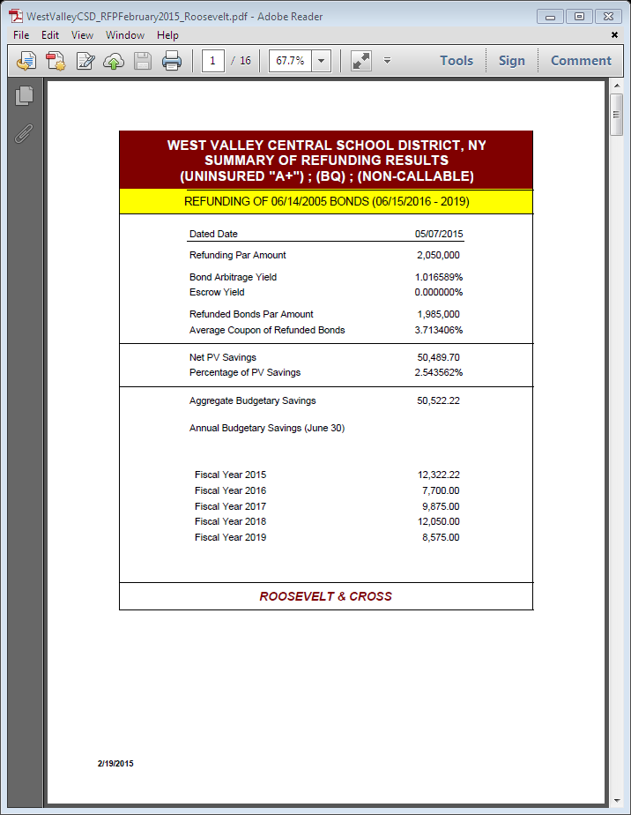
REFUNDING FINANCIAL PLAN
PREPARED BY ROOSEVELT & CROSS INCORPORATED
February 19, 2015

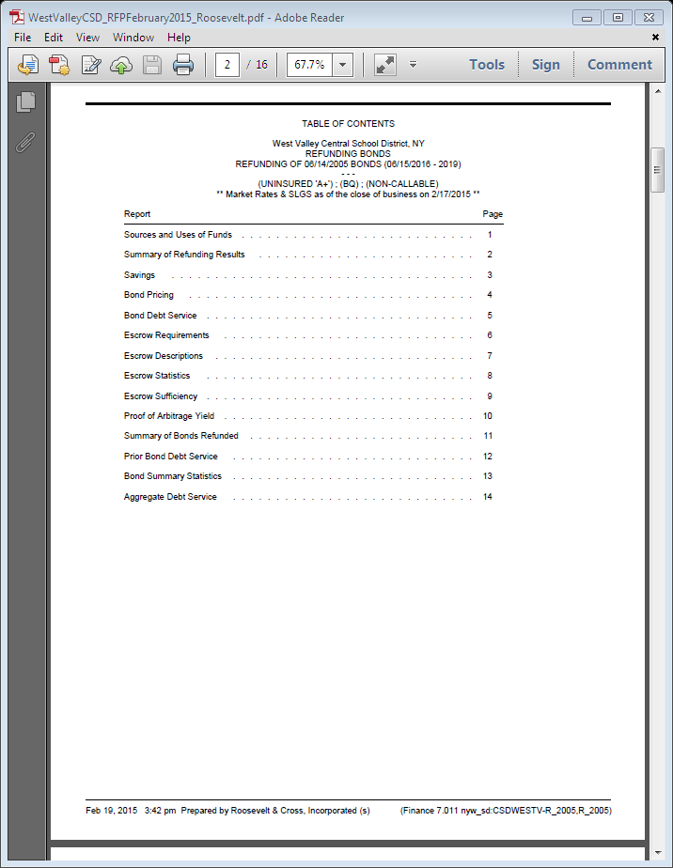

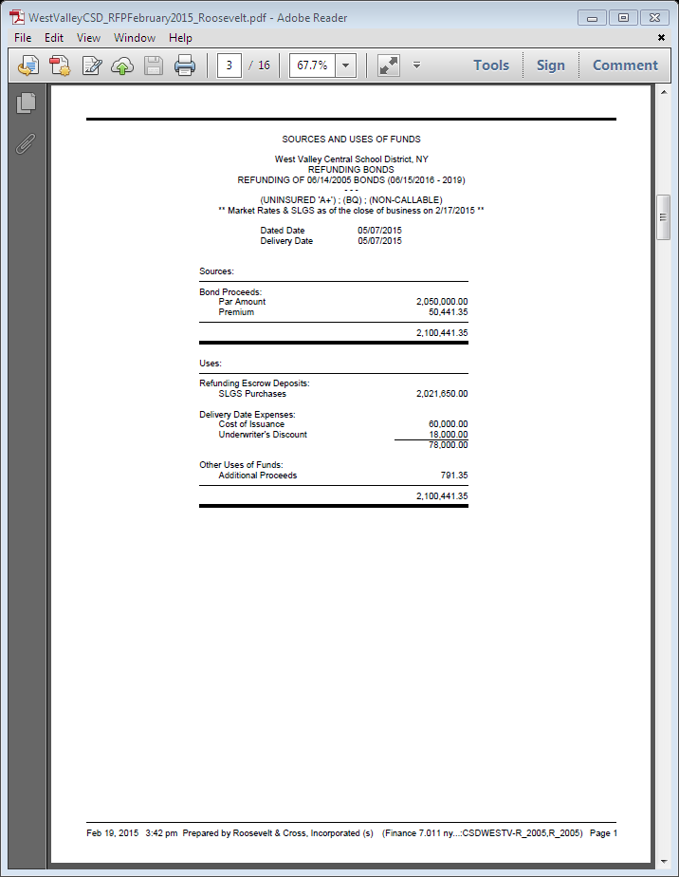

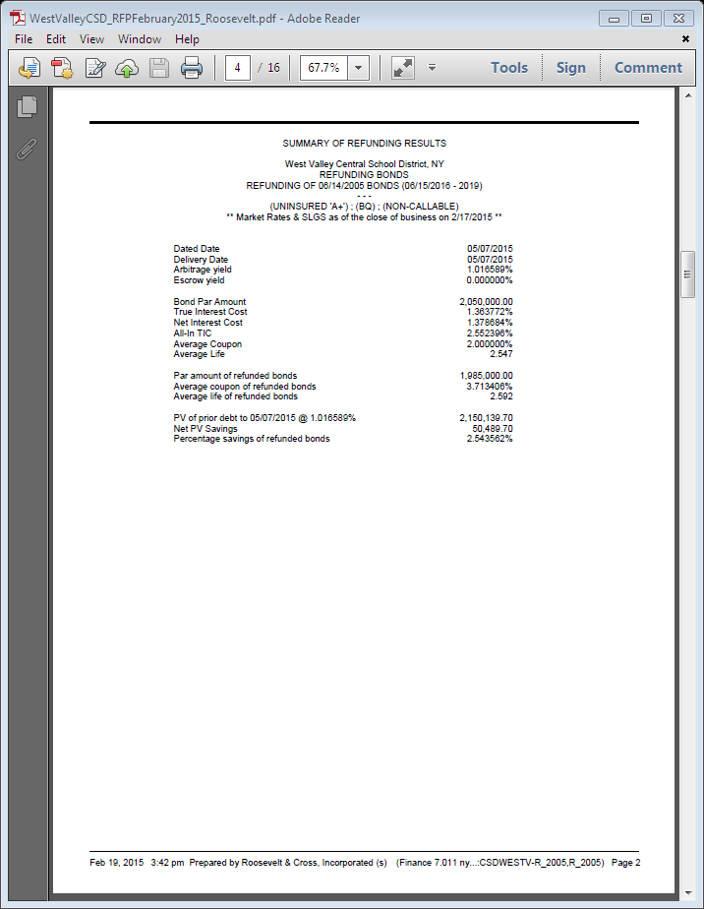

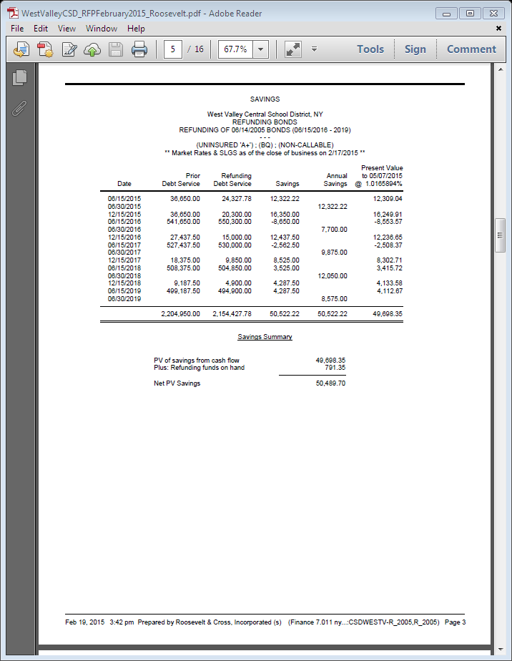

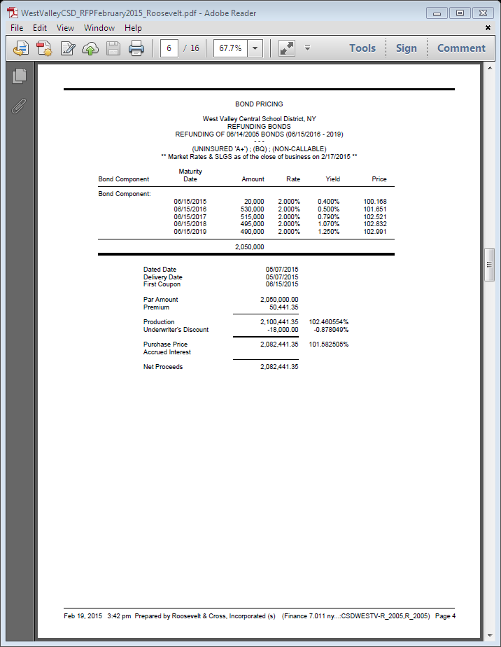
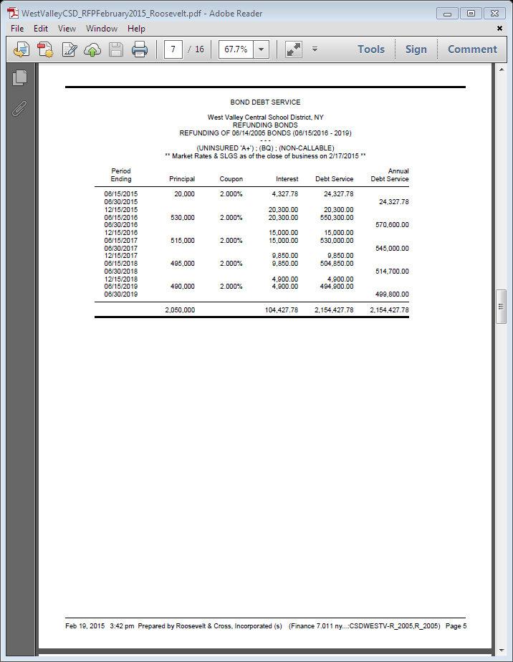
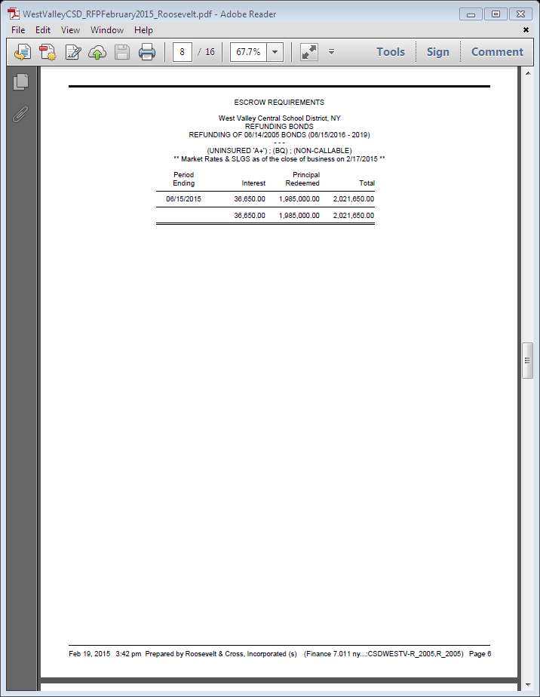

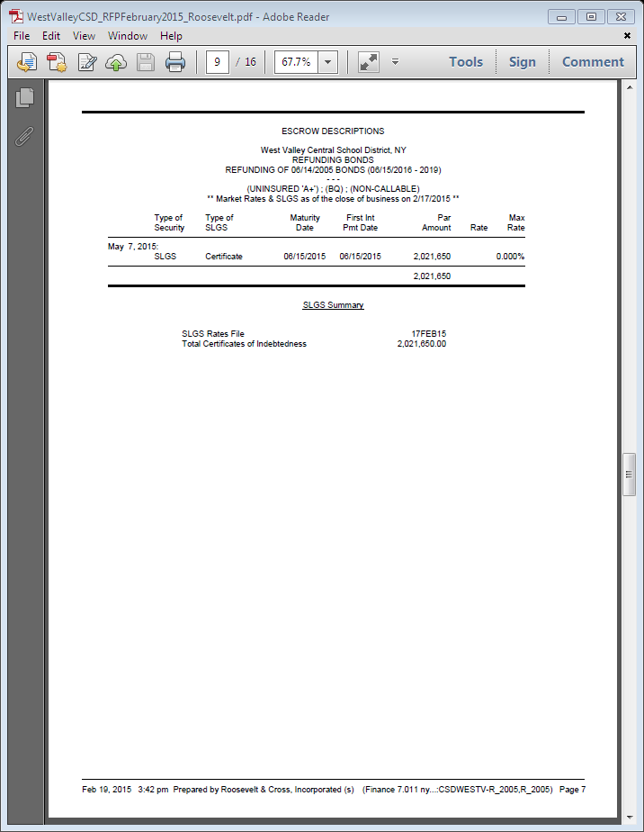

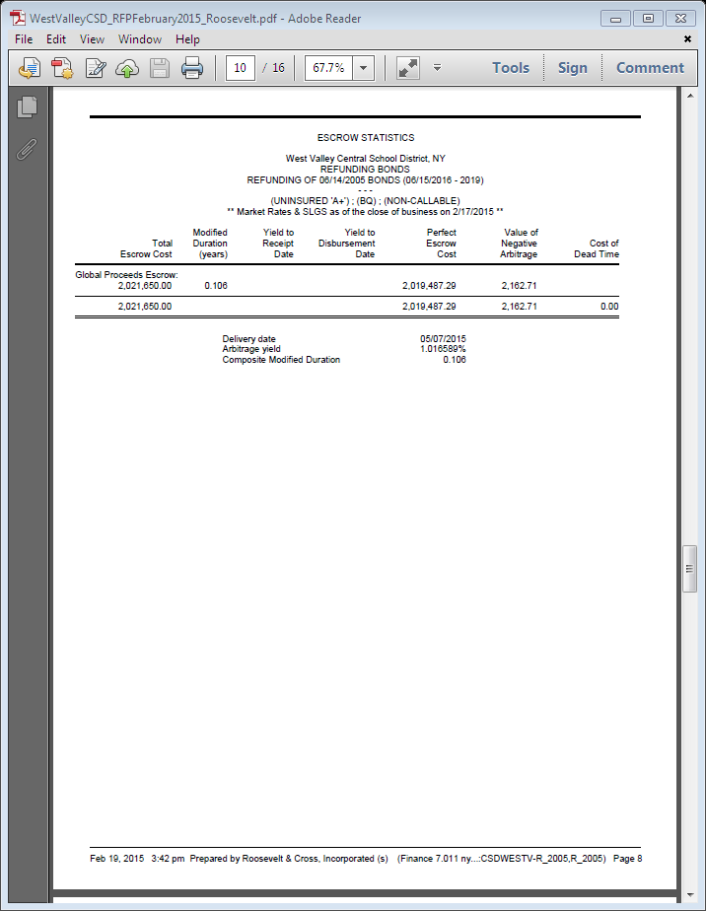

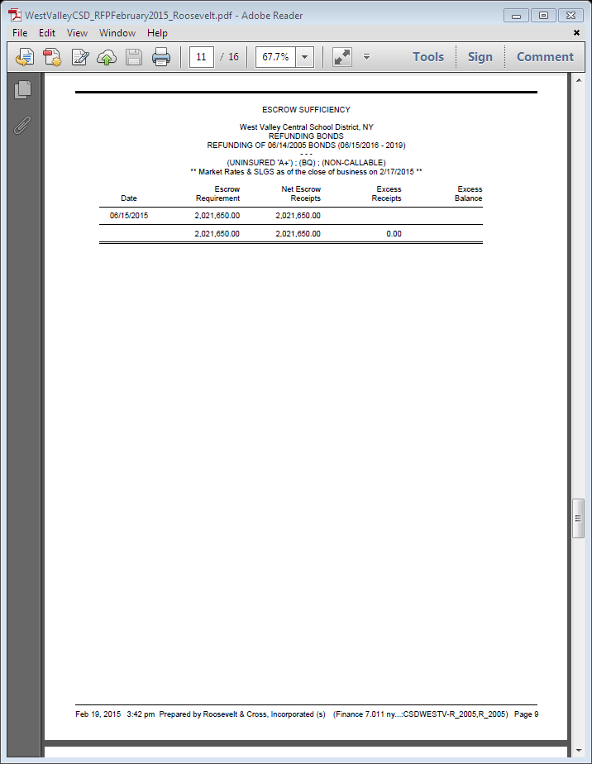

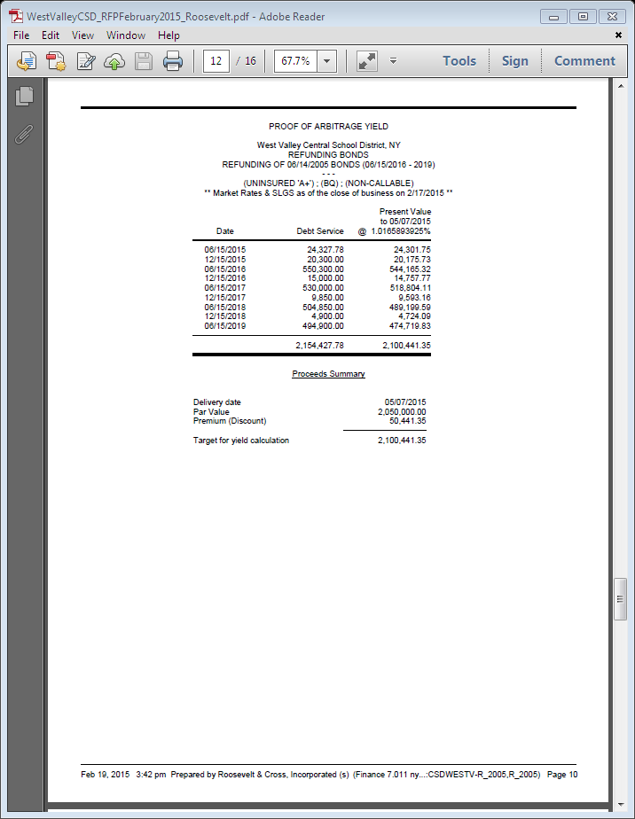

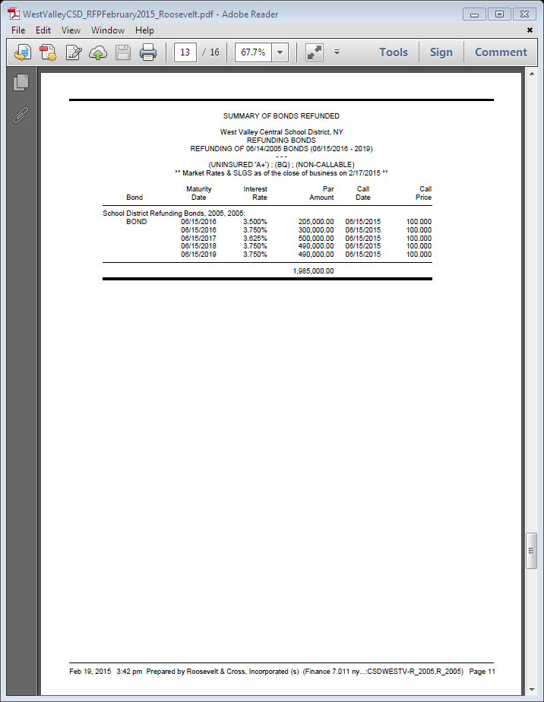

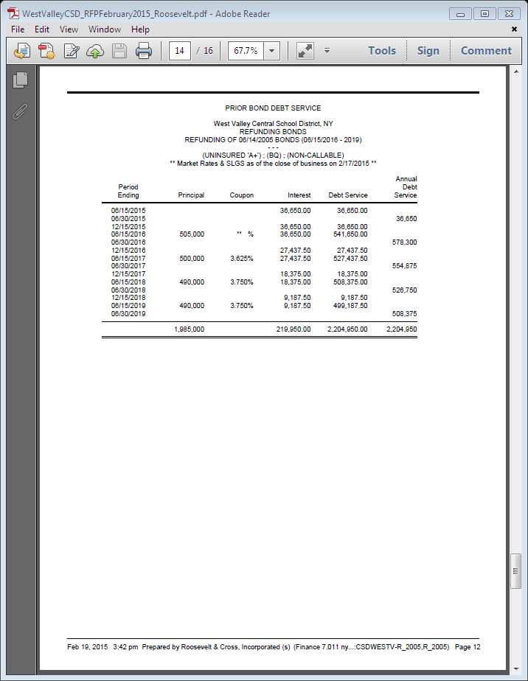

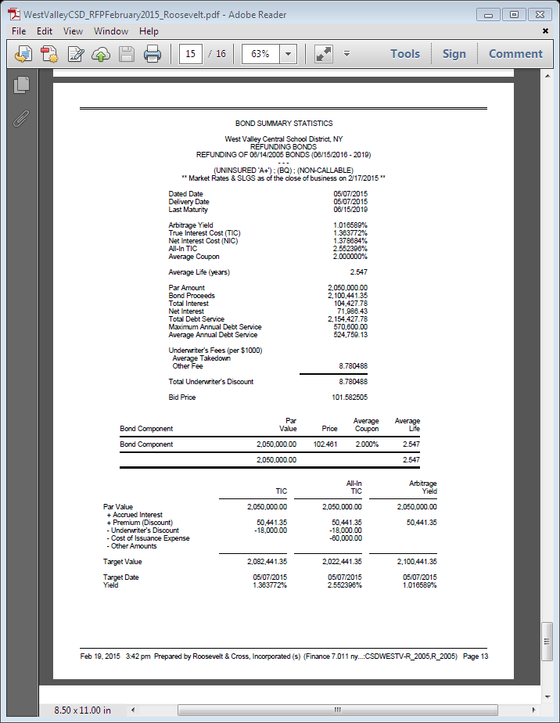

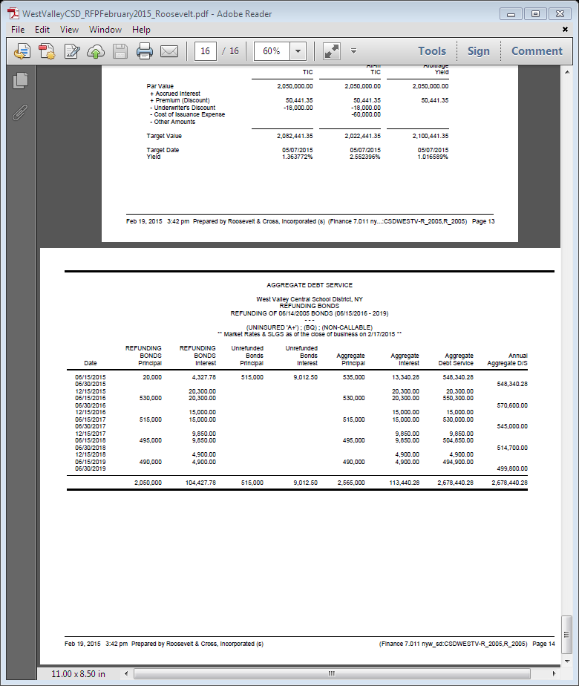

Page 27

EXHIBIT B
DESCRIPTION OF OBJECTS OR PURPOSES

Refunded Bonds

Dated Date | Object or Purpose | Original  Amount | Outstanding Amount
June 14, 2005 | Refunding of Serial Bonds of the District issued in 1999 | $8,145,000 | $1,985,000 (for the 2016-2019 maturities that are to be refunded)

Moved by ____________Seconded by _______________ Discussion

District Clerk will conduct the vote by a roll call

Kazmierczak ___, Jackson-McCarty ___, Frank ___, Boberg ___, Fleischman ___, McCauley ___, Frascella ___

Total ____Ayes ____ Nays ____ Abstain Accepted/Rejected

G. Moved by Frank, Seconded by McCauley to approve a facilities use request from Stephen Howe to use the high school, gym and auditorium roof on March 28th, April 4th or April 11th during the afternoon to early evening, for the purpose of conducting a parachute science experiment for 5th grade. 4 ayes, 0 nays, motion accepted

XII. Moved by Frank, Seconded by Frascella to ADJOURN at 8:24pm
4 ayes, 0 nays, motion accepted

_____________________
District Clerk

