Educating Exceptional Students
EDUC 240 Dual Credit with VCSU for 2 college credits
Fall 2024

When and where do we meet How will you succeed in the class
Why should I care about Intro to Teaching How will you and I evaluate progress
What information/skills will we learn
Course alignment Grading Scale
VCSU Policies
What resources will help me in the class Support from VCSU

When and where do we meet?
We will meet Block 2.2B Monday -Friday

Why should I care about Educating Exceptional Children

This course explores exceptional students that are in every classroom. Various topics reflect priorities for preparing general education teachers to effectively instruct all their students. Field experience will also be embedded into this course

What information/skills will we learn that will help me for a career in education?
Educating the Exceptional Child will begin to show you what you will need to know to be a successful educator. We will look at:
- The history and evolution of special education which will help you understand the role that education plays in preparing our future.
- Philosophical concepts that will challenge you to think about connecting with your learners through relationship development that will meet their individual needs.
- Exploring diversity in the learning center focusing on defining the term, reflecting on your understanding of it and how to plan to work with it.
- What are effective strategies to engage learners with the content, so learners feel empowered to own their learning and connect with it.
- Building their own units around standards that include presenting content knowledge, designing activity(s) and assessing learner knowledge

Course alignment in the Professional Education Sequence Curriculum
EDUC 240: Educating Exceptional Students - 17812 - F23

VCSU School of Education aligns course curriculum with ND State Standards, InTASC Standards, Program Learning Outcomes, and Teaching for Learning Capstone (TLC)
Proficiency Statement:
Learning Environments
Designs and creates a sensory-based learning environment that meets individual student needs based on a needs analysis.
Standards |  |  |  |  |  | POG
CEC Standard 2: Beginning special education professions create safe, inclusive, culturally responsive learning environments so that individuals with exceptionalities become active and effective learners and develop emotional well-being, positive social interactions, and self-determination |  | INTASC: Standard #3: | ND CTE Teaching: 1.2.7 | ND CTE Teaching: Topic 4.4 | ND CTE Teaching: Topic 4.6 |   
 |  | Learning Environments. | Analyze factors that contribute to maintaining safe and healthy school, work, and community environments. | Demonstrate a safe and healthy learning environment for children, youth, and adults | Demonstrate professional practices and standards related to working with children, youth, and adults, including diverse populations.
Topic 12.3
Analyze strategies that promote growth and development across the life span.
Proficiency Statement:
Learner Development and Differences
Recognize obstacles that students with exceptionalities encounter daily and generate learning situations to help overcome said obstacles.
Standards |  |  |  |  |  | POG
CEC Standard 1: Beginning special education professionals and understand how exceptionalities may interact with development and learning and use the knowledge to provide meaningful and challenging learning experiences for individuals with exceptionalities |  | INTASC: Standard #1: | INTASC: Standard #2 | ND CTE Teaching: 1.2.7 | ND CTE Teaching: Topic 4.6
 |  | Learner Development | Learning Differences | Analyze factors that contribute to maintaining safe and healthy school, work, and community environments. | Demonstrate professional practices and standards related to working with children, youth, and adults, including diverse populations.
ND CTE Teaching: Topic 12.3
Analyze strategies that promote growth and development across the lifespan.
Proficiency Statement:
Instructional Planning Strategies
Select and adapt a repertoire of evidence-based instructional strategies to advance learning of individuals with exceptionalities.
Standards |  |  |  |  |  | POG
CEC Standard 5: Beginning special education professionals select, adapt, and use a repertoire of evidence-based instructional strategies to advance learning of individuals with exceptionalities |  | INTASC: Standard #1: | INTASC: Standard #2 | ND CTE Teaching: Topic 4.3 | ND CTE Teaching: Topic 4.6
 |  | Learner Development | Learning Differences | Demonstrate integration of curriculum and instruction to meet developmental needs and interests of children, youth, and adults, considering gender, ethnicity, geographical, cultural, and global influences. | Demonstrate professional practices and standards related to working with children, youth, and adults, including diverse populations.
ND CTE Teaching: Topic 12.3
Analyze strategies that promote growth and development across the lifespan.
Proficiency Statement:
CRP 4 - Communication
Career-ready individuals communicate thoughts, ideas, and action plans with clarity, whether using written, verbal, and/or visual methods
State Standards |  |  |  |  |  | POG
2.2.1 |  | 2.2.2 | 2.3.1 |  |  |   
Use common roots, prefixes, and suffixes to communicate information. |  | Interpret medical abbreviations to communicate information. a. Common abbreviations b. Joint Commission official “Do Not Use List” | Utilize proper elements of written and electronic communication (spelling, grammar, and formatting).

Introduction to Inclusive Teaching (INTASC 2, 3, 9, 10)
Summarize legal foundations, litigation, and legislation regarding services to special needs populations.
Apply and use “people-first” language.
Identify the categories of disabilities.
Explain the basic components of IDEA – zero reject, nondiscriminatory evaluation, appropriate education, least restrictive environment, procedural due process and parent-student participation.
Collaboration: Partnerships & Procedures (INTASC 1-5, 9, 10)
Reflect on how the use of a universally designed learning experience can support students with exceptionalities and contribute to the overall quality of curriculum and instruction.
Differentiate among various placement options.
Recall key characteristics of inclusion.
Discuss the importance of establishing partnerships among special and general educators and paraprofessionals.
Describe how collaboration can enable students with disabilities to progress through the general
curriculum.
Teaching Students with Higher-Incidence Disabilities (INTASC 2- 10)
Describe and discuss the prevalence and characteristics of students with communication disorders, learning disabilities, intellectual disabilities, behavioral disorders and emotional behavioral disabilities.
List, describe and recommend adaptations and modifications to promote inclusion of students with higher-incidence disabilities.
Teaching Students with Lower-Incidence Disabilities (INTASC 2-10)
Describe and discuss the prevalence and characteristics of students with sensory impairments, physical disabilities, other health impairments, severe and multiple disabilities, and autism.
List, describe and be able to recommend adaptations and modifications to promote inclusion of students with lower-incidence disabilities.
Teaching Students with Other Special Learning Needs (INTASC 2-10)
Describe and discuss the prevalence and characteristics of students with ADD, ADHD, gifted, creative, or talented, culturally, and linguistically diverse backgrounds, and students at risk for school failure.
List, describe and be able to recommend adaptations and modifications to promote inclusion of students with other diverse learning needs.
Improving Classroom Behavior & Social Skills (INTASC 2, 5)
Identify effective classroom management strategies.
Describe interventions to improve social behavioral skills.

Profile of a Graduate
Throughout this course we will also be addressing some specific skills that are attached to our Profile of a Graduate competency, these are:
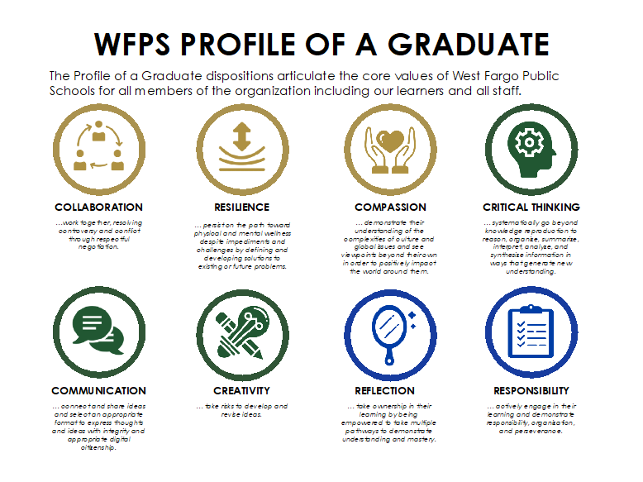

What resources will help me in the class?
There is a vast number of resources available to help you in the class. We will be using a textbook throughout the year; we will be accessing online resources/articles that will counter and contribute to our discussions. You will also be working with the current educators and curriculum coaches at West Fargo High School to see some firsthand experience in the learning centers. I will continue to provide some articles, sites, resources etc. not listed in this rubric throughout the year but don’t limit your resources to what is provided, this is a time to expand and find sources on your own to get many perspectives on teaching.

How will you succeed in the class?
Participate. We are trying to create an authentic learning experience, the only way that this truly happens is through participation. This will also mimic what skills will allow you to succeed in whatever profession you end up choosing to pursue by effectively working in groups. To get the most out of this class you must choose to participate.

Communicate. This class will be different from previous classes you have taken given the goal for the class: we are trying to introduce and prepare you to teach others using professional language, not just to retain information and represent it to your peers. Given that, you need to be sure to communicate with myself or your peers when you have questions or concerns. If we are not in class and you have questions please email me, I stop checking my emails nightly at 7 p.m. to honor my family time but will always respond within 24 hours to your questions/concerns. The more that you communicate at the beginning of the year, the easier it will be to help you as the year progresses.

Take risks and be creative. There are no single answers or solutions to questions in this class so I am telling you to try, be bold, and be yourself. The class is designed to create a safe space for you to experiment, inquire and learn through the process so you feel more comfortable in your future professions.

Have fun. The final way to succeed in this class is for you to enjoy your time. Ultimately, this is up to you to control but all of us contribute to.

How will you and I evaluate your progress?
All course work will be stored/submitted in Schoology and will consist of discussions, reflections, formative and summative assessments, projects, a midterm, and a capstone final project. Out of class assignments are designed to give you ideas, concepts and/or information for the following days in class. You will often be provided with opportunities to apply this knowledge in our class set-up in controlled examples or discussion helping you develop your own understanding or style. You will also be working with professionals in the educational field where you may be asked to help out and authentically apply providing the best and most authentic learning experience possible.

Practicum Experience
An invaluable experience of this class is your practicum experience. You will be participating in 4 hours of volunteer time where you will be able to put what we have learned and discussed into practice. You will be responsible for keeping track of your hours, a total of 4 is required, and journaling/reflecting on your experiences. We will be discussing this in more detail as we get closer to the time.

Grading Scale*
VCSU Grading Procedure WFHS Grading Procedure
Total points accumulated will determine Total Points accumulated will
the final grade determine the final grade
92-100% A 90-100% A
85-91% B 80-89% B
77-83% C 70-79% C
70-76% D 60- 69 % D
69% and below F 59 % and below F

All course pacing and resources will be stored in Schoology and if you have any questions throughout the course please email me: hfriedrich@west-fargo.k12.nd.us

Valley City State University Policies
VCSU follows the academic integrity policy
VCSU follows the Final Examination requirement set by NDUS

Support Services through Valley City State University
Students needing support in courses may contact Support Services.
Disability support services are available through VCSU.
Students needing assistance for academics may contact the Learning Center for tutoring or academic assistance.
The Library at VCSU has extensive on campus and online resources.

