**BMMS Band Supply List**

**Instruments:** Three ways students get instruments:

1. They have an instrument already. If you have questions about the quality of the instrument or wonder if the instrument needs any repairs, please contact myself or an instrument repair technician to evaluate the instrument.
2. They buy/rent an instrument through a store such as Meyer Music or Music and Arts.
3. They use a school-owned instrument. The school will provide Bass Clarinets, Tenor and Bari Saxes, Oboes, Bassoons, F Horns, Baritones, and Tubas at the middle and high school level. There are a limited number of flutes, clarinets, trumpets, and trombones that students can rent as beginners and at the middle school level. Students will fill out a rental form at the beginning of the year and return it to Mr. Watgen before the instrument can go home with the student. There is a fee to rent the instrument, but it can be waived if the student qualifies for free/reduced lunch.

**Band Books:** One book will be provided to each student. Another book will need to be purchased by the student if that first one is lost.

**WOODWIND PLAYERS:**

Flute: silk swab, cleaning cloth

Clarinet/Bass Clarinet: cleaning swab, cork grease, box (10-count) of reeds

Saxophones: cleaning swab, cork grease, neck strap, box (10-count) of reeds

Oboes: silk swab, cork grease, water cup, reeds (2 or more) in a reed case

Bassoon: bassoon silk swab, water cup, reeds (2 or more) in a reed case

**Clarinet/Bass Clarinet/Saxophone Reed selection:**

Some quality reed brands: Rico Royal, Vandoren, D’Addario. May be ordered online, through Meyer Music, or some are available at Supersonic Music on Massachusetts Street.

Strength: beginners should start on 2.5. Students should progress to strength 3 or 3.5 as they develop their embouchure and range on their instrument. No 2nd/3rd year player should play on 2.5 strength reeds.

**Oboe Reeds:** <https://www.prismreeds.com/>

**Bassoon Reeds:** <https://charlesmusic.com/shop/charles-student-bassoon-reed/>

**BRASS PLAYERS:**

Trumpet: valve oil, slide grease

F Horn: rotary oil (yes, it is different from valve oil) and slide grease

Baritone: valve oil, slide grease

Trombone: slide grease, tuning slide grease

Tuba: valve oil, slide grease (some full size tubas are rotary valve and will need rotary oil)

**PERCUSSION STUDENTS**

Beginner Percussion

* Education Kit with Bells and Snare Drum or Practice Pad
* Vic Firth SD1 snare drum sticks or similar stick (typically included with education kit)
* Smith Hard Nylon or Rubber mallets or similar mallets (typically included with education kit)
* Stick Bag for storing and transporting sticks/mallets
* Yarn Mallets such as Smith- hard or medium (not typically included with education kit)

Advancing Percussion

* All materials from Beginner Percussion
* Timpani Mallets- Vic Firth General
* Rubber Mallets- Innovative F9

Smith brand are budget-friendly mallets, but upgrades are available from a variety of brands:

* Vic Firth
* Innovative
* Encore
* Malletech
* Balter

Supersonic Music (1029 Massachusetts Street) and <https://www.steveweissmusic.com/> are great resources for percussion materials.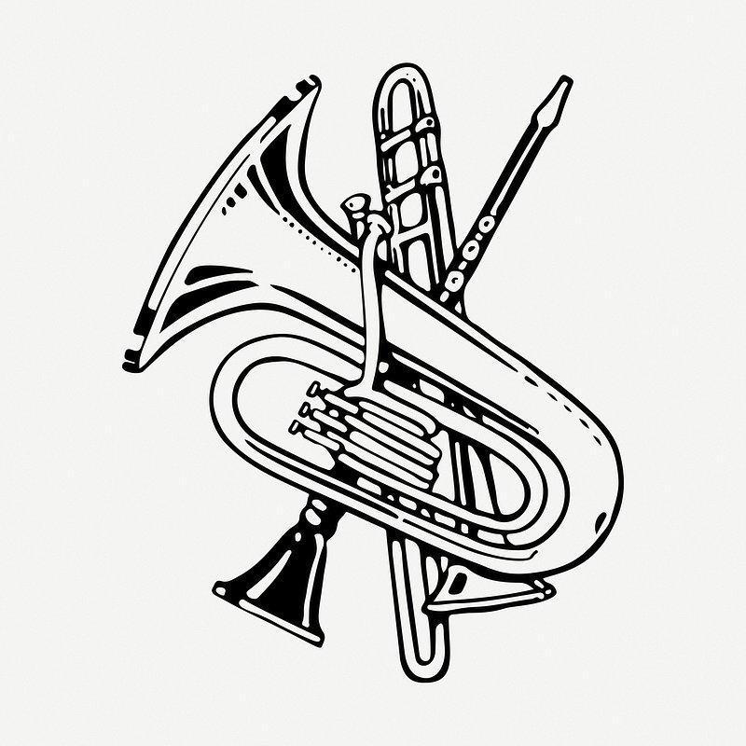

I look forward to a great year of making music!

Collin Watgen

BMMS Band Director

[cwatgen@usd497.org](mailto:cwatgen@usd497.org)