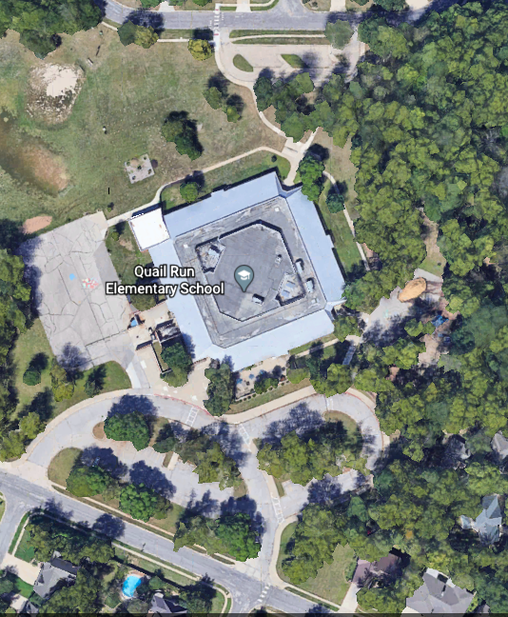

4-5

Crosswalk

Crosswalk

Crosswalk

2-3

K-1

K/1 Enter Building

4/5 Enter Building

2/3 Enter Building

**Quail Run Elementary Traffic Plan**

Thank you for taking the time to review this document. Safety is our number one priority, and we appreciate your help.

Please remember to always drive slowly and safely near and on our school grounds.

**Morning Drop-Off:** Please follow the path illustrated with green arrows directly to the when entering off of Inverness Drive. This is where students can be dropped off in the morning. Follow the green arrows when dropping off from the north side of the school off of Woodland Drive. Students will walk around to their designated entrance, regardless of where they are dropped off.

**Afternoon Pick-Up:** Off of Inverness Drive, please follow the appropriate path illustrated with green arrows to the K-1 blue area for your K-1 student(s) or the 2-3 blue area for your 2-3 student(s). The 4-5 blue area will be located off Woodland Drive for 4th and 5th grade students that do not have younger siblings. Older siblings should be picked up with their younger family members (Ex: siblings in 4th and 2nd grades should be picked up with the 2nd grade teacher).

**Yellow Arrows** – Please use extreme caution while in waiting areas and while in the traffic flow. Please pay attention for children and traffic at all times, including at crosswalks.

**Red Lines** – These are no parking areas during morning drop-off or afternoon pick-up (3:50 to 4:00). For safety reasons, the crosswalk from the reserved staff parking area will also be closed during afternoon pick-up (3:50 to 4:00).

**Orange Lines**- indicate where students will enter the building in the mornings. Staff will open the building at 8:30 AM. Breakfast will be offered in the cafeteria at this time.