EL PHYSICAL SCIENCE

Karla Maahs

West Fargo High School

Classroom: 213J

**Office: 222J**

**Email: kmaahs@west-fargo.k12.nd.us**

TEACHER SCHEDULE

Location Varies

213J

|  |  |  |  |  |
| --- | --- | --- | --- | --- |
| Block | Regular | Extended Advisory | A | B |
| 1 | 8:25-9:55 | 8:25-9:45 | EL Physical Science II | EL Physical Science I |
| ADV | 10:00-10:20 | 9:50-10:50 | Cybersecurity (Grade 11 Advisory) | |
| 2.3 | 10:25-11:55 | 10:55-12:15 | MTSS Study Hall | EL Physical Science I |
| 3 | 12:30-2:00 | 12:50-2:10 | EL Physical Science II | Meetings/Collab |
| 4 | 2:05-3:35 | 2:15-3:35 | Teacher Prep | Teacher Prep |

COURSE DESCRIPTION

Physical Science is the initial science course for high school (no prerequisites) which primarily focuses on the study of matter and energy and their interactions (non-living systems). These can into two major aread of study: Physics (semester 1) or Chemistry (semester 2). The table on the following page contains an overview of what you can expect to learn from each of these areas of science. All content is guided and assessed using the NGSS (Next Generation Science Standards).

Our first unit of our Physics semester is the scientific method, a central concept in science and our future standards. To fully grasp physics and chemistry, it’s important to first understand how scientists have made and validated the discoveries you’ll explore this year. This knowledge will empower you to make your own predictions, analyze data, and experience science in action. The following table contains an overview of the units in each semester and their main ideas.

|  |  |  |
| --- | --- | --- |
| Unit | Semester 1 Units | Main Ideas |
| 1 | Scientific Method | Identify parts and order of the scientific method to make predictions, design your own controlled experiments, analyze data, and form conclusions |
| 2 | Matter in Motion | Calculate and explain changes in speed, distance, and time to explain and interpret motion graphs |
| 3 | Forces and Motion | Apply Newton’s 3 laws of motion to mathematical scenarios of motion to solve for unknown variables |
| 4 | Energy | Identify common types of energy and how it transforms into different types of energy |
|  |  |  |
|  | Semester 2 Units |  |
| 1 | Properties of Matter | Identify common physical properties and changes as well as chemical properties and changes |
| 2 | Classifying Matter | Conduct research to classify elements, compounds, molecules, and mixtures based on properties and use these properties to separate a mixture into 4 individual components |
| 3 | Introduction to Atoms | Understand and identify the subatomic particles within an atom and how each plays a role in an isotope’s stability and classification |
| 4 | Periodic Table | Explain the trends of the periodic tables within groups and periods such as reactivity, valence electrons, properties, and predict properties and locations of new elements |
| 5 | Chemical Bonds | Compare and contrast ionic, covalent, and metallic bond properties and model how they are created |
| 6 | Chemical Reactions | Use understanding of atoms, the periodic table, and chemical bonding to identify and balance different chemical reactions |

Semester Grades and Graduation Credit

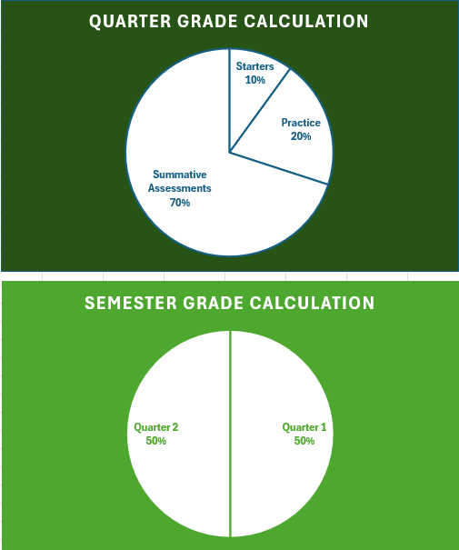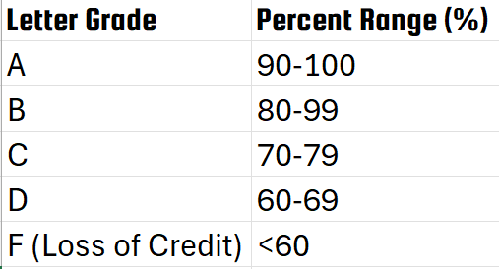

Physical Science is a yearlong course consisting of two semesters; passing each semester is required for graduation. Receiving an F in either semester of Physical Science will result in you retaking the failed semester the following year. Semester grades will determine if you earn credit for graduation

Weighted Grades and Quarters

Quarter grades are weighted. 30% of your grade is collected from formative assessments: tools and methods used by educators to evaluate learners’ understanding and progress throughout the learning process. They will occur throughout the class in the form of starters, practice, Kahoot!, Quizlet, assignments, etcetera. By utilizing time management, you should bring minimal work outside of class. Formative assessments allow the educator to determine if and when additional practice is needed.

When a learner has provided sufficient evidence that they have mastered the learning target(s) or standard, summative assessments (70%) will be used to obtain a comprehensive understanding of a learner’s proficiency over the course of a learning target as well as the entire unit. Summative assessments will be given at the teacher’s discretion and only after sufficient evidence of proficiency has been obtained. This allows the educator and learner to obtain the most reliable and valid summative assessment score.

Many different formative and summative assessments will be used in this class and have different weights in the grade book, see the next table for ways you can expect to demonstrate understanding in this course.

Assignments will be graded within 24 working hours (1 business day) from submission. At a minimum, grades will be synced from Schoology to PowerSchool daily before 4:00 PM.

|  |  |  |  |  |  |  |  |
| --- | --- | --- | --- | --- | --- | --- | --- |
| Assessment Category | Descriptor | Time Limits | Access | Content | Available Resources | Purpose | Ability to redo |
| Formative  Total weight= 30% | Starters | Timed | On/before beginning bell of class. | Material from the most recent lesson, topics from any previous lessons in this school year, or predictions | Previous Notes, Internet, Teacher  No help from other learners | Provide educators with data on learners’ understanding of the previous lesson to guide next steps | No Retakes |
| Kahoot! | Timed | Following lesson  In class only | Gamified learning. Used as a predictor to determine if additional practice is needed. Can take the place of some/all daily homework assignments if proficiency has been reached | Previous Notes, Internet, Teacher  No help from other learners | Provide a fun alternative to practice which provides instant feedback on learners’ understanding of today’s lesson | Rarely retakes.  Games are specific to each day and played only once. |
| Schoology Practice | No time limit | Open after daily lesson | Material from today’s (and previous) lessons | Previous Notes, Internet, Teacher  Help from other learners only with permission | Offers learners structured, step-by-step approaches to break down assignments into manageable parts and provide immediate feedback. | Retake up to 3 times. |
| Other summative assessments may be used throughout the semester and fall under the Practice category including, but not limited to Quizlet, flashcards, etcetera. | | | | | | |
| Summative  Total Weight=  70% | Learning Target Quizzes | Timed (ranging from 10-30 minutes) | Opens in class, password protected | Learning Target(s) consisting of content from multiple lessons | Teacher Only | Allows learners to demonstrate their highest level of skills and knowledge with prompt feedback provided | No retakes |
| Unit Assessment | Timed (90 minutes) | Opens in class, password protected | Multiple Learning Targets and or Standards | Teacher Only | Provides a final snapshot of a learner’s ability to apply skills and knowledge learned throughout a unit, connecting multiple learning targets together | No retakes |
| Lab | Suggested time limit of one block, difficult to make up | Only available after Pre-lab is complete and proficiency of learning targets is reached | Multiple Learning Targets and or Standards | Notes, Internet, collaborating with learners, teacher | Provides opportunity for collaboration, hands on learning, and application of knowledge developing high level thinking | No retakes |
| Projects/Modeling | No time limit | Open following learner proficiency of critical learning target(s) | One or more learning target, one standard, or one unit | Notes, Internet, collaborating with learners, teacher | Learners demonstrate English Language Proficiency of scientific words and understanding through hands on learning | No retakes |