EL MTSS Study Hall

Karla Maahs

West Fargo High School

Classroom: 213J

**Office: 222J**

**Email: kmaahs@west-fargo.k12.nd.us**

TEACHER SCHEDULE

Location Varies

213J

|  |  |  |  |  |
| --- | --- | --- | --- | --- |
| Block | Regular | Extended Advisory | A | B |
| 1 | 8:25-9:55 | 8:25-9:45 | EL Physical Science II | EL Physical Science I |
| ADV | 10:00-10:20 | 9:50-10:50 | Cybersecurity (Grade 11 Advisory) | |
| 2.3 | 10:25-11:55 | 10:55-12:15 | EL MTSS Study Hall | EL Physical Science I |
| 3 | 12:30-2:00 | 12:50-2:10 | EL Physical Science II | Meetings/Collab |
| 4 | 2:05-3:35 | 2:15-3:35 | Teacher Prep | Teacher Prep |

COURSE DESCRIPTION

An EL MTSS (Multi-Tiered System of Supports) Study Hall is a structured academic environment designed to provide additional support to students who need it while offering elective credit for graduation.

**Purpose**: support learners who may be struggling academically or require extra help to meet grade-level expectations; Focus is on addressing individual learning needs and promoting academic success through grade checks and communication. As English Language ability lies at the core of student success, we will work to improve our proficiency of the English Language through World English 3 text and activities <30 minutes total per week. Time not utilized on these strategies will be used to complete other coursework.

World Language

|  |  |  |  |
| --- | --- | --- | --- |
| Unit | | Topics | Unit Goals |
| 4 | The Good Life | | * Talk about things you value * Discuss important people or events * Discuss good financial habits * Talk about great jobs * Express agreement or disagreement |
| 5 | Survival | | * Say how things could be different * Discuss the survival of species * Talk about threats to survival * Discuss rescues * Give advice about difficult situations |
| 6 | Art Matters | | * Report other people’s ideas * Express opinions about public art * Talk about types of art * Discuss the value of art * Produce a biographical profile |

Semester Grades and Graduation Credit

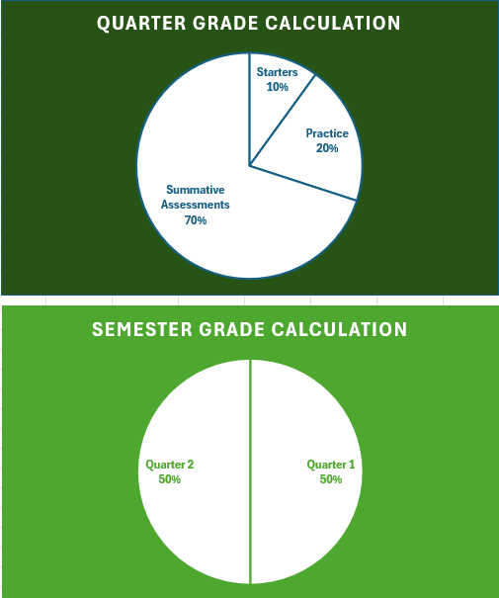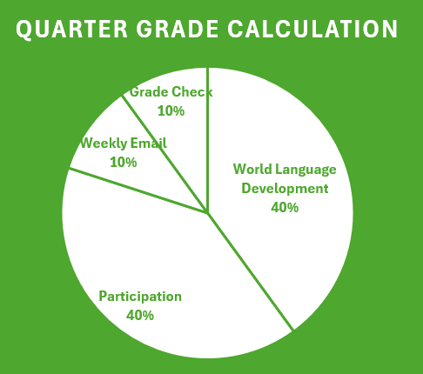

MTSS Study Halls count for credit towards graduation. Each semester can accrue .25 credits, for a total of .5 credits in a year to count towards your electives. Semester grades are recorded as Satisfactory (Credit) or Unsatisfactory (No Credit).

Weighted Grades and Quarters

Quarter grades are weighted.

* 40% Participation: present, prepared, on time, and on task
* 40% World Language Development: Completion of tasks to develop English Language Proficiency as outlined in our World English 3 texts in units 4-6
* A white background with black text

  Description automatically generated10% Weekly Grade Check: record grades in each class and missing work
* 10% Weekly Email: send an email to caring adults to fill them in on how your learning is going at WFHS

Assignments will be graded within 24 working hours (1 business day) from submission. At a minimum, grades will be synced from Schoology to PowerSchool daily before 4:00 PM.

PowerSchool contain a letter grade for you throughout each quarter to help you assess your demonstrated abilities in this course.