Consumer Math Syllabus 2024-2025
Instructor: Mrs. Laura Preston Office: Room 220H
Classroom: 219H Prep Period: Period 3(B) in 219H 4(A) ½ block in 219H
School Phone: 356-2050 Email: lpreston@west-fargo.k12.nd.us
Hello, and welcome to Consumer Math! Here is some information that you will need for my course:
What do I need to bring to class? | Every day, I expect you to have:  - A pencil with an eraser (homework, quizzes and tests should be done in pencil when in person)  - A basic calculator for homework  - iPad and stylus charged and ready – We use this daily for Lesson Openers  - Your Algebra I book (optional) Do not write in your book!!! Leave at home for Homework purposes.  - A folder or binder for keeping homework, worksheets, and other returned material  - A good attitude and a good work-ethic! You have a choice to make each day excellent. Make good choices!
Attendance Policy | Gone for a school related activity:  MUST communicate this with me prior to leaving. You will be responsible for missed material. LOOK at weekly calendar to see what missing on Schoology. You should be able to complete it even though missed class.  Gone for a vacation:  MUST communicate this with me prior to vacation so we can figure out what missing. You will be responsible for missed material. LOOK at weekly calendar to see what missing on Schoology. You should be able to complete it even though missed class.  If a student is aware of an upcoming absence in which they will miss at least three consecutive days of school (family travel, etc.), the student is expected to complete a Planned Absence Approval Form. Using the Planned Absence Approval form, the student will connect with each teacher to document expectations for missing work. Upon completing the form, the student submits it to the Main Office who will then email it to all appropriate stakeholders for documentation.  If expectations of the Planned Absence Approval Form are not met or a form is not submitted and the student misses three consecutive days (marked excused), educators can withhold credit for missing work  Gone because you are sick:  LOOK at weekly calendar to see what missing on Schoology. You should be able to complete it even though missed class. TALK/Email to me the next day you come back so we can arrange times for what material you missed.  Most importantly, COMMUNICATE with me. I have many students, so you need to be willing to talk to me when you are absent or need help. Talking to me in person is best; however, that is not always feasible. Please email me with questions or concerns if you can’t see me in person. (I check my email frequently. Schoology messages sometimes get lost in the shuffle.)  How it works in the office:  - Automatic alerts at the end of the period for each UV to families  - Automatic alerts sent at 5 and 7 absences  - Family contact by admin when nearing 10 absences to discuss contract
Tardy Policy | - Students who come late to class without a pass will be marked UT.  - Students who come late to class without a pass after 20 minutes will be marked UV  - Every 5th UT tardy will be marked as a UV  - If student continues to be late, an email will be sent home as well as a packer referral submitted.
Homework Policy | - Homework is due at the beginning of the next class period, unless otherwise stated.  - Homework that is graded MUST be turned in when DUE – no exceptions.  REMEMBER: Homework is important and greatly enhances learning. Do not get behind. Each new lesson is built on the lesson before it. Ask questions. If there is not enough time to answer all of your questions in class, get help outside of class. It is your responsibility to get help before or after school or during your free period.
Late Work Policy | - Students have until the day of the quiz on that material to turn in any late daily homework for credit. Once we have quizzed or tested on the material, late work is no longer accepted.  - Students do NOT have extra time to turn in graded assignments. If they are not handed in when they are due, the student receives a zero.
Classroom Rule | - I expect you to be respectful to yourself, your classmates, all of the materials in the room, and to me. Deep down, I think you all understand what is right and what is wrong. If you aren’t sure, be sure to ask and I will give my best answer. All of the school rules apply to my classroom.  - Cell Phones- If it rings/text messaging in my class I will bring it down to the main office that day when I leave. If I catch you texting/rings during TEST OR QUIZ will get an automatic zero on the assessment! TODAY is your warning about cell phones!  - Cell phones need to be OUT OF SIGHT-OUT OF USE!  - No earbuds/headphones to be in your ears at any time during class. If I continually must ask you to take them out, they will be brought down to the main office at the end of the day.  - Cheating will result in an automatic ZERO (No Excuses)  - Hats may be asked at any time to be removed in class at teacher discretion.  - Hoods are to be taken down as the student enters the room.  - No food is allowed in the academic areas. Only beverages in a spill-proof container are allowed in the classroom. If you bring food or a container that is not approved, you must return to the commons to throw it away. If you are not back before the bell rings, you will be marked UT.
Cellphone Procedures | 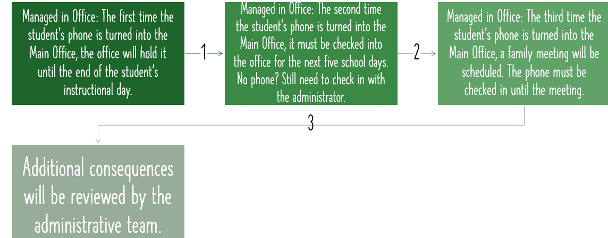

Grading Scale | Grades are weighted by category, meaning some points are worth more than others. Tests are a large part of your grade.  Weighted categories for classroom work:  Unit Tests/Cumulative Test: 70%  Quizzes: 20%  Daily work/Lesson Openers: 10%  Quizzes will go in as 30 points each time  Scale:  A = 90 – 100 %  B = 80 – 89 %  C = 70 – 79 %  D = 60 – 69 %  F = Below 60%  Overall weighted grades for Semester 1  Quarter 1: 50% Quarter 2: 50%  - There are tests throughout the quarter: 3-4 unit tests and 1 cumulative test.
Tests | - Tests will be given at the end of each unit. Each test will be worth 100 points and will contain questions that are worth 1-5 points each. You must follow directions and show work for each problem to earn full credit.  - Cumulative test will be given at the end of each quarter. This will be worth 150 points and will contain questions from the entire quarter material covered.  - Tests are written to be FINISHED in given time frame. Students will NOT be given extra time to complete the test. It must be finished in the time allotted.  - If you are gone when the test is scheduled, you should set up a time and expect to take it the NEXT DAY when you return.  - Tests will be weighted at 70% of the student’s overall grade for the class.
Extra Credit | - An extra credit test question is asked at the end of each unit for a chance to earn 2% bonus on your test.  - I do not offer individual extra credit! The department does Not offer extra credit!  You cannot earn extra credit!!!
Integrity Policy | Any violation of Integrity will result in a 0 grade for that assignment or test. You will not have an opportunity to earn those points back.
Resources | - You can make arrangements to meet with me or another math teacher to receive help during the school day or during Packer time/WIN  - You may come to the math office (220H) or my room at any time to see if there is a teacher available.  - Re-watch recorded lessons for the day found on Schoology.  - The following websites can provide additional help:  - Khan Academy (b) CK-12 (c) Google Topics (d) Ask Parents

