NORTHSIDE HIGH SCHOOL
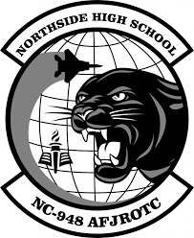

NC-948 AIR FORCE JUNIOR RESERVE
OFFICER TRAINING CORP
CADET HANDBOOK
MEMORANDUM FOR NC-948 CADETS

SUBJECT: Introduction

The Air Force Junior ROTC North Carolina-948 unit was established at Northside High School in 1994 by agreement between the Beaufort County School District and the United States Air Force. From the very beginning, interested individuals within the school system and the community have been working hard to ensure a successful AFJROTC program.
Building and sustaining a successful program requires structure, rules, and regulations. This cadet handbook provides that structure for the cadets of the Northside High School AFJROTC unit. It was designed for the purpose of establishing a high standard of performance for our cadets, a standard to permit the entire cadet corps to aim high and work toward common goals of “Developing citizens of character dedicated to serving their nation and community.”
The handbook will provide you with a resource of information that will help you become a successful and contributing member of our cadet corps. It furnishes a reference for the many details that will permit a high standard of performance, e.g., proper fit and wear of the uniform, placement of insignia, classroom and campus conduct, etc. It gives information on the course and how the cadet group is organized. You should read and understand this handbook, and then place into practice the standards outlined herein.
Kent Cast Keith Waltz
Kent Cast, Major, USAF (Ret) Keith Waltz, SMSgt, USAF (Ret)
Senior Aerospace Science Instructor Aerospace Science Instructor
TABLE OF CONTENTS
Subject Page
INTRODUCTION |  | 1
TABLE OF CONTENTS |  | 2
Chapter 1 | Mission, Standards and Unit Operations | 3
Chapter 2 | NHS AFJROTC Program | 8
Chapter 3 | Organization of the Corps | 10
Chapter 4 | Cadet Promotion System | 15
Chapter 5 | Dress and Appearance | 18
Chapter 6 | Awards and Decorations | 30
Chapter 7 | Special Teams | 38
Chapter 8 | Cadet Activities | 41
Chapter 9 | Reserve Cadet Program | 44
FIGURES
Figure 3.1 | Cadet Unit Manning Document | 13
Figure 3.2 | Cadet Unit Organization Chart | 14
Figure 5.1 | Male Hair Standards Examples | 22
Figure 5.2 | Male – Unauthorized Hair Examples | 23
Figure 5.3 | Mustache | 23
Figure 5.4 | Female Hair Examples | 25
Figure 5.5 | Authorized Female Hair Styles Ex of Locs, Braids, & Cornrows | 25
Figure 5.6 | Authorized Ponytails/Equivalent & Long braid(s) Hair Styles Examples | 25
Figure 5.7 | Ponytail/Braid Length | 26
Figure 5.8 | Unauthorized Ponytails | 26
Figure 5.9 | Female – Unauthorized Hair Examples | 26
Figure 5.10 | Authorized & Unauthorized Nail Polish Colors (Not All-Inclusive) | 27
Figure 5.11 | Personal Appearance Inspection | 29
ATTACHMENTS
1 | Cadet Creed | 45
2 | AF Song, National Anthem, Alma Mater, High Flight | 46
3 | Military Time, Phonetic Alphabet | 47
4 | Air Force Junior ROTC Insignia | 48
5 | Air Force Junior ROTC Badges | 49
6 | Cadet Airman Battle Uniform (ABU) | 50
7 | Cadet OCP Uniform | 51
8 | Chain of Command | 52
9 | AF JROTC Ribbon Chart | 53
10 | 30-Step Drill Evaluation as a Member | 54
11 | 30-Step Drill Evaluation as a Commander | 55

Chapter 1
MISSION, STANDARDS AND UNIT OPERATIONS
  - Mission. The mission of AFJROTC and NC-948 is to “Develop citizens of character dedicated to serving their nation and community.”

1.2. Air Force Core Values. Core values are the foundation upon which a truly quality AFJROTC Program is built. Core values are also a fundamental set of guidelines that can serve you throughout your life. These are:

INTEGRITY FIRST. Integrity means devotion to honesty, truthfulness, doing one’s duty, and doing what is right. This means that your word can always be counted upon and that you can be trusted to accomplish your job. The willingness to do the right thing even when no one is looking.

SERVICE BEFORE SELF. Service is the giving of self to provide for the welfare of others. Personal desires are not considered in the concept of service. Professional duties take precedence over personal desires.

EXCELLENCE IN ALL WE DO. Excellence means doing the very best you can in each job you perform regardless of how large, small, difficult, or easy it is to accomplish. Strive to do your best, always giving 100 percent.
1.3. Goal. The goals of the AFJROTC program are to instill values of citizenship, service to the United States, personal responsibility, and a sense of accomplishment in high school students.

1.4. Objectives. The objectives of JROTC are to educate and train students in citizenship and life skills, promote community service, instill a sense of responsibility, and develop character, and self-discipline, through education and instruction in air and space fundamentals and the Air Force's core values.

1.5. Cadet Creed. (See Attachment 1)
1.6. Standards of Conduct
a. You become a leader by exhibiting qualities of intelligence, good judgment, decisiveness, and initiative. You inspire others to follow you by setting examples of confidence, maturity, and respect. In order to realize your highest potential, you must maintain high standards of self-discipline, high ideals, good manners, social grace, appropriate dress (in or out of uniform), and good grooming.
- You will display friendliness and respect to students, Northside High School faculty, Aerospace Science instructors and AFJROTC cadets. You will greet other cadets and Aerospace Science instructors in a pleasant manner, regardless of location.
- Cadet Officers will exercise discretion in enforcing military courtesy. Cadets will not be placed in an embarrassing situation by a public reprimand. However, cadet officers have the authority and the responsibility to deal with violations of military customs or courtesies.
- You will show respect for instructors and any guest speakers by addressing them as "sir" or "ma'am" and by responding to them in the same manner (e.g. yes/no sir/ma'am).
- Enlisted cadets show their respect for cadet officers by addressing and responding to them as "sir" or "ma'am” and saluting them when outdoors.
- You will not wear hats (uniform or civilian) indoors unless permission is obtained from the SASI/ASI. When you are in uniform you will wear the correct headgear outdoors.
- You will follow procedures outlined in this cadet guide and will obey reasonable orders from all senior cadets, regardless of position or rank.
- You will come to the AFJROTC classroom prepared to engage in aerospace science/leadership education activities. Preparation includes completed assignments, proper textbooks, notepaper, pen/pencil, and an attitude conducive to learning.
- You will not litter the classroom or leave study materials or personal items in the AFJROTC office, classroom, or logistics room. You will put your trash in the trashcans and leave tables and/or chairs correctly placed. Classes will not be dismissed until the room is neat and orderly.
- You will not mark, scratch, or otherwise deface Air Force or Northside High School property.
1.7. Public Display of Affection (PDA)

a. At no time, while in uniform, will cadets do the following:
- Hold hands with girlfriend/boyfriend
- Kiss
- Sit on laps
- Engage in any PDA which may reflect unfavorably on the AFJROTC program
b. The reasons for this policy are as follows:
- The good order and discipline of the corps
- Detracts from the image we are trying to establish and maintain
- Potential undermining of superior to subordinate roles/relationships
- Changes relationships from professional to personal
- Gives rise to perceptions of favoritism within the corps
1.8. The Chain of Command
- The chain of command (Attachment 8) is a fundamental part of a structured environment. It has been in existence for several millennia. The basic reason for the military’s use of it is efficiency.
- We, just like the military, use it to:
- Communicate objectives/information from senior positions/functions to lower positions/functions.
- Communicate responses or to advise from lower positions/functions to higher positions/functions.
- Voice grievances on policies, directives/orders, or perceived wrong doings (if the complaint is about an
aerospace academic grade, the cadet should communicate directly with the SASI/ASI). If you want to use the chain of command to voice a complaint, do the following:
- Talk with your supervisor about the concern first. This is extremely important because most complaints are
resolved at this level.
- If talking with your supervisor fails to resolve the problem, then use organizational chart, Figure 3.1
(posted on the bulletin board), to figure out who is next in the chain of command to express your grievance. This process is repeated until the cadet feels that their grievance has been addressed to their satisfaction. Although unusual, it is conceivable for a complaint to go all the way to the SASI.
NOTE: It is important for all parties (complainant and those responding to the complaint) to act professionally and without recriminations as long as proper procedures are followed.

1.9. Saluting.
- The salute is a military greeting recognized all over the world. In many countries, as in our nation, it is a symbol of respect. Military personnel consider the salute a courteous and respectful greeting between members. It is among the oldest traditions binding military professionals together.
- You will be taught the proper manner for saluting and the rules that govern its use among military services. There are some special rules within our unit with which you must become familiar.
- All cadets salute the SASI and all active-duty officers. Enlisted cadets salute cadet officers when in uniform and out-of-doors adjacent to the school grounds. Cadet Officers salute each other with the junior officer saluting first. This policy includes the parking lots, bus loading and unloading area, and the main entrance to the school. Also, we salute at military installations when we are on a field trip. Saluting IS NOT required when cadets are moving between classes. Saluting when not in uniform is not required.

- Cadets will NOT render the salute indoors except when in formation and participating in ceremonies or when reporting to cadet officers or the SASI/ASI. The proper sequence for reporting includes the rendering of the salute and the statement "SIR/MA'AM, CADET (LAST NAME) REPORTS”, or “REPORTS AS ORDERED”, as appropriate. The cadet holds the salute until the cadet officer, or the SASI/ASI returns it. When the meeting is concluded, the cadet salutes to terminate the session. The cadet officer or SASI/ASI will return the salute and the cadet will leave by the most direct route.

- Salutes are never given or returned while running. Cadets will go to "Quick Time" (a walk), and salute when approximately six paces from the cadet officer or SASI.

(4) If a cadet in uniform observes the American Flag being raised or lowered from any flagpole, he or she will assume the position of attention, render "PRESENT ARMS" and hold it until the flag has reached the summit or base of the staff. If the cadet is in civilian clothes, he or she will assume the position of attention with the right hand over the heart. If a male cadet is wearing civilian headgear, he will remove it and hold it to his left shoulder so that the right hand is over the heart.

(5) When a cadet is late for a formation, he or she will approach the individual in charge when the formation is halted. The tardy cadet will salute and ask permission to fall-in.

(6) Cadet officers and NCOs should correct saluting violations by cadet’s junior to them in a courteous and helpful manner. You are expected to accept these corrections in the same spirit.
1.10 Unit Operations

- The content and course of study for the AFJROTC classes are based on the Aerospace academics and Leadership/Drill activities as recommended by the AFJROTC Headquarters personnel at Maxwell AFB, AL. Each class period (flight) will receive academic and leadership training. AFJROTC Headquarters has authorized the NC-948 Squadron to requisition, receive, store, issue, and account for Air Force equipment sent to the unit for AFJROTC usage. Any equipment (uniforms, books, drill, rifle, or color guard, etc.) issued to a cadet is the responsibility of that cadet. Each cadet in receipt of any AFJROTC equipment is the sole responsible person and will be charged the cost of the equipment if it is lost, stolen, or damaged.

- Cadet Participation is the key to esprit de corps and is vital to your enjoyment and learning during the school year. Esprit de corps is the feeling of pride, fellowship, and common loyalty shared by the members of a particular group.

- Each term NC-948 will take at least one Curriculum-In-Action (CIA) Trip. Cadets are not required to attend but are encouraged. Cadets who are serving disciplinary actions are not eligible to attend. Cadets on Academic Restriction will be taken on a case-by-case basis.

- Cadets are encouraged to join the color guard to increase their skill-level, build camaraderie, compete against other units, and learn leadership/teamwork skills. These teams are voluntary.

- The bulletin boards in the classroom are important sources of information and can enhance the flow of communication and aid in recruiting. These bulletin boards will be kept updated with information.

- Cadets may enter the SASI/ASI office area only with the permission of the SASI or ASI. Knock once and wait until recognized by either the SASI or ASI. When recognized, enter the room, and proceed to an area in front of the person with whom you wish to speak. Remain at the position of attention until instructed otherwise. If this is your first contact of the day with the SASI or you are told to “report” to the SASI’s office, then a salute upon entering is required. State your reason for wishing to speak with the SASI or the ASI only when prompted. When exiting, return to the position of attention, do an “about face”, and exit the room.

- Integrity is the firm adherence to a set of shared moral values and is the cornerstone of the AFJROTC program. Integrity is doing the right thing even when no one is looking! It’s that sense of right versus wrong and is the foundation of trust and respect within any military unit. The cadet honor code states, “We will not lie, cheat or steal, nor tolerate anyone among us who does so.” A cadet’s integrity allows others to know you will do the best you can, and your word can be trusted. Cadets who fail to learn or display integrity cannot expect to advance into leadership roles.

- Self-discipline is one of the principal concepts in the Air Force and within NC-948. Self-discipline is the ability to control one's feelings and overcome one's weaknesses and is it also the ability to pursue what one thinks is right despite temptations to abandon. Self-discipline is required for each cadet when he/she follows orders, shows proper courtesies, uses the proper form of addressing (sir, ma’am, or rank/last name), wears the uniform properly, and performs directed duties.

- All cadets are expected to follow the directions of the SASI, ASI, and senior ranking cadets. Senior ranking cadets will not abuse this authority. All discipline or authority problems will be referred to the SASI or ASI for action. Failure to accept the AFJROTC authority guidelines will result in dismissal from the AFJROTC program.

- AFJROTC is a military environment; therefore, cadets will use the chain of command to the maximum extent and show proper respect, military bearing, and military courtesy at all times.

- Cadets will address the SASI and the ASI as “sir” or by their proper rank.

- Senior ranking cadets will also be treated with proper respect and courtesy.

- Failure to observe military courtesies (saluting, proper forms of address, etc.) will incur penalties that will be reflected in the grading for this course. The C/GP/CC, and SQ/CCs may authorize penalties for breaches in military conduct or bearing with the permission of the SASI or ASI. Serious cases of disrespect to fellow cadets, the SASI, or ASI may result in disenrollment from the AFJROTC course.

- When in uniform, cadets will not engage in Public Displays of Affection (PDA). FPA rules apply to PDA. Touching is not permitted between students except for contact for the safety and health of the individual (ex. First aid).

- Your behavior and participation in class are graded. Your behavior and participation in other classes can also affect your AFJROTC opportunities. In AFJROTC class, cadets are expected to:
- Attend class daily.
- Come to class prepared for the day’s work; participate in classroom activities, and the health/wellness program.
- Contact the SASI or ASI to make accommodations for known forthcoming absences or to make up unexpected absences.
- Take an active interest in and participate in as many AFJROTC extracurricular activities as possible.
- Participate in at least one community service activity each semester.

- All cadets must follow all school rules regarding, but not limited to alcohol, tobacco, drugs, weapons,
appropriate dress, physical/verbal attacks, damaging property, appropriate dress, cell phone use, etc. In
addition, you are expected to meet the following expectations:
- No statements that degrade color, national origin, race, religion, age, ethnic group, gender, disability, or physical appearance.
- No sleeping (stand up if needed).
- No use of profanity or vulgarity.
- Stand at attention during roll call.
- Do not sit on the desks or put feet on chairs and desks.
- Keep your tables and the classroom clean.
- Do not deface desks, walls, or equipment.
- No gum chewing in formation or during drill.

- Cadets may be disenrolled from AFJROTC based on any conduct related reason deemed appropriate by the AFJROTC SASI or the principal. The SASI will be the final decision maker regarding a cadet’s enrollment, or disenrollment from the program. Disenrollment is a last resort, and must be preceded by documentation and corrective counseling, however, a cadet either chooses to comply as required, or is removed from AFJROTC. Disenrollment is necessary in some cases, to maintain the morale and discipline of the unit. If that is the case, the SASI will recommend to the principal that a student be disenrolled from the AFJROTC program.
1.10. Hazing. Hazing of cadets IS STRICTLY PROHIBITED!!! Any form of physical or mental abuse is strictly prohibited. Your receipt of this guide constitutes your understanding and acceptance of the prohibition on cadet hazing in NC-948.

  - Examples of hazing include (but are not limited to): striking someone, tedious chores, eating/drinking from a degrading container (ex. dog food bowl), wearing degrading symbols/drawings/text on skin or clothing, restraint (ropes, chains, cuffs, duct tape, etc.), forcing someone to kneel/grovel to show respect, exposure to extreme temperatures/weather, dares, abandoning someone in the middle of nowhere, forcing someone to break any law or do something harmful to the image of the school or Air Force.

  - Any physical activity used as punishment is not allowed. This includes extra PT, push-ups, or any other form of exercise for punishment. These activities may only be performed as part of the regular physical fitness program.

Chapter 2
NORTHSIDE HIGH SCHOOL AFJROTC PROGRAM
2.1. Unit Designation. The unit designation for Northside High School AFJROTC is NC-948.
2.2. Cadet Honor Code:
“I will not lie, cheat or steal, nor will I tolerate those who do.”
a. The simple words in the Honor Code provide the basis for a personal code of honesty that will sustain you for the rest of your life. The Honor Code is specific and clear in what it demands. You are expected to have complete integrity and honesty in both word and deed; you shall avoid evasive or misleading statements. You will do your own work. The Honor Code belongs to you.
b. Maintaining the high standards of trustworthiness is your responsibility. This always requires self-control and a conscious effort.
c. The purpose of the code goes beyond the part of your life that involves AFJROTC training. It should become your ethical code and lifestyle.

d. If you become aware of lying, stealing, or cheating, report the episode through the chain-of-command to the Cadet Corps Commander. The commander will investigate the charges and recommend appropriate action to the SASI. The SASI will take action deemed appropriate in each case.
2.3. AFJROTC Instructors. Northside High School has two AFJROTC instructors, both selected and certified by the Air Force and hired by the school district to provide instruction. The Senior Aerospace Science Instructor (SASI) is a retired Air Force Officer, and the Aerospace Science Instructor (ASI) is a retired Senior Noncommissioned Officer (SNCO).
2.4. Cadet Responsibilities
- Each cadet will be faced with many new responsibilities in the AFJROTC program, which are not required of him or her in other classes. Wearing the uniform properly one day each week is a program requirement. Cadets enter the program with a minimum level of knowledge. The program is designed to teach all cadets what they need to know and allow them to gain the experience they need to run the cadet corps. Once proper instruction has been provided, it is up to the individual cadet to demonstrate the attitude and put forth the effort required for achieving success and promotion.
- Cadets must always conduct themselves as intelligent, mature young men or women both on and off school grounds. Field trips are intended to be informative and demand professional, attentive conduct at all times.

- Each cadet will be issued a uniform and taught how to properly wear and care for it. The uniform represents the dignity of our great nation and pride of the world's greatest and most powerful Air Force. It must be kept clean, properly fitted, and worn on prescribed uniform days. If a cadet requires item replacement or alterations to the uniform, they should notify the ASI/SASI. We do our absolute best to keep cadets properly attired. All uniforms, textbooks, and instructional materials will be issued on a loan basis at no cost to the student. Students are required to properly maintain the uniform and ensure it is periodically cleaned.

d. Cadets are responsible to take care of and maintain School District property and United States government uniforms, textbooks and equipment issued to them. Items must be returned in an acceptable condition at the end of the school year or when otherwise directed. Cadets are responsible for any items lost or damaged through negligence and will be required to reimburse the school.

2.5. Classroom Procedures. The following are the daily classroom procedures:
- The Flight Commander is responsible for the conduct of the flight during the class period. All cadets will abide by the Flight Commander instructions.
- When you walk into the AFJROTC classroom, you will assume your military bearing. Remember you are walking into a disciplined environment. You should scan the room for announcements, e.g., bulletin boards, white boards, etc., that may provide information important to you.
- When you reach your desk remove any AFJROTC materials that you will need from your book bag, place them on your desk.
- The below listed actions will occur to begin the class:
CADET (POSITION) | ACTION REQUIRED
Flt Commander | Approximately one minute before bell, Flt Commander will assume position in front  of the classroom.
Flt Commander | When the bell rings the Flt Commander will give the command, “ROOM  ATTENTION”.
Flt Commander | Flt Commander will then take attendance by conducting a roll call.
Flt Commander | Report to SASI/ASI the results of the report attendance and to receive instruction for the day.
Flt Commander | Select flag detail personnel and prepare the flight for reveille/retreat.
Flt Commander | When the bell rings the Flt Commander will give the command:” ROOM ATTENTION. The SASI/ASI will dismiss the class.

- The Flight Commander, or flight member, will call the class to “ATTENTION” whenever the superintendent, principal, or vice principal enters the classroom. This is a cadet responsibility – don’t wait for the instructors to do it!

Chapter 3
ORGANIZATION OF THE CORPS
3.1. Organization of the Corps. NC-948 is established as a Squadron consisting of – Squadron Commander, Squadron Operations Commander, Color Guard Commander, and Logistics and Public Affairs NCOIC’s. Each block is a flight: 1st Block – Alpha Flight; 2nd Block – Bravo Flight; 4th Block – Charlie Flight.

3.2. Cadet Job Descriptions:

a. The Cadet Squadron Commander (C/SQ/CC) is responsible for:
- The overall training, operations, discipline, and mission of the cadet Squadron.
- Recommending cadets for jobs IAW the NC-948 Squadron Organizational Chart.
- Developing and monitoring unit goals.
4. The Unit Mission Briefing.
5. The supervision/management/accountability of the cadet senior staff.
6. Commanding the Squadron during parades and ceremonies.
7. Recommending cadets for awards and promotions to the SASI/ASI.
8. Advising the SASI/ASI on all group operations and activities.

b. The Cadet Squadron Operations (C/SQ OPS/CC) is responsible for:
1. Assuming command in the absence of the C/SQ/CC.
- The supervision and oversight of administration, and Public Affairs/Community Service.
- Coordinating activities with the C/SQ/CC.
- Ensuring cadet records are kept up to date in WINGs.
- Administrative support to the SASI/ASI.
- The promotion process to include scheduling promotion tests and ensuring cadet ranks are properly tracked in WINGs.
- Ensuring ribbons are properly tracked in WINGs.
- Planning and Executing Community Service Opportunities for NC-948 and ensuring community service is tracked in WINGs.
- Reports directly to the Squadron Commander.

c. The Cadet Color Guard Commander (CG/CC) is responsible for:
1. Recruiting, training, appearance, motivation, and efficiency of color guard members.
2. Having scheduled, well planned training sessions.
3. Maintaining accurate attendance of performance records of color guard members.
4. Dress, appearance, and conduct of members while performing.
5. Publicizing team activities in corps, school, and community publications and news media.
6. Recommending when cadets are eligible for the color guard ribbon.
7. Ensuring adequate controls are established for accounting of all team equipment and supplies.
8. Attend 90% of all color guard practices and 75% of all performances.
9. Ensure a team performs at all home varsity football games, basketball games, and other
requested school activities.
10. Reports directly to the Squadron Operations Commander.

d. The Cadet Health and Wellness Commander (C/NCOIC PT/HW) is responsible for:
- The appearance, discipline, effectiveness, and physical training of flight members.
- Planning and coordinating physical training activities within the flight.
- Developing and publishing a monthly schedule of PT activities.
- Ensuring cadets are properly trained in physical activities and team building activities.
- Motivating and encouraging flight cadets to wear their uniform, participate in PT, and other
cadet corps activities.
- Track and schedule cadet physical training assessments.
- Ensure deserving cadets are awarded the health and wellness ribbon with devices as required.
- Maintaining an inventory of athletic equipment and recommends the purchase of equipment as needed.
- Reports directly to the Squadron Operations Commander.

e. Standardizations & Evaluations Noncommissioned Officer in Charge (C/NCOIC SE) is responsible
for:
1. Acting as administrator of the NC-948 Cadet Corps Group Staff.
2. Managing and enforcing all Staff and Cadet Regulations in accordance with all applicable; Air
Force JROTC, Beaufort County School regulations, Northside Student Handbook, and NC-948 Cadet Guide.
3. Responsible for assisting the Squadron Operations Commander in conducting and/or executing all
promotion and evaluations boards.
4. Responsible for tracking and recording all Cadet Corps Inspections and Evaluations.
5. Assisting Squadron Operations Commander in the completion of the unit self-inspections and
preparing for Unit Evaluations.
6. Assisting the Squadron Operations Commander in conducting an annual self-inspection of the
Squadron that ensures standardization of goals and objectives, and compliance with all applicable
AFJROTC regulations.
7. Training squadron and flight leadership in evaluating the operation of flights, to include the
flight’s effectiveness in doing personal appearance inspections. Establishing goals for the position
within two weeks of assuming the position. Working with SASI in tracking group goals and
present updated progress to the cadet corps weekly by placing on the bulletin board.
8. Training one or more cadets on the responsibilities of the position and create a continuity folder to
help the replacement with the job the following year.
9. Reports directly to the Squadron Operations Commander.

f. The Cadet Logistics Noncommissioned Officer in Charge (C/NCOIC LG) is responsible for:
1. Working closely with the SASI/ASI on the uniform issue.
2. Ensuring every cadet is issued the proper uniform items.
3. Ensuring cadets have proper rank.
4. Ensuring cadets have the proper ribbons.
5. Ensuring uniform issue items are tracked in WINGs.
6. Ensuring uniform inventory is always correct.
7. Maintaining appearance/organization of the uniform storage area.
8. Reports directly to the Squadron Operations Commander.

g. The Cadet Public Affairs Noncommissioned Officer in Charge (C/NCOIC PA) is responsible
for:
1. Ensuring all NC-948 events are photographed/recorded.
2. Maintaining the group bulletin boards.
3. Assisting in developing recruiting posters/information.
4. Historical collection/organization/storage of unit’s photos and videos.
5. Assist the SASI in updating and maintaining the BCS website.
5. Reports directly to the Squadron Operations Commander.

h. The Cadet Color Guard Commander (CG/CC) is responsible for:
1. Recruiting, training, appearance, motivation, and efficiency of color guard members.
2. Having scheduled, well planned training sessions.
3. Maintaining accurate attendance of performance records of color guard members.
4. Dress, appearance, and conduct of members while performing.
5. Publicizing team activities in corps, school, and community publications and news media.
6. Recommending when cadets are eligible for the color guard ribbon.
7. Ensuring adequate controls are established for accounting of all team equipment and supplies.
8. Attend 90% of all color guard practices and 75% of all performances.
9. Ensure a team performs at all home varsity football games, basketball games, and other
requested school activities.
10. Reports directly to the Squadron Operations Commander.

3.3. Chart. An organization chart shows how a unit is organized. In looking at the organization chart, it
identifies position relationships and most importantly, it shows who works for whom. The AFJROTC NC-948
Cadet Corps is organized as a Cadet Squadron as outlined in Figure 3.2.

3.4. Unit Manning Document. The Squadron’s Unit Manning Document (UMD) (Figure 3.1) is used as a guide for position and rank authorizations for NC-948. Changes to the UMD to enhance cadet operations will be made in accordance with AFROTC Instructions and will be approved by the SASI.
3.5. Chain of Command. The chain of command starts at the lowest level and works its way up. Issues and problems should be resolved at the Flight Commander level before being elevated. Cadet officers and noncommissioned officers (NCOs) are key to an effective and efficient corps. They provide the leadership essential to a successful organization. The chart at Attachment 8 outlines the NC-948 chain of command.
3.6. Transfer Cadets. In some cases, a cadet may transfer from another AFJROTC unit or from a high school, which offered one of the other military services’ JROTC. While academic credit may be transferred, cadet positions and rank earned in another unit are not necessarily transferable. Temporary rank normally relates to the cadet’s position in the corps. His/her permanent rank is normally tied to the cadet's year in Junior ROTC. Awards and decorations from other service JROTC units will be worn below AFJROTC awards and decorations. Authorized Civil Air Patrol (CAP) ribbons will be worn below other service JROTC ribbons. All transfers will be evaluated by the SASI on a case-by-case basis to determine appropriate cadet rank and position.

3.7. Disenrollments. You may be disenrolled for a number of reasons. It is important to note that disenrollment for cause generally will result in a failing grade for the term or academic year.
- Cadet honor code violation, failing to maintain acceptable course standards, failing grades, improper haircuts, unacceptable grooming, incorrect uniform wear, failure to wear the uniform when required, i.e., four or more no uniform days per term or half of the academic year, etc.
- Inaptitude (inability or unwillingness to grasp academic material), indifference to training (lack of interest in drill and ceremonies or leadership development activities), or disciplinary problems, drug or alcohol abuse, or undesirable traits of character.
- Failing to remain enrolled in school and make satisfactory progress towards graduation.
- Individual request for release, consistent with current NHS drop/add policy.
3.8. Failure to Meet AFJROTC Standards. Cadets who are determined not to meet Air Force standards by not wearing the AFJROTC uniform, not keeping a satisfactory personal appearance that meets Air Force standards, and not demonstrating proper conduct will be limited in participation so that the “good order and discipline” of the unit is not compromised. If rescheduling these cadets is not possible, they will be permanently removed from the training environment for not meeting Congressional standards.

CADET UNIT MANNING DOCUMENT

NC-948 Air Force Junior Reserve Officer Training Corps
Level Position | Grade | # Auth
Squadron Commander | C/Maj | 1
Squadron Operations Commander | C/Capt | 1
Color Guard Commander | C/1st Lt | 1
Standardizations & Evaluations NCOIC | C/TSgt | 1
Logistics NCOIC | C/TSgt | 1
PT/HW NCOIC | C/TSgt | 1
Public Affairs NCOIC | C/TSgt | 1

(Figure 3.1)

CADET UNIT ORGANIZATION CHART
NC-948

(Figure 3.2)

Chapter 4
CADET PROMOTION POLICY

4.1. All cadets are assigned a permanent rank commensurate with the number of AFJROTC years satisfactorily completed. Permanent grades may be awarded during the second semester of each year. Retention of permanent grades is contingent upon satisfactory performance and behavior as determined by the AFJROTC Instructors.

NOTE: A copy of the current corps structure and chain-of-command is posted on the cadet bulletin board.

4.2. Cadets will be awarded rank as follows:

  - First year students have the permanent grade of Airman Basic (AB).

  - Second year students have the permanent grade of Airman (Amn).

  - Third year students have the permanent grade of Airman first class (A1C).

  - Fourth year students have the permanent grade of Senior Airman (SrA).

  - Cadets may be assigned a temporary grade based on a specific position. Cadets serving in a temporary grade may revert to their permanent grade upon completion of those duties. However, permanent officer status will be awarded to cadets holding officer positions for two or more grading periods. At the discretion of the AFJROTC Instructors, cadets in their final term of AFJROTC may retain the highest rank to which they have been promoted, regardless of course level.

  - Cadets who earn rank through the promotion process earn them permanently. However, a cadet may lose rank based on disciplinary issues, or a failure to maintain any standards to be promoted to that rank. Cadets may test for their permanent rank while in a leadership position if they choose. For example, a cadet with the permanent rank of C/SSgt who is in a leadership position that allows them to wear C/Major rank would be allowed to apply for C/TSgt and, if they are promoted would wear C/TSgt when they are no longer in the Cadet/Major position.

4.2. Promotion Criteria for AFJROTC enlisted ranks:

  - Airman (Amn)
Earn a 90 percent on the LE 100 unit 1/Airman promotion test

- Airman First Class (A1C)
Earn Amn
80% ROTC grade point average
80% Average for all uniform inspections
Earn 90% on A1C knowledge test (Chapter 1, Attachment 3, 4)

- Senior Airmen (SrA)
Earn A1C
80% OTC grade point average
80% average for all uniform inspections
Earn 80% on SrA Cadet Guide test (Chapter 1, 5, Attachment 3, 4, 6, 7)

- Staff Sergeant (SSgt)
Earn SrA
80% ROTC grade point average
90% average for all uniform inspections
Earn 90% on SSgt Cadet Guide test (Chapter 1, 5, Attachment 1, 3, 4, 6, 7, 8, 10)
Earn 90% during 30-step drill sequence as member of a flight

- Technical Sergeant (TSgt)
Earn SSgt
80% ROTC grade point average
90% average for all uniform inspections
Earn 90% on TSgt Cadet Guide Test (Chapter 1, 5, Attachment 1, 4, 6, 7, 8, 10, 11)
Earn 90% commanding 30-step drill sequence

- Master Sergeant (MSgt)
Earn TSgt
Promotion recommendation from Squadron Commander
90% grade point average
90% average for all uniform inspections
Earn 90% on MSgt Cadet Guide Test (Can/will receive questions from the entire cadet guide)

- Senior Master Sergeant (SMSgt)
Earn MSgt
Promotion recommendation from Squadron Commander
90% grade point average
90% average for all uniform inspections
Earn 80% on 5-minute presentation on the Air Force (Anything related)
Recommendation from the SASI and ASI

- Chief Master Sergeant (CMSgt)
Earn SMSgt
90% grade point average
95% average for all uniform inspections
Recommendation from the SASI and ASI
Earn 90% on 5-minute presentation on the Air Force (anything related)
Develop and execute your own 5 minutes drill exhibition using 8 flight members

  - Promotion criteria for AFJROTC Officers Ranks:

  - Second Lieutenant (2Lt)
Earn CMSgt
Recommendation from Squadron Commander
90% ROTC grade point average
95% average for all uniform inspections
90% on 2Lt Cadet Guide test (Can/will receive questions from the entire cadet guide)

  - First Lieutenant (1Lt)
Earn 2Lt
Recommendation from Squadron Commander
90% ROTC grade point average
95% average for all uniform inspection

  - Captain (Capt)
Earn 1Lt
Recommendation from Squadron Commander
90% ROTC grade point average
95% average for all uniform inspections
4.4. Loss of Rank and Position as the Result of Disciplinary Action. It is impossible to list every possible breach of discipline that could lead to the loss of a leadership position and the rank that goes with the position. The SASI will weigh each case carefully before reaching a decision. However, the following actions will always lead to the loss of any leadership position:
- Purchase, possession, use, or sale of alcohol or illegal drugs.
- Two or more suspensions during any semester. In-school suspension for a full day counts as a suspension.
- One suspension from school for three (3) or more days during a semester.
- A discipline referral for the In School Suspension (ISS) from the SASI or ASI two (2) or more times during a semester. This applies to the cadet’s AFJROTC class period.
- Any other discipline problems, including violations of the Cadet Honor Code, may result in a loss of leadership position and the rank that goes with the leadership position.

Chapter 5

DRESS AND APPEARANCE

5.1. GENERAL. Except as authorized in this Guide, we inspect AFJROTC cadets on their adherence to all uniform and grooming standards IAW DAFI 36-2903 and Chapter 7: Uniform and Awards, Operational Supplement. AFI 36-2903, establishes policies, procedures, and standards governing the wear of the Air Force uniform. All cadets must ensure they thoroughly understand this AFI because our compliance is mandatory. We must follow it to continue to be an Air Force program. If any information in this Cadet Handbook is inconsistent with the governing AFI, the AFI will take precedence and we will update this Cadet Handbook at the next opportunity. The fitting standards, wearing instructions, and personal grooming standards prescribed in this guide are also applicable.

a. Each cadet must wear the uniform properly. The importance of wearing the uniform properly cannot be over-emphasized since the uniform, except for the insignia, is the same uniform worn by members of the United States Air Force. The Air Force, as a professional military organization, is known worldwide and has no equal. The uniform you will wear is a symbol of that reputation. WEAR IT PROUDLY!!!

b. Uniforms must be clean, neat, fitted properly, pressed and in good condition (not frayed, worn out, torn, faded, patched, etc.). Uniform items are to be kept zipped, snapped, buttoned, or tied. The four elements that govern wear of the uniform are neatness, cleanliness, safety, and military image. Military image is subjective due to varying opinions on high standards.

c. Protecting government property is everyone’s responsibility. All your uniform and equipment items are loaned to you by the United States Air Force. These items remain the property of the Air Force and each item of the uniform must be always accounted for.

d. All AFJROTC cadets will be issued one complete uniform and the appropriate accessories. When a cadet is issued a uniform, they will sign a hand receipt. Each item then becomes the temporary property of the cadet who is responsible for its care.

e. Cadets may only exchange uniform items on non-uniform days. When turning in or exchanging uniform items or other equipment, deal only with the logistics staff or Aerospace Science Instructor.

f. It is important that each cadet understand all items of the uniform must be returned at the end of the semester (date will be announced) or upon request of the Senior Aerospace Science Instructor or Aerospace Science Instructor. Items not returned in a timely manner will result in the cadet being added to the student debt list. Graduation diplomas, Certificates of Completion, or Certificates of Training will not be awarded until your AFJROTC account is cleared.

g. To preclude unnecessary expense to the cadet and to provide for the efficient turn-in of uniforms and equipment, adhere to the following guidelines:
(1) Do not leave uniform items in unlocked lockers or unattended in other places at school
(2) Do not lend uniform items to other cadets or persons.
(3) Do not permit another cadet or person to turn in uniform items or equipment.
(4) Do not place your uniform items or equipment in other students’ lockers.
(5) Be alert for uniform items left or misplaced by another cadet. Turn such items in to an instructor.
(6) Clothing items that become worn or otherwise unserviceable should be turned in immediately. Items of clothing that do not fit properly should be exchanged immediately.

h. When cadets graduate or disenroll from AFJROTC, they must return all uniform items. Cadets who fail to do so, will have a bill for their uniform on their student account.

5.2. UNIFORM WEAR.

a. There are three cadet uniform combinations worn at Northside High School.
(1) Airman Battle Uniform (ABU).
(2) Operational Camouflage Pattern (OCP) uniform.
(3) Issued Polo Shirt and Khaki Pants.

b. Cadets will wear the prescribed AFJROTC uniform one (1) day per week. The uniform day at Northside High School is Thursday, unless otherwise directed by the instructors. If a cadet is absent from school on the designated uniform day, the cadet must wear the uniform to school on the first day back. Cadets will wear the uniform the entire school day, from the first bell until the last bell. On uniform day, cadets will wear the uniform combination prescribed by the SASI/ASI. Failure to wear the uniform on designated uniform days is a missed class assignment and will directly affect a cadet’s grade. A make-up day will be offered to the cadet within one week of the missed assignment; however, only partial credit will be awarded, 80% of assignment. Consistent failure to wear the uniform could result in a failing grade, removal from the program, and loss of credit.

c. Never mix and match uniform items with civilian garments.

d. Trim loose strings and frayed seams on the uniform.

e. Do not carry bulky items in the pockets, which distort pocket flaps or the uniform. No items should ever protrude out of the pockets.

f. Gym bags, backpacks, purses, etc., may only be carried over the left shoulder. Backpacks may be carried over both shoulders. Develop a habit of carrying items in the left hand to free the right hand for saluting.

g. The uniform cannot be worn at any functions outside the AFJROTC program without prior approval from the Senior Aerospace Science Instructor or the Aerospace Science Instructor.

h. Do not engage in any activity while wearing the uniform that may discredit it or cause damage to the uniform.

5.3. INSPECTIONS. Cadets will have a uniform inspection on uniform days. The inspections generally will be conducted by Flight Commanders with instructors providing oversight. Any discrepancies will be documented on an inspection sheet and all results will be recorded for a grade (See Figure 5.11). Failure to wear the uniform on the prescribed day is an automatic failed inspection.
a. Cadets will begin each personal appearance and uniform wear inspection with a score of 100. Subtractions will be made for each sub-standard condition noted. The inspector will be evaluating hair, shave, insignia, name tag, earrings, socks, pockets, boots, neatness and cleanliness of the uniform and any inappropriate items worn. NOTE: If infractions are repeated from week to week, the inspector may increase the penalty.
b. Cadets will not quibble or argue with an inspector. Occasions may arise wherein a cadet's appearance does not project the military image, although his/her uniform and hair are technically correct. The goal is to comply with the intent of Air Force policy, not to find loopholes in it or this handbook. The judgment and decisions of the JROTC instructors will be final and binding.
c. Cadets who are in school but fail to wear the uniform on the prescribed day may make up the uniform day with a maximum score of “80.” Until the make-up occurs, the cadet will receive a zero grade. The cadet has one week to make up the missed uniform day. Failure to do so within that time frame, the zero becomes permanent. If a cadet is assigned to In School Suspension (ISS), the uniform will not be worn until the suspension has been served.
d. Cadets who fail to wear the uniform four or more times during the nine-week grading period could receive a failing grade for that period and may be required to turn in the uniform or be removed from the program at the SASI’s discretion.

5.4. UNIFORMS.

a. UTILITY UNIFORMS (ABU/OCP)
1. Airman Battle Uniform (ABU), Men’s and Women’s. ABUs may be worn off school grounds for
short convenience stops and when eating at restaurants where people wear comparable civilian
attire. When worn, ABUs will present a clean, professional military image. Uniforms are not to be
wrinkled, soiled, faded, or damaged. Cadets are responsible for all laundering costs to maintain the
ABU.

a. ABU Coat (Shirt) (see attachment 6)
1. The bottom of the ABU coat will rest at the hips.

2. Pockets will be secured, and items stowed in pockets will not be visible except pens stowed in
the pen pocket on the sleeve. The top button of the ABU coat will not be fastened; however, all
other buttons will be always secured.

3. Inside the classroom, cadets may remove the ABU coat and carefully drape it over the back of
their chair. The coat must be put back on and BUTTONED before leaving the classroom. The
coat will NOT be unbuttoned or removed in public areas (hallways, commons, etc.).

4. Grade insignia (officer or enlisted) worn on both lapels. Place insignia halfway up the seam,
rest on but not over it. Bottom of the insignia is horizontal with the ground.

5. Nametapes. Nametapes will be an Air Force digitized tiger print background with dark blue
block lettering. The nametapes will be worn immediately above the upper ABU coat pockets.
Cut off or fold tapes to match pocket width. The “AFJROTC” nametape will be worn above
the upper ABU pocket on the wearer’s left. The last name nametape will be worn above the
upper ABU pocket on the wearer’s right.

6. The AFJROTC patch will be worn on the wear’s left pocket. The unit Patch is worn on the
wear’s right pocket.

b. T-Shirt - Desert Sand colored (Tan). A desert sand (tan), short or long-sleeved t-shirt
will be worn under the ABU coat.

c. ABU Trouser’s waistband will rest on the Airman’s waist. Pockets will be secured, and items
stowed in pockets will not be visible except pens stowed in the pen pocket. Exception: ABU patrol
cap may extend outside when placed in the ABU trouser cargo pocket. Tucking the ABU trouser
into the boot is optional. Whether tucked in or bloused, the trouser must be evenly bloused
(gathered in and draped loosely) over the top of the combat boot and must present a bloused
appearance. Over the sage green boots.

d. ABU garrison cap will be worn outdoors at all times, unless in a designated “no hat” area.

e. Cadets are responsible for returning issued boots. Only sage green boots are authorized with
ABUs. Boots will be sprayed with disinfectant spray before reissuing.

f. Sage green socks will be worn with the sage green or tan boots.

2. The Operational Camouflage Pattern (OCP), Men’s and Women’s. OCPs may be worn off school
grounds for short convenience stops and when eating at restaurants where people wear comparable
civilian attire. When worn, OCPs will present a clean, professional military image. Uniforms are not to
be wrinkled, soiled, faded, or damaged. Cadets are responsible for all laundering costs to maintain the
OCP.

a. OCP Coat (Shirt). (See attachment 7). The coat is worn outside the trousers. The coat will not
extend below the top of the cargo pocket on the trousers and will not be higher than the bottom of the
opening of the side (hip) pocket on the trousers. Patches or badges will not be affixed to the front
pockets.

1. Pockets will be secured, and items stowed in pockets will not be visible except pens stowed in the
pen pocket on the sleeve. The top button of the OCP coat will not be fastened; however, all other
buttons will be always secured.

2. Inside the classroom, cadets may remove the OCP coat and carefully drape it over the back of
their chair. The coat must be put back on and BUTTONED before leaving the classroom. The coat
will NOT be unbuttoned or removed in public areas (hallways, commons, etc.).

3. Grade insignia (officer or enlisted) worn centered in on center of the chest.

4. Name and AFJROTC tapes are mandatory for all personnel and will be Spice Brown embroidery
on the OCP background. The nametapes will be worn immediately above the upper OCP coat
pockets. The “AFJROTC” nametape will be worn above the upper OCP pocket on the wearer’s
left. The last name nametape will be worn above the upper OCP pocket on the wearer’s right.

5. Right Sleeve. A maximum of two patches may be worn. The U.S. flag patch is mandatory. The
second patch directly below the U.S. flag patch will be the unit patch

6. Left Sleeve. A maximum of two patches may be worn. The U.S. AFJROTC patch is mandatory.
The color guard patch will go on this sleeve directly above the AFJROTC Patch

b. T-Shirt will be Coyote Brown (Tan 499) and will be tucked into OCP trousers.

c. OCP Trouser’s waistband will rest on the Airman’s waist. Pockets will be secured, and items
stowed in pockets will not be visible except pens stowed in the pen pocket. Exception: OCP patrol
cap may extend outside when placed in the OCP trouser cargo pocket. Tucking the OCP trouser
into the boot is optional. Whether tucked in or bloused, the trouser must be evenly bloused
(gathered in and draped loosely) over the top of the combat boot and must present a bloused
appearance. Over the sage green boots.

d. Cadets are responsible for returning issued boots. Only Coyote Brown boots will be worn with the
OCP. Boots will be sprayed with disinfectant spray before reissuing.

e. Socks may be Desert Sand, Tan, DLA-issued green socks, or Coyote Brown socks.

f. OCP garrison cap will be always worn outdoors, unless in a designated “no hat” area.

b. Khakis and Polo shirt for men and women
1. This uniform combination is ONLY authorized for first year cadets that opt out of the ABU/OCP
uniform wear.

a. The unit polo is considered an extension of the JROTC uniform. When worn, the unit polo must be
tucked in. Because the unit polo is an extension of the JROTC uniform, do not allow others to wear
your unit polo.

b. Trousers will be with or without cuffs and pleats and khaki in color (shorts are not authorized).

c. Socks are mandatory and the color must not distract from the uniform.

d. Shoes will be plain business casual low quarters or plain conservative athletic style sneakers.

c. A conservative belt must be worn.

5.5. MALE PERSONAL APPEARANCE

a. HAIR. (See Figure 5.1) Men’s hair will be kept clean, neat, and trimmed. It must not contain large amounts of grooming aids such as greasy creams, oils and sprays that remain visible in the hair. Men’s Hair will have a tapered appearance on both sides and the back of the head, both with and without headgear. A tapered appearance is one that when viewed from any angle outlines the member’s hair so that it conforms to the shape of the head, curving inward to the natural termination point without eccentric directional flow, twists, or spiking. A block-cut is permitted with tapered appearance. Hair will not exceed 1 1/4” in bulk, regardless of length and 1/4” at natural termination point; allowing only closely shaved hair on the back of the neck to touch the collar. Hair will not touch the ears or protrude under the front band of the headgear. Cleanly shaven heads, military high-and-tight, or flat-top cuts are authorized. Prohibited examples (not all inclusive) are Mohawk, mullet, cornrows, dreadlocks, or etched designs. Men are not authorized hair extensions. (See Figure 5.2) Cadets may have one (cut, clipped or shaved) front to back, straight-line part, not slanted or curved, on either side of their head, above the temple. Part will not exceed 4 inches length or ¼ inch width. Men are not authorized hair extensions.

Figure 5.1. Male Hair Standards Examples.

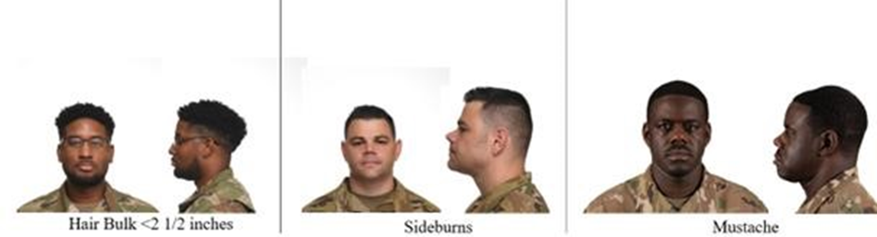

Figure 5.2. Male – Unauthorized Hair Examples.
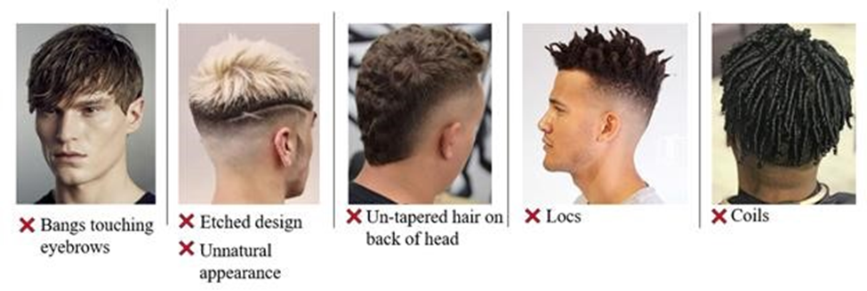

b. MUSTACHES. Male cadets may have mustaches (See Figure 5.3); however, they will be conservative and will not extend downward beyond the lip line of the upper lip or extend sideways beyond a vertical line drawn upward from both corners of the mouth.

Figure 5.3. Mustache.
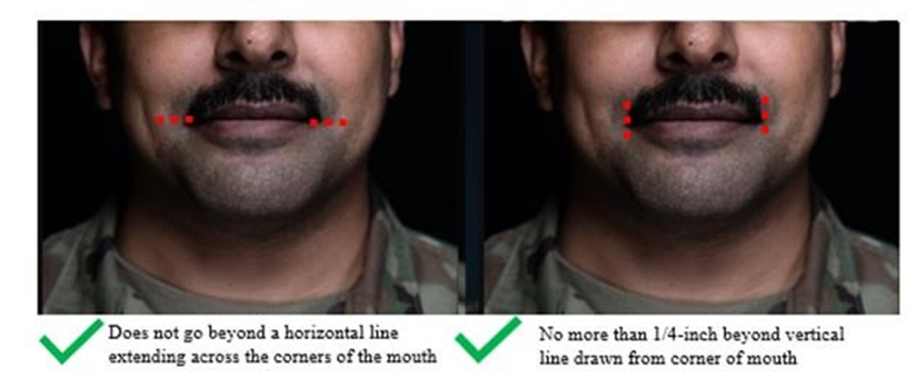

c. BEARDS. Beards are not authorized unless for medical reasons, when authorized by a medical official, or as authorized pursuant to a request for a religious accommodation. Beard wear authorized for
religious reasons are governed by AFJROTCI 36-2001. When authorized for medical reasons, members will keep all facial hair trimmed not to exceed ¼ inch in length. Individuals granted a shaving
profile may shave or trim their facial hair to present a neat, clean, professional image.

d. SIDEBURNS. Will be neatly trimmed in the same manner as the hair; must not extend beyond the bottom of the ear opening; must be straight and even in width; and end with a clean shaven, horizontal line.

e. SHAVE. Cadets must be clean-shaven when wearing the uniform. Mustaches, if worn, must be neatly trimmed and cannot extend downward over the lip line or past the corners of the lip. Handlebar mustaches are not authorized. Beards or goatees are not authorized. Any medical concerns must be address with the SASI/ASI.

f. JEWELRY. Male cadets are NOT authorized to wear earrings while in uniform. Body piercings are NOT allowed when in the AFJROTC uniform or engaged in AFJROTC related activities. Earrings will not be worn while in uniform. You may wear a maximum of three rings on both hands combined (EXCEPTION: No thumb rings are authorized). One conservative wristwatch is authorized, and one bracelet is permitted if it is neat and conservative and not wider than ½-inch. Cadets may wear conservative sunglasses, except while in military formation. Necklaces must be concealed; not visible.
g. FINGERNAILS. Male cadets are NOT authorized to wear nail polish.

h. COSMETICS. Male cadets are NOT authorized to wear cosmetics.

5.6. FEMALE PERSONAL APPEARANCE.

a. FEMALE HAIR. No minimum hair length, to a maximum bulk of 4 inches from scalp and allows proper wear of headgear (See Figure 5.4). Hair will end above the bottom edge of collar and will not extend below an invisible line drawn parallel to the ground, both front to back and side to side unless pulled back and secured or worn in an authorized ponytail or equivalent or long braid(s) (See Figure 5.6). If hair is pulled back and secured behind the head, radius will not exceed 6 inches from the point where the hair is gathered (i.e., no more than 6 inches to the left and 6 inches to the right, 12 inches total width; and 6 inches protruding from where hair is gathered) and must allow for proper wear of headgear. One or two braids or a single ponytail or equivalent may be worn down the member’s back with length not extending below a horizontal line running between the top of each sleeve inseam at the under arm through the shoulder blades. The braid(s) or ponytail or equivalent cannot be worn over the shoulder or pulled in front of the body. They shall extend down the member’s back (See Figure 5.7). Bangs, or side-swiped hair, may touch eyebrows but will not touch or cover eyes. When in doubt, assess correct length of hair with the cadet standing in the position of attention. Exception: While wearing the Physical Training Gear (PTG), long hair will be secured but may have loose ends and may extend below a horizontal line running between the top of each sleeve inseam at the under arm through the shoulder.

1. Pinned-up hair should be styled in a manner that prevents loose ends from extending upward on the
head. When hair is in a bun, the bun must be a single bun, all loose ends must be tucked in and secured.
When hair is in a ponytail or equivalent, it must be a single ponytail or equivalent that does not extend
below a horizontal line running between the top of each sleeve inseam at the under arm through the
shoulder blades.

2. Locs, braids, twists, micro-braids, French braids, Dutch braids and cornrows are authorized (See Figure
5.5). Locs are defined as portions of hair that have been intentionally or unintentionally fused together
to form a lock or Locs. A braid or twist is two or more portions of interwoven hair. If adding additional
hair, it must be a natural-looking color (similar to the individual's hair color) and conservative
(moderate, being within reasonable limits; not excessive or extreme). Multiple Locs, braids, twists or
cornrows may come together down the back in one or two braids or a single ponytail. Hair must not
exceed length and bulk standard and headgear must fit properly.

3. All Locs, braids, and twists, when worn will be of uniform dimension, no wider than one inch, with
natural spacing between the Locs, braids, and twists and must be tightly interwoven to present a neat,
professional and well-groomed appearance. When worn, multiple Locs, braids, or twists shall be of
uniform dimension, small in diameter (approximately ¼ inches), show no more than ¼ inch of scalp
between the Locs, braids, or twists and must be tightly interwoven to present a neat, professional
appearance.

4. A braid/twist must continue to the end of the hair without design and following the contour of the
head, and may be worn loose or in a secured style within hair standards. Exception: Micro-braids or
twists are not required to continue to the end of the hair.

5. UNAUTHORIZED: Mohawk, mullet, or etched design (See Figure 5.9).
6. HAIR ACCESSORIES. If worn, hair accessories (e.g., fabric scrunches, hairpins, combs, clips,
headbands, elastic bands, barrettes, etc.) must match hair color. Black hair accessories are authorized
regardless of hair color. Invisible hairnets are authorized; hairnet must match hair color. Hair must still
comply with bulk and appearance standards. Headgear must fit properly. Headbands or fabric scrunches
will not exceed two inches in width. Ornaments are not authorized (i.e., ribbons, beads, jeweled pins).

Figure 5.4. Female Hair Examples.

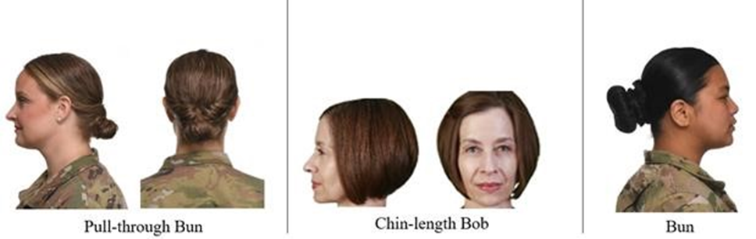

Figure 5.5. Authorized Female Hair Styles Examples of Locs, Braids, and Cornrows.

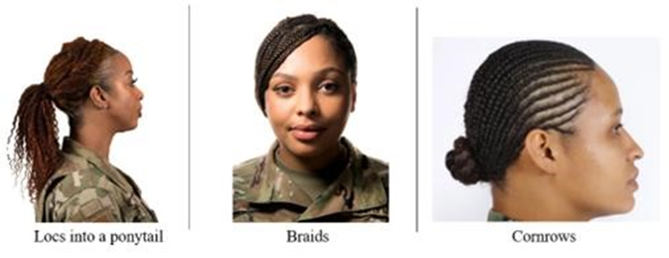

Figure 5.6. Authorized Ponytails/Equivalent and Long braid(s) Hair Styles Examples.



Figure 5.7. Ponytail/Braid Length.

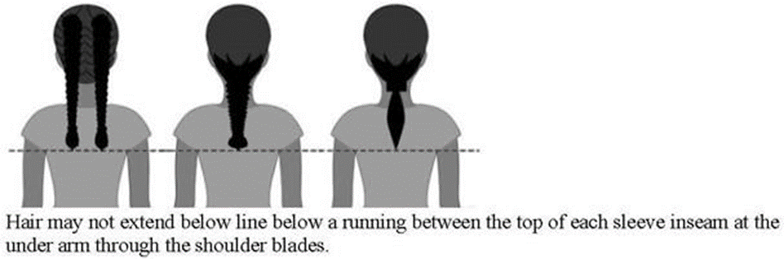

Figure 5.8. Unauthorized Ponytails.

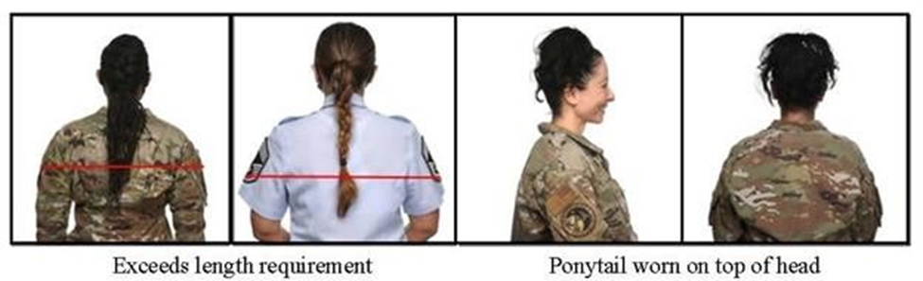

Figure 5.9. Female – Unauthorized Hair Examples.
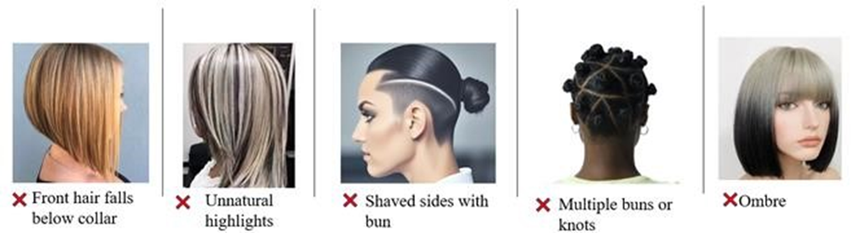

b. JEWELRY. One bracelet is permitted if it is neat and conservative and not wider than ½-inch. You may wear a wristwatch and one pair of earrings. Earrings can be gold, silver, diamond, or pearl stud earrings.
Earrings must be spherical or of plain design. No earrings may extend or dangle below the bottom of the
earlobe. You may wear a maximum of three rings on both hands combined (EXCEPTION: No thumb
rings are authorized). Cadets may wear conservative sunglasses, except while in military formation.
Necklaces must be concealed under collar or undershirt; not visible.

c. FINGERNAILS (See Figure 5.10). If worn by females, nail polish will be a single color that does not detract from the uniform, nor can the nail polish be extreme in color. Some examples of extreme colors include, but are not limited to, purple, gold, blue, black, bright (fire engine) red and florescent colors. Do not apply designs to nails or apply two-tone or multi-tone colors; however, white-tip French manicures are authorized. Fingernails must not exceed ¼ inch in length beyond the tip of the finger and must be clean and well groomed. Fingernails must not interfere with the performance of assigned duties. Fingernails must not
hinder proper fit of prescribed safety equipment or uniform items.

Figure 5.10. Authorized and Unauthorized Nail Polish Colors (Not All-Inclusive).

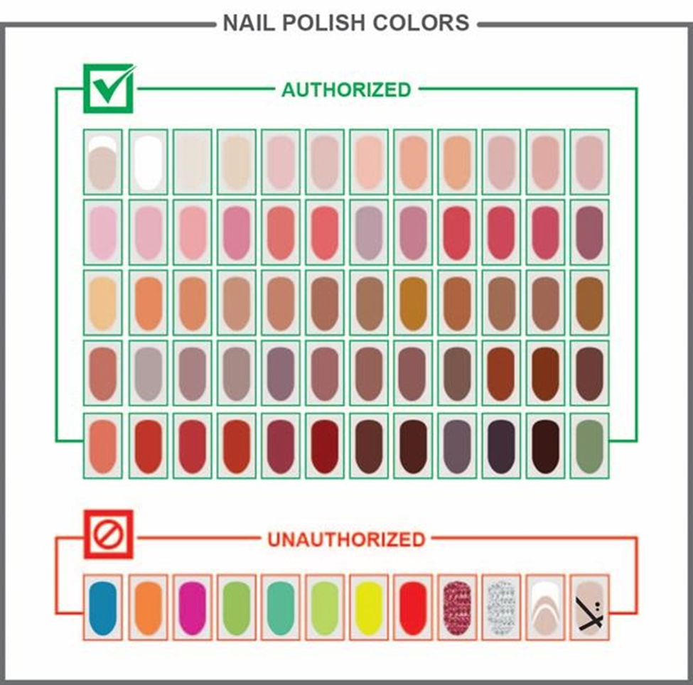

d. EARRINGS. Female cadets may wear small (not exceeding six mm in diameter) conservative (moderate,
being within reasonable limits; not excessive or extreme) round or square white diamond, gold, white
pearl, or silver earrings as a set with any uniform combination. If member has multiple holes, only one
set of earrings are authorized to be worn in uniform and will be worn in the lower earlobes. Earrings
will match and fit tightly without extending below the earlobe unless the piece extending is the connecting
band on clip earrings. When not wearing earrings, male and female cadets are authorized to wear
transparent piercing spacer(s) in lower earlobes while in uniform. Transparent spacers are not
allowed in ear holes outside of the lower earlobes or any other piercing holes visible in uniform
(nose, lip, eyebrow etc.). Piercing holes will not be large enough to permit light to shine through.
e. COSMETICS. Cosmetics must be conservative, moderate, being within reasonable limits, not excessive
or extreme and in good taste. Females will not wear shades of lipstick that distinctly contrast with their
complexion, that detract from the uniform or that are extreme colors. Some examples of extreme colors
include but are not limited to, purple, gold, blue, black, bright (fire-engine) red, and fluorescent colors.
5.7. COMBAT BOOTS. When worn, they will be laced to the top with laces tucked in.

5.8. RELIGIOUS HEADGEAR. Religious headgear may be worn indoors upon the approval of the SASI, school principal, and HQ AFJROTC. Religious headgear may be worn outdoors so long as it is not visible (i.e., the standard issue Air Force cap must conceal any religious headgear).

5.9. OTHER RELIGIOUS ITEMS. Religious items (other than headgear) will not be visibly worn with any AFJROTC uniform unless written permission is granted by the SASI, the school principal, and HQ AFJROTC.

5.10. TATTOOS OR BRANDS. Whether you are in or out of uniform, tattoos or brands anywhere on the body are not allowed if they are obscene or if they advocate sexual, racial, ethnic, or religious discrimination. Tattoos or brands that might harm good order and discipline or bring discredit upon the Air Force are also barred, whether you are in or out of uniform.

a. Excessive tattoos or brands, even though they do not violate the prohibitions in the above paragraph, will not be exposed or visible on the hand, neck, face, tongue, lip or scalp.

b. The SASI may exercise discretion if a new cadet arrives with a tattoo that may not be in full compliance with the above guidance. The tattoo may be covered up with a skin-colored bandage while in uniform and still participate in the program. However, tattoos and brands should be discouraged. The cadet should be counseled on the fact that tattoos and brands may preclude him or her from serving in the military.

5.12. BODY PIERCING. Cadets in uniform are not allowed to attach or display objects, articles, jewelry, or ornamentation to or through the ear, nose, tongue, or any exposed body part (including anything that might be visible through the uniform). Female cadets in uniform, however, are allowed to wear conservative earrings, pierced or clip style, in their earlobes.

PERSONAL APPEARANCE INSPECTION
(Reference NC-948 Cadet Handbook, Chapter 5)
FLIGHT: DATE:
Name | Best Dressed | 2 point deduction | 5 point deduction | 10 point deduction | 15 point deduction | TOTAL | Legend
2 point deductions
2a – Buttons missing/unfastened
2b – Lint/Strings
2c – Small spot(s) on uniform
2d – Rank position

5 point deductions
5a – Earrings
5b – Hair Ornaments
5c – Jewelry
5d – Makeup
5e – Nails
5f - Wrong/No socks
5g – Shoe Laces Out
5h – Military bearing
5i – Missing badge/pin
5j – Pants not bloused

10 point deductions
10a – No Nametag
10b – Uniform soiled/badly
wrinkled
10c – Wrong Uniform
10d – Wrong T-Shirt/No T-Shirt
10e – No belt

15 point deductions
15a – Hair touching ears,
Bulky and excessively long
15b – Inappropriate hair color
15c – Hair, Facial

NC-948 Form 5, Aug 2023
Flight inspected by: Approved by SASI/ASI:_______
Figure 5.11. Personal Appearance Inspection
Chapter 6
AWARDS AND DECORATIONS
6.1. Philosophy. A number of distinctive awards are authorized for AFJROTC cadets in recognition of outstanding performance in academics, leadership, or for specific displays of valor. AFJROTC awards and national awards are authorized by the AFJROTC Reference Guide and are presented to cadets selected by the SASI and approved by the principal. Awards will be presented at appropriate ceremonies and families and friends of recipients will be invited to attend.
- Awards, decorations, and devices are earned.
- Cadets are required to wear all awards, decorations and devices that go on the uniform.
- Special Orders authorizing the wear of awards, decorations and devices are issued only after the SASI/ASI have made the best determination possible. Their determination is based on corps recommendations, available information, cadet performance, bearing and behavior.
- Cadets wearing awards, decorations, or devices that they have not been appropriately awarded are violating the Cadet Honor Code.
6.2. MEDALS, RIBBONS AND OTHER AWARDS
- Air Force Junior ROTC cadets may earn a variety of medals, ribbons, and other awards. The Air Force imposes several limitations and restrictions on the presentation of medals and ribbons to maintain their prestige and validity. Active duty, guard, and reserve ribbons, medals and badges are not permitted on cadet uniforms. However, certain devices of the Civil Air Patrol are authorized.
- You may only wear medals, ribbons, clusters, cords, badges, and any other insignia that has been specifically authorized by the SASI through a Special Order. Medals may be worn simultaneously with ribbons during formal, semi-formal, and special occasions as determined by the SASI.
- Bronze oak leaf clusters are used to designate the second or subsequent award of ribbons that do not include a star as part of the ribbon. When a fifth bronze oak leaf cluster is awarded, a silver oak leaf cluster will be used in lieu of the five bronze oak leaf clusters. If the combination of silver and/or bronze oak leaf clusters exceeds four, a second ribbon will be worn. When future awards reduce the number of oak leaf clusters so that they will fit on one ribbon, the second ribbon will be removed.
- Silver oak leaf clusters are worn to the left of bronze oak leaf clusters (as viewed by an observer) on the same ribbon. A maximum of four oak leaf clusters (bronze and/or silver) will be worn on a ribbon at one time. Oak leaf clusters are tilted downward to the wearer’s right to allow the maximum number of clusters on the ribbon. The bronze and silver oak leaf clusters are provided by the Air Force.
- All medals and ribbons authorized by Air Force Junior ROTC, the Junior ROTC programs of the other services and the Civil Air Patrol are rank-ordered and will be worn in a specified manner. These ribbons are worn from left to right, top to bottom, with the highest in the top left position and the lowest at the bottom right position, as viewed by an observer.
6.3. NATIONAL ORGANIZATION-SPONSORED AWARDS. A list of the requirements for National Awards is outlined below. To be eligible, a cadet must meet all requirements, whether it is for academic or moral standing. Award criteria listed below is for general guidelines only. See current AFJROTC Reference guide for more details.
- Gold Valor Award -- Awarded to recognize the most outstanding voluntary acts of self-sacrifice and personal bravery by a cadet involving conspicuous risk of life above and beyond the call of duty. The award consists of a medal, ribbon, and certificate. Recommendations for this award must be forwarded to HQ-OpsSupport@afjrotc.com for review and approval within six months of the incident.
- Silver Valor Award -- Awarded to a cadet for a voluntary act of heroism which does not meet the risk-of-life requirements of the Gold Valor Award. The award consists of a medal, ribbon, and certificate. Recommendations for this award must be forwarded to HQ-OpsSupport@afjrotc.com for review and approval within six months of the incident.
- Cadet Humanitarian Award -- Recognizes cadets who provide aid in response to a singular extraordinary event such as a natural disaster or other catastrophe that has placed or has the potential to place a hardship on their fellow citizens. This award is not to be used to recognize day-to-day service in the community. The award consists of a ribbon and certificate. Recommendations for this award must be forwarded to HQ-OpsSupport@afjrotc.com for review and approval within six months of the incident.
- Community Service with Excellence Award -- Recognizes those individual cadets who provide significant leadership in the planning, organizing, directing, and executing of a major unit community service project that greatly benefit the local community. This is not an award given to participants but to the key leader(s) of the project. The award consists of a ribbon and certificate. Recommendations for this award must be forwarded to HQ-OpsSupport@afjrotc.com for review and approval within six months of completion of the project.
- Air Force Association (AFA) Award -- This AFA-sponsored award consists of a medal and ribbon and is presented annually at each unit to the outstanding AS-5/6 (junior) cadet. The award recipient must possess/meet the following personal characteristics and eligibility criteria:
- Positive attitude (toward AFJROTC and school)
- Outstanding personal appearance (uniform and grooming)
- Display personal attributes such as initiative, judgment, and self-confidence
- Courteous demeanor (promptness, obedience, and respect for customs)
f. Daedalian Award -- The Order of Daedalians is a fraternity of commissioned pilots from all military services. It is named after the legendary figure, Daedalus, and was organized by WWI military pilots who sought to perpetuate the spirit of patriotism, love of country, and the high ideals of self-sacrifice, which place service to the nation above personal safety and position. This award is offered to encourage the development of these traits in cadets and to interest them in a military career. The medal is fashioned after an ancient Grecian plaque discovered by a Daedalian in the village of Lavadia, Greece and depicts Daedalus and his son Icarus fabricating their legendary wings of wax and feathers. The award includes a medal and ribbon. This annual award recognizes one outstanding AS-5/6 (junior) cadet at each unit. Each cadet must:
- Demonstrate an understanding and appreciation of patriotism, love of country, and service to the nation
- Indicate the potential and desire to pursue a military career
- Rank in the top 10% of the AS class and top 20% of the school class
g. American Legion Scholastic Award -- This award consists of a bronze or silver medal accompanied by a ribbon with a distinctive miniature attachment depicting a scholastic scroll. It is presented annually to an AS-3/4 (sophomore) or AS-5/6 (junior) cadet based on overall scholastic achievements. Each cadet must:
- Rank in the top 25% of the AS class and top 10% of the school class
- Demonstrate leadership qualities
- Actively participate in constructive student activities

h. American Legion General Military Excellence Award -- This award consists of a bronze or silver medal accompanied by a ribbon with a distinctive miniature attachment depicting a torch. This award is presented annually to an AS-3/4 (sophomore) or AS-5/6 (junior) cadet based on overall scholastic achievements. Each cadet must:
- Rank in the top 25% of the AFJROTC class
- Demonstrate outstanding qualities in military leadership, discipline, character, and citizenship
i. Daughters of the American Revolution (DAR) Award -- This award consists of a bronze medal and ribbon and is presented annually to an AS-3/4 (sophomore) or AS-5/6 (junior) cadet. Each cadet must:
- Rank in the top 25% of the AS class and top 25% of the school class
- Demonstrate qualities of dependability, good character, and adherence to military discipline
- Possess leadership ability and a fundamental and patriotic understanding of the importance of JROTC training
j. American Veterans (AMVETS) Award -- This award consists of a medal pendant and ribbon and is presented annually to one qualified cadet at each unit. Each cadet must possess individual characteristics contributing to leadership such as:
- A positive attitude toward Air Force JROTC programs and service in the Air Force
- Personal appearance (wearing of the uniform, posture, & grooming, but not physical characteristics
per se)
- Personal attributes (initiative, dependability, judgment and self-confidence)
- Officer potential (capacity for responsibility, adaptability, and maintenance of high personal standards)
- Obtained a grade of "A" in their AS class
- Be in good scholastic standing in all classes at the time of selection and at the time of presentation
k. Reserve Officers Association (ROA) Award -- This award consists of a bronze medal, ribbon, and certificate and is presented annually for military and academic achievement to an outstanding AS-3/4 (sophomore) or AS 5/6 (junior) cadet. Each cadet must possess individual characteristics contributing to leadership such as:
- Positive attitude toward the AS curriculum
- Outstanding personal appearance (wear of the uniform, posture, and grooming)
- Attributes of initiative, judgment, and self-confidence
- Courtesy (promptness, obedience, and respect)
- Growth potential (capacity for responsibility, high productivity, adaptability to change)
- Demonstrate the highest personal and ethical standards and strong positive convictions
- Rank in the top 10% of the AS class
- The Military Order of World Wars (MOWW) Award -- This award consists of a bronze medal pendant, certificate, and ribbon and is presented annually to an outstanding cadet who has committed to continue the aerospace science program the following school year. Selection is based on outstanding accomplishments or service to the AFJROTC unit.
- The Military Officers Association of America (MOAA) Award -- This award, formerly known as The Retired Officers Association Award, consists of a medal pendant with ribbon and is presented annually to an outstanding AS-5/6 (junior) cadet who shows exceptional potential for military leadership. Each cadet must:
- Be a member of the junior class, in good academic standing, and of high moral character
- Show a high order of loyalty to the unit, school, and country
- Show exceptional potential for military leadership
n. Veterans of Foreign Wars (VFW) Award -- This award consists of a medal pendant with ribbon and is presented annually to an outstanding AS-3/4 (sophomore) or AS-5/6 (junior) cadet who is actively engaged in the AFJROTC program and who possesses individual characteristics contributing to leadership. Each cadet must:
- Have a positive attitude toward AFJROTC
- Have outstanding military bearing and conduct
- Possess strong positive personal attributes (such as courtesy, dependability, punctuality, respect, and cooperation)
- Demonstrate patriotism (being a member of the color guard or drill team) and actively promote Americanism
- Demonstrate leadership potential
- Attain a grade of "B" or better in AFJROTC with an overall average grade of "C" in all subjects for the previous semester
- Be active in student activities
- Not have been previous recipients of this award
o. National Sojourners Award -- This award consists of a ribbon, medal pendant, and certificate. It is presented annually to an outstanding AS-3/4 (sophomore) or AS-5/6 (junior) cadet who contributed the most to encourage and demonstrate Americanism within the corps of cadets and on campus. Each cadet must:
- Be in the top 25% of their academic class
- Encourage and demonstrate ideals of Americanism
- Demonstrate potential for outstanding leadership
- Not have previously received the award
p. Sons of the American Revolution (SAR) Award -- This award consists of a bronze medal with ribbon and recognizes an outstanding AS-3/4 (sophomore) or AS-5/6 (junior) cadet who is enrolled in the AFJROTC program. The recipient must exhibit a high degree of leadership, military bearing, and all- around excellence in AS studies and have not previously received the award. Each cadet must:
- Be currently enrolled in the AFJROTC program
- Be in the top 10% of the AFJROTC class and top 25% of the school class
q. Scottish Rite, Southern Jurisdiction Award -- This award consists of a medal, ribbon, and certificate that annually recognizes an outstanding AS-3/4 (sophomore) or AS-5/6 (junior) cadet. Each cadet must:
- Contribute the most to encourage Americanism by participation in extracurricular activities or community
projects
- Demonstrate academic excellence by being in the top 25% of the class
- Demonstrate the qualities of dependability, good character, self-discipline, good citizenship, and patriotism
- Not have been a previous recipient of this award
r. Military Order of the Purple Heart (MOPH) Award -- This award consists of a medal pendant with a ribbon and annually recognizes an outstanding AS-3/4 (sophomore) or AS-5/6 (junior) cadet who is enrolled in the AFJROTC program and demonstrates leadership ability. Each cadet must:
- Have a positive attitude toward AFJROTC and country
- Hold a leadership position in the cadet corps
- Be active in school and community affairs
- Attain a grade of "B" or better in all subjects for the previous semester
- Not have been a previous recipient of this award
s. Air Force Sergeants Association (AFSA) Award -- This annual award consists of a medal pendant with a ribbon and recognizes an outstanding AS-3/4 (sophomore) or AS-5/6 (junior) cadet. The recipient must demonstrate outstanding qualities in military leadership, discipline, character, citizenship. Each cadet must:
- Be in the top 25% of the AFJROTC class
- Demonstrate outstanding qualities in military leadership, discipline, character, and citizenship
- Not have been a previous recipient of this award
- Tuskegee Airmen Incorporated (TAI) AJFJROTC Cadet Award -- This award consists of a ribbon and certificate and is presented annually to two cadets. Cadets must:
- Attain a grade of “B” or better in the AS class
- Be in good academic standing
- Actively participate in cadet corps activities
- Participate in at least 50% of all unit service programs

- The Retired Enlisted Association (TREA) Award -- This award consists of a medal set with ribbon and a certificate and is awarded for exceptional leadership to the most outstanding AFJROTC cadet while serving in an enlisted rank. The selected enlisted cadet must have shown outstanding leadership throughout the course of the school year.
- The Celebrate Freedom Foundation Award -- This award consists of a certificate and ribbon and is presented annually to an outstanding AS-AS-1/2 (freshman) or AS-3/4 (sophomore) cadet for outstanding performance in academics and cadet corps activities.

- National Society United States Daughters 1812 Award. Awarded annually, at the SASI’s discretion, for academic excellence, leadership, military discipline, dependability, patriotism and upright character in speech and habits. This award consists of a ribbon, medal and certificate.
- Air Commando Association Award. Awarded annually at the SASI’s discretion for completing a one page essay based on a historical AF Special Operations Mission possessing the thirteen critical attributes of success: integrity, self-motivation, intelligence, self-discipline, perseverance, adaptability, maturity, judgment, selflessness, leadership, skilled, physical fitness and family strength. This award consists of a ribbon and certificate.
6.4. AIR FORCE JUNIOR ROTC-SPONSORED RIBBONS

a. Distinguished Unit Award (DUA) -- Awarded to cadets enrolled during the academic year when a unit is selected by HQ AFJROTC to receive the DUA or DUA with Merit. The criteria for the Distinguished Unit Award is the timely submission of both the cadet developed/written unit goals and the cadet developed/written unit impact associated with their goals. If the unit meets these criteria, they will receive the Distinguished Unit Award, which consists of a congratulatory letter, a certificate of recognition, and a streamer which will be posted in WINGS. The DUA ribbon is ordered through EMALL.

- If DUA is won by unit in multiple years, then consecutive awards are denoted by single oak leaf clusters for each additional award.

- If during a Unit Evaluation the JROTC unit receives an “Exceeds Standards” as the overall evaluation and is identified by HQ AFJROTC as a unit “with merit”, then unit is authorized to wear a silver star on the ribbon.

b. Outstanding Organization Award (OOA) – Awarded to cadets enrolled during the academic year when a unit is selected by HQ AFJROTC to receive the OOA. The Outstanding Organization Award consists of a congratulatory letter and a certificate of recognition, which will be posted in WINGS. The OOA ribbon is ordered through EMALL. OOA recipients do not receive a streamer.
c. Outstanding Flight Ribbon -- Awarded each academic term to cadets in a flight designated Outstanding Flight. Criteria normally include academic grades, uniform wear, homework, attendance, conduct, and involvement in corps activities.

d. Top Performer Award -- The Cadet Top Performer Award is a Headquarters, AFJROTC award presented to a maximum of 2% of the current unit cadet corps population (unduplicated headcount). All currently enrolled cadets may be considered. Specific consideration is given to cadets not previously recognized for superior performance. The award recognizes a cadet’s performance in the following key areas: (1) Leadership and job performance: in primary duty and specifically in preparation for the unit’s annual assessment. (2) Leadership qualities: involvement and positions held in extracurricular activities. (3) Academic performance: nominee must be in good academic standing in all high school course work. (4) Significant self-improvement. (5) Community involvement. (6) Other accomplishments. SASIs may nominate candidates to their respective Area Administrator. Area Administrators will present awards to nominees during their visit unless personal observation of the cadet warrants otherwise. SASIs may select recipients and present award in years that unit does not receive AA visit. Ribbons will be available from HQ AFJROTC and distributed to the Area Administrators for presentation. The award consists of a certificate and a ribbon, which may be presented by the Area Administrator during the visit or the SASI if the cadet(s) is unavailable due to class scheduling conflict, etc. The ribbon may be worn for the duration of a cadet’s tenure in AFJROTC.
e. Outstanding Cadet Ribbon -- Awarded annually to the cadet Airman/NCO/Officer of the Year. The recipients must be of high moral character, demonstrate positive personal attributes, display outstanding military potential, and attain academic and military excellence. Cadets must have an “A” average in AFJROTC.
f. Leadership Ribbon -- Awarded for outstanding performance in a position of leadership as an AFJROTC cadet in corps training activities. Recognition goes to cadets who have consistently displayed outstanding leadership ability above and beyond expected performance.
g. Achievement Ribbon -- Awarded to cadets for a significant achievement as deemed appropriate by the SASI. Individuals may not receive more than one ribbon during a one-year period.
h. Superior Performance Ribbon -- Awarded to Cadets at the end of each semester. Also, awarded at the SASI’s discretion for outstanding achievement or meritorious service rendered specifically on behalf of AFJROTC. Recognition goes to cadets whose achievements and services are clearly outstanding and exceptional when compared to achievements and accomplishments of other cadets.

i. Academic Ribbon -- Awarded for academic excellence at the end of each semester as signified by attaining a “B” average in AFJROTC and is on the school’s all A or A/B honor roll.
j. Leadership School Ribbon -- Awarded for completion of an approved leadership school program of at least 5 days duration. For each additional Leadership School completion, an additional Bronze Star will be awarded. Add a silver star for outstanding performance or leadership ability at a leadership school instead of the Bronze Star. Limit the Silver Star to 10 percent of the class.
k. Special Teams Competition Ribbon -- Awarded to team members for placing first, second or third place in an Air Force or Joint Service Competition to include Color Guard Teams, Rifle Teams, Drill Teams, Saber Teams, Academic Bowl Teams, CyberPatriot, etc.
l. Orienteering Ribbon -- Awarded to team members for completing unit specific Orienteering Program as part of unit curriculum.
m. Co-curricular Activities Leadership Ribbon -- Awarded at the SASI’s discretion for leadership in AFJROTC co-curricular activities (such as dining-in chairperson, military ball chairperson, etc.) The recipient must have demonstrated exceptional leadership in achieving objectives through the coordinated efforts of others. The ribbon may be awarded a maximum of four times. An oak leaf cluster should be added to this ribbon for each additional award.
n. Drill Team Ribbon -- Awarded for distinguished participation in scheduled drill team events. Cadet must have completed one school term on the drill team without suspension. An oak leaf cluster will only be awarded once for each academic year, not semester beginning with the second year.
o. Color Guard Ribbon -- Awarded for distinguished participation in at least five-scheduled color guard events (at least one with rifle and one with a flag). An oak leaf cluster is added to this ribbon for each year of qualifying membership beginning with the second year.

NOTE: Members must satisfy the practice requirements for the entire year to earn the Drill Team, Color Guard, and Special Teams Competition Ribbons. Members who drop from the team before the end of the season do not qualify.
- Saber Team Ribbon -- Awarded for distinguished participation in at least two-scheduled saber team events (Football homecoming, Military Ball, etc.) An oak leaf cluster is added to this ribbon for each year of qualifying membership beginning with the second year.

q. Marksmanship Ribbon – This unit does not have a Marksmanship Program.
r. Good Conduct Ribbon -- Awarded at the end of each semester to cadets with no out-of-school suspensions (OSS), in-school-suspension (ISS), no after school detention (ASD), and no integrity violations, insubordination, and disrespect.
s. Service Ribbon -- Awarded to cadets for distinctive performance in school, community, or AFJROTC events. Generally, Salvation Army Ring-a-Bell, adopt-a-highway litter pickup, and placing flags on veteran graves warrant a Service Ribbon for each activity. There are others that may require more service time to be awarded a ribbon. The SASI/ASI will specify before the activity if a Service Ribbon will be awarded. Cadets participating in activities such as Drill Team, Saber Team or Color Guard are ineligible to receive a Service Ribbon.
t. Health and Wellness Ribbon -- Awarded for participation in the unit’s Physical Fitness Program.
NOTE: Cadets attending Cadet Leadership School are also expected to meet the following requirements:
(1) Male: one mile run in 9 min or less.
(2) Female: one mile run in 10 min or less.
u. Recruiting Ribbon -- Awarded for outstanding effort in support of unit recruiting activities. Cadets who participate in presentations to groups of 25 or more are eligible. These presentations may occur at Northside High School or during a recruiting trip at the middle school. Cadets who can be confirmed as recruiters of at least two middle school students (non-relatives) may also be eligible. The recruited students must enroll and successfully complete a full school term for the ribbon to be awarded.
v. Activities Ribbon -- Awarded to cadets who contribute to the success of formally scheduled, school sanctioned, co-curricular activities such as military ball, dining in/out, field trips, fundraisers, parades, community service activities, and other activities as determined by the SASI/ASI. (Color Guard, Drill Team, and Special Teams participation do not apply.) It takes three activities to earn one Activities Ribbon. For each three activities completed, an oak leaf cluster is added to this ribbon.
w. Attendance Ribbon -- Awarded each semester to cadets with no more than two excused absences, no unexcused absences and no tardies in their AFJROTC class.

- Dress and Appearance Ribbon -- Awarded at the end of the semester to cadets that maintained a 90% or better on weekly uniform inspections.
- Longevity Ribbon -- Awarded for completion of each AS year. Cadet must have a passing grade

6.6. BADGES.
- Ground School Badge: Awarded for completion of the AFJROTC aviation honors ground school curriculum or successful completion of another aviation ground school program prescribed by the FAA. The badge is ordered through WINGS.
- Flight Solo Badge: Awarded to any cadet possessing a solo flight certificate signed by a FAA certified flight instructor for either powered or non-powered aircraft. The badge is ordered through WINGS.
- Pilot Certificate Badge. Awarded to any cadet who possesses a valid FAA pilot’s certificate for either powered or non-powered aircraft. The badge is ordered through WINGS.
- Awareness Presentation Team (APT) Badge: Awarded to cadets who make at least one public appearances or presentations as a member of the unit Awareness Presentation Team (APT). The badge may be worn for as long as the cadet is an active member in good standing on the APT. To obtain the badge, go to WINGS-Logistics-Create Display Orders and select Awareness Presentation Team Badge.
- Academy Modeling of Aeronautics (AMA) Wings: Awarded to cadets who are members of a local AMA chartered model airplane club. To obtain the badge, contact AMA.
- Aerospace Education Foundation (AEF) Academic Cadet Award: Awarded to rising Junior and Senior cadets for academic excellence as signified by attaining an overall 3.3 grade point average with no grade below “C” on their transcript. The individuals must be recommended by the SASI. To obtain the badge, go to WINGS-Logistics-Create Display Orders and select the badge.
- Model Rocketry Badge: Awarded to cadets who have fulfilled model rocketry program requirements. Program requirements are listed in the Model Rocketry Handbook available in WINGS-Published Files-Directory-JROTC-Instruction and Guides-Model Rocketry Handbook.
- Other Badges: Wearing badges from other services beyond their intended purpose, badges from the regular Air Force, or other organizations on the AFJROTC uniform is prohibited. Example: Unit cannot designate Army Signal Corps or Infantry badges to signify membership in the unit color guard or drill team. However, badges earned by cadets enrolled in a sister service JROTC program may be worn on the AFJROTC uniform in the location specified by the sister service. The AFJROTC badge location will always take precedence over the sister service badge.

Chapter 7
SPECIAL TEAMS
7.1. General. An important function of the NC-948 AFJROTC Group Cadet Corps is to provide an Air Force presence at various school and community functions. Many times, the cadet corps presence is accomplished by our Color Guard, Drill Team, and Awareness Presentation Team. Members of these three "teams" compete for membership and receive personal observation by the SASI/ASI and are recommended by their squadron commander and/or a group staff officer. To be eligible for selection, and to remain a member of either of these units, a cadet must meet the most rigorous standards of military bearing, behavior, and dress and appearance. They are the most visible members of the cadet corps within the community and, as such, are required to set a high standard of excellence in all their endeavors.
7.2. Color Guard.
a. Composition. A color guard is normally made up of four to five cadets depending upon the occasion. These cadets are handpicked by the SASI/ASI and Color Guard Commander/NCOIC. Selections are made only after personal observation of the individual cadets and a review of their past performance as a member of NC-948 AFJROTC. The criteria for selection are military bearing and behavior, dress and appearance, personal conduct, attitude, and drill ability. Qualified individuals can be selected at any time during the year.
- Practice. All members are expected to attend practices. Practice times and dates will be
announced in advance and will be posted on the bulletin board in the classroom. Each color guard performance will include a minimum of fifteen minutes practice on the day of the performance unless otherwise directed by the SASI/ASI.
- Performances. The color guard commander will be notified by the SASI/ASI as soon as possible of any upcoming color guard details. Color Guard members should check the Color Guard schedule to sign up for their fair share of events. Once an event is selected, you should check with your parents, bosses, etc., to make sure that there is no reason you cannot perform on the date and time posted. You then sign your name by the detail selected. Your signature indicates that on your word of honor, you will show up at the time indicated ALREADY DRESSED IN THE PROPER UNIFORM, prepared to honor your commitment. After the performance, the AFJROTC classroom will be open for a MAXIMUM of fifteen minutes for cadets to change clothes if they desire and to put away equipment. For their time and effort, Color Guard members will receive the following awards:
- After five performances, the cadet will be eligible to wear the Color Guard Ribbon.

d. Participation. The SASI/ASI will determine the number of cadets necessary for each performance. The Color Guard Commander will then notify the SASI/ASI of the names of those members who have volunteered. When necessary, the Color Guard Commander will select members to perform using a rotational system so that all members get to participate equally. As stated earlier, once selected you have made a commitment and failure to show up is a serious breach of trust. Failure to perform on any two occasions during a semester will result in your removal from the color guard and raise serious questions about your reliability and character. Only under extreme circumstances will the SASI/ASI waive this requirement.

- Prior to each performance, the color guard commander will conduct practice as necessary to ensure a flawless performance at the scheduled event. A personnel inspection will be accomplished by the commander to determine that all participants meet or exceed the standards outlined in paragraph 7.2e below.

- As a member of the color guard, you DO NOT have the right to refuse to perform when asked. If you are designated to perform and fail to perform on any two occasions during a semester, you will be removed from the color guard. Only under extreme circumstances will the SASI/ASI waive this requirement.
e. Standards. As mentioned earlier, the color guard is an elite, highly visible unit that is called upon to represent the unit and Northside High School at many community and school functions. As such, you must maintain the highest standards of military bearing and behavior, as well as dress and appearance. Your performance must always accurately reflect the fact that NC-948 AFJROTC is the best of the best. Therefore, the following guidelines will be strictly enforced WITHOUT DISCUSSION.
- Any male color guard member whose hair does not meet or exceed the standards set forth in the AFI 36-2903, will not be permitted to perform.

- All cadets are required to wear the uniform at least one day per week during the school year. Cadets who do not wear it on the designated day can make it up as outlined in paragraph 5.2b. Color guard members who fail for any reason to meet this requirement will be dismissed from the team AFTER THE SECOND OFFENSE. Just as important as wearing the uniform is the requirement for wearing it properly and maintaining it in the proper manner. Color guard members who constantly fail in either of these areas, as noted in the weekly inspection of cadets, will be dismissed from the team. YOU MUST SET THE EXAMPLE.

- Each time a competitive team participates as a unit, they are a direct reflection on the group as a whole. Therefore, conduct of any kind that does not accurately portray the NC-948 AFJROTC Group as the best of the best will not be tolerated. The military term for actions on the part of a cadet that does not meet acceptable standards of behavior is "Conduct Unbecoming of a Cadet". This includes such things as lying, cheating, stealing, fighting, starting rumors or any other action deemed inappropriate for the occasion. Remember, there is no such thing as cheating a little bit, stealing something of little or no value, or telling a little lie. Either you lie, cheat, and steal, or you don't. COMPETITIVE TEAM MEMBERS DO NOT. Conduct unbecoming of a cadet, deemed as such by the SASI/ASI, is cause for immediate dismissal from the team for the remainder of the semester.
7.3. Drill Team. The NC-948 drill team unit represents our most experienced drill members who participate in competitive drill meets.

- Composition. A drill team is made up of not less than thirteen members plus a commander. Thirteen member teams are required to participate in drill meets. ALL MEMBERS WILL BE SUBJECT TO ALL RULES AND REGULATIONS CONCERNING THE TEAM.
- Practice. Practices will be conducted after school. Practice times and dates will be announced in advance and will be posted on the whiteboard in the classroom. During each practice, the drill team commander will have the responsibility to conduct practice in a military manner. Since the sequences will have been pre-approved by the SASI/ASI and will not be changed without their approval, practice time will be devoted to practice, not a discussion or question and answer period. Practice is what is required for a team to win a competition since all scoring is based on the precision of movement demonstrated by the team. Thirteen people must move as one. Therefore, the team will never be any better than its weakest member. By nature, then, drill practice must consist of repetition followed by more repetition until each of the thirteen members coordinate their movements to the point of moving as one. You will perform at a meet at the same level at which you perform at practice. Desire, dedication, and discipline coupled with complete CONCENTRATION during practice will be rewarded with a trip to the winner's circle at the meet. Like any athletic event, drill meets are won or lost on the practice field. Poor performance on the day of a meet can always be traced back to poor practice habits. The SASI/ASI will not allow poor practice habits or poor attitudes. If you are not prepared to dedicate yourself during practice to always giving total effort, your resignation will be gladly accepted. If your idea of total effort does not correspond with those of the SASI/ASI...you lose. BE PREPARED TO WORK HARD EVERY DAY!!

- Participation. You were chosen to be a member of a competitive team not only because you asked to be considered, but also more importantly because of the potential you have displayed. The most important factors considered in determining potential are DESIRE, DEDICATION, DISCIPLINE, AND CONCENTRATION. Everything else can be taught. Now is not the time for you to relax and feel as though you "have it made". Rather, now is the time that you must prove yourself on a daily basis. Nothing less than your best effort each and every time you take the field, whether in a meet or practice, will be accepted.
- Standards. As a member of the drill team, you are expected to represent the group in many highly visible situations. As such, military bearing and behavior, as well as dress and appearance, is of utmost importance. Members of the drill team are expected to exceed the standards set for the other members of the group AT ALL TIMES. Therefore, the following guidelines as outlined in paragraph 7.2e. for the Color Guard applies to the Drill Team and will be strictly enforced.
7.4. Awareness Presentation Team – Recruiting. An additional requirement of the Awareness Presentation Team effort is to recruit new students for the cadet corps. In addition to delivering presentations at elementary and middle schools, this team is expected to tell the AFJROTC message at the high school level. They are to seek opportunities to make presentations to school clubs, during classroom settings, and during freshmen orientations. Cadets on this team must meet rigorous standards of military bearing, behavior, and dress and appearance.

Chapter 8
CADET ACTIVITIES
8.1. Co-curricular/Extra-curricular Activities: Cadet activities give an added dimension to the corps to make it more fun, entertaining, and educational. They serve to augment AFJROTC aerospace education and leadership education course requirements. It is your corps, and your involvement helps to make it stronger. Standards of conduct, academic achievement, personal behavior, uniform wear, and appearance must be routinely adhered to before a cadet will be considered for participation in co-curricular/extracurricular activities.
8.2. Cadet Staff and Corps Meetings
a. Cadet staff and corps meetings are held before drill practice, during the 10-minute break or on an as needed basis. The location of these meetings will normally be in AFJROTC Classroom.
b. The SASI or the ASI must attend all cadet corps meetings. They will attend in the capacity of advisors to support cadet staff and to ensure meetings are consistent with AFJROTC goals.
c. Unexcused absences from cadet corps or staff meetings are cause for removal from position and possible additional disciplinary action.
8.3. Color Guard, Drill Team, APT. See Chapter 7.
8.4. Service Projects. Supporting our school and community. These can include park cleanups, graffiti eradication, highway litter pickup, etc. The corps is always open to new projects.
8.5. Fundraising. NC-948 besides being a class is also a “club”, therefore we need money to support activities and projects that the Air Force and Northside High School do not fund. Two major fundraising activities will be scheduled during the school year. Types of activities for which funds will be used are:
- Military Ball, Dining Out, Awards Banquet/Brunch, etc.
(b) Field Day, Drill Meets, Picnics, etc.
- Drill Team, Color Guard, APT supplies/equipment.
8.6. Model Rocketry Program: The model rocketry program involves the designing, building and flying model rockets that are made of paper, plastic, balsa wood or other suitable lightweight material. The model rocketry club is organized in accordance with AFJROTCI 36-2001. The program may be offered throughout the school year. Cadets must have parental/guardian permission in order to participate. Cadets must complete all requirements of AFROTCI 36-16, paragraph 18 to be awarded the Model Rocketry Badge.
8.7. AFJROTC Static Model Program: Static models are nonflying models that can be built from commercial kits. They are usually made from styrene plastic, although some wooden and paper kits are available.

8.8. Military Ball: A formal military dinner and dance for cadets and their guests. It is held once a year. The dress for male cadets will be the service dress uniform (suit coat and tie) with medals. Male cadets will not wear tuxedo shirts or bow ties with the uniform. Male guests of female cadets must wear suit or coat and tie. Tuxedos are also permitted for non-cadet males. No tennis shoes may be worn to the Ball. Female cadets may wear Sunday dress, cocktail dress, or ball gown. Dresses must comply with Northside High School prom guidelines.
8.9. Field Day (Optional): A military-styled activity day held once a year for cadets, usually in conjunction with other JROTC units. Cadets must be eligible for a field trip if Field Day is held during school hours. Safety, sportsmanship, and camaraderie are emphasized. Activities include sports, games and other events designed to give every participating cadet an opportunity to have fun. Field Day normally lasts most of the day and usually includes a picnic.
8.10. Awareness Presentation and Recruiting Team (APRT):
a. The APRT team makes presentations at local middle and elementary schools. The presentations are three to seven minutes in length on topics about drug abuse, dropping out of school, avoiding fights, issues facing society etc. The presentations are made without questions and answer sessions (those are reserved for the recruiting trips). See Chapter 7.
b. The most important duty of the APRT is to help increase our cadet corps membership through recruiting. Recruiting is mainly conducted through visits to middle schools, Northside High’s Open House, and cadets recruiting other students one-on-one. A recruiting team made up of three to six cadets and the ASI or SASI conducts recruiting visits. Cadets must be nominated by senior cadet staff and approved by the SASI/ASI in order to be on the recruiting team. Cadets participating in recruiting visits to schools will be awarded a Recruiting Ribbon at the end of the school year. The Awareness and Presentation Team is tasked to lead NC-948’s recruiting efforts.
- Open House involves cadets, ASI and SASI working to increase AFJROTC awareness by staffing a table in the main Northside High School academic building and manning the NC-948 facility. Literature on AFJROTC is passed out to interested parents and students and questions are answered about AFJROTC. Tours of the NC-948 facility are offered.
- One-on-one recruiting is the most powerful way to keep NC-948’s enrollment healthy. Every cadet should consider himself or herself to be a recruiter. Asking a friend to join should be easy if you believe in the AFJROTC program. Each cadet who gets a student to enroll in NC-948 earns a Recruiting ribbon with confirmed registration.
8.11. Parade: The Belhaven and Bath Christmas Parades and the Veterans Day ceremonies are very visible public relations activities. They give the NC-948 cadets exposure to more people on these two occasions than they will receive all year from any other activity. These parades are an opportunity for
NC-948 to display their marching and drill skills, appearance, discipline, Northside High School spirit and corps pride. Each cadet is expected to participate in these parades.
8.12. Field Trips. Field trips are taken to enhance the cadets’ morale and awareness of the “Real World” job opportunities. Trips are taken to military bases, civilian airports, and educational sites. Trip requirements:
- Parental Permission Slip.
- Meet AFJROTC personal grooming standards.
- Meet Northside High School’s minimum eligibility requirements as outlined in the student handbook.

8.13. Cadet Leadership Course. NC-948 cadets have an opportunity each summer to attend the Cadet Officer Leadership School at Fayetteville State University or other designated school. Attendance teaches cadets aspects of citizenship and leadership in a highly structured and focused instructional environment. The week-long training is designed to prepare cadets for leadership roles in their units, schools, and local communities. As such, the activities during CLC stress the following: team building, leadership, respect for authority, time management, responsible citizenship, personal character, academic achievement, health, and community service. Only NC-948 cadets in good standing and physical fitness are eligible to attend.
8.14. Awards Ceremony. Held annually to recognize outstanding cadets for their efforts during the school year. Local awards and AFJROTC/national awards are presented in accordance with AFJROTCI 36-2001.
8.15. Color Guard. This is a special team’s unit, which carries and presents the U.S. and North Carolina flags at parades, school and civic events. Practice is usually held one or two days a week and just prior to each performance. Cadets who achieve proficiency in color guard procedures will be authorized to wear the color guard cord. See performance requirements in Chapter 7.
8.16. Drill Team. Much extra effort is required in this activity. Here is a chance to "polish" the basic skill learned in Drill and Ceremonies classes. After school practice, learning the manual-of-arms, extreme concentration, complete compliance with the commands of the team commander, extra care of uniforms and personal grooming standards, a desire for public exhibition and recognition, and competition will limit this activity to only our best cadets. Also, see chapter 7.

8.17. Physical Fitness. The goals of the NC-948 physical fitness program is to develop an appreciation of lifelong physical fitness, and encourage physical fitness goals beyond the minimum.

Chapter 9
RESERVE CADET PROGRAM
9.1. Purpose. The purpose of the “Reserve Program” is to provide some training continuity for the first-year cadets and opportunity for all other cadets, who desire, to continue to participate in the AFJROTC Co-curricular activities.
9.2. Applicability. This program is voluntary for all cadets who cannot enroll in AFJROTC during any given school semester or school year. You must be enrolled in one semester or a previous school year to be in the reserve program. This program will offer no academic credit for the participating cadets. Reserve cadets are attached to the first period class for accountability purposes and uniform inspection.
9.3. Requirements. Cadets wishing to join this program will:
- Have successfully completed at least one semester or a previous school year of AFJROTC at
NHS.
- Obtain prior written parental approval and agree to follow the program’s guidelines.
- Pay any costs associated with the co-curricular activities they wish to participate.
- Participate in any fundraising project while they are in the program.
- Keep one set of issued uniform (one pair of pants, one shirt/blouse, a tie/tab, a windbreaker,
and a service dress coat).
- Wear the uniform every uniform day. Failure to wear the uniform three or more times in a
semester voids the student’s reserve status. It is the student’s responsibility to present
themselves to an instructor each week for inspection and certification that the uniform
requirement is being satisfied.
- Be “attached/assigned” to a current-semester flight for formations and any co-curricular
activities they participate.
- Be eligible to earn ribbons the same as active cadets.
- Be eligible to participate as a member of the Drill Team and Color Guard. They must meet
all the requirements pertaining to the selected team.
- Turn-in all uniform items at the end of the annual school year/semester.

9.4. Incentives and Rewards. Cadets who participate in this program will be able to maintain a high level of proficiency in drill and the wear of the uniform. Cadets will be able to wear their new rank and ribbons received during the previous semester’s final promotions and awards banquets. Reserve cadets will have an opportunity to interact with all cadets year-round, thus, obtaining a greater “name recognition” within the corps. Participating in the Reserve will be annotated on each cadet’s official AFJROTC Cadet Record. Finally, Reserve cadets will be able to participate in any of the AFJROTC co-curricular activities without being enrolled in the AFJROTC program. They will also be able to hold positions within the corps (as long as they can put in the time before or after school to do the job) and compete for promotions just as if they were an active cadet enrolled in AFJROTC.

CADET CREED

I am an Air Force Junior ROTC Cadet.
I am connected and faithful to every Corps of Cadets
who served their community and nation with patriotism.
I earn respect when I uphold the Core Values of Integrity First,
Service Before Self, and Excellence in All We Do.
I will always conduct myself to bring credit to my family, school,
Corps of Cadets, community, and to myself.
My character defines me. I will not lie, cheat, or steal.
I am accountable for my actions and deeds.
I will hold others accountable for their actions as well.
I will honor those I serve with, those who have gone before me,
and those who will come after me.
I am a Patriot, a Leader, and a Wingman devoted to those
I follow, serve, and lead.
I am an Air Force Junior ROTC Cadet.

Attachment 1

THE AIR FORCE SONG  Off we go into the wild blue yonder,  Climbing high into the sun;  Here they come zooming to meet our thunder, At ‘emboys, giv’er the gun!  Down we dive spouting our flame from under, off with one hell-uv-a-roar!  We live in fame or go down in flame,  Nothing’ll stop the U.S. Air Force! | THE STAR SPANGLED BANNER  O say, can you see, by the dawn’s early light, what so proudly we hailed at the twilight’s last gleaming,  Whose broad stripes and bright stars, thro’ the perilous fight,  O’er the ramparts we watched, were so gallantly streaming?  And the rockets’ red glare, the bombs bursting in air  Gave proof thro’ the night that our flag was still there.  O say, does that Star-spangled banner yet wave  O’er the land of the free and the home of the brave?  O thus be it ever when free men shall stand  Between their loved homes and the war’s desolation.  Blest with victory and peace, may the heaven rescued land  Praise the Power that hath made and preserved us a nation!  Then conquer we must, when our cause it is just;  And this be our motto: “In God is our trust!”  And the Star-spangled Banner in triumph shall wave  O’er the land of the free and the home of the brave.

Attachment 2

MILITARY TIME & PHONETIC ALPHABET

TIME |  | THE PHONETIC ALPHABET
Civilian | Military
1:00 a.m. | 0100 | A | Alpha
2:00 a.m. | 0200 | B | Bravo
3:00 a.m. | 0300 | C | Charlie
4:00 a.m. | 0400 | D | Delta
5:00 a.m. | 0500 | E | Echo
6:00 a.m. | 0600 | F | Foxtrot
7:00 a.m. | 0700 | G | Golf
8:00 a.m. | 0800 | H | Hotel
9:00 a.m. | 0900 | I | India
10:00 a.m. | 1000 | J | Juliet
11:00 a.m. | 1100 | K | Kilo
12:00 noon | 1200 | L | Lima
1:00 p.m. | 1300 | M | Mike
2:00 p.m. | 1400 | N | November
3:00 p.m. | 1500 | O | Oscar
4:00 p.m. | 1600 | P | Papa
5:00 p.m. | 1700 | Q | Quebec
6:00 p.m. | 1800 | R | Romeo
7:00 p.m. | 1900 | S | Sierra
8:00 p.m. | 2000 | T | Tango
9:00 p.m. | 2100 | U | Uniform
10:00 p.m. | 2200 | V | Victor
11:00 p.m. | 2300 | W | Whisky
12:00 Midnight | 2400 | X | X-Ray
 |  | Y | Yankee
 |  | Z | Zulu

Attachment 3
AIR FORCE JUNIOR ROTC INSIGNIA
CADET OFFICER RANK

C/Second C/First C/Captain C/Major C/Lieutenant C/Colonel
Lieutenant Lieutenant Colonel
NOTE: Cadet Officer rank used is either cloth epaulet or collar rank, depending on specific uniform worn.
CADET ENLISTED RANK
(No Insignia) | 
C/Airman C/Airman C/Airman First C/Senior C/Staff
Basic Class Airman Sergeant

C/Technical C/Master C/Senior C/Chief
Sergeant Sergeant Master Master
Sergeant Sergeant

NOTE: Cadet Enlisted rank used is small collar rank only, regardless of uniform worn.

Rank insignia not listed here is unauthorized. The First Sergeant device is not authorized.

Attachment 4

AUTHORIZED AIR FORE JROTC
BADGES/INSIGNIA/PINS

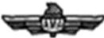

ACADEMY OF

MODEL AEROOAUTICS

S LVER WINGS

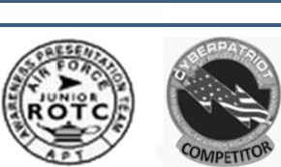



KITTY HAWK AIR SOCIETY BADGE

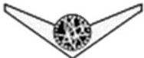
GROUND SCHOOL.
BADGE


DISTINGUISHED CADET BADGE

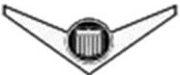
FLIGHT SOLO
BADGE

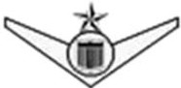
FLIGHT CERTIFICATE
BADGE

AEFBADGE
(OLD)

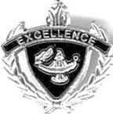

AEFBADGE
(NEW)

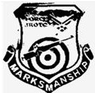

Marksmanship
Shield

AWARENESS
PRESENTAT-ION TEAM

Cyber Patriot
Badge

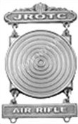
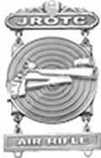
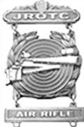
MARKSMANSHIP SHARPSHOOTER EXPERT

(Choose one only. Follow APT placement criteria. May NOT wear Marksmanship Shield and a Marksmanship Badge)
(Choose one. Placed directly underneath ribbons. May NOT wear Marksmanship Shield and Marksmanship Badge)

Badges/Insignia/Pins not listed here are unauthorized

Attachment 5
Attachment 6

(50)
CADET OCP
UNISEX
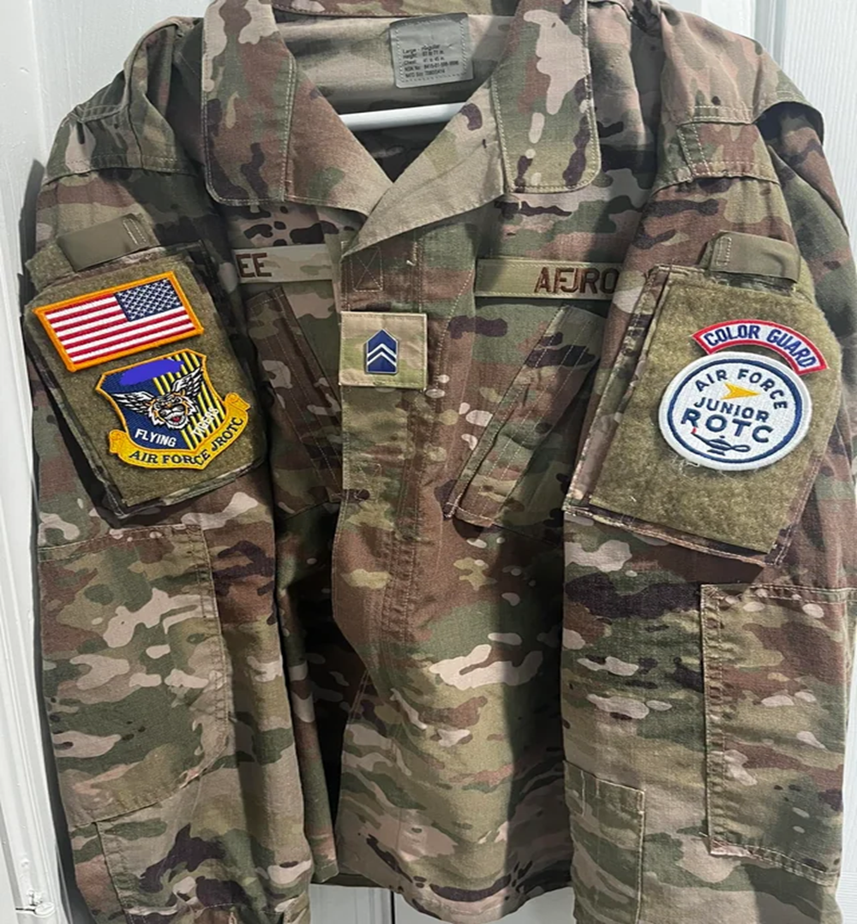

Attachment 7
(51)
CHAIN OF COMMAND
President of the United States /Commander-in-Chief
Secretary of Defense
Secretary of the Air Force
Chief of Staff, United States Air Force
Chief Master Sergeant of the Air Force
Commander, Air Education and Training Command
Commander, Air University
Commander, Holm Center
Director, Air Force Junior ROTC
Superintendent, Beaufort County School District
Principal, Northside High School
Senior Aerospace Science Instructor
Aerospace Science Instructor
Cadet Squadron Commander
Cadet Squadron Operations Commander
Cadet Color Guard Commander
Cadet Health and Wellness NCOIC
Cadet Standardization & Evaluations NCOIC
Cadet Public Affairs NCOIC
Cadet Logistics NCOIC

Attachment 8

(52)

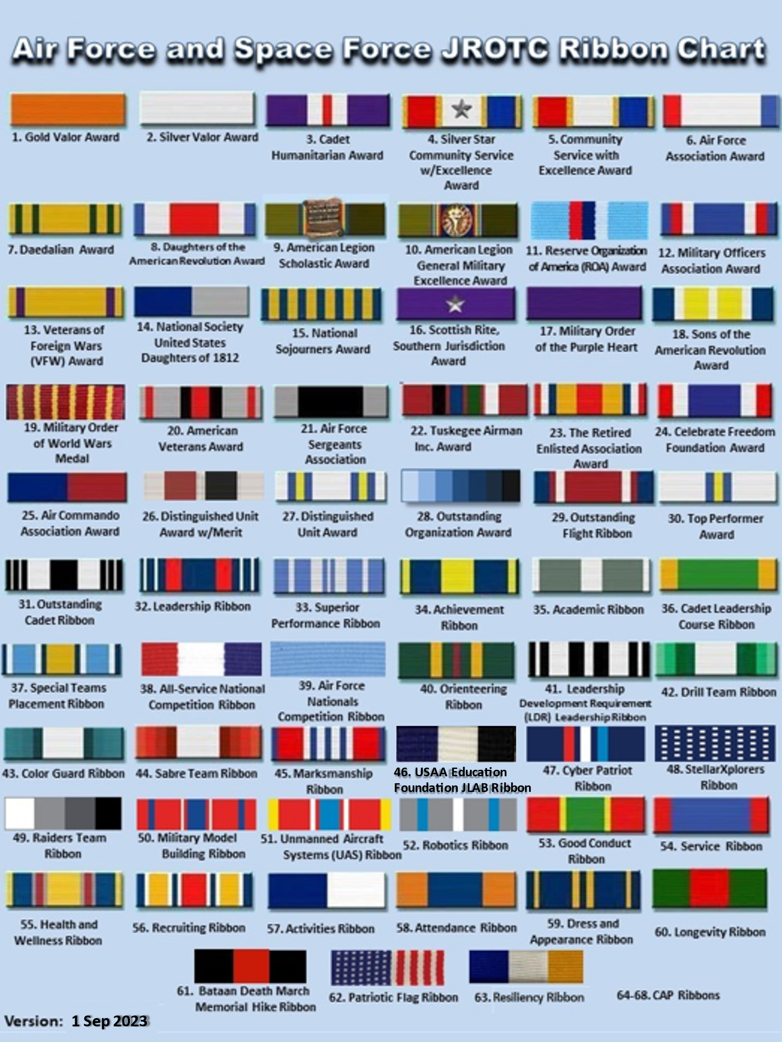

Attachment 9

(53)

30-Step Drill Evaluation as a Member

Name: __________________________________ Evaluator: _______________________
Flight/Element: ___________________________ Date: ___________________________
# COMMAND SCORE
1 Individual, attention 1 2 3 4 5
2 Present, Arms 1 2 3 4 5
3 Order, Arms 1 2 3 4 5
4 Right, Face 1 2 3 4 5
5 About, Face 1 2 3 4 5
6 Left, Face 1 2 3 4 5
7 Parade, Rest 1 2 3 4 5
8 Individual, attention 1 2 3 4 5
9 Forward, March 1 2 3 4 5
10 Left Flank, March 1 2 3 4 5
11 Change step, March 1 2 3 4 5
12 To the rear, March 1 2 3 4 5
13 Eyes, Right 1 2 3 4 5
14 Ready, Front 1 2 3 4 5
15 Right Flank, March 1 2 3 4 5
16 Half Step, March 1 2 3 4 5
17 Individual, Halt 1 2 3 4 5
18 Mark time, March 1 2 3 4 5
19 Individual, Halt 1 2 3 4 5
20 Left Step, March 1 2 3 4 5
21 Individual, Halt 1 2 3 4 5
22 Right Step, March 1 2 3 4 5
23 Individual, Halt 1 2 3 4 5
24 Military Bearing 0 1 2 3 4 5 6 7 8 9 10
5 x ___ = ____
4 x ___ = ____
3 x ___ = ____
2 x ___ = ____
1 x ___ = ____
0 x ___ = ____
18= ____ + ____ = _____ + _____ ÷ 2 = _______
Total Brg Eval 1 Eval 2 Average
Score Score Score

Attachment 10

(54)
30-Step Drill Evaluation as Commander

Name: _______________________________ Evaluator: _____________________
Flight: _______________________________ Date: _________________________
# COMMAND SCORE
1 Fall in 0 1 2 3
2 Open ranks march 0 1 2 3
3 Ready front 0 1 2 3
4 Close rank march 0 1 2 3
5 Present arms 0 1 2 3
6 Order arms 0 1 2 3
7 Parade rest 0 1 2 3
8 Flight Attention 0 1 2 3
9 Left face 0 1 2 3
10 About face 0 1 2 3
11 Forward march 0 1 2 3
12 Right flank march 0 1 2 3
13 Left flank march 0 1 2 3
14 Column right march 0 1 2 3
15 Forward march 0 1 2 3
16 To the rear march 0 1 2 3
17 To the rear march 0 1 2 3
18 Column right march 0 1 2 3
19 Forward march 0 1 2 3
20 Eyes Right 0 1 2 3
21 Ready Front 0 1 2 3
22 Column Right march 0 1 2 3
23 Forward march 0 1 2 3
24 Change step march 0 1 2 3
25 Column right march 0 1 2 3
26 Forward march 0 1 2 3
27 Flight halt 0 1 2 3
28 Left face 0 1 2 3
29 Right step march 0 1 2 3
30 Flight halt 0 1 2 3
Out of bounds -5 0 5
Out of Sequence -5 0 5
3 x ___ = ____
2 x ___ = ____
1 x ___ = ____
0 x ___ = ____
= ____ + ____ + _____ = _____ + ____ ÷ 2 = _______
Total Bndry Seq Eval 1 Eval 2 Average
Score Score Score

Attachment 11

(55)

