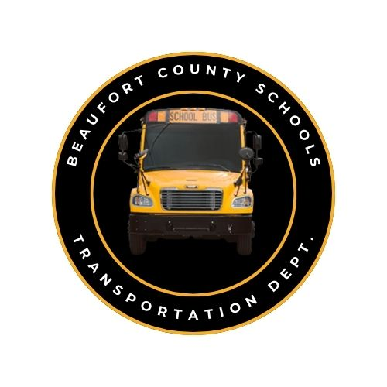

BCS Transportation Department
School Bus Trouble Report
Email: transportation@beaufort.k12.nc.us

- Date/Time: ____________
- Bus #: ________________
- School: _______________
- Driver Name (Print): ______________________

- Description of issue:

___________________________________________
___________________________________________
___________________________________________
___________________________________________
___________________________________________
___________________________________________
___________________________________________
___________________________________________
___________________________________________
___________________________________________
___________________________________________

**All trouble reports must be submitted no later than 8:45am.**

