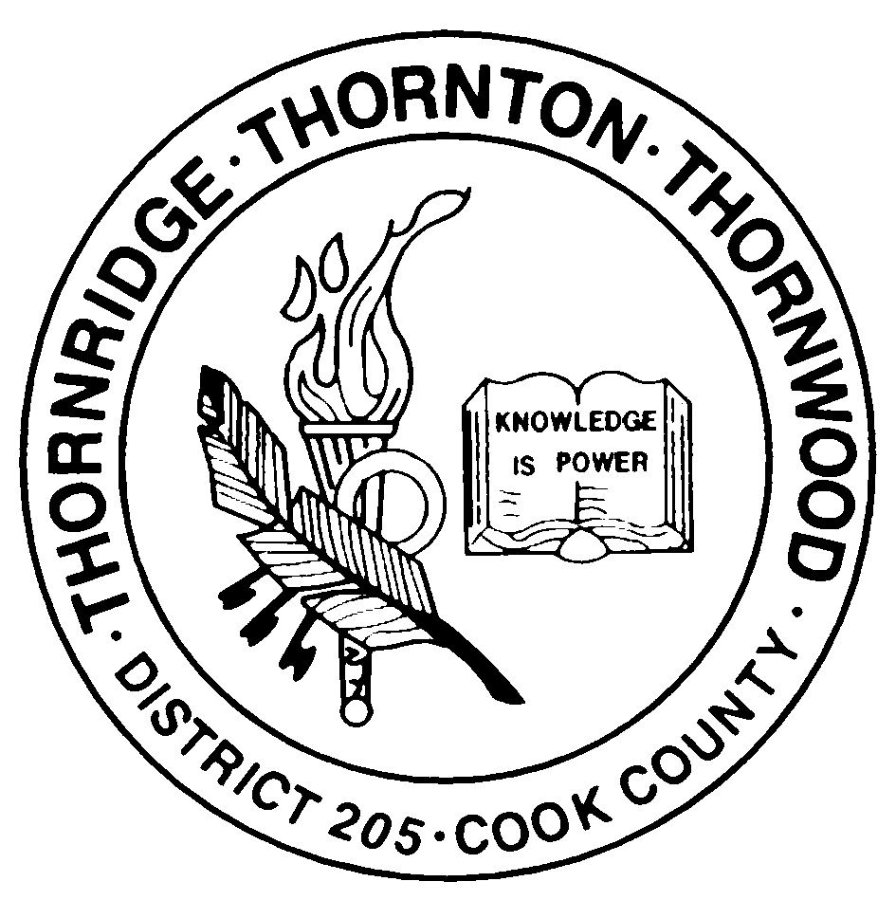

Thornton Township High School District 205
465 East 170th Street • South Holland, Illinois 60473-3481
708.225.4000 • fax: 708.225.4004

NOTICE/AGENDA FOR A SPECIAL MEETING

Notice is hereby given that a Special Meeting of the Board of Education of Thornton Township High School District 205 is being called to discuss the following issues:

AGENDA

- Recommended Approval of Science Labs Renovations Bid (Open session)
- Recommended Approval of 2010 Auditorium Seating Renovations Bid (Open session)
- Public Participation (Open session)

This Special Meeting of the Board of Education will be held on Wednesday, July 21, 2010, at 5:00 p.m., in the District Office Conference Room, at 465E. 170th Street, South Holland, Illinois 60473.

Meeting called by:

Rev. Dr. Carl E. King, Sr.
___________________________________
President
Board of Education, Thornton Township
High School District 205
Cook County, Illinois

rp
(spec.brd.mtg.7-21-10)

Thornridge High School Thornton High School Thornwood High School
15000 Cottage Grove Ave. 15001 Broadway Ave. 17101 South Park Ave.
Dolton, Illinois 60419 Harvey, Illinois 60426 South Holland, Illinois 60473
708.841.5180 708.596.1000 708.339.7800

