

12th Grade
AVID Elective Syllabus

The Advancement Via Individual Determination (AVID) Elective is an academic elective course that prepares students for college and career readiness and success, and it is scheduled during the regular school day as a year-long, academic elective course. Each week, students receive instruction that utilizes a rigorous college-preparatory curriculum provided by AVID Center and aligned to the AVID College and Career Readiness Framework. Students engage in learning tasks that incorporate strategies focused on writing, inquiry, collaboration, organization, and reading (WICOR®) to support their academic growth. Additionally, students engage in tutor-facilitated tutorials, academic success skills, and in motivational activities centered around exploring college and career opportunities and developing their student agency.

The 12th grade AVID Elective course is the final preparation for students before they move onto their postsecondary selections. Students will complete college-bound activities, methodologies, and tasks that support them as they apply to four-year universities, scholarships, financial aid, and confirm their postsecondary plans. Seniors continue to refine the WICOR skills they’ve gained throughout their years in AVID, including a scaffolded release of responsibility in AVID senior tutorials. All AVID seniors curate and present a portfolio representing their years of work in the AVID elective, as well as completing the requirements for the senior year course.

Weeks at a Glance Terms

The curriculum for each AVID Elective course is divided into four terms. Each term contains nine weeks of curricular units. The full set of instructional units is designed to implement the AVID elective standards for that grade level over the course of the year.

Term 1 | Term 2 | Term 3 | Term 4
- AVID College and Career Readiness Framework  - Organization  - Senior Year: Ready!  - Tutorology  - Goal Setting  - Financial Literacy with EVERFI  - Packback: Setting Up for Success  - Relational Capacity: Stage 1 | - Disciplinary Literacy: Writing  - College & Career with Tallo  - Senior Year: Set!  - Tutorology  - Packback: Inquiry Lessons  - Opportunity Knowledge  - Relational Capacity: Stage 2 | - Disciplinary Literacy: Reading  - Research, including optional Packback application  - Senior Year: Go!  - Tutorology  - Packback: Disciplinary Literacy Lessons  - Relational Capacity: Stage 3 | - STEM  - Tutorology  - Senior Year: Countdown to College!  - Student Agency: Transitions  - Relational Capacity: Stage 4  - Portfolio Presentations

A Week in AVID

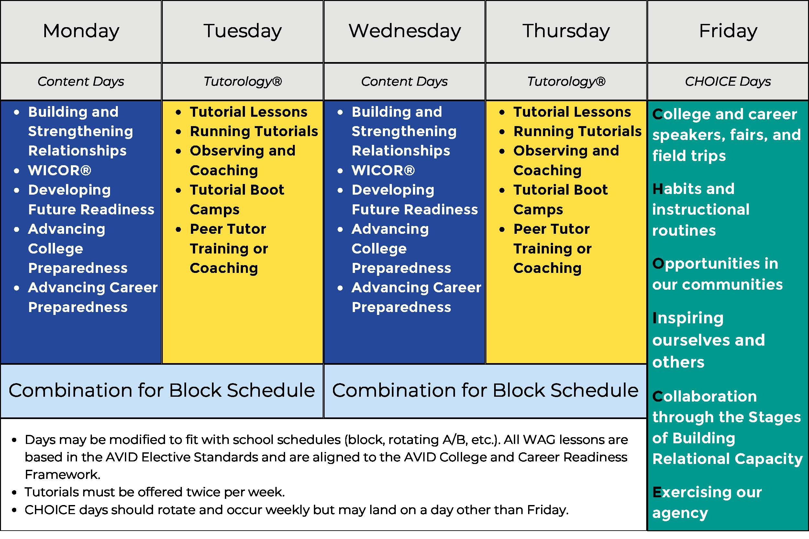
There are three types of curricular units: content units, Tutorology® (a collaborative, student-centered tutorial model), and instructional routines, which generally occur on CHOICE Days. AVID lessons utilize strategies to provide rigor and engagement to students as they develop college and career readiness skills.

Grading in the AVID Elective

30% = Weekly binder organization, note-taking, and planner checks

30% = Tutorials/College Study Groups (completed forms, notes, and reflections)

40% = Class activities such as critical reading, writing projects, other major projects, class discussions etc.

Grading Scale: A = 90% or higher B = 80-89% C = 70-79% D = 60-69% F = 59% or lower

Semester Grade: Each quarter grade is 50% of your semester grade. KEEP THIS IS MIND!

Teacher Contact Information
Mr. Christie 124G (Block 2.3) cchristie@west-fargo.k12.nd.us
- As the AVID District Director, I will be out of the building regularly to support AVID teachers across the district.
- The best way to get in contact with me is by email or Schoology message.
- After 4 PM, I am at home with my family and might not be responsive to messages.
 | Framework Overview
What Does College and Career Readiness Mean?
No matter what postsecondary path high school graduates choose, students must develop certain essential skills to design their own futures: critical thinking, collaboration, reading, writing, and relationship building. The development of these skills is rooted in belief in self. If students believe they are capable, there is a foundational confidence to learn and a resiliency to overcome setbacks.
Ensure Student Success  Over four decades, we have seen that when school leaders focus on rigorous instruction, insist on access and equity for all students, align work to a common vision, and believe in students’ potential, student outcomes improve. In addition to graduating more college-bound and career-ready students, schools are equipping their students with the social and emotional faculties they need for life and career success. By placing students in a learning setting that engages them in rigor with support, opportunities to explore their future pathways, and deliberate instruction in self-management and leadership, students develop the agency and skills that will serve them for life. With AVID, students excel regardless of their circumstances, socioeconomic status, ethnicity, or English proficiency. |  | AVID College & Career Readiness Framework  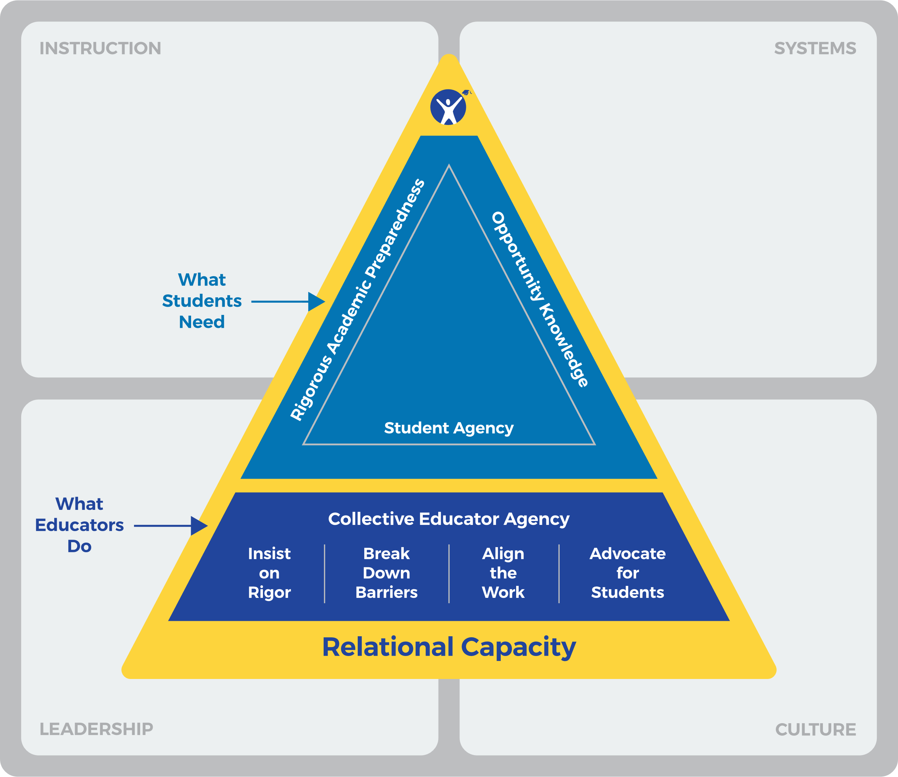
What Students Need  AVID students receive intentional support and mentoring in three major areas that help them become confident individuals who can successfully navigate life and career: |  |  | Relational Capacity  AVID defines Relational Capacity as the connection among individuals that develops over time when interactions are built on respect, trust, and authenticity. When educators connect with students and colleagues, and students connect with peers, learning and confidence are activated among all on a campus.  All three connections are instrumental  in helping students grow to see their capabilities and find their own way.
Rigorous Academic Preparedness — Students develop academic skills and can successfully complete rigorous college and career preparatory curriculum and experiences.
Opportunity Knowledge — Students research opportunities, set goals, make choices that support their long-term aspirations, and successfully navigate transitions to the next level.
Student Agency — Students believe in themselves and act intentionally to build relationships, persist through obstacles, and activate their academic, social, emotional, and professional knowledge and skills to reach their potential.

